Supporting Information

Towards the High-performance Lithium Primary Batteries by Chemically Modified Fluorinate Carbon with δ-MnO₂
Luyu Li^{1, #}, Ruizhe Wu^{3, #}, Bingbing Cheng⁴, Hancheng Ma¹, Shaoqin Rao¹, Sheng Lin¹, Chunbo Xu⁴, Lei Li⁴, Yao Ding^{1, *}, Liqiang Mai^{1, 2, *}
¹School of Materials Science and Engineering, Wuhan University of Technology, Wuhan 430070, PR China.
²Hainan Institute, Wuhan University of Technology, Sanya 572000, PR China.
³Collaborative Innovation Center for Advanced Organic Chemical Materials Co-constructed by the Province and Ministry, Ministry of Education Key Laboratory for the Synthesis and Application of Organic Functional Molecules, College of Chemistry and Chemical Engineering, Hubei University, Wuhan 430062, PR China.
⁴Wuhan Institute of Marine Electric Propulsion, Wuhan 430064, PR China.

⁎ Corresponding authors.
# L. Li and R. Wu contributed equally to this work.
E-mail addresses: ydingaf@whut.edu.cn (Y. Ding); mlq518@whut.edu.cn (L. Mai)

Keywords: δ-MnO₂; Chemical bonding; Fluorinate carbon; Lithium primary batteries

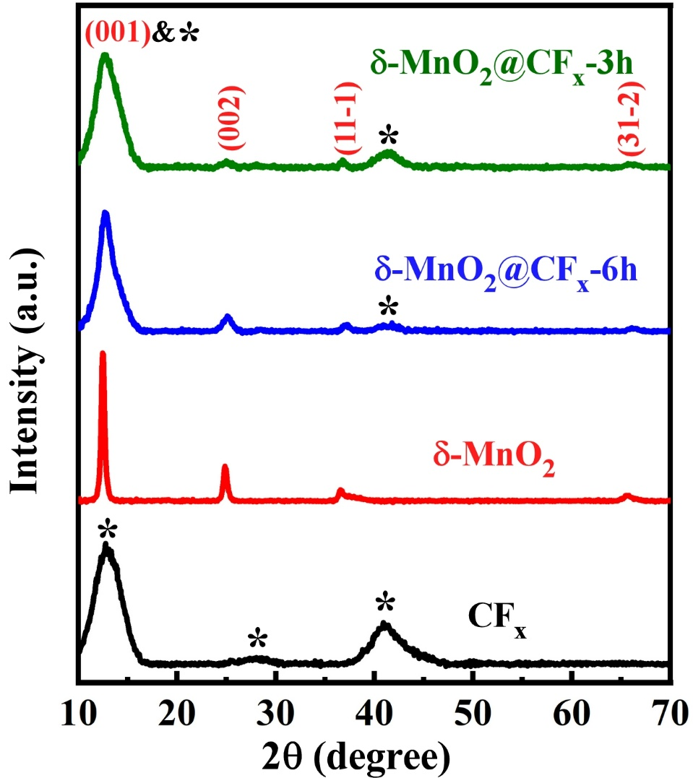
Figure S1. The full ex situ XRD patterns of CF_{x}, δ-MnO₂, δ-MnO₂@CF_{x}-6h and δ-MnO₂@CF_{x}-3h.

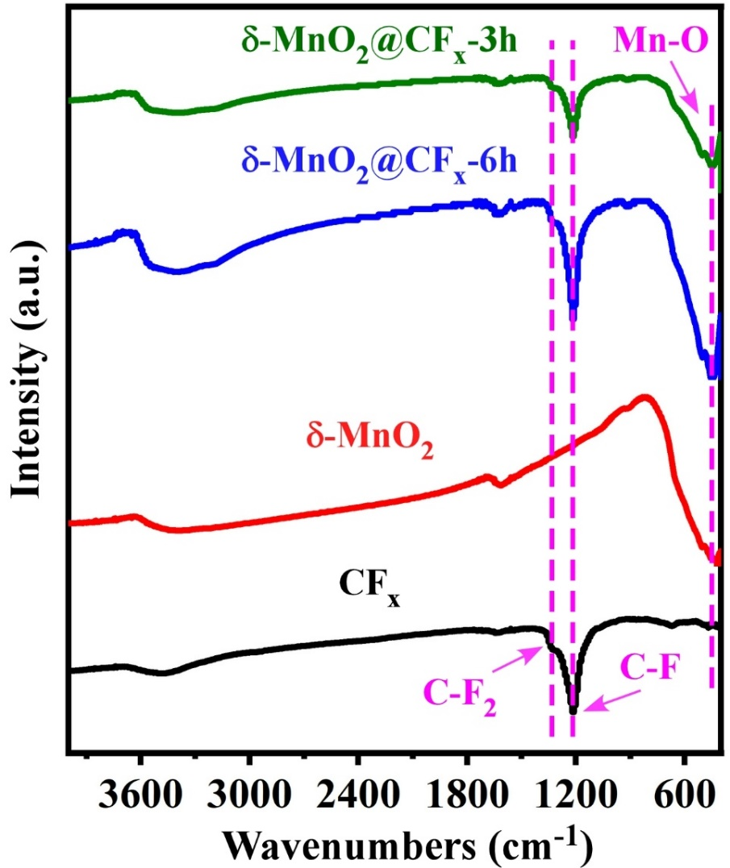
Figure S2. The full FT-IR patterns of CF_{x}, δ-MnO₂, δ-MnO₂@CF_{x}-6h and δ-MnO₂@CF_{x}-3h.

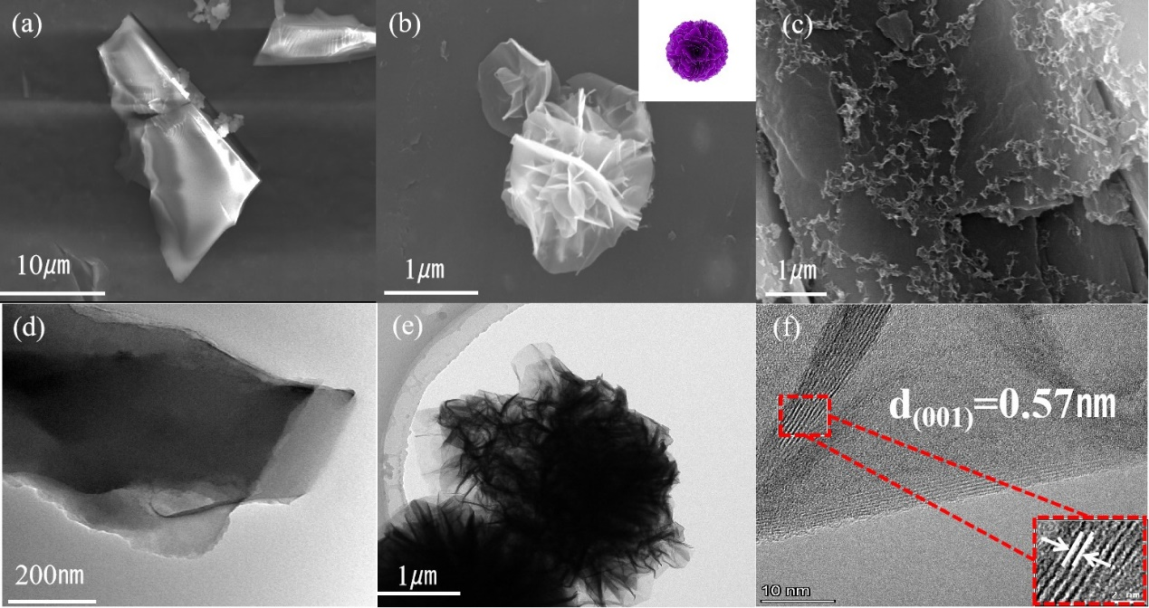
Figure S3. SEM and TEM images of O-CF_{x}, δ-MnO₂ and δ-MnO₂@CF_{x}. (a) SEM images of O-CF_{x}. (b) SEM image of δ-MnO₂. Inset: Model diagram of δ-MnO₂. (c) SEM image of δ-MnO₂@CF_{x}. (d) TEM images of O-CF_{x} and (e) δ-MnO₂. HRTEM images of (f) δ-MnO₂. Inset: Layer spacing of related materials.

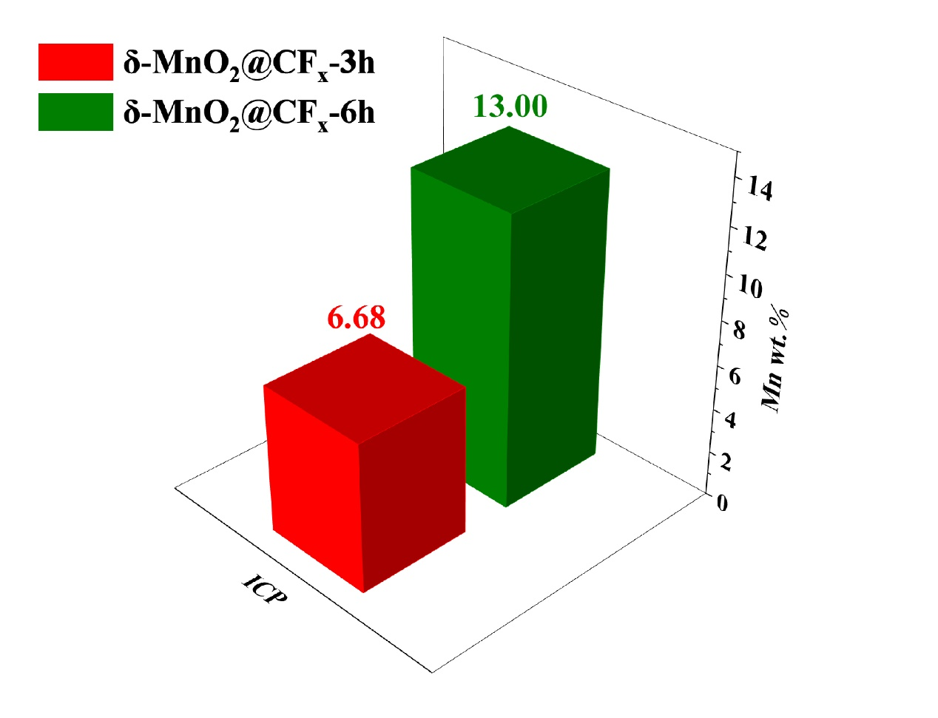
Figure S4. ICP results of δ-MnO₂@CF_{x}-3h and δ-MnO₂@CF_{x}-6h.

Figure S5. A single step of GITT for (a) CF_{x}, (b) δ-MnO₂/CF_{x}(1:9), (c) δ-MnO₂@CF_{x}-3h measured at 50 mA g⁻¹.

Figure S6. Linear behavior of the transient voltage changes against τ^{1/2} during a single titration process of CF_{x}, δ-MnO₂/CF_{x}(1:9) and δ-MnO₂@CF_{x}-3h.

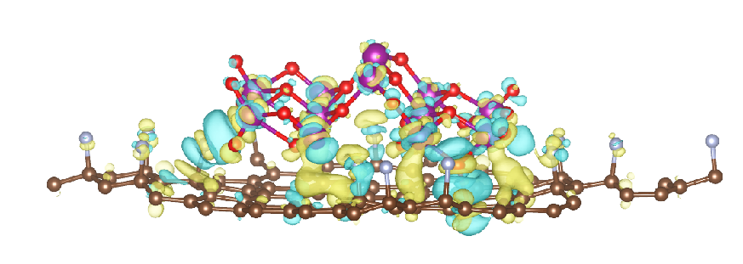
Figure S7. Front view of charge density differences of δ-MnO₂@CF_{x}.

