Supporting Information

Submerged-Plant-Inspired Five-Level-Synergetic Hierarchical Single-Fe-Atom-Doped Micro-Electrodes for High-Performance Multifunctional Electrocatalysis
Yiming Chen^{‡,a}, Yuyang Cai^{‡,a}, Ruohan Yu^{‡,a}, Xuelei Panª, Jianyong Zhangª, Zhaoyang Wangª, Xiao Xiaoª, Jinsong Wuª, Lin Xu*^{,a,b} Liqiang Mai*^{,a,b}

Figures and Tables:

Figure S1. The schematic illustration of added constituents in the hydrogel ink.
Figure S2. Test results of rheological property of the hydrogel ink.
Figure S3. The diagram illustration of the process.
Figure S4. SEM images of 3DC in different magnification.
Figure S5. SEM images of 3DC-Fe-CNTs.
Figure S6. TEM images of CNTs in different magnification.
Figure S7. TEM image of the grown CNT and corresponding EDS mapping results of the selected area for Fe, O, N and C.
Figure S8. XRD and Raman curves of 3DC-Fe-CNTs.
Figure S9. STEM images of Fe-CNTs-Ni/Ni(OH)₂ and corresponding mapping results for Ni, C and Fe.
Figure S10. Cross-sectional SEM image of the CFCNN electrode and EDS mapping of the selected area for C, Ni and Fe.
Figure S11. Cross-sectional SEM image of the CFCNN electrode and corresponding EDS mapping results of C, Ni and Fe.
Figure S12. EDS result of CNTs embedded in the CFCNN electrode.
Figure S13. N₂ isothermal adsorption-desorption and pore size distribution for the CFCNN electrode.
Figure S14. XRD patterns of the CFCNN electrode.
Figure S15. XPS curve of the CFCNN electrode.
Figure S16. High magnification EELS curves of Fe L_{2, 3} edge, O K edge and Ni L_{2, 3} edge.
Figure S17. Selected regions for conducting the EELS test and corresponding EELS curves.
Table S1. Detailed contents of the whole region and selected Region 1-4 in Figure S15.
Figure S18. Lattice structure of Ni/Ni(OH)₂ and single-Fe-atom-doped Ni/Ni(OH)₂ in different observation angle.
Figure S19. STEM images of Ni/Ni(OH)₂ and corresponding EDS mapping of Fe, Ni and O.
Figure S20. Electrode was fixed on titanium network and used for electrochemical tests.
Figure S21. High magnification XPS curve of Ni 2p and Fe 2p in the original state, after 10 h OER test (30 mA cm⁻²) and after 10 h HER test (30 mA cm⁻²).
Figure S22. The OER/HER LSV curves and corresponding Tafel plots of CFCNN, Bulk-CFCNN, 3DC-NN and P-CFCNN.
Figure S23. The gas contact angle of 3DC-NN and CFCNN electrode.
Figure S24. SEM images of 3DC-Ni-CNTs, 3DC-Ni-CNN, 3DC-Co-CNTs and 3DC-Co-CNN.
Figure S25. The OER/HER LSV curves and corresponding Tafel plots of 3D CFCNN, 3D-Ni-CNN and 3D-Co-CNN.
Figure S26. CV curves at different scan rate of CFCNN, 3DC-Fe-CNTs-Ni, 3DC-NN, P-CFCNN electrode, and the corresponding C_{dl} of different samples.

Figure S27. The schematic illustration of the home-made Zn-air battery vehicle.
Figure S28. ORR curves of P-CFC and P-CFCNN electrodes under rotating speed of 400-2500 rpm, and the comparison of different samples under 900 and 1600 rpm compared with Pt-C&RuO₂.
Figure S29. SEM images of different selected area of 3D CFCNN electrode after test and corresponding EDS mapping result of Fe, Ni, C, K and Zn.
Figure S30. SEM images of the selected area of the prepared P-CFCNN electrode and corresponding EDS mapping result of Fe, Ni, C, K, Zn, S, F, O and N.
Figure S31. Liquid contact angles of Fe-CNTs-modified carbon paper, 3DC electrode and CFCNN electrode.
Figure S32. The schematic illustration of different electrodes in Zn-air batteries.
Figure S33. The stability test of open-circuit voltage of the assembled Zn-air battery.

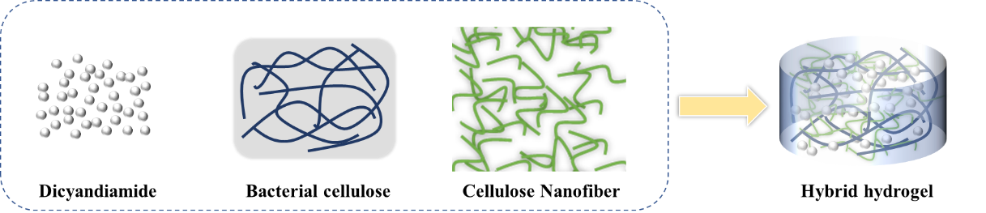
Figure S1. The schematic illustration of added constituents in the hydrogel ink: Dicyandiamide, bacterial cellulose and cellulose nanofiber.

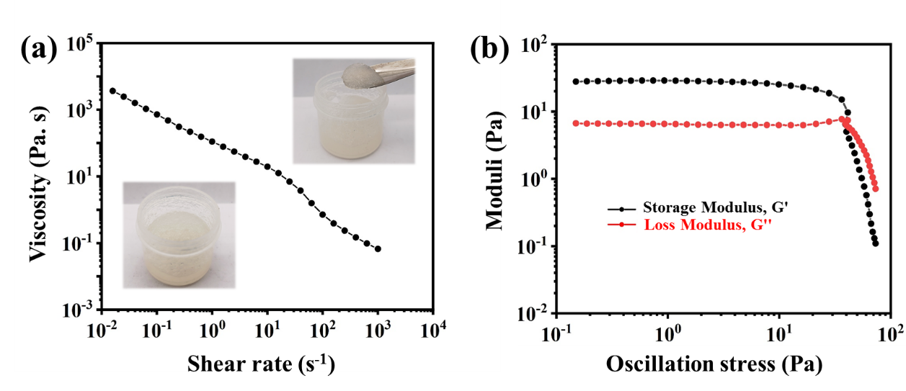
Figure S2. Test results of rheological property of the hydrogel ink. (a) The viscosity with respect to shear rate. Insets are the digital photographs of the prepared hydrogel. (b) Storage Modulus (G') and Loss Modulus (G'') with respect to oscillation stress.

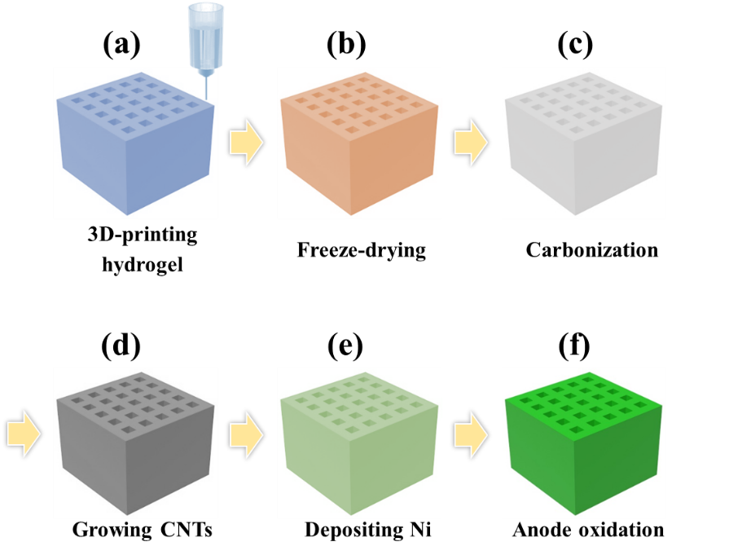
Figure S3. The diagram illustration of the process: (a) 3D printing of hybrid hydrogel; (b) freeze-drying; (c) carbonization; (d) growth of Fe-CNTs; (e) deposition of Ni and (f) anode oxidation of Ni into Ni(OH)₂.

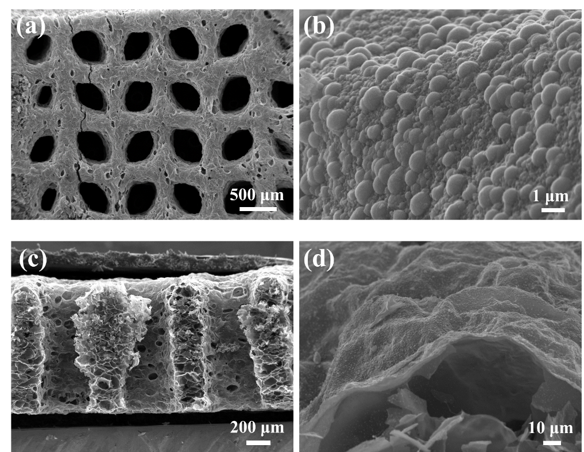
Figure S4. (a, b) Top view and (c, d) cross-sectional SEM images of 3DC in different magnification.

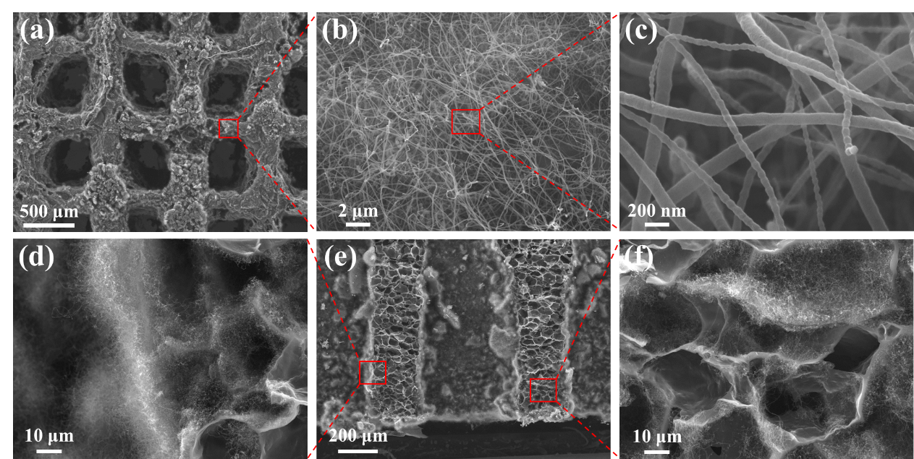
Figure S5. Top-view (a-c) and cross-sectional (d-f) SEM images of 3DC-Fe-CNTs.

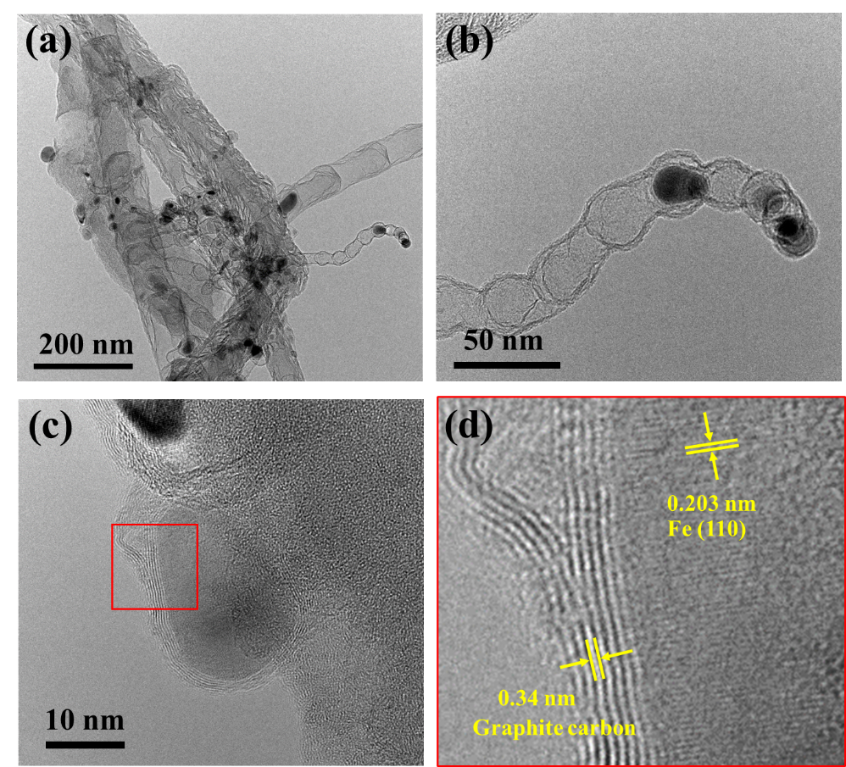
Figure S6. (a, b, c) TEM images of CNTs in different magnification. (d) High magnification image of the selected area of (c).

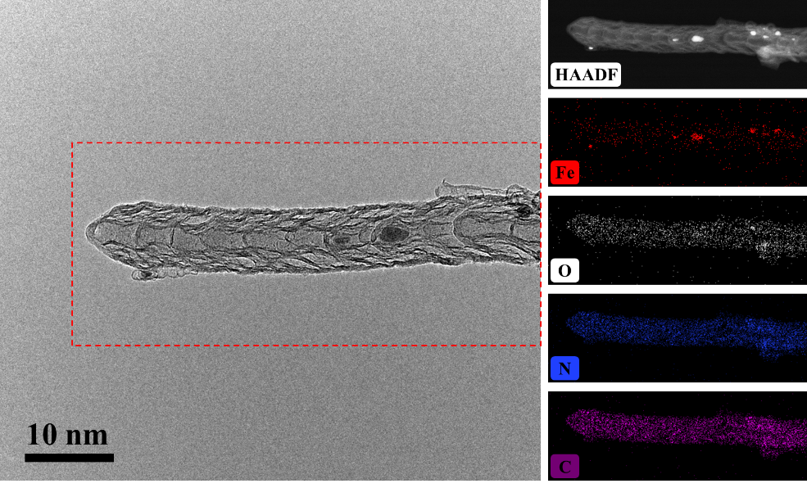
Figure S7. (a) TEM image of the grown CNT and corresponding EDS mapping results of the selected area for Fe, O, N and C.

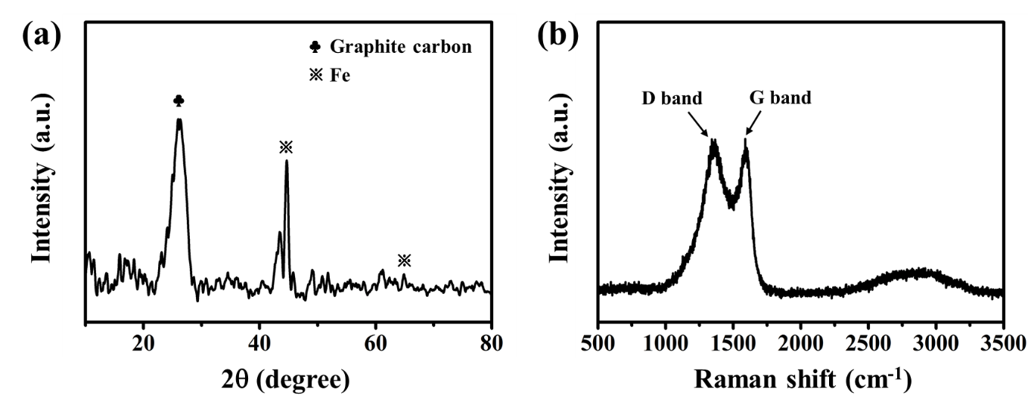
Figure S8. (a) XRD and (b) Raman curves of 3DC-Fe-CNTs.

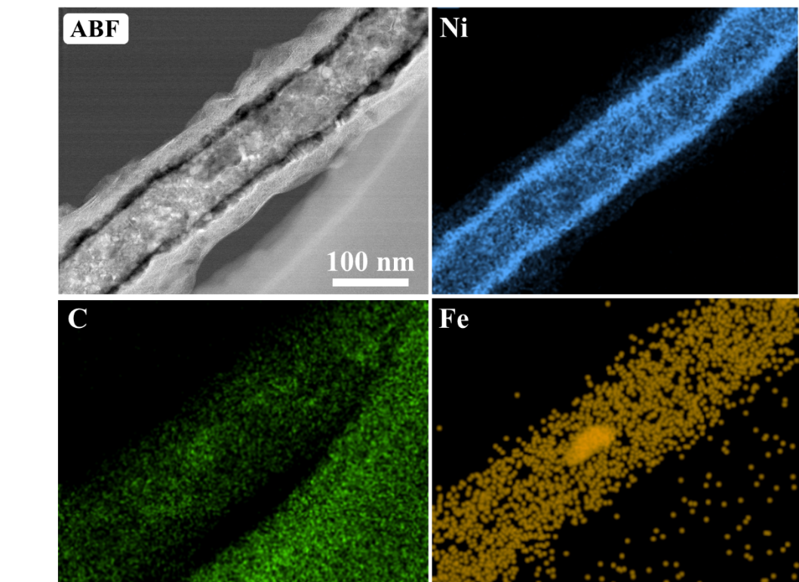
Figure S9. STEM images of Fe-CNTs-Ni/Ni(OH)₂ and corresponding mapping results for Ni, C and Fe.

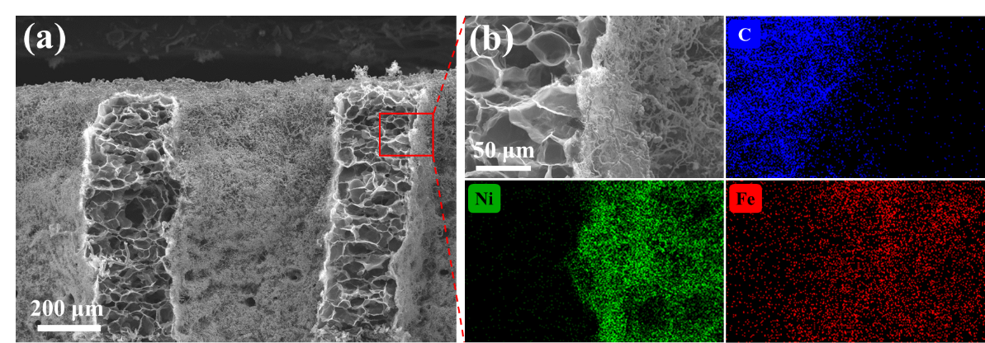
Figure S10. (a) Cross-sectional SEM image of the CFCNN electrode and (b) EDS mapping of the selected area for C, Ni and Fe.

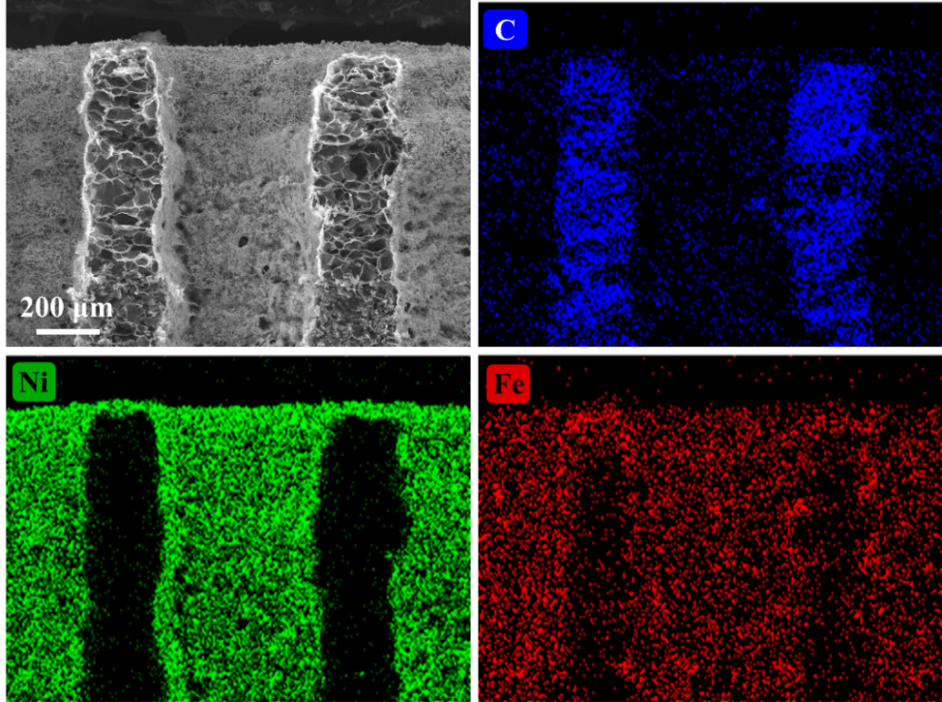
Figure S11. Cross-sectional SEM image of the CFCNN electrode and corresponding EDS mapping results of C, Ni and Fe.

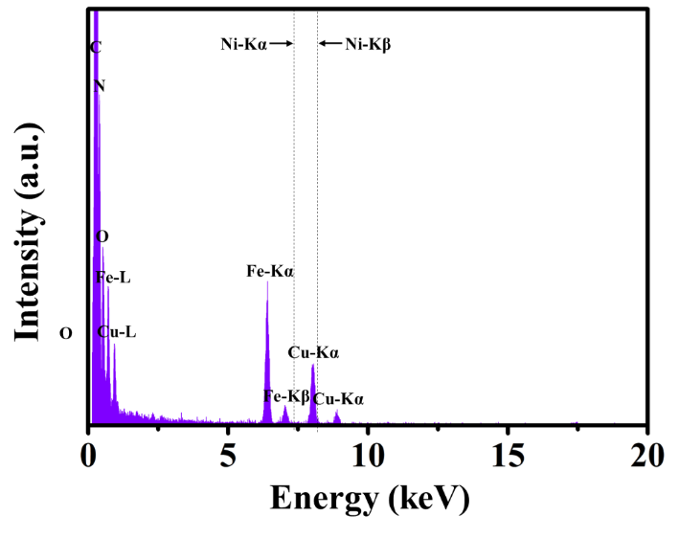
Figure S12. EDS result of CNTs embedded in the CFCNN electrode.

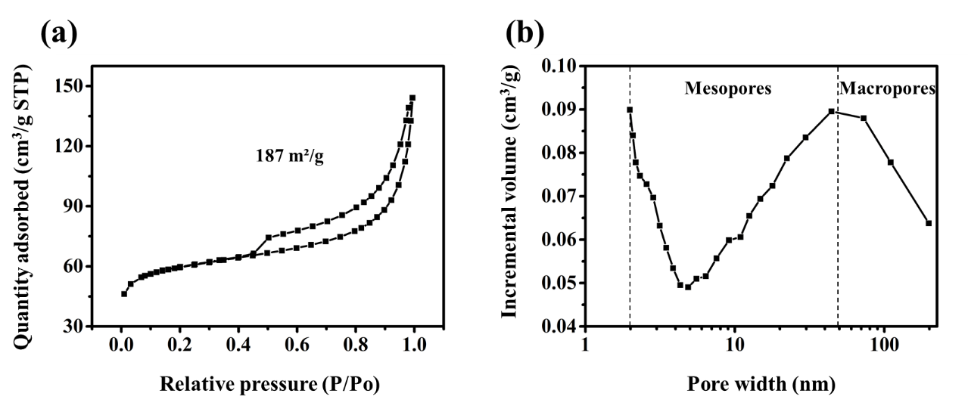
Figure S13. N₂ isothermal adsorption-desorption (a) and pore size distribution (b) for the CFCNN electrode.
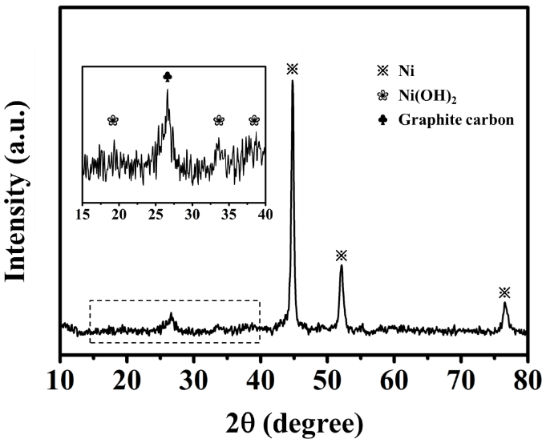
Figure S14. XRD patterns of the CFCNN electrode.
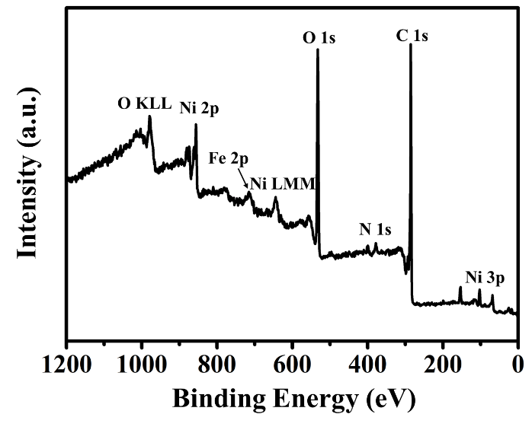
Figure S15. XPS curve of the CFCNN electrode.

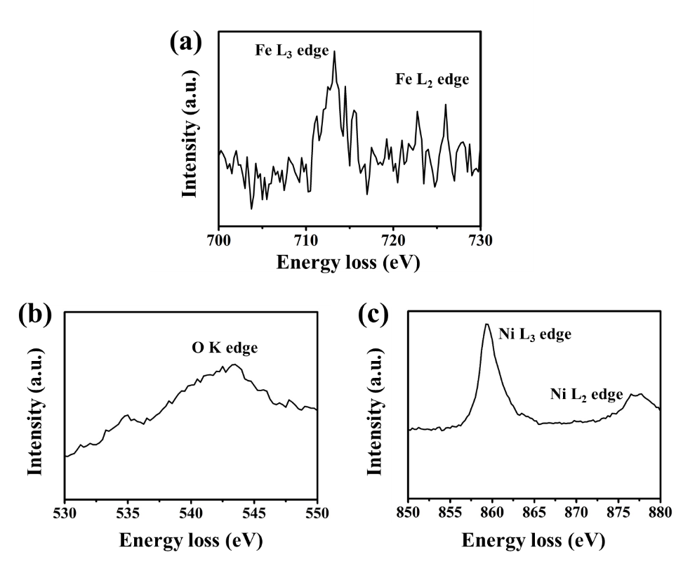
Figure S16. High magnification EELS curves of (a) Fe L_{2, 3} edge, (b) O K edge and (c) Ni L_{2, 3} edge.

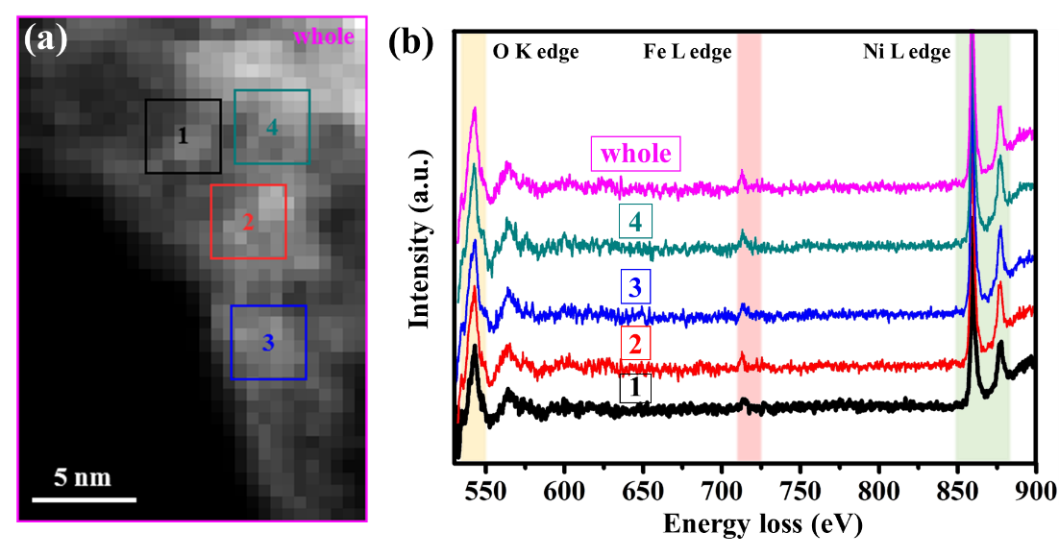
Figure S17. (a) Selected regions for conducting the EELS test. (b) EELS curves of the whole area and Region 1-4.

Table S1. Detailed contents of the whole region and selected Region 1-4 in Figure S17.
 | whole | 1 | 2 | 3 | 4
O | 51.7% | 49.1% | 55.5% | 54.0% | 56.9%
Fe | 2.5% | 2.6% | 1.9% | 2.2% | 1.8%
Ni | 45.8% | 48.3% | 42.6% | 43.8% | 41.2%

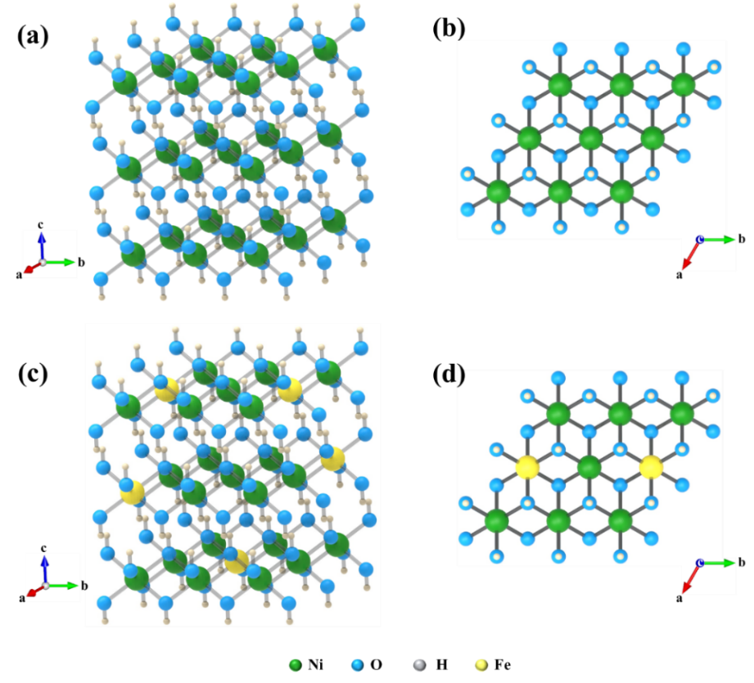
Figure S18. (a, b) Lattice structure of Ni/Ni(OH)₂ in different observation angle. (c, d) Lattice structure of single-Fe-atom-doped Ni/Ni(OH)₂ in different observation angle. Inserts of each image show the corresponding direction of basis vector.

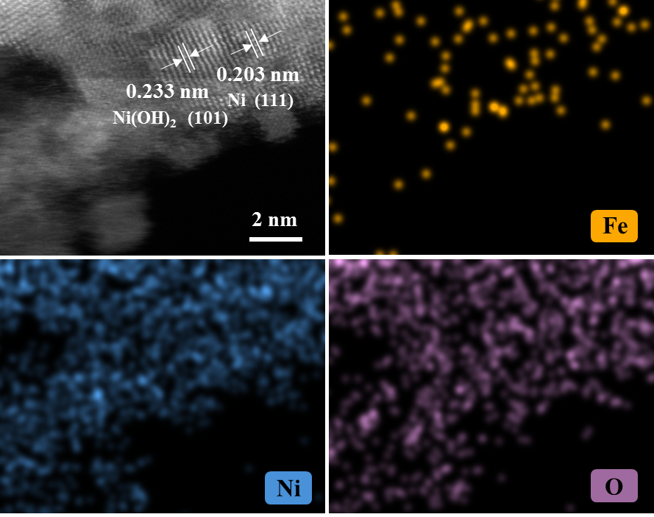
Figure S19. STEM images of Ni/Ni(OH)₂ and corresponding EDS mapping of Fe, Ni and O.

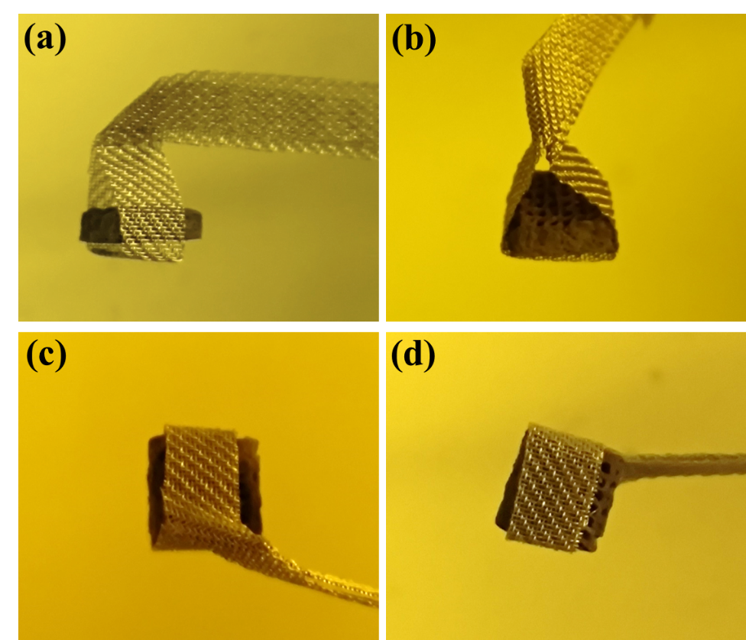
Figure S20. Electrode was fixed on titanium network and used for electrochemical tests.

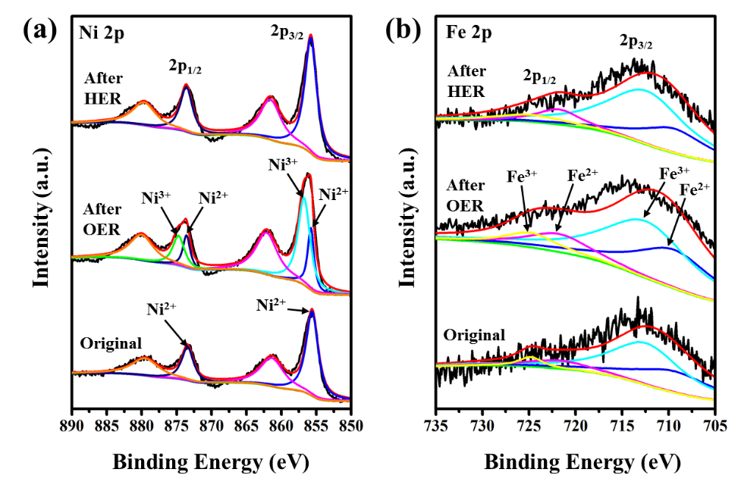
Figure S21. High magnification XPS curve of (a) Ni 2p and (b) Fe 2p in the original state, after 10 h OER test (30 mA cm⁻²) and after 10 h HER test (30 mA cm⁻²).

To reveal the significance of this multi-level structure, electrodes with different configurations were fabricated: Bulk-CFCNN electrode was fabricated, which the sample was 3D-printed without configuring the vertical pore in the scale of ~500 μm; 3DC-NN electrode was fabricated by directly depositing Ni/Ni(OH)₂ on the 3DC (without Fe-CNTs modified); P-CFCNN electrode was obtained by grinding 3D CFCNN electrodes into powder and prepared into catalytic ink. Details were all shown in Experiment section. Contrastive curves of OER/HER and relevant Tafel plots were shown in Fig. S22, which demonstrated the better performance of 3D CFCNN. Compared with P-CFCNN, the better performance of CFCNN declared the advantages of 3D configuration, which provided more active materials in a foot-printed area. Moreover, the comparison with bulk-CFCNN declared the significance of the 3D-printed periodic pores, which increased the effective contacting area and constructed vertical transport channels for the release of gas bubbles. In addition, the comparison with 3DC-NN indicated the significance of CNT modification, which increased the surface area and further promoted the areal loading mass of active materials.
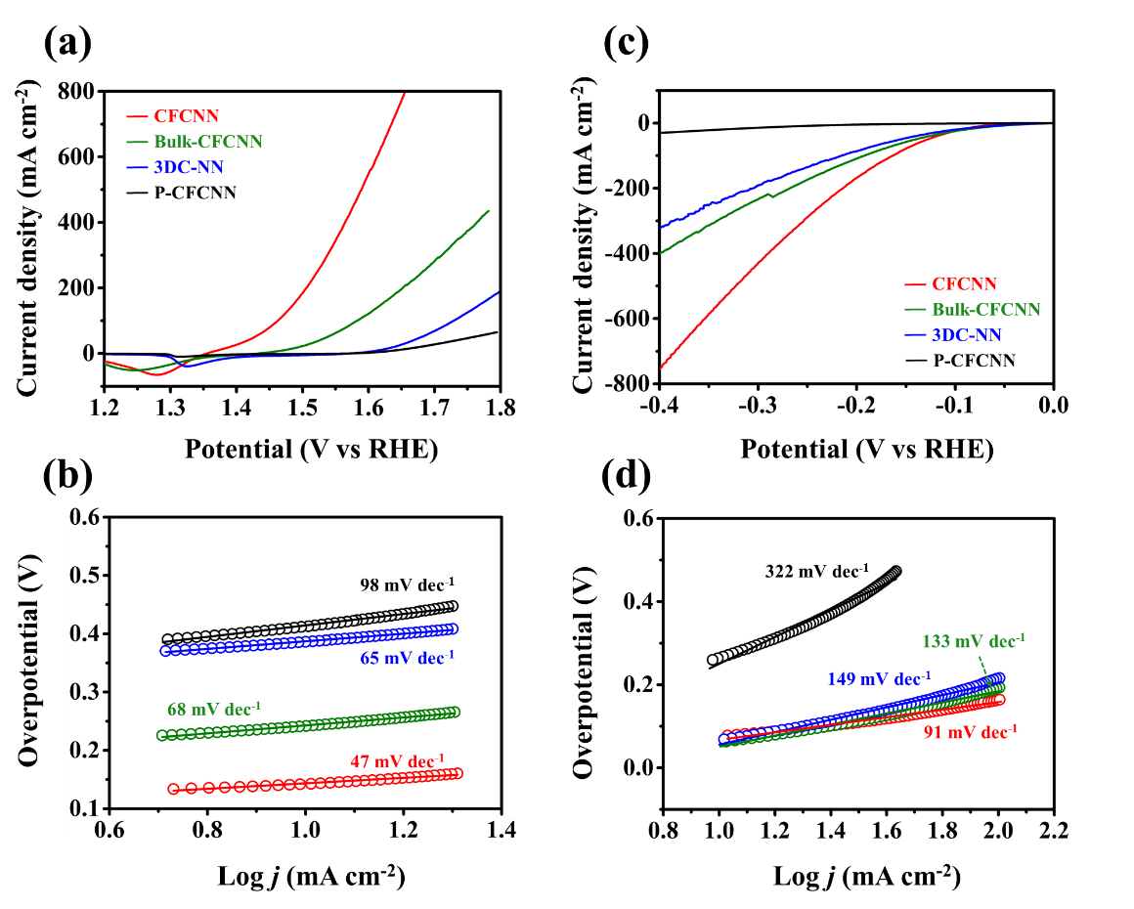
Figure S22. (a) The OER LSV curves and (b) corresponding Tafel plots of CFCNN, Bulk-CFCNN, 3DC-NN and P-CFCNN. (c) The HER LSV curves and (d) corresponding Tafel plots of CFCNN, Bulk-CFCNN, 3DC-NN and P-CFCNN.

The hydrophilia and aerophobicity of 3DC-NN and CFCNN electrode were evaluated by conducting the contact angle measurement, shown in Video 4, 5 and Fig. S23, respectively. It is obvious that these two electrodes both exhibited highly hydrophilic property, and CFCNN electrode (CA_{bubble}=127°) exhibited higher aerophobicity than 3DC-NN electrode (CA_{bubble}=117°) due to vertically aligned Fe-CNTs-Ni/Ni(OH)₂ nanowire arrays. The aerophobicity test results proved that, the modification of CNTs provided a more aerophobic surface for the electrode, which facilitated the rapid release of generated gas bubbles and lowered the polarization voltage.
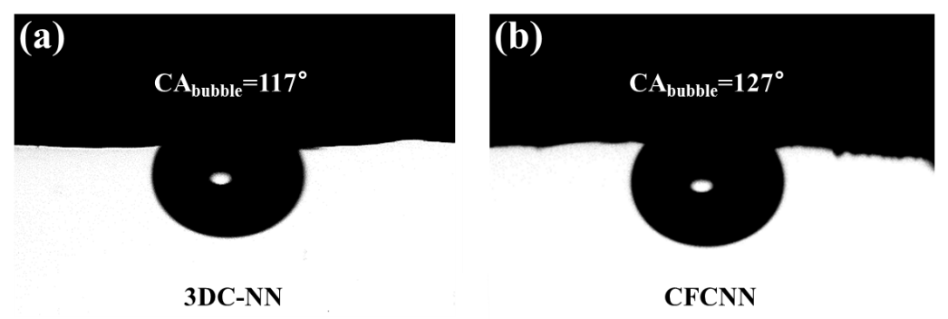
Figure S23. The gas contact angle of (a) 3DC-NN and (b) CFCNN electrode.

To demonstrate the significance of incorporated Fe, samples modified by Ni-CNTs (denoted as 3DC-Ni-CNN) and Co-CNTs (denoted as 3DC-Co-CNN) were shown in Fig. S24 (See Experiment section for preparation details), relevant OER/HER performance and corresponding Tafel plots were shown in Fig. S25. CFCNN electrodes especially delivered better OER performance than that of 3DC-Ni-CNN and 3DC-Co-CNN, which is similar to the reported results.^{[1, 2]} This further verified the optimizing effect of incorporated Fe source from Fe-CNTs: Single-Fe-atom doping regulated the electronic structure of Ni/Ni(OH)₂, immensely decreased the reacting energy barrier of OER process, and further decreased the overpotential of OER process.

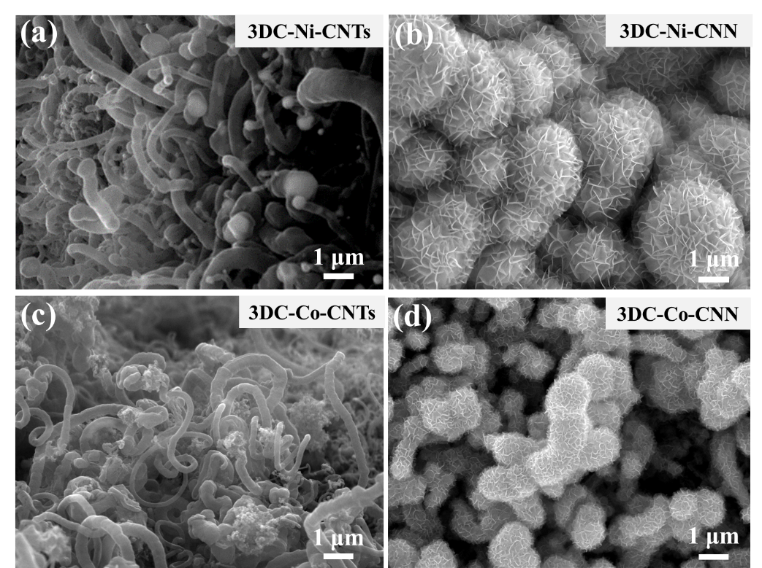
Figure S24. SEM images of (a) 3DC-Ni-CNTs, (b) 3DC-Ni-CNN, (c) 3DC-Co-CNTs and (b) 3DC-Co-CNN.

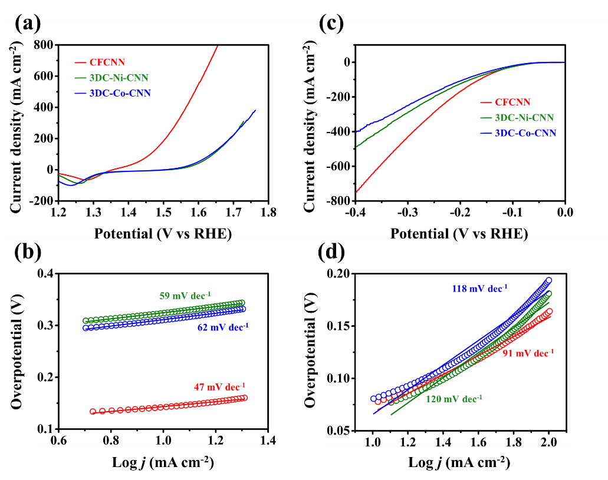
Figure S25. (a) The OER LSV curves and (b) corresponding Tafel plots of 3D CFCNN, 3D-Ni-CNN and 3D-Co-CNN. (c) The HER LSV curves and (d) corresponding Tafel plots of 3D CFCNN, 3D-Ni-CNN and 3D-Co-CNN.

Electrochemical surface area (ESCA) is the effective contacting area between electrode and electrolyte, which can be evaluated by electric double layer capacitance (C_{dl}). The CV curves of CFCNN, 3DC-Fe-CNTs-Ni, 3DC-NN and P-CFCNN electrode under different scan rates were respectively shown in Fig. S26a-d, and the fitting results were shown in Fig. S26e. The calculated C_{dl} of different samples was 1892, 1636, 1065 and 287 mF cm⁻², respectively. Compared with 3DC-NN and P-CFCNN, the former two electrodes exhibited obvious promotion, declaring the significance of 3D-printed structure and CNT modification. In addition, the oxidized CFCNN possessed higher C_{dl} than DC-Fe-CNTs-Ni, which is possibly due to the formation of nano-structure and defects during the oxidation process.

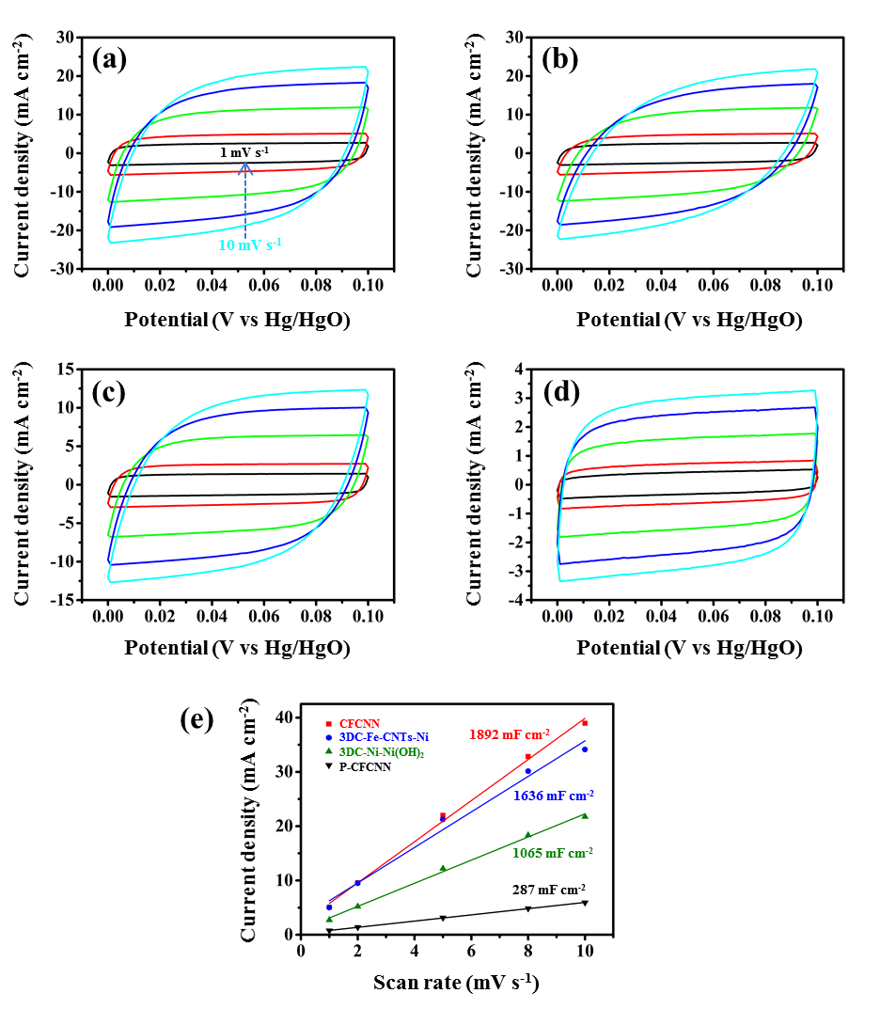
Figure S26. CV curves at different scan rate of (a) CFCNN, (b) 3DC-Fe-CNTs-Ni, (c) 3DC-NN and (d) P-CFCNN electrode. (e) The corresponding C_{dl} of different samples.

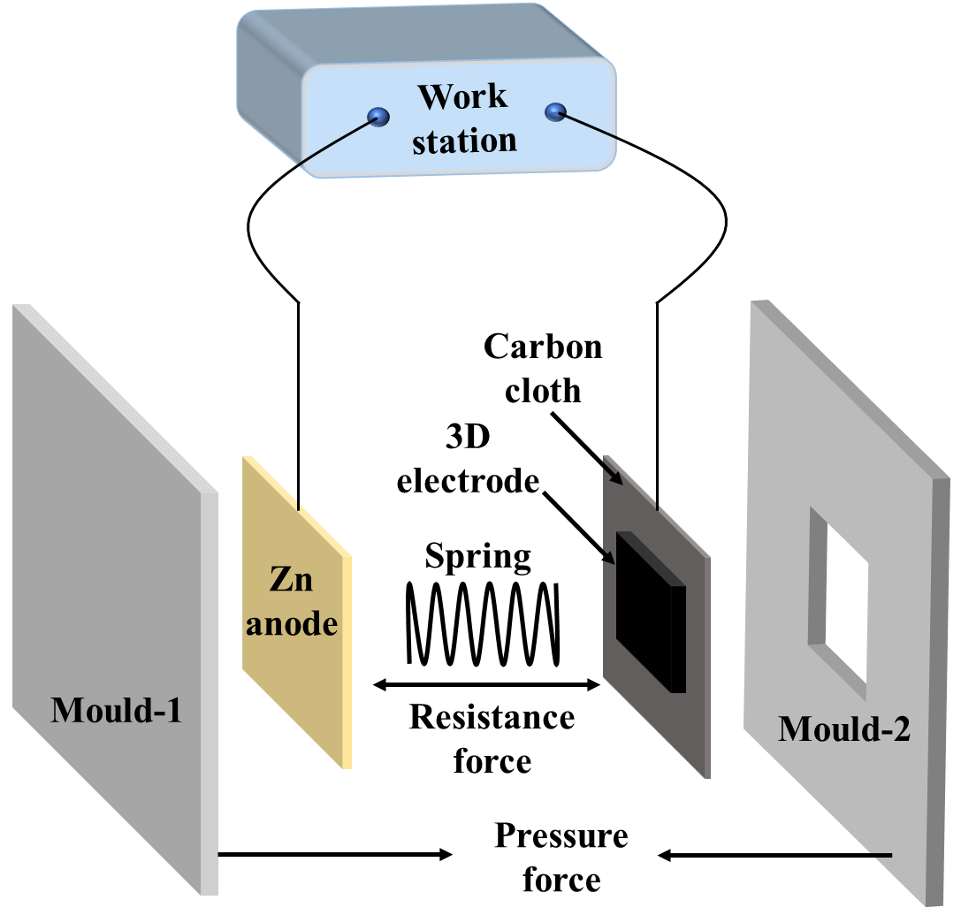
Figure S27. The schematic illustration of the home-made Zn-air battery vehicle.
To investigate the mechanism leading to this high discharging performance, powder material of CFC (P-CFC) was prepared by grinding the electrodes as well as P-CFCNN. Together with Pt-C&RuO₂ powder, the performance of ORR was evaluated by LSV test in oxygen-saturated 0.1 M KOH solution using three-electrode system (vs. Hg/HgO electrode). Response current of P-CFC and P-CFCNN was recorded under a rotating speed of 400-2500 rpm (respectively shown in Fig. S28). Under 1600 rpm (Fig. S28d), CFC and CFCNN shown half-wave potential of 0.84 and 0.7 V, and delivered limited current densities of 5.5 and 7 mA cm⁻², respectively. The finding was that, the ORR performance of P-CFCNN was weaker than that of P-CFC, and the latter exhibited a considerable ORR performance (approximate to that of Pt-C&RuO₂, consistent with the reported results^{[3]}). So we considered that, during discharging process, Fe-CNTs uncovered by Ni/Ni(OH)₂ in the honeycomb-like framework still exhibited high ORR performance, and mainly contributed to the discharging process.
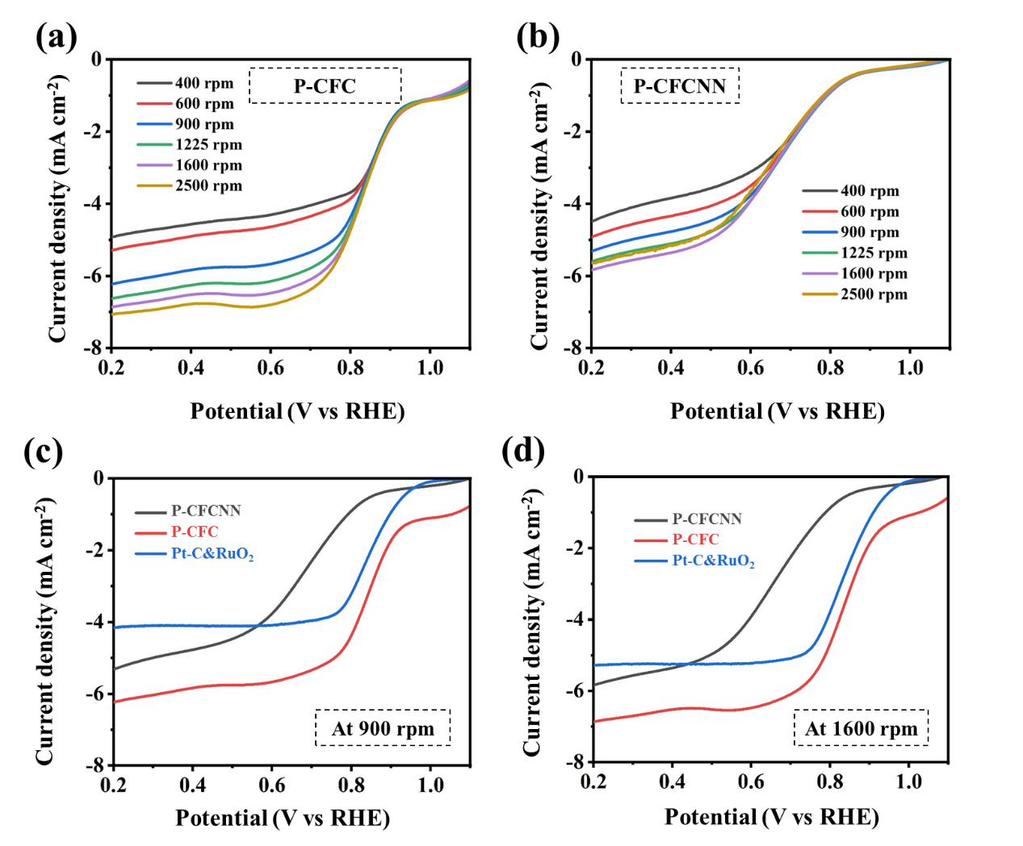
Figure S28. ORR curves of (a) P-CFC and (b) P-CFCNN electrodes under rotating speed of 400-2500 rpm. The comparison of different samples under (c) 900 and (d) 1600 rpm with Pt-C&RuO₂.

The cross-sectional SEM images of 3D CFCNN electrode and P-CFCNN electrode after cycling were checked to identify the possible transport channel of O₂, shown in Fig. S29, 30. Since the dispersion of K element (resulting from remaining salt in the electrolyte) can reflect the permeation of electrolyte, the electrode was found to be half-permeated by electrolyte (shown in Fig. S29a, b) and the less-permeated region will facilitate the diffusion of O₂, which created abundant three-phase interface. However, P-CFCNN electrode (Fig. S30) exhibited unobvious half-permeated state of K element in the thickness of ~10 μm, which provided limited three-phase interface. Thus, 3D CFCNN electrode can operate under a large current density compared with P-CFCNN electrode.
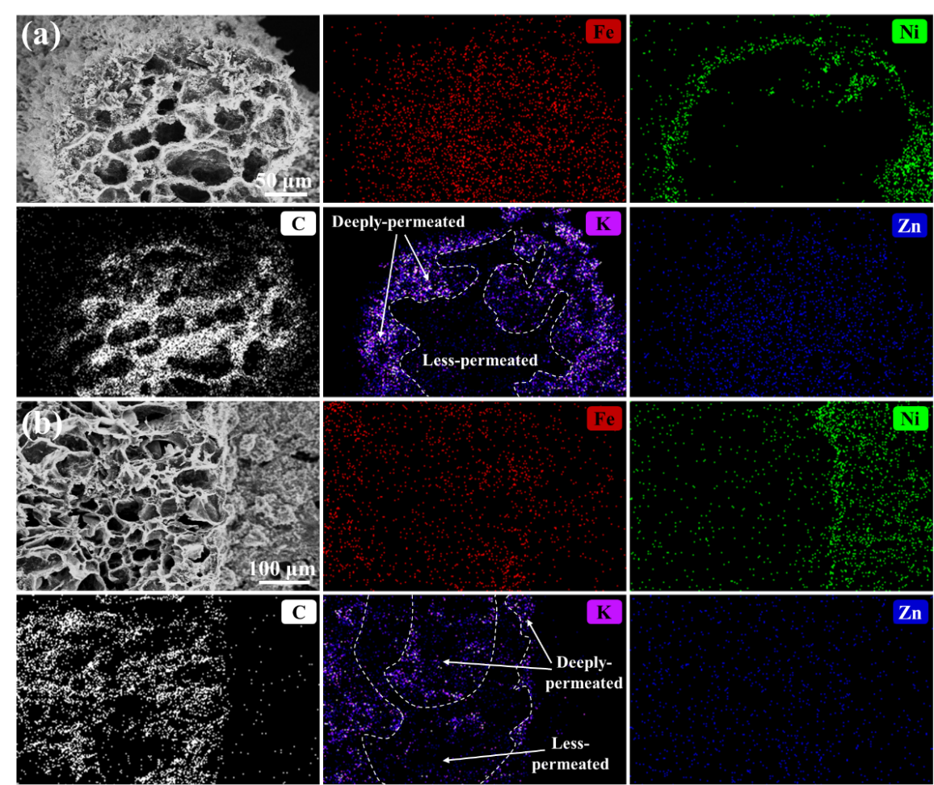
Figure S29. (a, b) SEM images of different selected area of 3D CFCNN electrode after test and corresponding EDS mapping result of Fe, Ni, C, K and Zn.

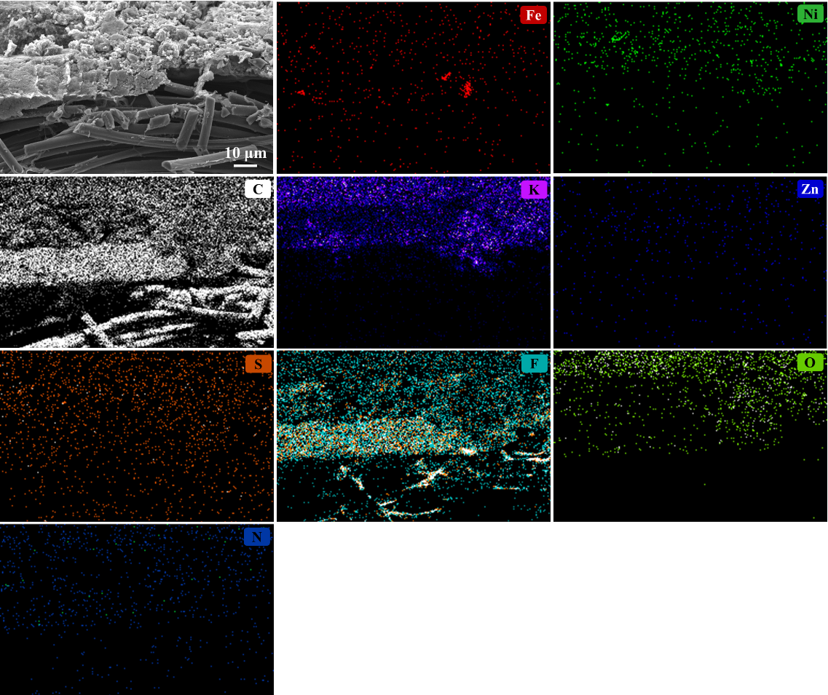
Figure S30. SEM images of the selected area of the prepared P-CFCNN electrode and corresponding EDS mapping result of Fe, Ni, C, K, Zn, S, F, O and N.

Since electrolyte permeation is highly correlated with the liquid contact angle of the electrode components, three kinds of electrodes: Fe-CNTs-modified carbon paper (the same method except for the substrate), 3DC electrode and CFCNN electrode were prepared to compare the contact angle with electrolyte (shown in Fig. S31). Fe-CNTs-modified carbon paper exhibited high hydrophobicity whereas 3DC and CFCNN electrode exhibited high hydrophilicity, which revealed the reason of partial permeation of electrolyte: pyrolysis carbon of CNF-BC- dicyandiamide (3DC substrate) and loaded Fe-doped Ni/Ni(OH)₂ (proved by CFCNN) were well infiltrated by electrolyte, whereas Fe-CNTs (high hydrophobicity) hindered the deeper infiltration of electrolyte, the hydrophobic/hydrophilic interlaced structure resulted in the partial permeation of electrolyte and led to individual transport channels for O₂.

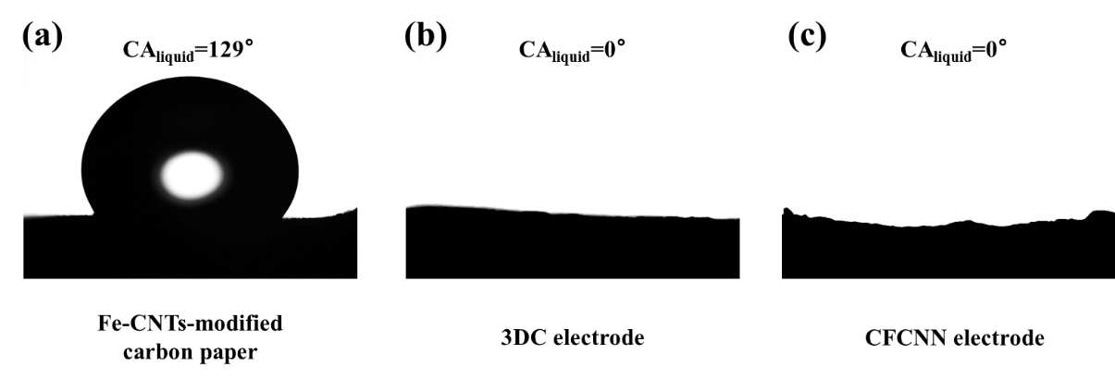
Figure S31. Liquid contact angles of (a) Fe-CNTs-modified carbon paper, (b) 3DC electrode and (c) CFCNN electrode.

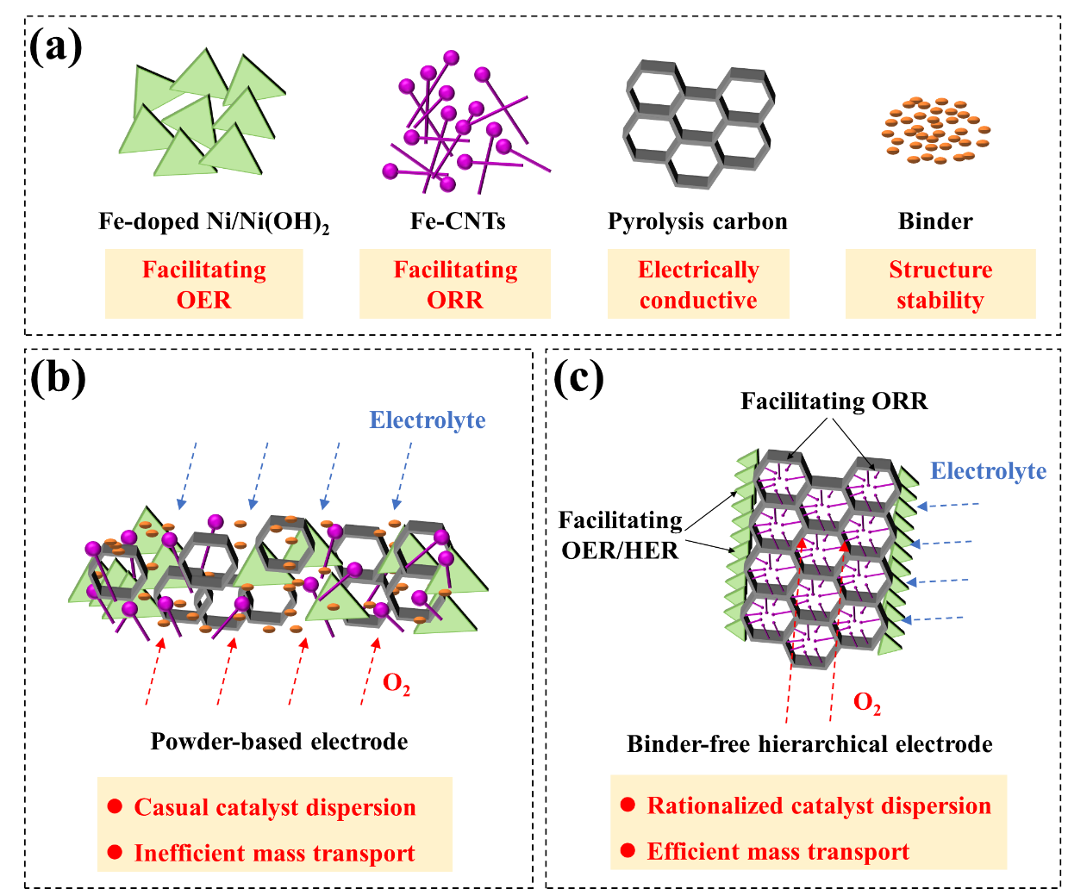
Figure S32. (a) The function of Fe-doped Ni/Ni(OH)₂, Fe-CNTs, pyrolysis carbon and binder. (b) The schematic illustration of catalyst dispersion and mass transport in powder-based electrode. (c) The schematic illustration of catalyst dispersion and mass transport in the 3D-printed binder-free hierarchical electrode.

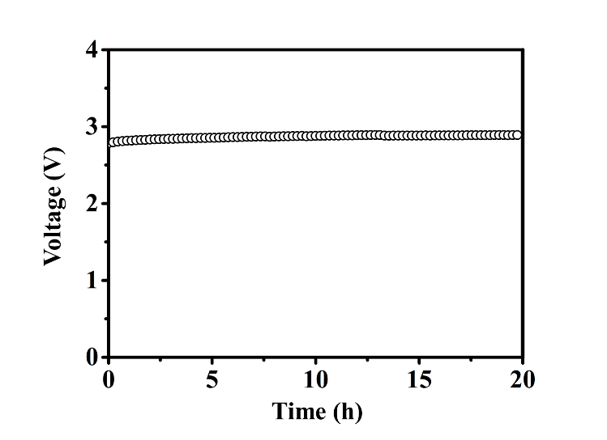
Figure S33. The stability test of open-circuit voltage of the assembled Zn-air battery.

Table S2. The comparison of performance of ORR and Zn-air battery with published representative works.
Materials of catalyst | Half-wave potential (V vs. Hg/HgO) | Charge−discharge voltage gap (V) | Peak power density (mW cm⁻²) | Works
3DC-Fe-CNTs | 0.84 | - | - | Our work
3DC-Fe-CNTs-Ni-Ni(OH)₂ | 0.70 | 0.81 | 143.8
Mo–N/C@MoS₂ | 0.81 | 0.83 | 196.4 | Adv. Funct. Mater. 2017, 27, 1702300.
La_{x}(Ba_{0.5}Sr_{0.5})_{1-x}Co_{0.8}Fe_{0.2}O₃-_{δ} | 0.66 | 0.94 | - | Energy Environ. Sci., 2016, 9, 176-183.
CuS/NiS₂ | 0.71 | 0.91 | 172.4 | Adv. Funct. Mater., 2017, 27, 1703779.
Co(OH)₂/N-rGO | 0.81 | 0.85 | 36.25 | ACS Appl. Mater. Interfaces, 2015, 7, 12930-12936.
Ni₃FeN | 0.5 | 1.00 | 200 | Nano Energy, 2017, 40, 382-389.
Nanoporous carbon fiber | 0.81 | 1.00 | 185 | Adv. Mater., 2016, 28, 30003006.
DN-CP@G | 0.80 | 0.99 | 135 | Adv. Energy Mater. 2018, 8, 1703539.
Carbon fiber@defective graphene | 0.61 | 1.01 | 91.4 | Energy Storage Mater. 2018, 15, 124.
NiCo@N-CC | 0.81 | 0.95 | - | Adv. Funct. Mater. 2018, 28, 1705094.
Ni₃Fe/N-C | 0.76 | 0.84 | - | Adv. Energy Mater. 2017, 7, 1601172.
PrBa_{0.5}Sr_{0.5}Co_{2−x}Fe_{x}O_{5+δ} | 0.68 | 0.95 | 127 | ACS Nano 2017, 11, 11594.
WS₂ on CNT | 0.79 | 0.95 | - | Adv. Energy Mater. 2017, 7, 1602217.
N-doped MoS₂/graphene heterostructure | 0.72 | 0.90 | - | Adv. Mater. 2018, 30, 1705110.
Co₃FeS_{1.5}(OH)₆ | 0.72 | 0.87 | 113.1 | Adv. Mater. 2017, 29, 1702327.
NiO/CoN | 0.68 | 0.85 | 79.6 | ACS Nano 2017, 11, 2275.
Co–N_{x}–C | 0.78 | 0.95 | 152 | Adv. Mater. 2017, 29, 1703185.
CoMn_{1.5}Ni_{0.5}O₄ | 0.78 | 0.86 | 147.4 | Chem. Eng. J, 2021, 417, 129179.
Ca-LaCoO₃ | 0.70 | 0.89 | 105.5 | Energy Storage Materials, 2021, 42, 470–476.
Distorted Calcium manganite | 0.82 | 1.03 | 149 | Nano Energy, 2021, 85, 106020.

Reference
[1] S. Klaus, Y. Cai, M. W. Louie, L. Trotochaud, A. T. Bell. J. Phys. Chem. C. 2015, 119, 7243.
[2] L. Trotochaud, S. L. Young, J. K. Ranney, S. W. Boettcher. J. Am. Chem. Soc. 2014, 136, 6744.
[3] J. Liang, R. F. Zhou, X. M. Chen, Y. H. Tang, S. Z. Qiao. Adv. Mater. 2014, 26, 6074.

