Supporting Information

Carbon Nanotube Interwoven Polyhedrons with Inside-out Lithiophilic Gradients toward Stable Lithium Metal Battery

Xinhui Chen^{a#}, Zhaohuai Li^{a#}, Yan Liª, Chunli Shenª, Cheng Zhouª, Xingnian Tanª, Kaijian Yanª, Ge Zhangª, Xu Xuª*

ª State Key Laboratory of Advanced Technology for Materials Synthesis and Processing, International School of Materials Science and Engineering
Wuhan University of Technology, Wuhan 430070, Hubei, P. R. China
# X. C. and Z. L. contributed equally to this work.

E-mail: xuxu@whut.edu.cn

Experimental section
1. Sample preparation
Synthesis of ZIF-8 polyhedrons
Solution A composed of Zn(NO₃)₂·6H₂O (3 mmol) and methanol (30 ml) was formed, and solution B was prepared by dissolving 2-methylimidazole (12 mmol) in methanol (30 ml). Solution A was quickly poured into solution B under stirring, and the mixture was continuously stirred for 5 min to ensure uniform mixing. Then, this mixed solution was aged for 24 h at room temperature. ZIF-8 polyhedrons were obtained by centrifuging several times and washing with methanol before drying at 60 °C in an oven.
Synthesis of ZIF-8@ZIF-67 core-shell polyhedrons
For the synthesis of ZIF-8@ZIF-67 core-shell structure, Co(NO₃)₂·6H₂O (150 mg) and methanol solution (10 ml) of 2-methylimidazole (328 mg) were subsequently poured into methanol (30 ml) consisting of ZIF-8 (3 mg/ml) under stirring. After stirring at 30 °C for 24 h, ZIF-8@ZIF-67 core-shell nanoparticle can be harvested through several centrifugation-rinsing cycles with methanol, followed by drying at 60 °C overnight.
Synthesis of carbon nanotube interwoven polyhedrons (CNIP)
To synthesize the desired CNIP, ZIF-8@ZIF-67 precursor was placed in a tube furnace, and the temperature was increased from room temperature to 600 °C with a heating rate of 1 °C min⁻¹ and held for 3 h. CNIP was obtained after the tube furnace cooled to the room temperature.
2. Materials characterization
XRD characterization was performed using an X-ray diffractometer with a non-monochromatic Cu K_{a} X-ray source (Bruker D8 Advance). SEM images were collected by electric microscopes (JEOL JSM-7100F). TEM and HRTEM were executed with a Titan G2 60-300 with EDS image corrector. XPS measurements were recorded using a VG MultiLab 2000 instrument. Raman spectra were collected using a Raman spectroscopy system (Renishaw INVIA). N₂ adsorption-desorption isotherms were measured using a Physisorption Analyzer (Micromeritic Tristar II 3020) at 77 K.
3. Measurements of electrochemical performances
Coin-type cells (CR2025) were assembled in a glovebox filled with pure argon gas to study the electrochemical performance. A Celgard 2400 polypropylene (PP) was used as the separator. The electrolyte was 1.0 M lithium bis (trifluoromethanesulfonyl) imide (99.95%, Sigma-Aldrich) dissolved in DOL (99.95%, Sigma-Aldrich) and DME (99.95%, Sigma-Aldrich) (1:1 ratio by volume) with 0.1 M lithium nitrate (LiNO₃, 99.9%, Alfa Aesar) as the additive. To prepare the CNIP electrode, the slurry composed of CNIP powder (80 wt%), a conducting agent (Acetylene Black, 10 wt%), and a binder (polyvinylidene fluoride, PVDF, 10 wt%) in an N-methyl-2-pyrrolidine (NMP) solution was coated on Cu foil. The long term cycling tests and CE tests were performed at one tenth of the following test current density for initial several cycles. The electrochemical impedance spectra (EIS) were tested by electrochemical workstation (Autolab PGSTAT302N). The Galvanostatic charge/discharge and cycling measurements were performed with a multichannel battery testing system (LAND CT2001A) in the potential range from 2.8-4.0 V at different current densities.

Fig. S1. XRD pattern of ZIF-8@ZIF-67 core-shell precursor.

b
a
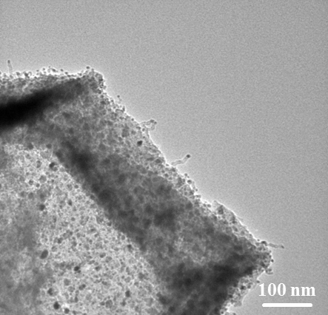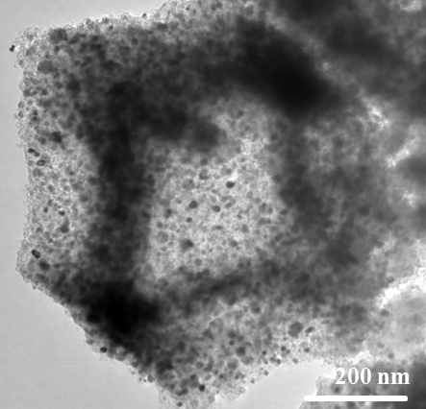
Fig. S2. Partially magnified TEM images of CNIP.
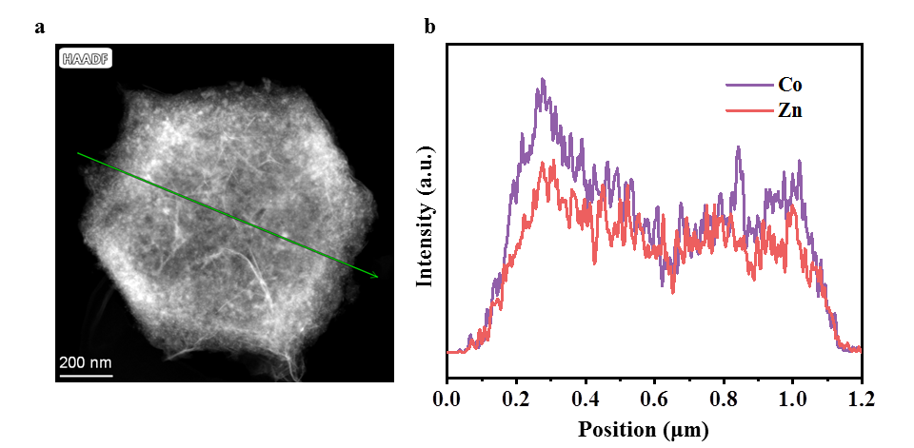
a
b
Fig. S3. Elemental line scan of Co and Zn of the CNIP.

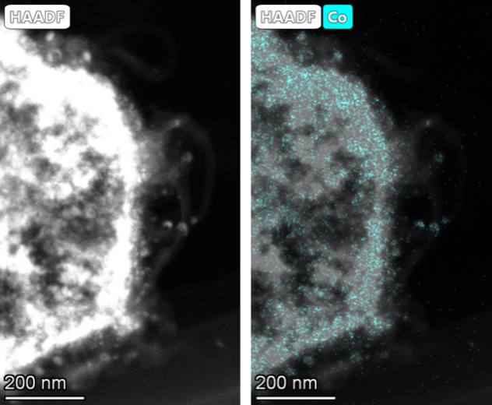
Fig. S4. Magnified elemental mapping of CNIP.

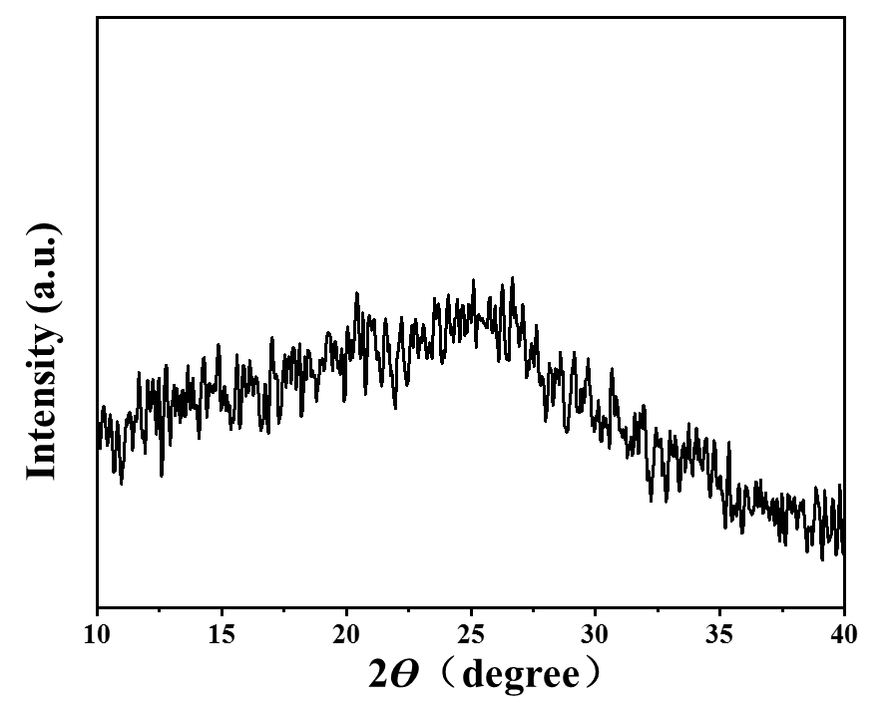
Fig. S5. XRD pattern of the CNIP.
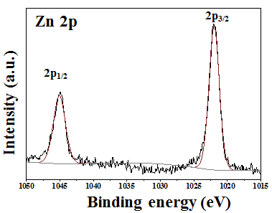
b
a
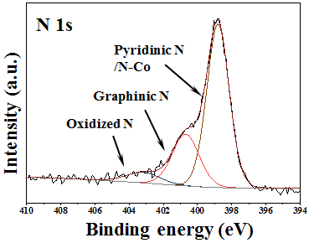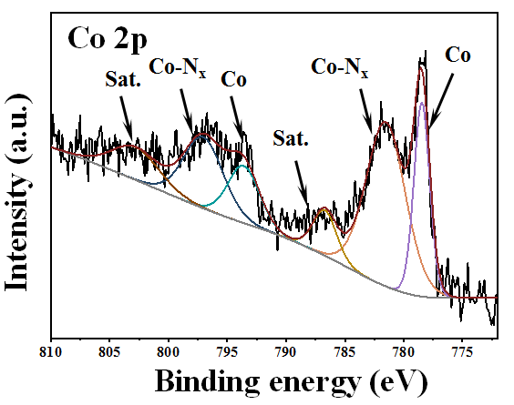
Fig. S6. XPS characterizations of the CNIP.
c
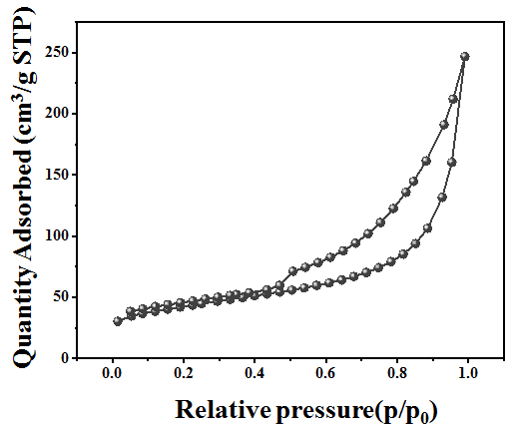
Fig. S7. Nitrogen adsorption-desorption isotherms of the CNIP.

Fig. S8. Coulombic efficiency comparison of Li plating on planar Cu and CNIP electrodes with 0.5 mA cm⁻² to 0.5 mA h cm⁻².

Fig. S9. Charge-discharge curves of the CNIP electrode of the 51st, 101st, and 151st cycles in Fig. 2(b).
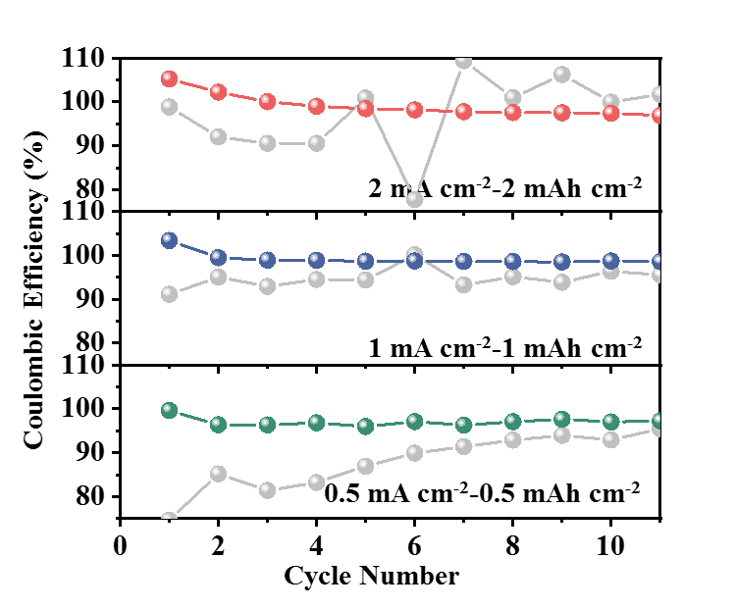
Fig. S10. Coulombic efficiency comparison of Li plating on planar Cu and CNIP electrodes with different current density.

Table S1. Capacity retention rate with different electrodes after ten cycles.
Electrode | Cu |  |  | CNIP
Plating capacity (mAh cm^{–2}) | 0.5 | 1 | 2 | 0.5 | 1 | 2
Capacity retention rate (%) | 25 | 57.7 | 68.66 | 74.0 | 92.6 | 93.4

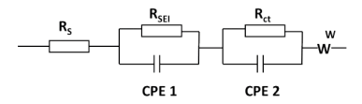
Fig. S11. The equivalent circuit of cells.

Table S2. The simulated parameters of impedance.
Samples | Cu/Li |  |  | CNIP/Li
Impedance (Ω) | R_{s} | R_{SEI} | R_{ct} | R_{s} | R_{SEI} | R_{ct}
Before cycling | 11.43 | 53.71 | 20.45 | 5.12 | 43.37 | 5.07
10 cycles | 16.32 | 103.4 | 27.54 | 4.23 | 20.24 | 8.48

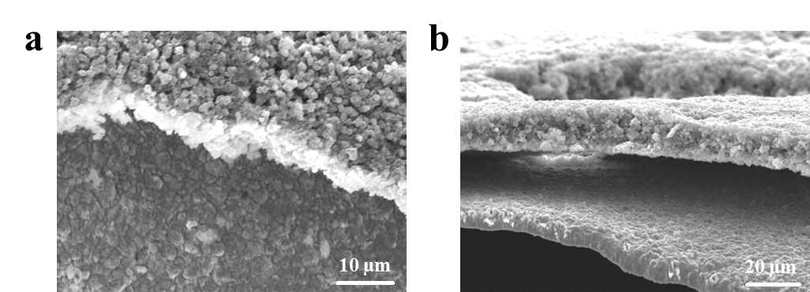
Fig. S12. Top views (a) and cross-sectional views (b) of CNIP electrodes after plating 0.5 mAh cm⁻² of Li.

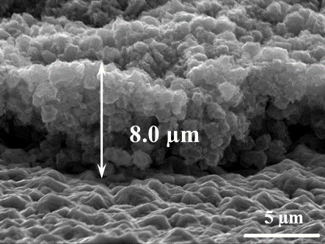
Fig. S13. Cross-section SEM images of CNIP electrode.

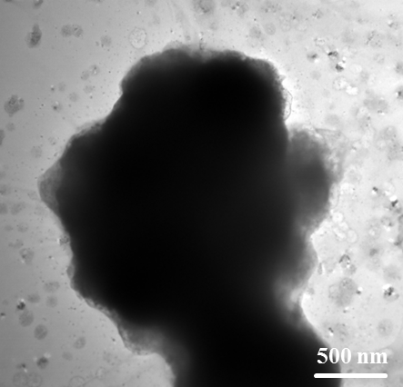
Fig. S14. TEM image of CNIP host after plating with metallic Li for 0.5 mAh cm⁻².

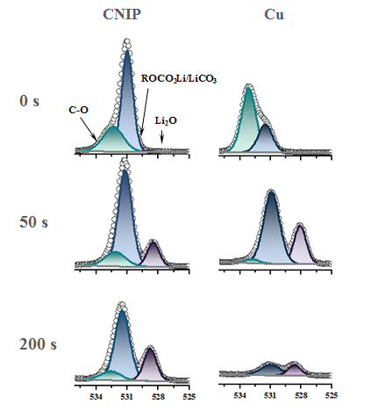
Fig. S15. XPS characterization of the SEI formed on CNIP electrodes and Cu foil for O 1s.

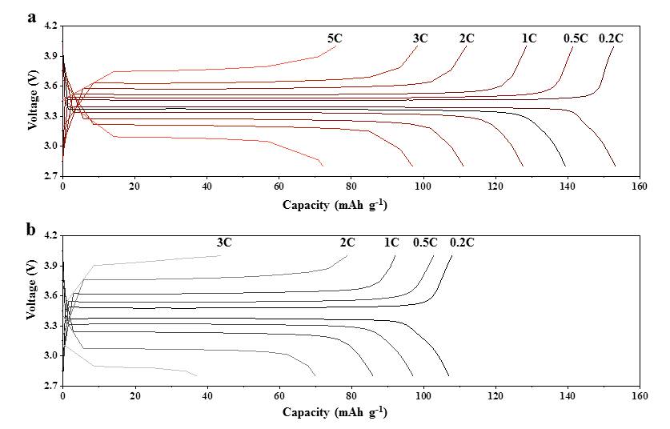
Fig. S16. Charging–discharging voltage profiles of full cells with CNIP/Li electrodes (a) and Cu/Li electrodes (b).

