Electronic Supplementary Material

In-situ selective surface engineering of graphene micro-supercapacitor chips
Yiming Chen^{1,†}, Minghao Guo^{1,†}, Lin Xu^{1,2} (), Yuyang Cai¹, Xiaocong Tian^{1,3}, Xiaobin Liao¹, Zhaoyang Wang¹, Jiashen Meng¹, Xufeng Hong¹, Liqiang Mai^{1,2} ()

¹ Type a State Key Laboratory of Advanced Technology for Materials Synthesis and Processing, Wuhan University of Technology, Wuhan 430070, P. R. China.
² Foshan Xianhu Laboratory of the Advanced Energy Science and Technology Guangdong Laboratory, Xianhu hydrogen Valley, Foshan 528200, China.
³ Faculty of Materials Science & Chemistry, China University of Geosciences, Wuhan 430074, P. R. China.
† These authors contributed equally to this work.

Supporting information to DOI 10.1007/s12274-****-****-* (automatically inserted by the publisher)

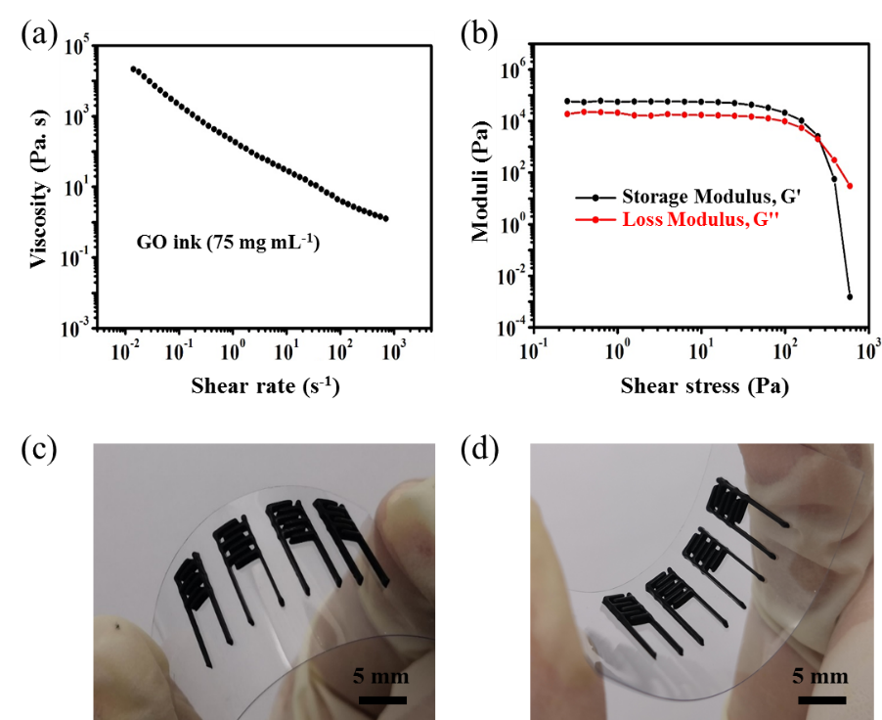
Figure S1 (a) Apparent viscosity as a function of shear rate for the GO ink. (b) Storage modulus and loss modulus as a function of shear stress for the GO ink. (c, d) The micro-patterns printed with GO ink.
Figure S1(a) is the curve of the apparent viscosity as a function of shear stress. It is apparent that the prepared ink exhibited the typical sheer-thinning non-Newtonian fluid behavior: the apparent viscosity decreased with the increasing of shear rate, which is beneficial for the ink to flow continuously passing through the extrusion nozzle. This ink exhibited an apparent viscosity of 203.12 Pa. s at a shear rate of 1 s⁻¹, the high apparent viscosity will enhance the printability of the electrode inks, finally constructing stable accurate 3D structures and designed micro-patterns. The inset image shows the high-viscosity ink. As shown in Fig. S1(b), the storage modulus (G') and loss modulus (G'') possesses plateaus around 5.5 × 10⁴ and 1.6 × 10⁴ Pa and both exhibit a yield stress around 100 Pa. In a wide range of shear stress (1-100 Pa), G' is 3-4 times of G'', this difference between G' and G'' considerably facilitated the printing process [S1]. While the ink flowed through the nozzle (under the shear stress over 100 Pa), G'' dominated because of the sharper decrease of G', which ensured the smooth flowing during the extrusion process [S2, S3]. After the ink was extruded and deposited on the substrate (under the shear stress less than 100 Pa), the recovery of G' helped maintain the shape of the filaments and construct stable 3D frameworks.
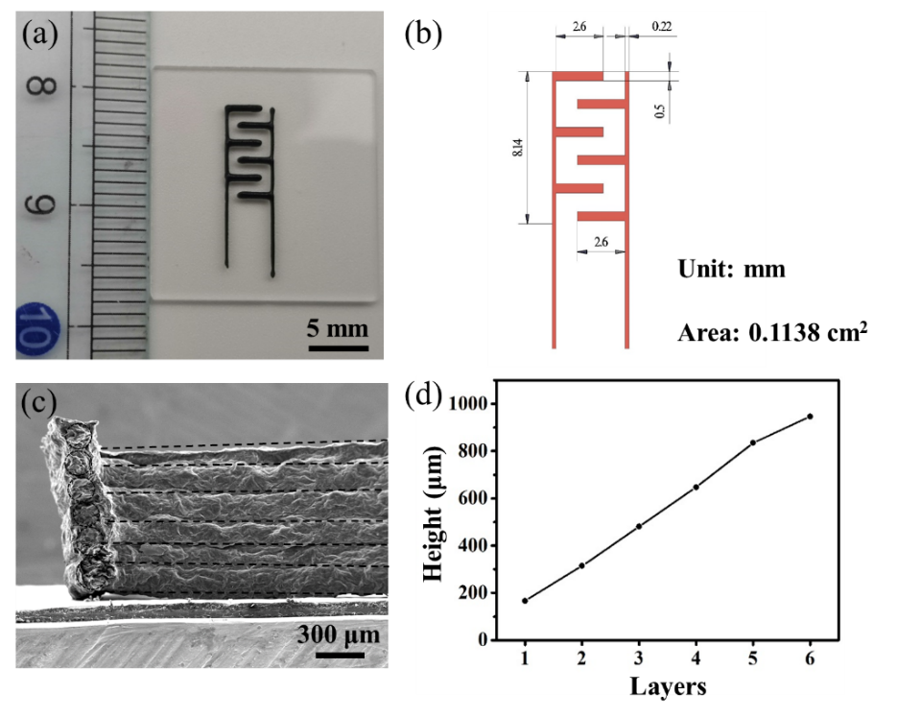
Figure S2 Dimensions of the fabricated MSCs. (a) Digital image of MSCs. (b) Planar scales of MSCs. (c) The cross sectional SEM image of the layer-by-layer structure for the microelectrode and (d) its corresponding height of different layers.

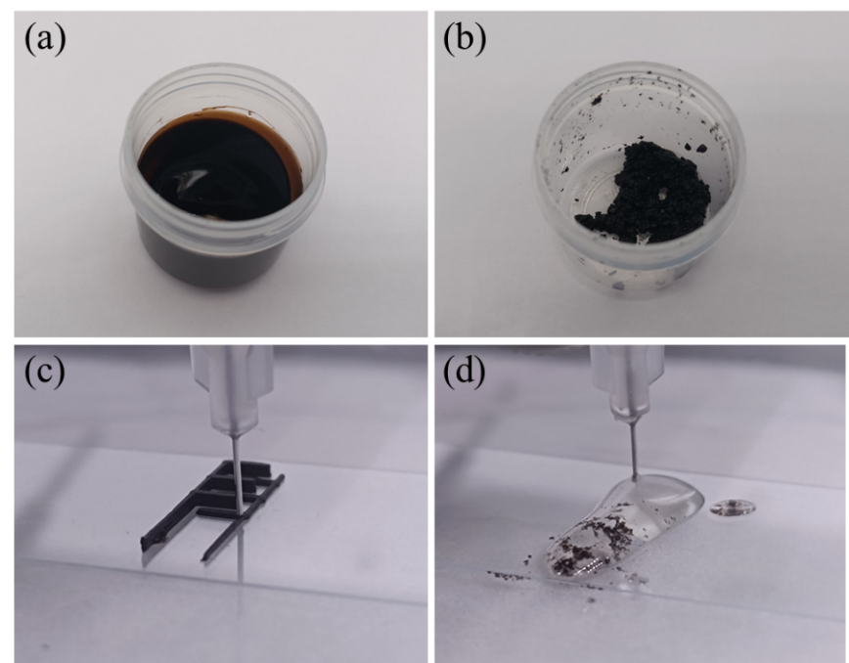
Figure S3 Digital photos of (a) GO ink and (b) GO-pyrrole ink. The printing process employing (c) GO ink and (d) GO-pyrrole ink.

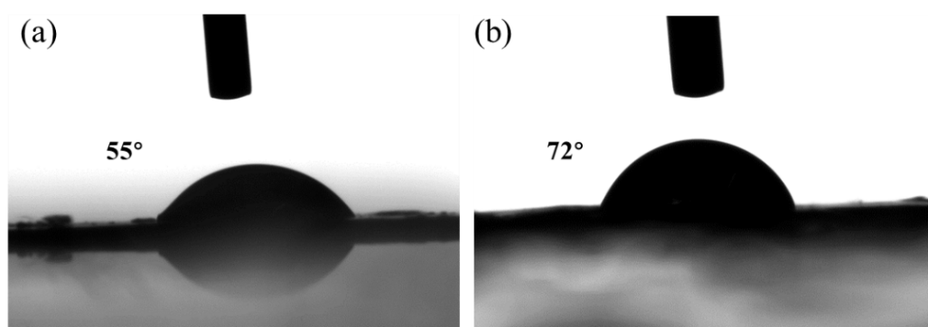
Figure S4 The contact angle tests of (a) typical GO film and (b) pyrrole-treated GO film.

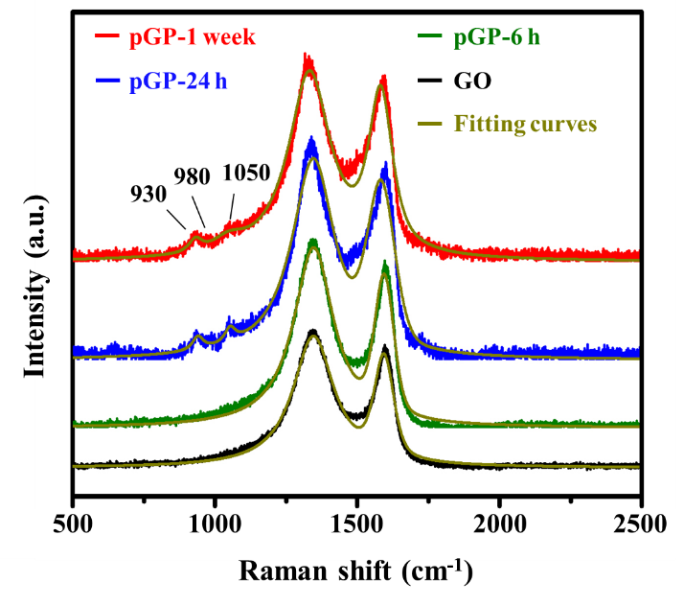
Figure S5 Raman spectra and corresponding fitting curves of different samples.

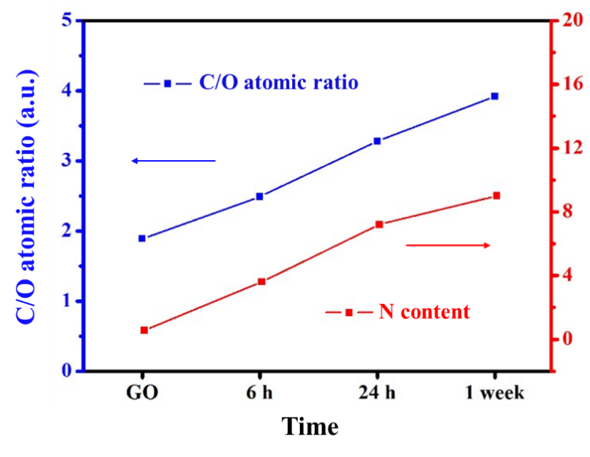
Figure S6 C/O atomic ratios and N contents of the pristine GO, pGP-6 h, pGP-24 h and pGP-1 week.
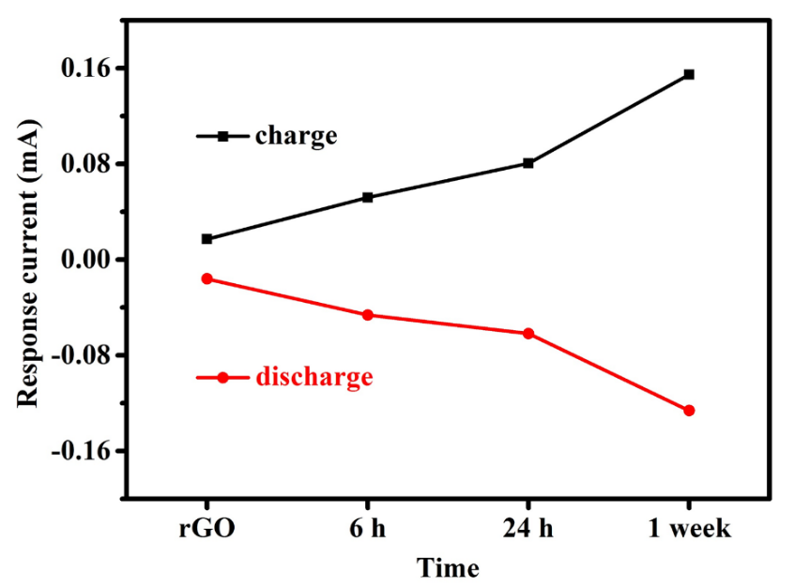
Figure S7 The response currents of different samples in the CV curves at the voltage of 0.5 V.

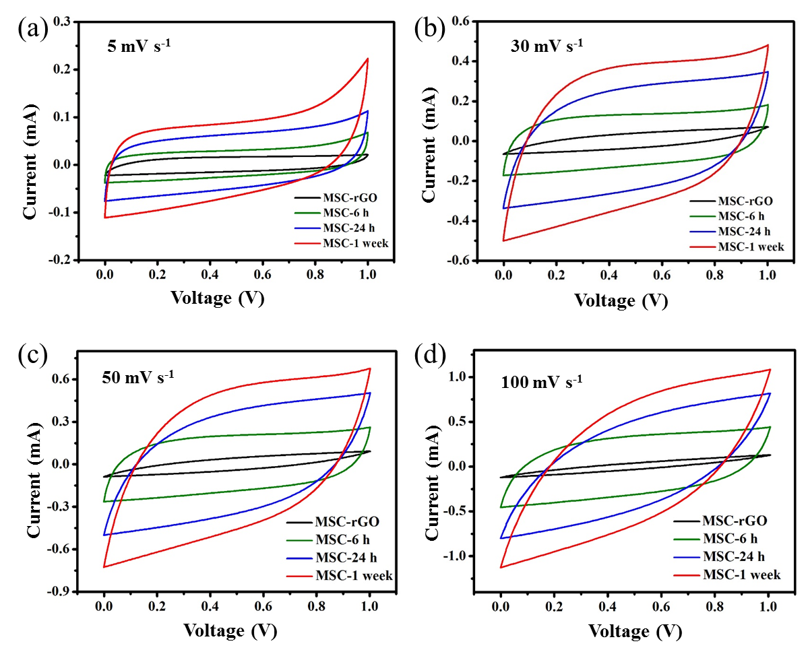
Figure S8 Samples with different treatment time tested under 5, 30, 50 and 100 mV s⁻¹.

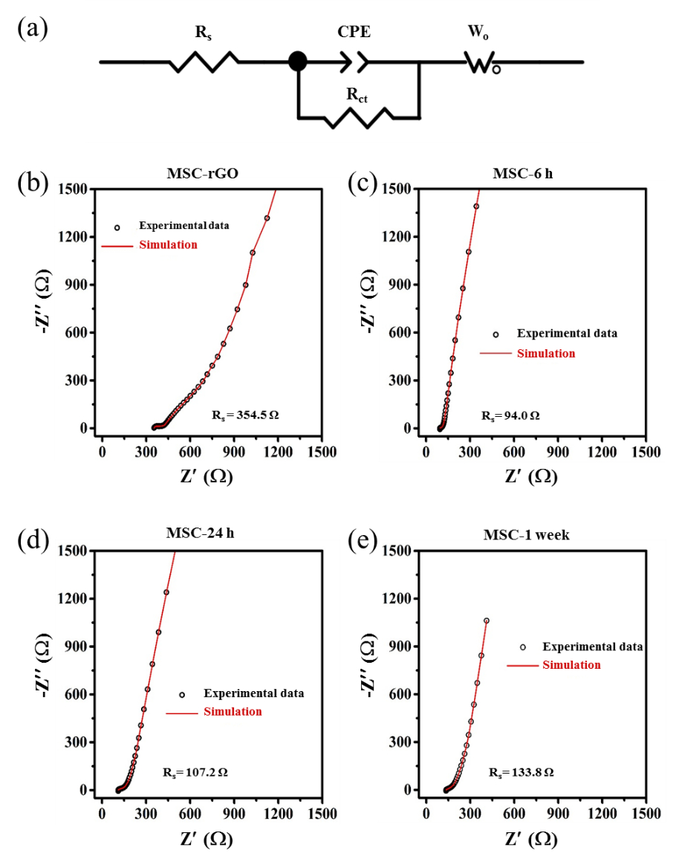
Figure S9 (a) Equivalent circuits for the simulations EIS plots. The simulation of EIS plots of (b) MSC-rGO, (c) MSC-6 h, (d) MSC-24 h and (e) MSC-1 week. R_{s} is the equivalent series resistance of the devices. CPE and R_{ct} are the double layer capacitance and charge-transfer resistance, respectively. W_{o} is the generalized finite length Warburg element.
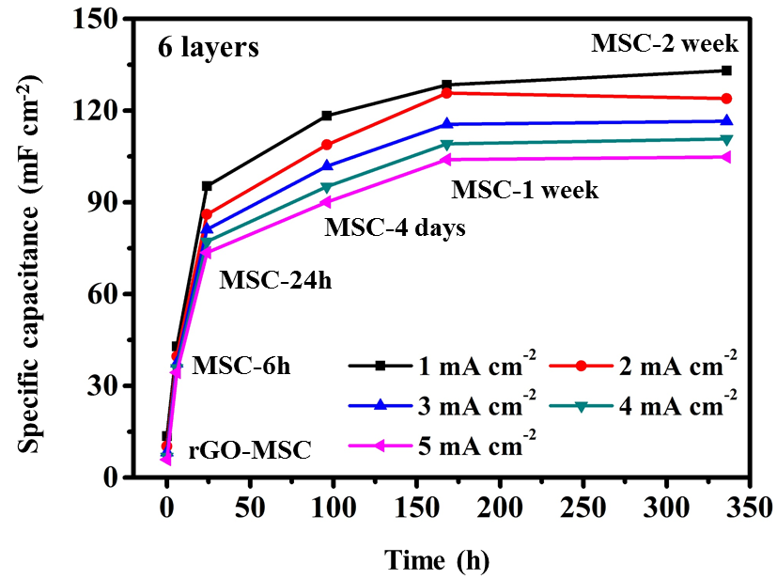
Figure S10 The comparison of MSC with 6 layers under different treating time.

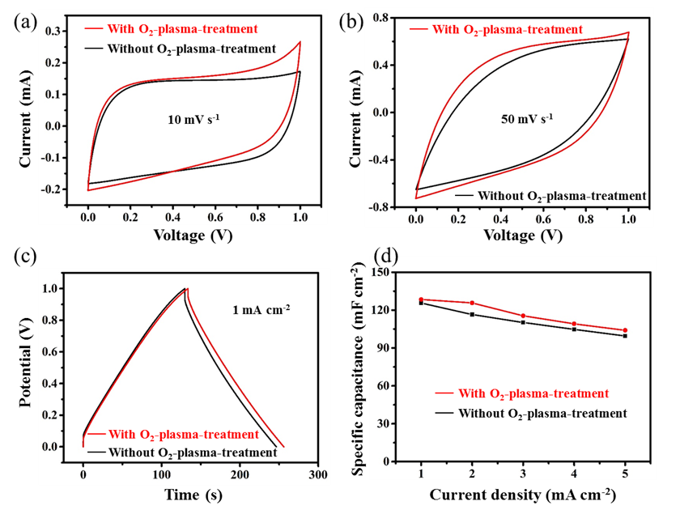
Figure S11 The comparison of MSC with 6 layers before and after O₂-plasma-treatment. Testing at (a) 10 mV s⁻¹, (b) 50 mV s⁻¹ and (c) 1 mA cm⁻². (d) Specific capacitance at different current densities.

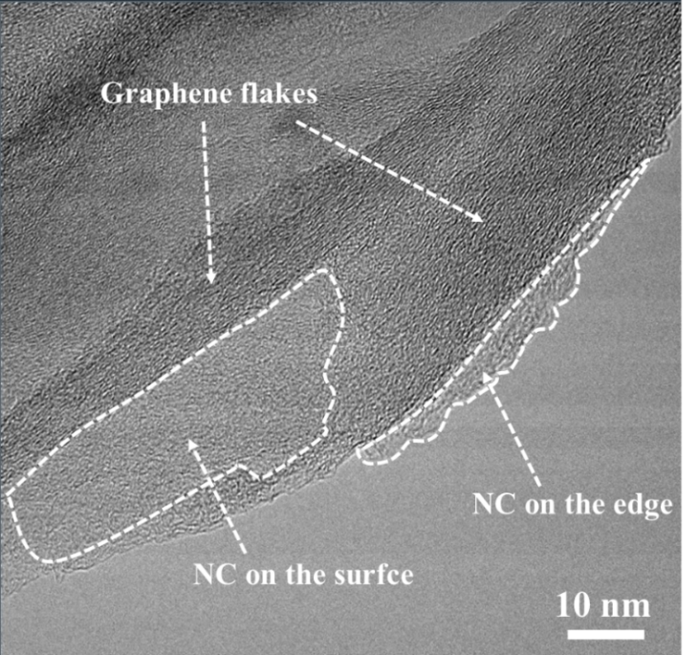
Figure S12 TEM image of NC/rGO. The circled amorphous parts refer to NC and the lattice fringe of graphene can also be identified.
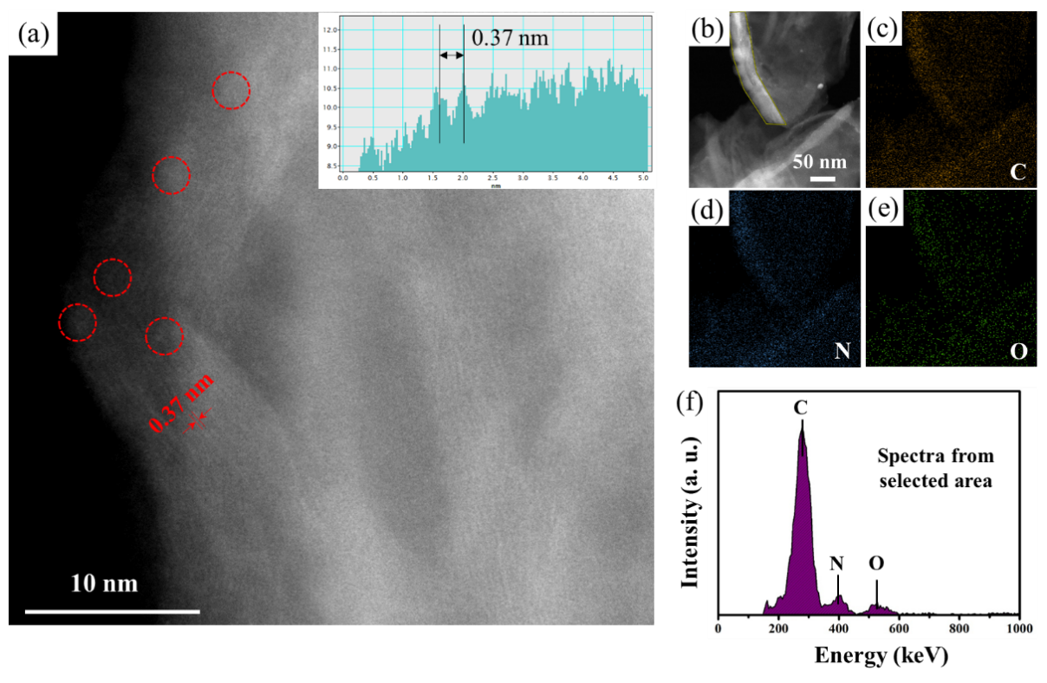
Figure S13 (a) STEM image of NC/rGO. Bright particles circled red were determined to be NC and interlamellar distance of rGO was measured to be 0.37 nm. (b-e) EDS results of C, N, O from STEM test. (f) The content of C, N, O obtained from STEM test.
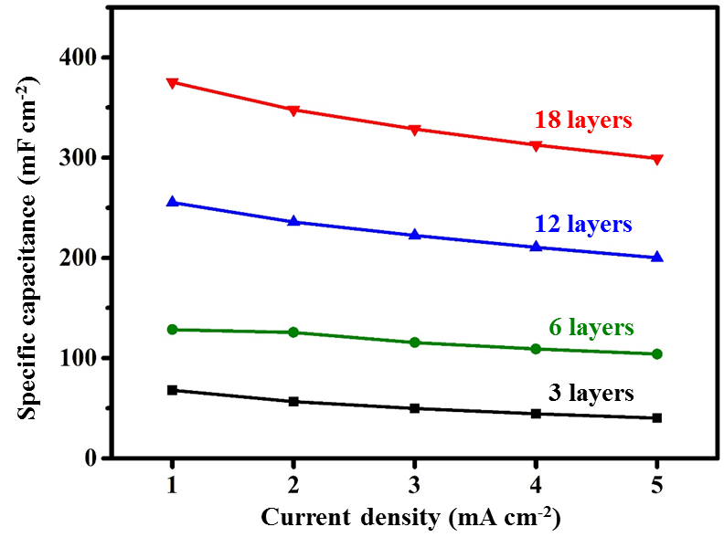
Figure S14 The specific-capacitance-comparison of samples with different layers treated by liquid pyrrole for 1 week.

Table S1. The relative contents of C-C/C=C, C-O-C/C-OH, C=O, HO-C=O and C-N bonds in C related bonds of different samples.
Content(%) Bonds  Sample | C-C/C=C | C-O | C=O | O=C-O | C-N
GO | 42.82 | 48.07 | 7.48 | 1.63 | 0.00
pGP-6 h | 51.28 | 37.72 | 6.93 | 0.63 | 3.44
pGP-24 h | 64.55 | 23.20 | 5.65 | 0.00 | 6.61
pGP-1 week | 74.14 | 13.09 | 1.95 | 0.86 | 9.96

Table S2. the capacitance-retention comparison with recently reported results under different current densities.
MSCs/AMSCs | Current density  ranging  (mA cm⁻²) | Capacitance  retention | Reference
MoS₂@rGO-CNT MSC | 0.1 to 2 | 68% | S4
VOx/rGO//  G-VNQDs/rGO AMSC | 0.63 to 4.71 | 58.30% | S5
PPy@MWCNT//  MnO₂@Ppy@MWCNT  AMSC | 0.1 to 0.5 | 81% | S6
ITO NWs@MnO₂ MSC | 0.5 to 10 | 54.90% | S7
VN NSAs/CNTF//  Na-MnOx/NCF/CNTF  AMSC | 1 to 10 | 71% | S8
NC/Graphene | 1 to 5 | 77.2% | Our work

Reference
[S1] Truby, R. L., J. A. Lewis. Printing soft matter in three dimensions. Nature. 2016, 540, 371-378.
[S2] Jiang, Y., Z. Xu, T. Huang, Y. Liu, F. Guo, J. Xi, W. Gao, C. Gao. Direct 3D printing of ultralight graphene oxide aerogel microlattices. Adv. Funct. Mater. 2018, 28, 1707024.
[S3] Naficy, S., R. Jalili, S. H. Aboutalebi, R. A. Gorkin Iii, K. Konstantinov, P. C. Innis, G. M. Spinks, P. Poulin, G. G. Wallace. Graphene oxide dispersions: tuning rheology to enable fabrication. Mater. Horiz. 2014, 1, 326-331.
[S4] Yang, W.; He, L.; Tian, X.; Yan, M.; Yuan, H.; Liao, X.; Meng, J.; Hao, Z.; Mai, L. Carbon-MEMS-based alternating stacked MoS₂@rGO-CNT micro-supercapacitor with high capacitance and energy density. Small. 2017, 13, 1700639.
[S5] Shen, K.; Ding, J.; Yang, S. 3D printing quasi-solid-state asymmetric micro-supercapacitors with ultrahigh areal energy density. Adv. Energy Mater. 2018, 8, 1800408.
[S6] Gao, J.; Shao, C.; Shao, S.; Wan, F.; Gao, C.; Zhao, Y.; Jiang, L.; Qu, L. Laser-assisted large-scale fabrication of all-solid-state asymmetrical micro-supercapacitor array. Small. 2018, 14, 1801809.
[S7] Du, J.; Zhao, Y.; Zhang, Z.; Mu, X.; Jiang, X.; Huang, B.; Zhang, Y.; Zhang, S.; Zhang, Z.; Xie, E. High-performance pseudocapacitive micro-supercapacitors with three-dimensional current collector of vertical ITO nanowire arrays. J. Mater. Chem. A. 2019, 7, 6220- 6227.
[S8] Zhang, Q.; Zhang, J.; Zhou, Z.; Wei, L.; Yao, Y. Flexible quasi-solid-state 2.4 V aqueous asymmetric microsupercapacitors with ultrahigh energy density. J. Mater. Chem. A. 2018, 6, 20145-20151.
Address correspondence to First A. Firstauthor, email1; Third C. Thirdauthor, email2

