Supporting Information
Structural properties and electrochemical performance of different polymorphs of Nb₂O₅ in magnesium-based batteries
Cunyuan Peiª, Yameng Yinª, Xiaobin Liao^{a,b}, Fangyu Xiongª, Qinyou An^{a,c,}*, Mengda Jinª, Yan Zhao^{b,}*, Liqiang Mai^{a,c,}*
ª State Key Laboratory of Advanced Technology for Materials Synthesis and Processing, Wuhan University of Technology, Wuhan 430070, Hubei, China
^{b} State Key Laboratory of Silicate Materials for Architectures, International School of Materials Science and Engineering, Wuhan University of Technology, Wuhan 430070, Hubei, China
^{c} Foshan Xianhu Laboratory of the Advanced Energy Science and Technology Guangdong Laboratory, Xianhu hydrogen Valley, Foshan 528200, Guangdong, China
*Corresponding authors.
E-mail: anqinyou86@whut.edu.cn (Q. An), yan2000@whut.edu.cn (Y. Zhao), mlq518@whut.edu.cn (L. Mai)

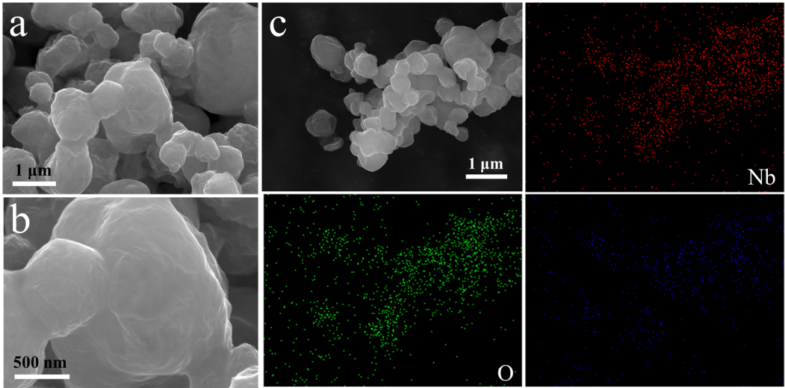
Fig. S1 SEM images (a, b) and EDS elemental mapping images (c) of Nb_{x}O_{y}@GO composite before calcination.
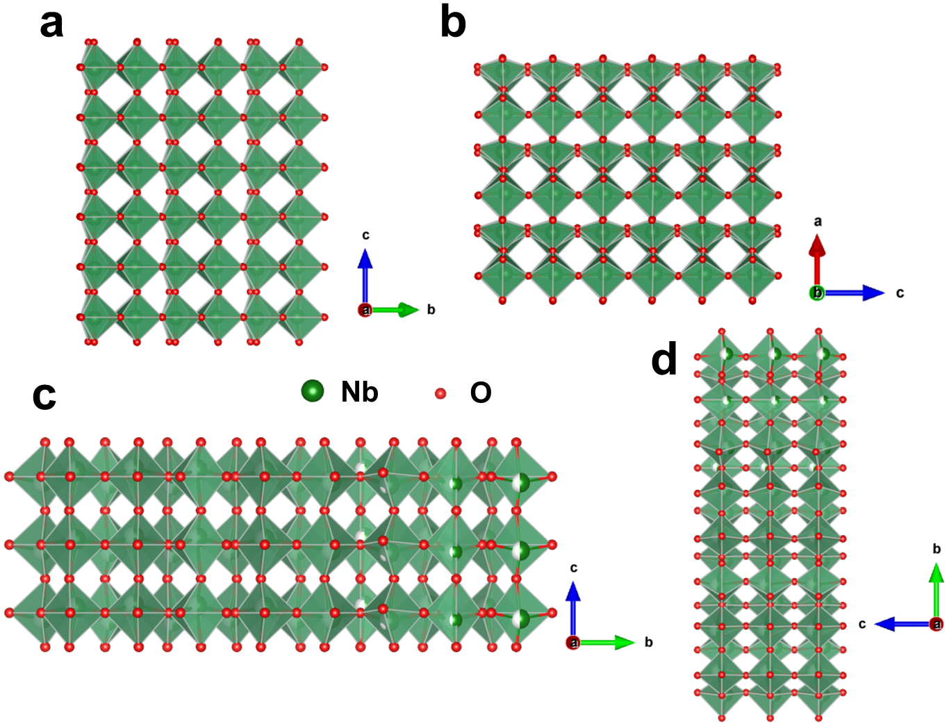
Fig. S2 Crystal structures of (a, b) TT-Nb₂O₅ and (c, d) T-Nb₂O₅.
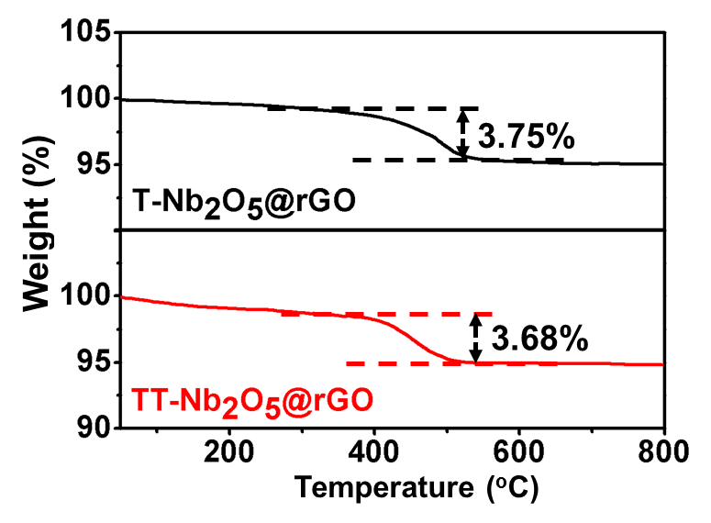
Fig. S3 TG curves tested under air condition.
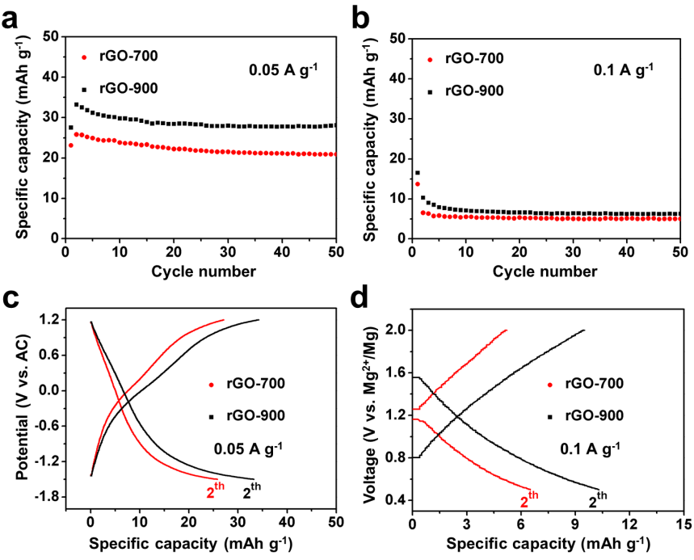
Fig. S4 The electrochemical performance of rGO annealing at 700 and 900 ^{ο}C as electrode for (a, c) Mg-storage (in 0.3 M Mg(TFSI)₂/DME electrolyte against AC anode) and (b, d) Li-storage (in APC-LiCl electrolyte against Mg metal anode).
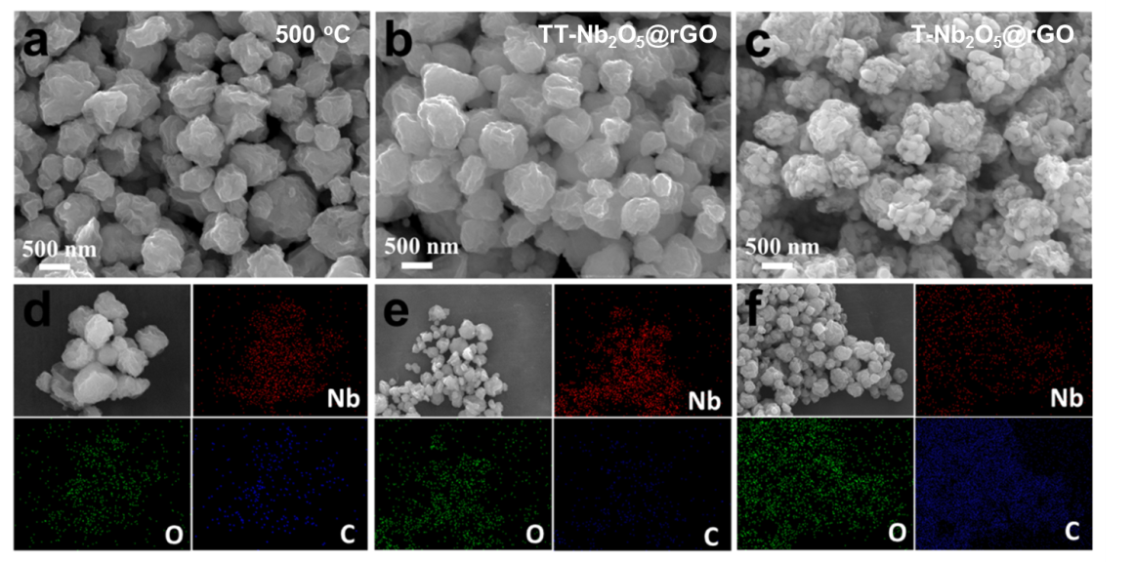
Fig. S5 SEM images and elemental mappings of the samples after annealing at 500 ^{ο}C (a, d), 700 ^{ο}C (b, e) and 900 ^{ο}C (c, f).
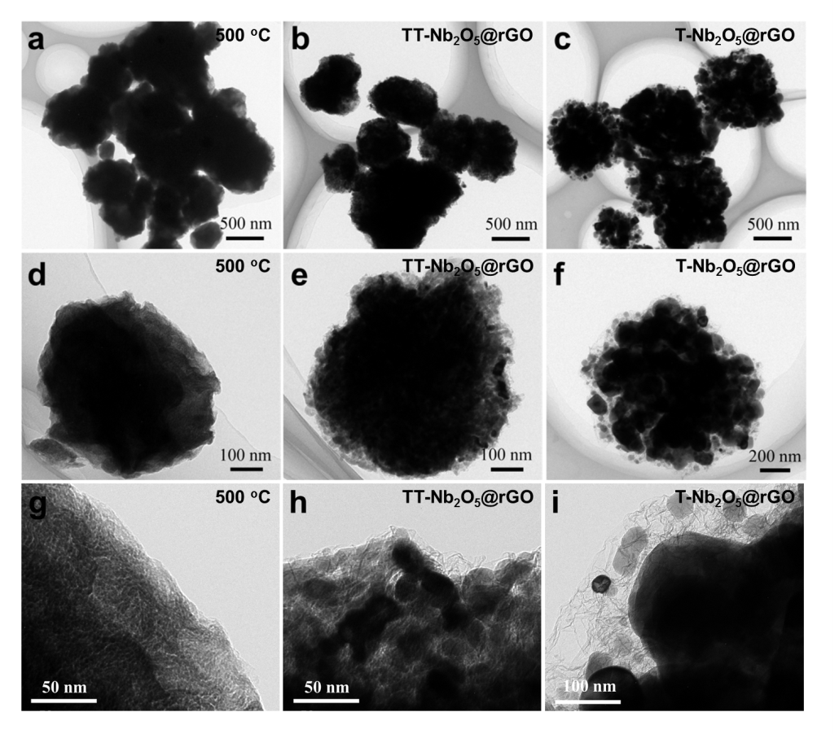
Fig. S6 TEM and HRTEM images of the sample after annealing at 500 ^{ο}C (a, d, g), 700 ^{ο}C (b, e, h) and 900 ^{ο}C (c, f, i).
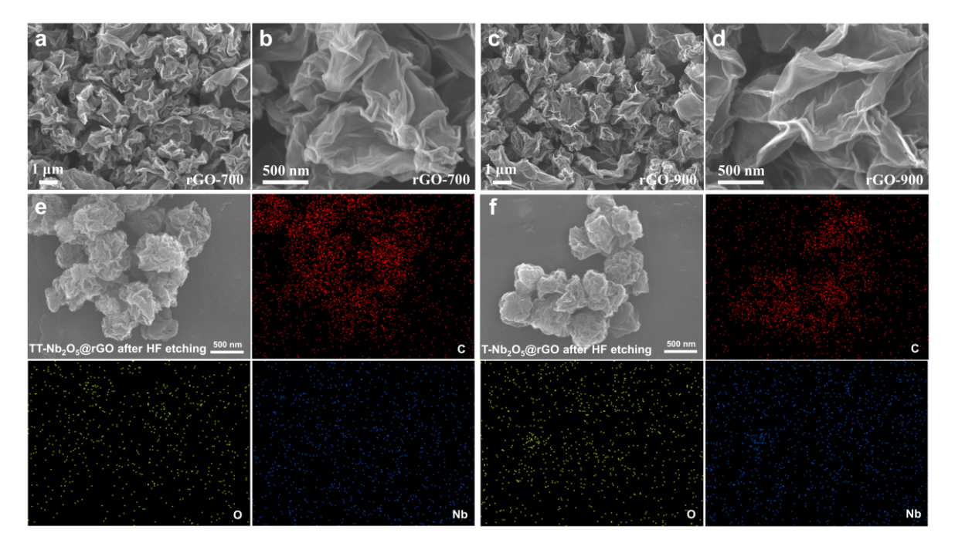
Fig. S7 The SEM images of pure rGO annealing at (a, b) 700 ºC and (c, d) 900 ºC. The SEM images and elemental mappings images of (e) TT-Nb₂O₅@rGO and (f) T-Nb₂O₅@rGO after HF etching.
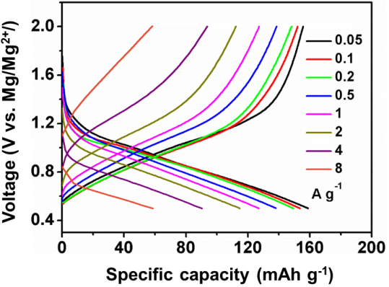
Fig. S8 Discharge-charge curves of T-Nb₂O₅@rGO at various current densities.
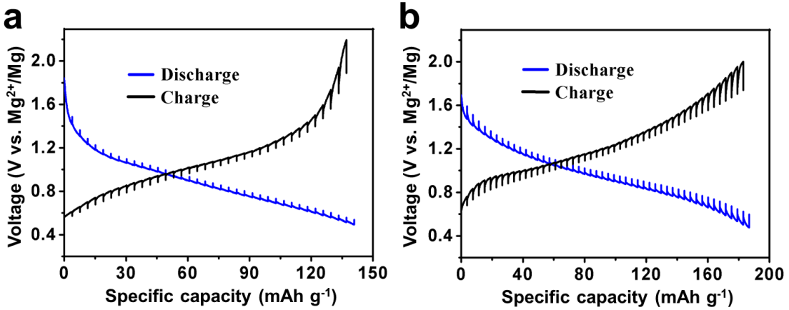
Fig. S9 The GITT curves of (a) TT-Nb₂O₅@rGO and (b) T-Nb₂O₅@rGO for Li-storage.
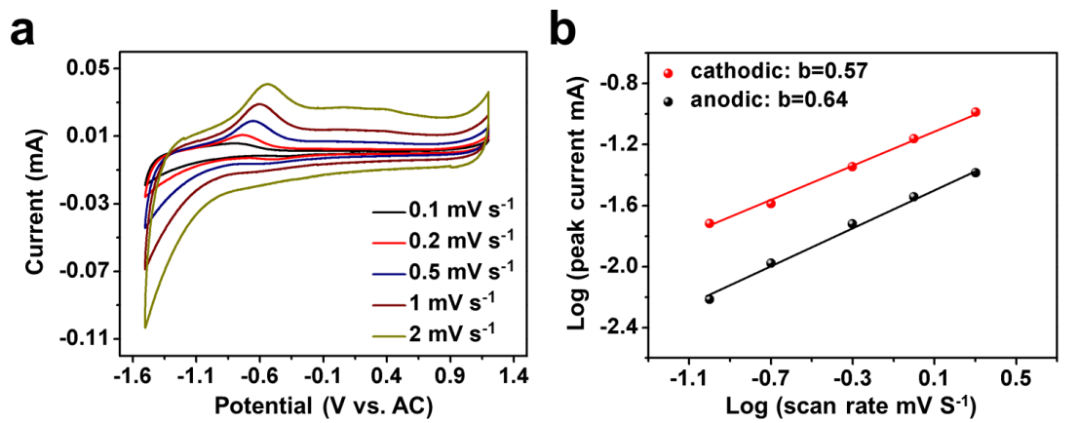
Fig. S10 (a) CV curves of TT-Nb₂O₅ electrode at different scan rates from 0.1 to 2 mV s⁻¹. (b) Determination of the b value by the plot of log (i) vs log (v).
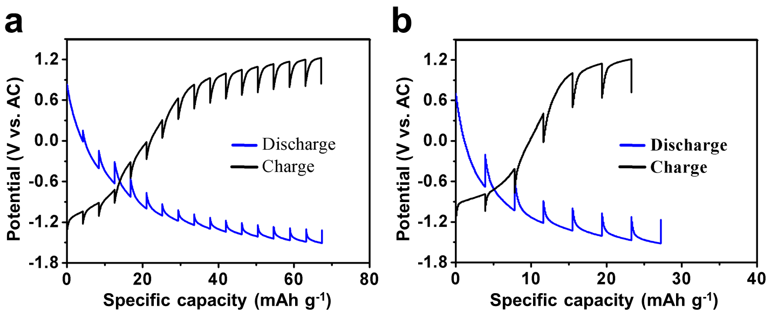
Fig. S11 The GITT curves of (a) T-Nb₂O₅@rGO and (b) TT-Nb₂O₅@rGO for Mg-storage.

