Supplementary material
Preparation of LiV₃O₈ nanorods: The V₂O₅ sols was prepared by a melt quenching process.¹ 2.1 mmol LiOH was added into 100 mL V₂O₅ sols (5.5 mg mL⁻¹), stirred for 10 min at room temperature and followed by a freeze-drying process, then annealed at 450°C for 2 hours.

Materials Characterization:
The prepared samples were characterized by XRD (D8 Discover X-ray diffractometer with Cu Kα radiation (λ = 1.54060 Å), Raman spectroscopy (Renishaw INVIA), X-ray photoelectron spectroscopy (XPS, Thermo Scientific Escalab 250Xi), field emission scanning electron microscopy (FESEM, JSM-7100F) transmission electron microscopy (TEM, JEM- 2100F), and energy disperse spectroscopy (EDS, Oxford IE250).

Ex situ XRD test:
For ex situ XRD test, the electrode was prepared by mixing LiV₃O₈ (70 wt%), conductive carbon (acetylene black, 20 wt%), and poly tetrafluoroethylene (PTFE, 10 wt%), then the slurry was evenly grinded, tableted and cut into Φ10 mm electrodes. The samples were obtained at different discharged states, and the XRD patterns collected at a step scan of 0.02°, a step time of 0.2 s, and a sample rotation speed of 10.00° min⁻¹.

Electrochemical Characterization:
The cathode electrode was prepared by mixing active material (LiV₃O₈, 70 wt%), conductive carbon (acetylene black, 20 wt%), and polyvinylidene fluoride (PVDF, 10 wt%), and then the slurry was cast onto titanium foil and dried in vacuum oven at 60 °C for 6 h. Zinc foil and glass fiber membrane were used as the anode and separator, respectively, and 3 M zinc trifluoromethanesulfonate aqueous solution was used as the electrolyte. CR2016-type coin cells were assembled in the air to evaluate the electrochemical performance on battery testing system (LAND, CT2001A). Cyclic voltammograms (CV) and Staircase Potential Electrochemical Impedance Spectroscopy (SPEIS) were measured by a VMP3 multichannel electrochemical workstation (Bio-Logic, France). All tests were performed at room temperature.

The Galvanostatic Intermittent Titration Technique (GITT):
The GITT method was applied to calculate the Zn²⁺ diffusion coefficients (D^{GITT}) in LiV₃O₈ via the following equation:
$D^{GITT}=\frac{4}{πτ}{(\frac{m_{B}V_{M}}{M_{B}S})}^{2}{(\frac{△E_{S}}{△E_{τ}})}^{2}$ (1)
where τ represents the constant current pulse duration, m_{B}, V_{M}, and M_{B} are the mass loading, the molar volume, and the molar mass of LiV₃O₈, respectively. S is the area of the electrode-electrolyte interface, ΔE_{S} and ΔE_{τ} are the change of steady-state voltage and the overall cell voltage during a constant current pulse τ of a single-step GITT experiment regardless of the IR-drop, respectively.

Staircase Potential Electrochemical Impedance Spectroscopy (SPEIS) measurements:
The potential of the working electrode follows the equation: 𝐸_{𝑤𝑒} = 𝐸 + 𝑉_{𝑎}sin (2𝜋𝑓𝑡) (Figure S6). A negative potential sweep is made from 1.6 V to 0.2 V with 10 mV potential decrease followed by 15 min rest per steps. On each step, an impedance measurement is performed for a whole frequency range from f_{i} = 100 kHz to f_{f} = 0.01 Hz with 71 points per decade, and there are 70 EIS plots during this process. Similarly, a positive potential sweep is made from 0.2 V to 1.6 V with 10 mV potential increase followed by 15 min rest per steps.

Density functional theory (DFT) calculations:
The calculations were performed with DFT using the CASTEP code in Materials Studio (version 2017 R2) of Accelrys Inc. The examination of the electronic exchange-correlation function of the interacting electrons was carried out using the Perdew-Burke-Ernzerhof (PBE) generalized gradient approximation (GGA). The DFT-D correction constructed by Grimme was used to account for the van der Waals interaction. The energy cutoff was set to 800 eV for the plane-wave basis expansion. The energy difference was set to 1.0×10⁻⁵ ev/atom for self-consistent loops and a maximum force tolerance of 0.01 eV/Å for structural optimization. The k-points for Brillioun zone were selected by Monkhorts-Pack method and set to 5×5×5. The models were allowed to embed zinc into the LiV₃O₈ structure. The corresponding binding energy was defined as follows:
E_{binding} = E_{total} – E_{sub} – E_{Zn} (2)
E_{total}, E_{sub}, and E_{Zn} were the energy of Zn_{X}LiV₃O₈ model bound with zinc, LiV₃O₈ model and zinc, respectively.

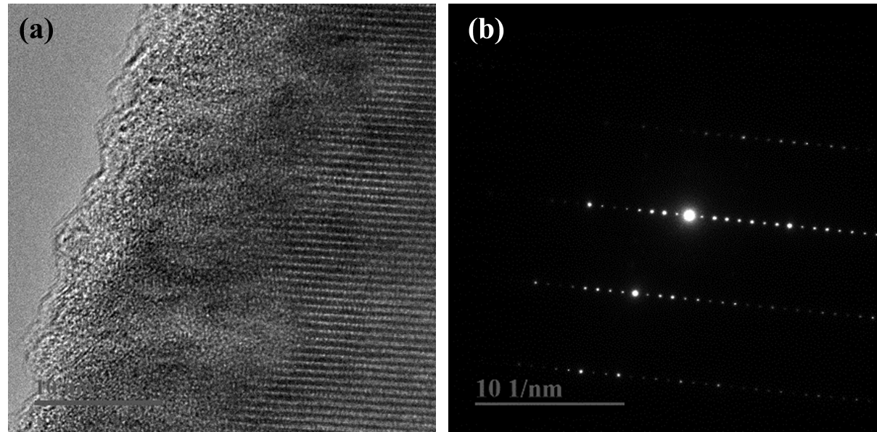

Figure S1. The HAADF-STEM image (a) and the corresponding SAED pattern (b) of LiV₃O₈ nanorods.

Figure S2 Self-discharge test of the Zn//LiV₃O₈ battery. The battery is resting for 18 days.

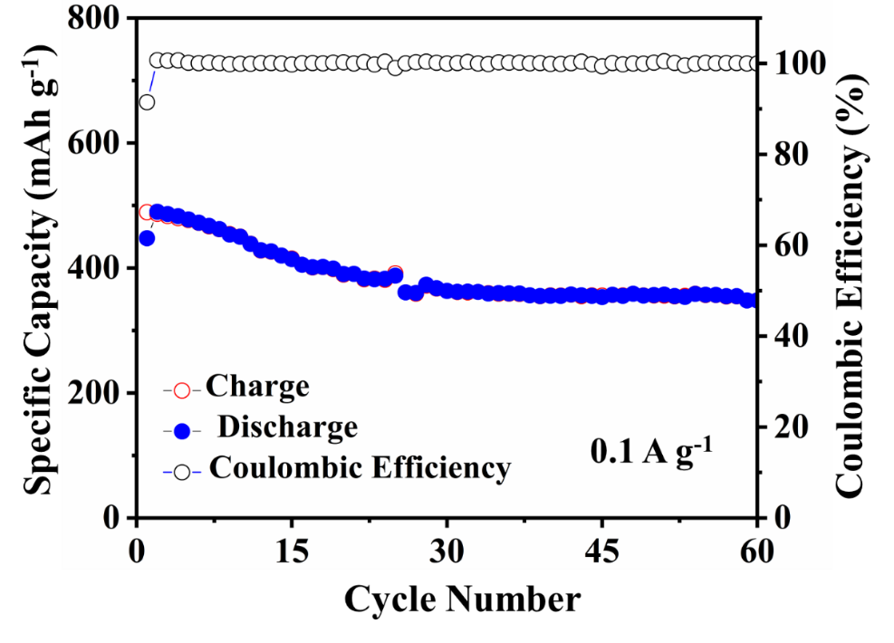

Figure S3 Galvanostatic cycling at 0.1 A g^{–1}.

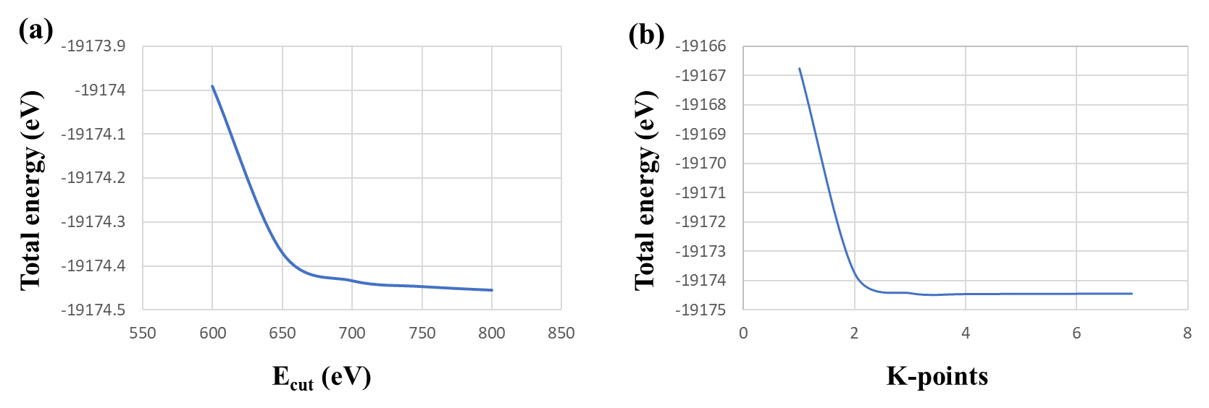

Figure S4 (a) Convergence test of plane wave cutoff energy, (b) K-point convergence test.

Figure S5 Multiple-scan rates of CV curves from 1.0 mV s⁻¹ to 10.0 mV s⁻¹ (a), from 10.0 mV s⁻¹ to 100.0 mV s⁻¹.

Figure S6 The contribution ratio of the capacitive capacities (shaded area) and diffusion-limited capacities at 0.5 mV s⁻¹.

Figure S7 Staircase Potential Electrochemical Impedance Spectroscopy (SPEIS).

Figure S8 (a) Schematic illustration of different resistances at interfaces. (a) the potential sweep is made from E_{i} = 1.6 V to E_{f} = 0.2 V with 10 mV potential steps after 15 min relaxation, (b) potential sweep is made from E_{i} = 0.2 V to E_{f} = 1.6 V with 10 mV potential steps after 15 min relaxation.

Table S1 The initial lattice parameters of LiV₃O₈ calculated by DFT calculations.
Lattice  parameter | a (Å) | b (Å) | c (Å) | α (°) | β (°) | γ (°)
DFT | 6.73 | 3.54 | 12.09 | 90.00 | 108.69 | 90.00
Experimental | 6.68 | 3.60 | 12.03 | 90.00 | 107.83 | 90.00

Table S2 The Volume change of LiV₃O₈ during Zn²⁺ intercalation by DFT calculations.
Formula | Energy (eV) | Volume  (10⁶ pm³) | Volume change  (%)
LiV₃O₈ | -19178.8 | 273.091 | —
Zn²⁺ | -1786.2 | — | —
Zn_{0.5}LiV₃O₈  Zn₁LiV₃O₈ | -20953.3  -22754.6 | 289.17  289.22 | 5.89  5.90
Zn_{1.5}LiV₃O₈ | -24541.2 | 288.29 | 5.57
Zn₂LiV₃O₈ | -26329.1 | 334.02 | 22.3
Zn₃LiV₃O₈ | -29904.3 | 293.96 | 7.64

Supplemental References
1. An, Q.; Li, Y.; Deog Yoo, H.; Chen, S.; Ru, Q.; Mai, L.; Yao, Y. Nano Energy 2015, 18, 265-272.

