Supporting Information

Three-Layer Structured SnO₂@C@TiO₂ Hollow Spheres for High-Performance Sodium Storage

Yu Tian, Ping Hu, Ting Zhu, Zhenhui Liu, Guangwu Hu, Congcong Cai, Zelang Jian, Liang Zhou,* and Liqiang Mai*
State Key Laboratory of Advanced Technology for Materials Synthesis and Processing, Wuhan University of Technology, Wuhan 430070, China

Liang Zhou, Liqiang Mai
Foshan Xianhu Laboratory of the Advanced Energy Science and Technology Guangdong Laboratory, Xianhu Hydrogen Valley, Foshan 528200, China
Corresponding Author
*E-mail: liangzhou@whut.edu.cn, mlq518@whut.edu.cn

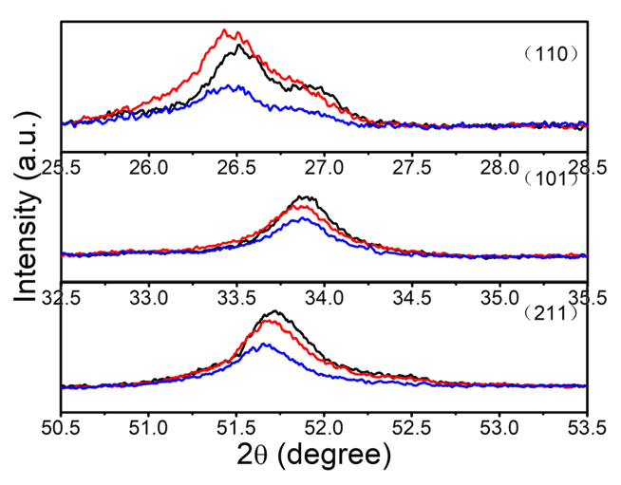
Figure S1. The enlarged XRD patterns of SnO₂@C@TiO₂ (red), SnO₂@C (blue), and SnO₂ (black).

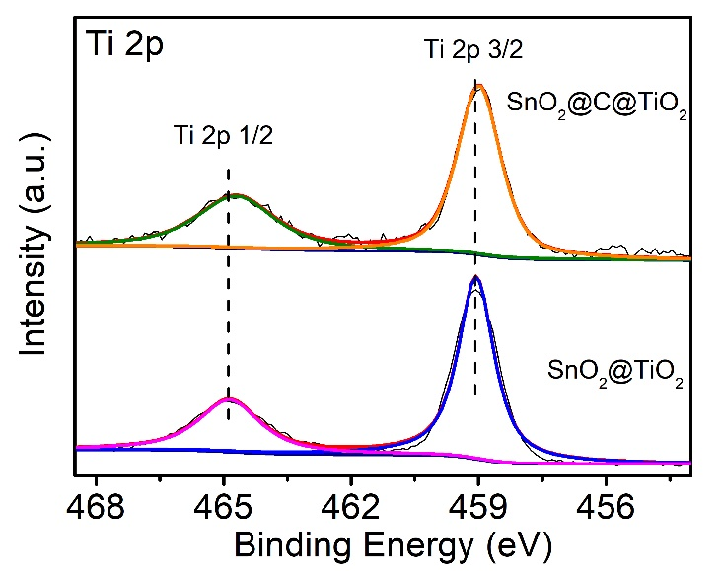
Figure S2. High-resolution XPS spectra of Ti 2p for SnO₂@C@TiO₂ and SnO₂@TiO₂.

Table S1. The elemental composition of SnO₂@C@TiO₂ determined by ICP.
Element | Sn | Ti
Content (wt %) | 58.74 | 1.084

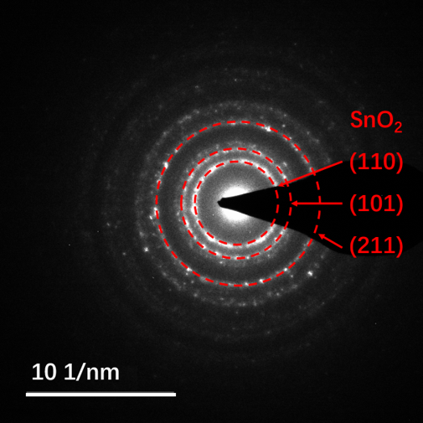
Figure S3. SAED pattern of SnO₂@C@TiO₂.
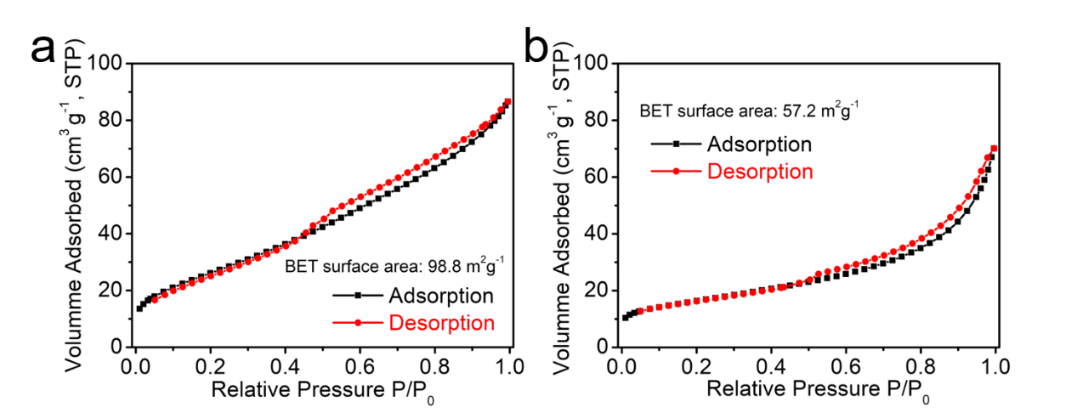Figure S4. Nitrogen adsorption-desorption isotherms of (a) SnO₂@C@TiO₂ and (b) SnO₂ hollow spheres.
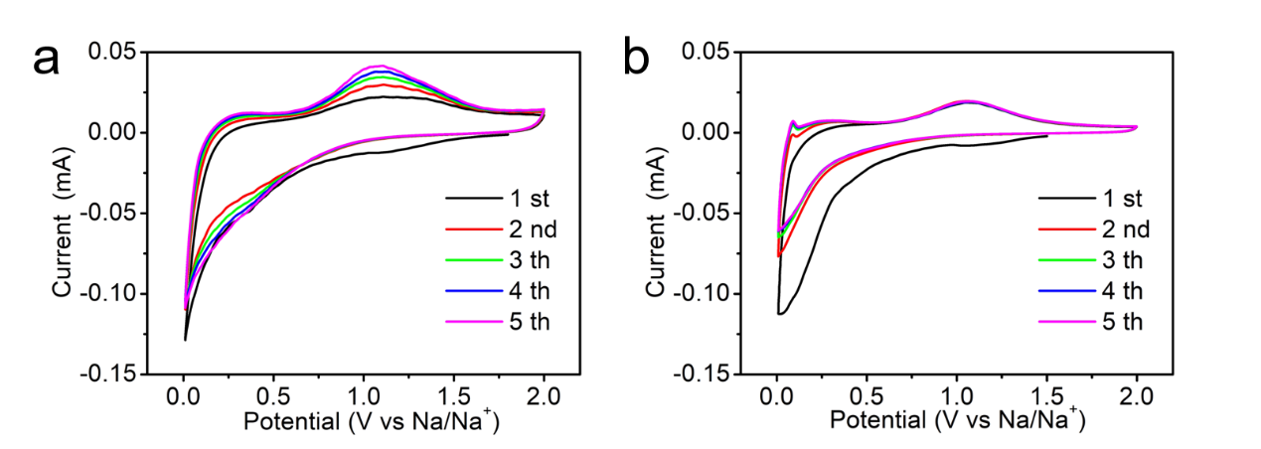Figure S5. CV curves for (a) SnO₂@C and (b) SnO₂ hollow spheres at a scan rate of 0.1 mV s⁻¹.
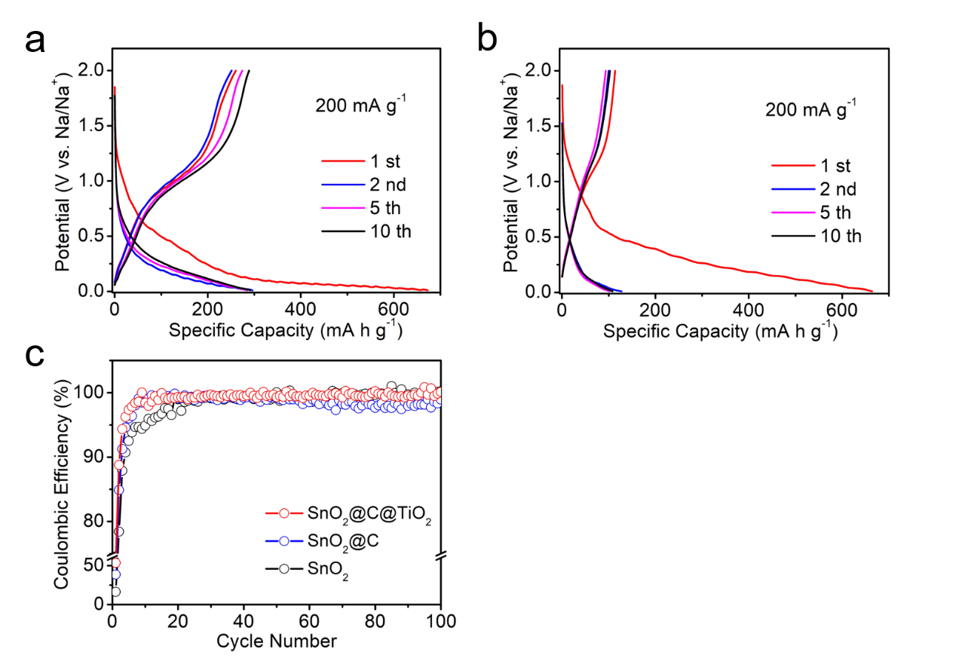
Figure S6. GCD profiles of (a) SnO₂@C and (b) SnO₂ at 0.2 A g⁻¹. (c) Coulombic efficiencies of the three SnO₂-based electrodes at 0.2 A g⁻¹.
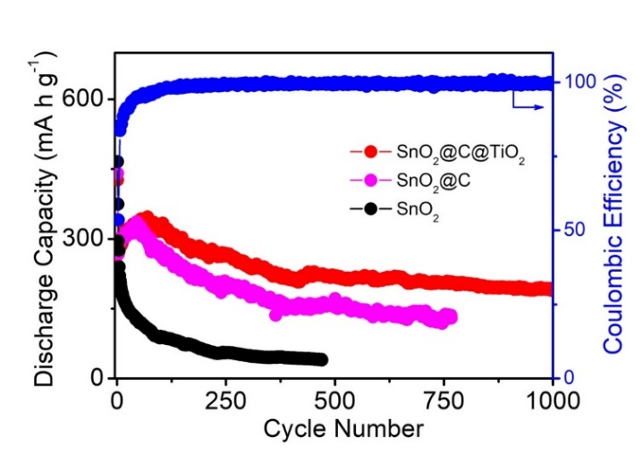
Figure S7. Long-term cycling performances of the SnO₂-based samples.
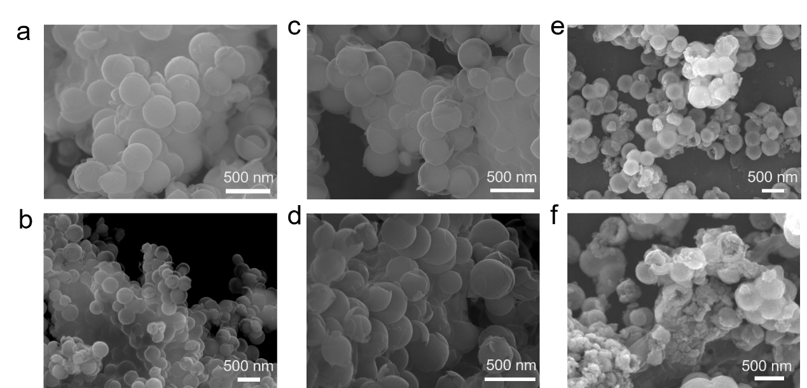
Figure S8. SEM images of SnO₂@C@TiO₂ hollow spheres after (a) 50, (b) 100, (c) 500, and (d) 1000 charge/discharge cycles at 1 A g⁻¹. SEM images of (e) SnO₂@C and (f) SnO₂@C hollow spheres after 50 cycles.
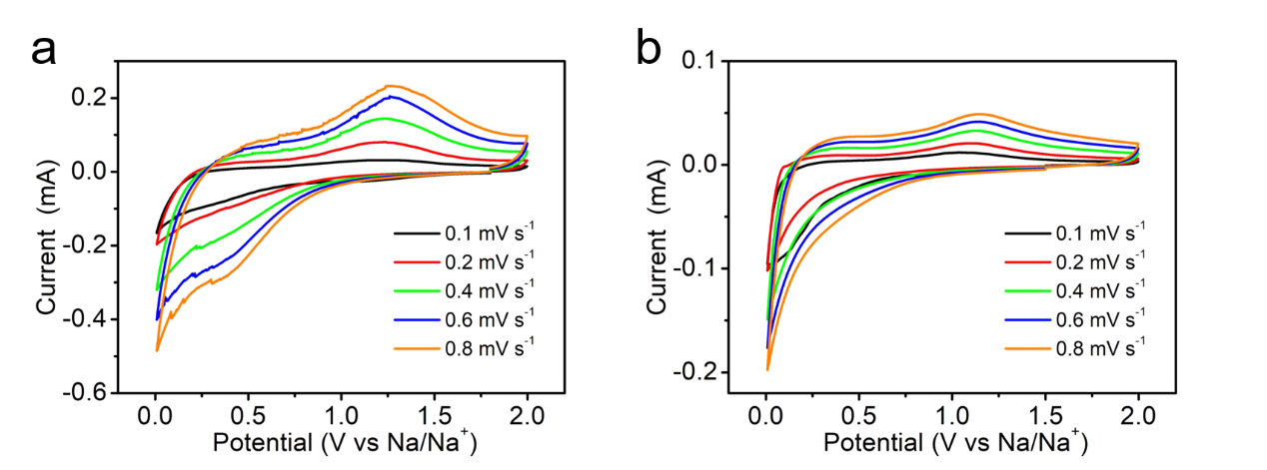Figure S9. CV curves in the potential range of 0.01 – 2.0 V at scanning rates of 0.1, 0.2, 0.4, 0.6, and 0.8 mV s⁻¹ for (a) SnO₂@C and (b) SnO₂.

