Supporting Information

Fast and stable Mg²⁺ intercalation in a high voltage NaV₂O₂(PO₄)₂F/rGO cathode material for magnesium-ion batteries

Junjun Wang, Shuangshuang Tan, Guobin Zhang, Yalong Jiang, Yameng Yin, Fangyu Xiong, Qidong Li, Dan Huang, Qinghua Zhang, Lin Gu, Qinyou An, and Liqiang Mai

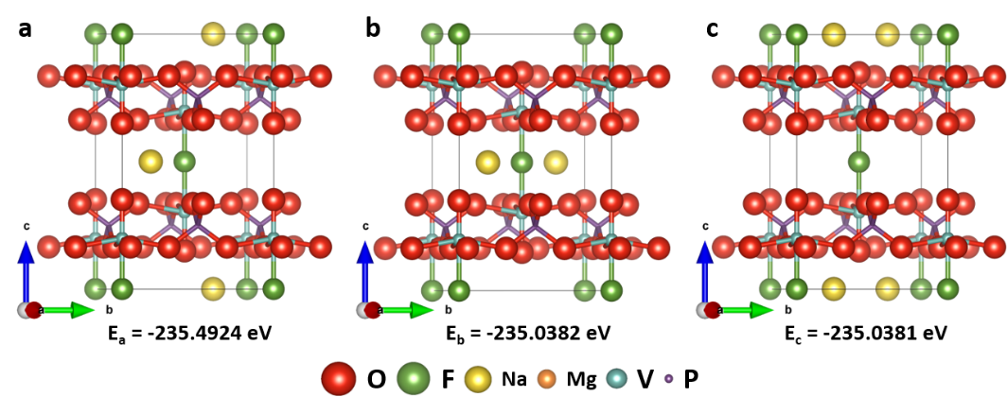
Figure S1. Three different alignment states of Na in NaV₂O₂(PO₄)₂F/rGO based on the refinement results in a unit cell. (a) One Na is inside the unit cell and the other Na is on the surface of the unit cell. (b) Two Na are inside the unit cell. (c) Two Na are on the surface of the unit cell.
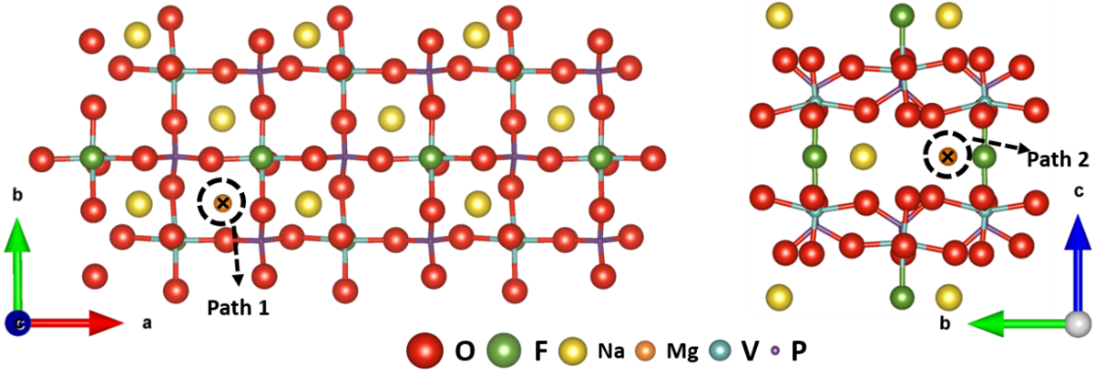
Figure S2. Diffusion profile of path 1 perpendicular to the ab plane (left) and path 2 parallel to the ab plane (right).
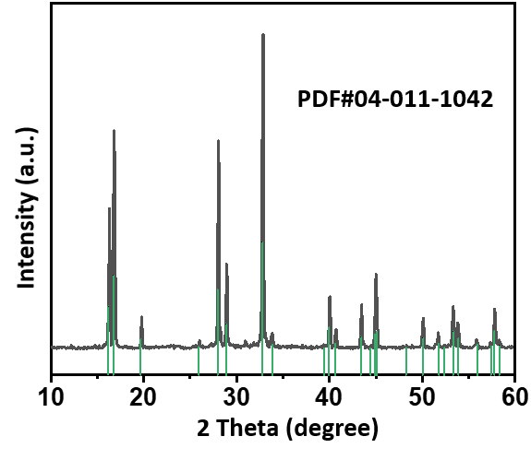
Figure S3. XRD pattern of NVOPF, indicating that the pure phase of the NVOPF is synthesized.
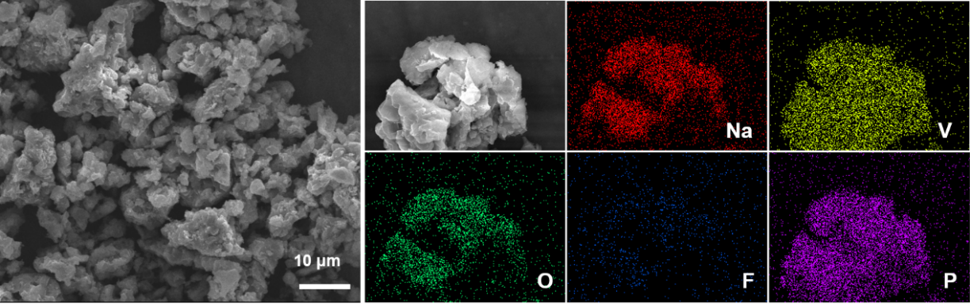
Figure S4. SEM image and elemental mapping images of NVOPF, which shows the morphology of the prepared NVOPF with micron size and the existence of Na, O, V, P, and F elements.
Figure S5 shows the Rietveld refinement and crystal structure of NVOPF/rGO. The Rietveld refinement gives the following lattice parameters: a = b = 6.38850(7) Å and c =10.60779(0) Å. The other structural parameters are given in Table S1. This is consistent with previous reports.^{[1, 2]} The refinement result meets low reliability factors of GOF=1.31, Rwp=4.44%, and Rp=3.35%.
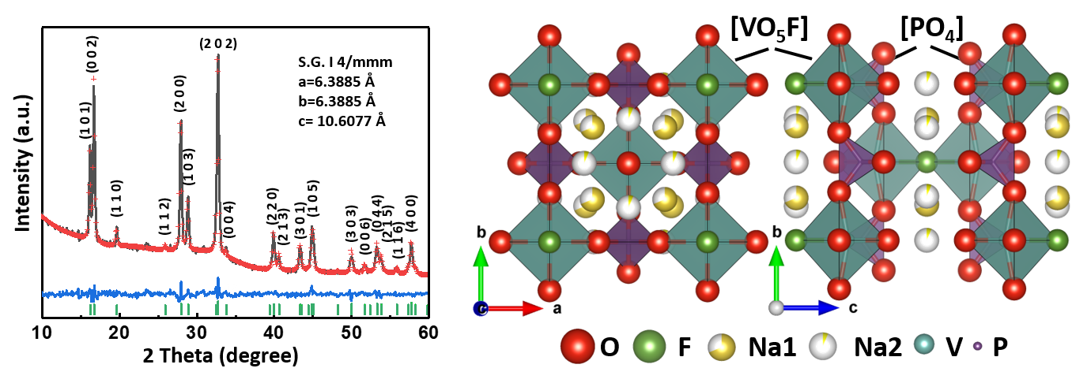
Figure S5. Rietveld refinement and crystal structure of NVOPF/rGO.
Table S1. Rietveld refinement atomic coordinates for NVOPF/rGO.
Atom | Site | Occupancy | x | y | z
Na1 | 8h | 0.688 | 0.2706 | 0.2706 | 0
Na2 | 8j | 0.063 | 0.2193 | 0.5000 | 0
V | 4e | 1.000 | 0 | 0 | 0.1984
P | 4d | 1.000 | 0 | 0.5000 | 0.2500
O1 | 16n | 1.000 | 0 | 0.3085 | 0.1648
O2 | 4e | 1.000 | 0 | 0 | 0.3504
F1 | 2a | 1.000 | 0 | 0 | 0
F1 | 2a | 1.000 | 0 | 0 | 0

The HRTEM image (Figure S6, inset) shows an interplanar distance of 0.317 nm, corresponding to the (110) planes of tetragonal phase NVOPF/rGO. C element is evenly distributed on the surface of the NVOPF/rGO microspheres, indicating that the microspheres are encased in graphene. The presence of C element is also proven by the Raman pattern (Figure S7) and the carbon content is 4.33 wt%.
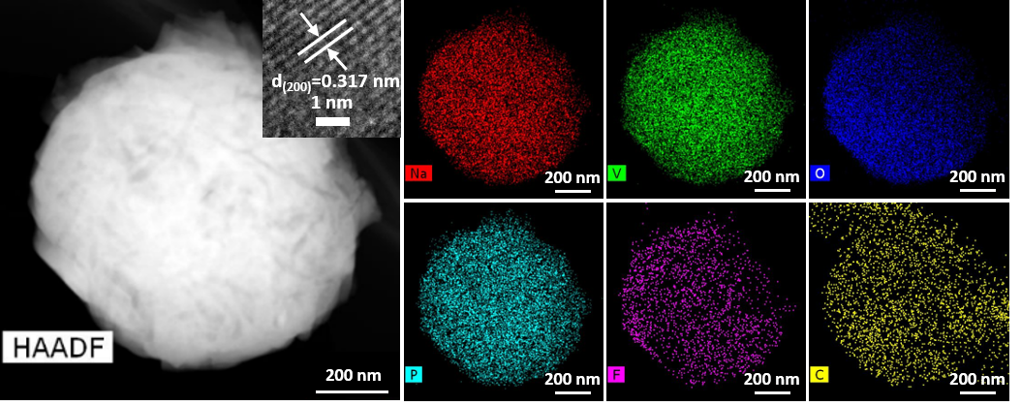
Figure S6. HAADF image with corresponding elemental maps of NVOPF/rGO and the inset is HRTEM image.
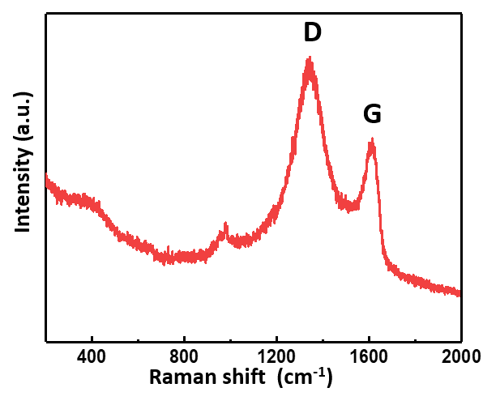
Figure S7. Raman spectrum of NVOPF/rGO.
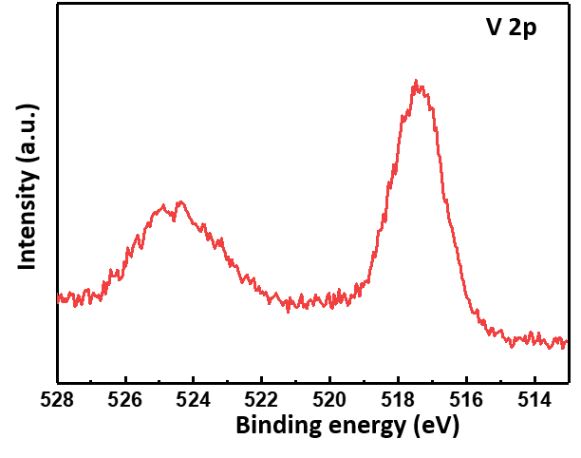
Figure S8. XPS spectrum of NVOPF/rGO.

Table S2. Rietveld refinement atomic coordinates for NaV₂O₂(PO₄)₂F/rGO.
Atom | Site | Occupancy | x | y | z
Na1 | 8h | 0.256 | 0.2974 | 0.2974 | 0
V | 4e | 1.000 | 0 | 0 | 0.1926
P | 4d | 1.000 | 0 | 0.5000 | 0.2500
O1 | 16n | 1.000 | 0 | 0.3085 | 0.1628
O2 | 4e | 1.000 | 0 | 0 | 0.3460
F1 | 2a | 1.000 | 0 | 0 | 0
F1 | 2a | 1.000 | 0 | 0 | 0

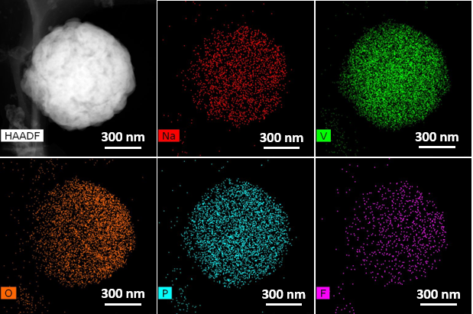
Figure S9. HAADF image with corresponding elemental maps of NaV₂O₂(PO₄)₂F/rGO.
Figure S10 (left) presents the GITT curves including discharge and charge processes at a current density of 0.02 A g⁻¹. NaV₂O₂(PO₄)₂F/rGO delivers a discharge capacity of 118.3 mAh g⁻¹ and two discharge plateaus. The Mg²⁺ diffusion coefficient (D^{GITT}) can be calculated according to the GITT curves by the following equation:^{[3]}
$D^{GITT}=\frac{4}{πτ}{\left(\frac{m_{B}V_{M}}{M_{B}S}\right)}^{2}{\left(\frac{∆E_{S}}{∆E_{τ}}\right)}^{2}$ (1)
where the D^{GITT} (cm² s⁻¹) is Mg²⁺ diffusion coefficient, m_{B}, M_{B}, V_{M}, and τ are the mass, molar mass, molar volume of NaV₂O₂(PO₄)₂F/rGO and constant current pulse time, respectively, S is electrode–electrolyte contact area. In Figure S10 (right), the ΔE_{t} refers to the voltage changes during a constant current pulse without the IR drop and the ΔE_{s} is the potential difference during the open circuit period.
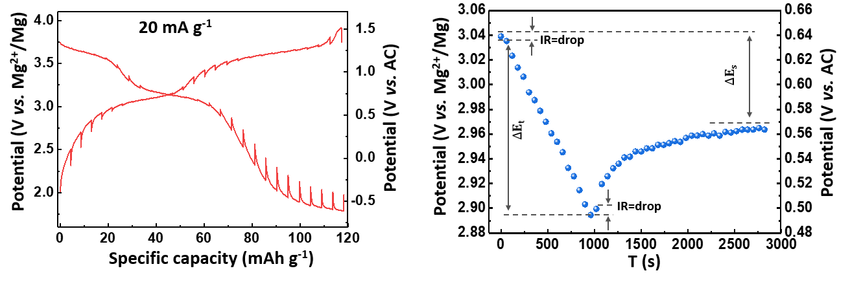
Figure S10. GITT curve of NaV₂O₂(PO₄)₂F/rGO electrode (left) and GITT potential response curve with time (right). The test was carried out at constant current pulse of 20 mA g⁻¹ for 15 min and a relaxation period of 30 min.
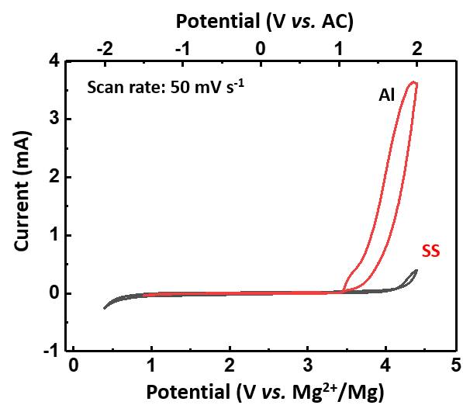
Figure S11. CV curves of stainless steel (SS) and aluminum (Al) was used as a working electrode at Mg(TFSI)₂/AN electrolyte with a scan rate 50 mV s⁻¹.
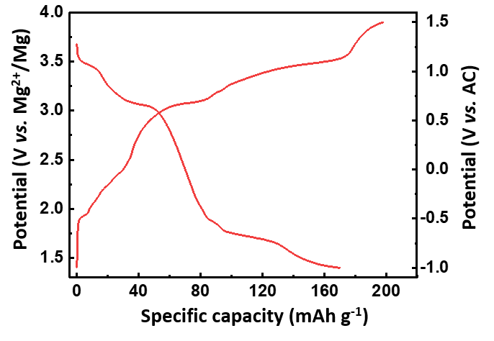
Figure S12. GCD curve of the NaV₂O₂(PO₄)₂F/rGO electrode by using three electrodes system cell.
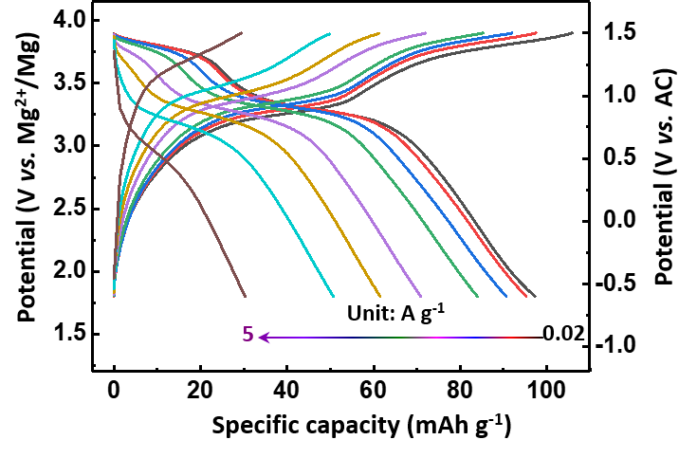
Figure S13. GCD curves of the NaV₂O₂(PO₄)₂F/rGO electrode at different current densities.
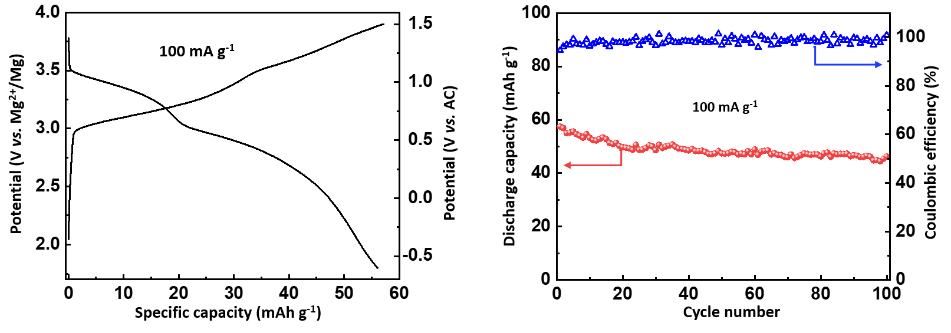
Figure S14. GCD curve (left) and cycling performances (right) of NaV₂O₂(PO₄)₂F electrode at 100 mA g⁻¹.
Table S3. Summary of the reported cathode materials with voltages exceeding 2 V for MIBs.
Materials | Voltage vs. Mg²⁺/Mg (V) | Rate (mAh g⁻¹/ mA g⁻¹) | Cycles/ mA g⁻¹ | Capacity retention （%） | Reference
NaV₂O₂(PO₄)₂F | ~3.3 | 106/20  61.5/1000  30.3/5000 | 280/20  1000/100  9500/500 | 98.7  97.5  76.0 | present study
NiHCF | ~3.0 | 52/10  41/100  32/500 | 2000/250 | 65.0 | ^{[4]}
V₂(PO₄)₃ | ~2.7 | 197/9.85(55 °C) | 5/9.85 | 100.0 | ^{[5]}
MgCoSiO₄ | ~2.7 | 73/6.2 | 30/6.2 | 85.7 | ^{[6]}
Mn₂O₄ | ~2.6 | 190/13.5 | 1/13.5 | - | ^{[7]}
NaV₂(PO₄)₃ | ~2.5 | 88/20 | 100/20 | 81.0% | ^{[8]}
MgCo₂O₄ | ~2.3 | 200/5.2(150 °C)  198/13(150 °C)  170/26(150 °C) | 1/5.2  1/13  2/26 | -  -  73.5 | ^{[9]}
V₂O₅ | ~2.3 | 153/0.5 μA cm⁻² | 36/0.5 μA cm⁻² | 83.3 | ^{[10]}
MnO₂ | ~2.3 | 140/100 | 20/100 | 66.7 | ^{[11]}
Mo_{2.5+y}VO_{9+δ} | ~2.1 | 397/2  114/4  114/10 | 15/2  25/4  25/10 | 62.5  100.0  75.0 | ^{[12]}
Mg_{0.3}V₂O₅.1.1H2O | ~2.1 | 162/100  120/1000  50/4000 | 500/100  3000/500  10000/2000 | 100.0  100.0  80.0 | ^{[13]}
NH₄V₄O₁₀ | ~2.1 | 175/42  108/211  68.9/421.2 | 100/211 | 100.0 | ^{[14]}
V₂O₅.1.42H₂O | ~2.1 | 320/50  150/500  100/2000 | 30/100  200/1000 | 89.1  81.0 | ^{[15]}
Figure S15 shows the XRD pattern of hexagonal structure of NaTi₂(PO₄)₃ (PDF#33-1296), indicating that the pure phase of the NTP/C is synthesized. The SEM image of the NTP/C shows the microflower morphology of the prepared NTP/C with a size of about 10 um (Figure S16). Figure S17 displays the CV curve of NTP/C electrode within 1~2.4 V vs. Mg²⁺/Mg at a scan rate of 0.1 mV s⁻¹. There is a pair of obvious redox peaks, which is corresponding to the redox of Ti⁴⁺/Ti³⁺.^{[16, 17]}
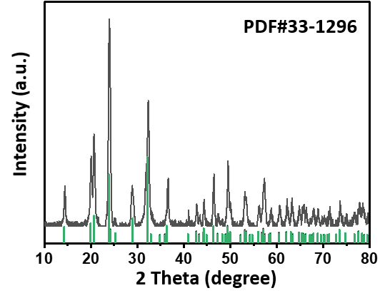
Figure S15. XRD pattern of NTP/C.
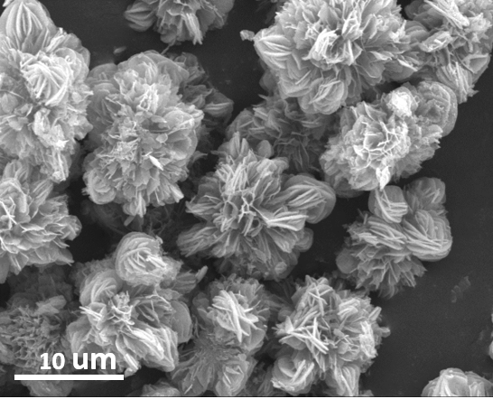
Figure S16. SEM image of NTP/C.
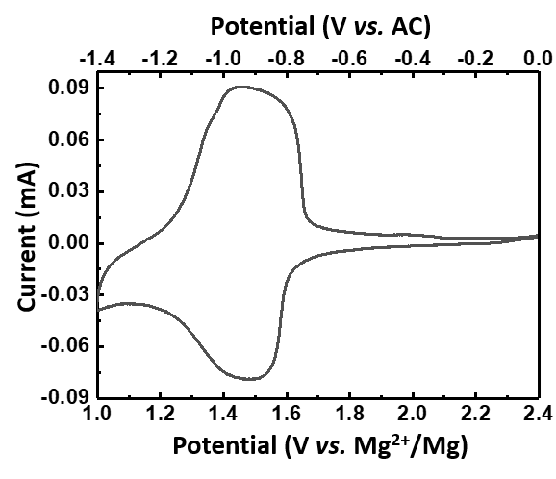
Figure S17. CV curve of NTP/C electrode within 1~2.4 V vs. Mg²⁺/Mg at a scan rate of 0.1 mV s⁻¹.
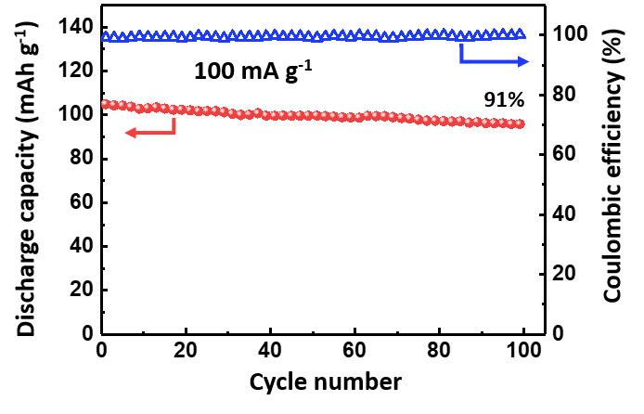
Figure S18. Cycling performances of NTP/C electrode at 100 mA g⁻¹.
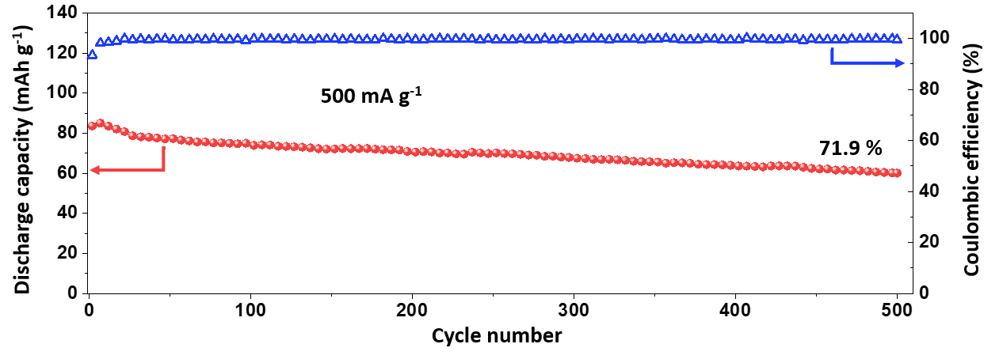
Figure S19. Cycling performances of NTP/C electrode at 500 mA g⁻¹.
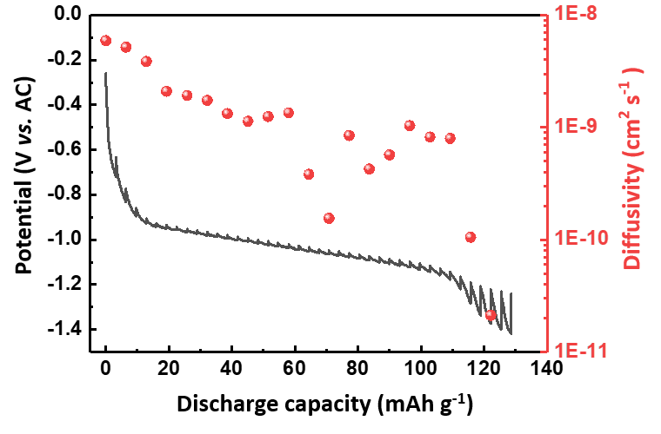
Figure S20. GITT curve of NTP/C electrode and diffusivity versus state of discharge.
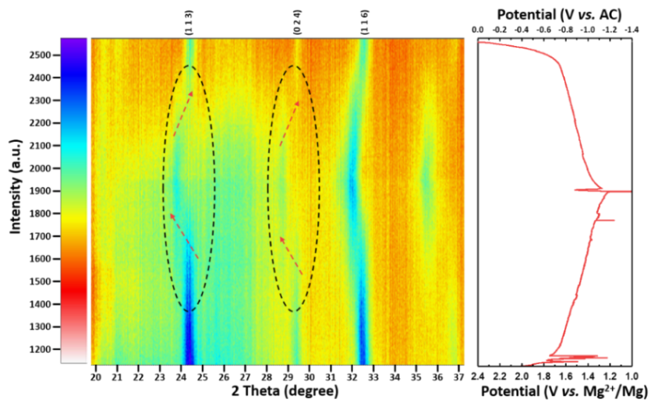
Figure S21. In situ XRD patterns and the corresponding charge/discharge curves of NTP/C electrode. The unsmooth charge-discharge curve may be due to the poor sealing and conductivity of the in situ mold cell.
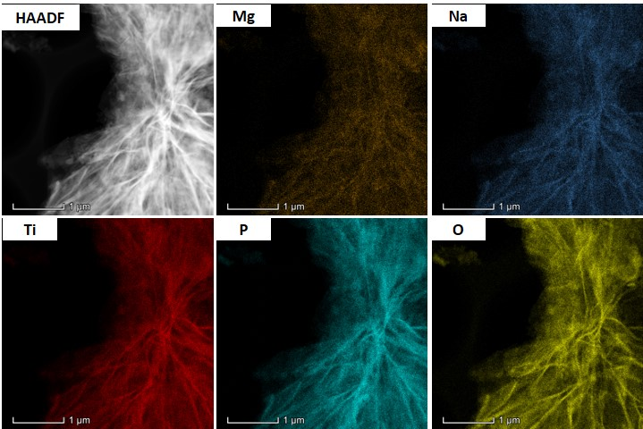
Figure S22. The HAADF image of discharged NTP/C and corresponding elemental maps
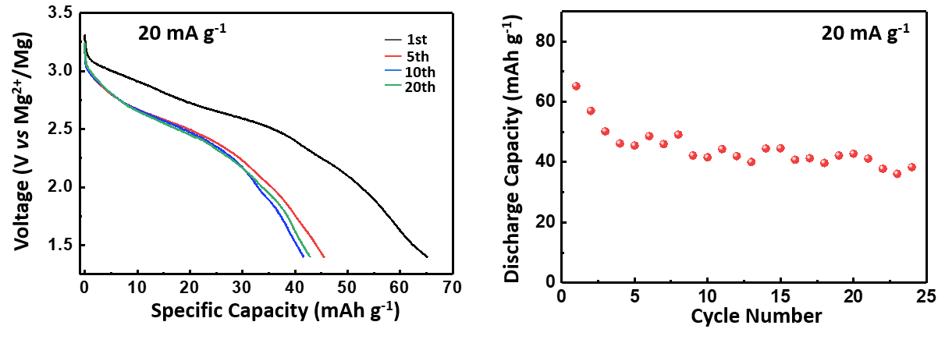
Figure S23. Discharge curves and cycling performances of NaV₂O₂(PO₄)₂F/rGO electrode at Mg-HMDS based electrolyte.
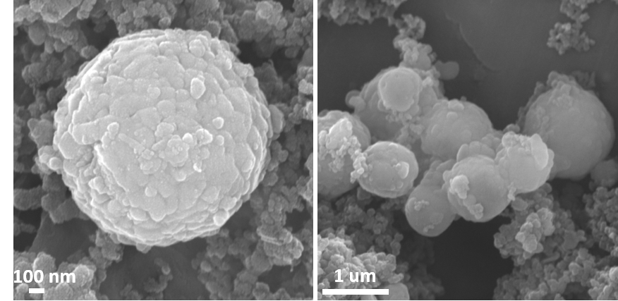
Figure S24. SEM images of NaV₂O₂(PO₄)₂F/rGO after 280 cycles.
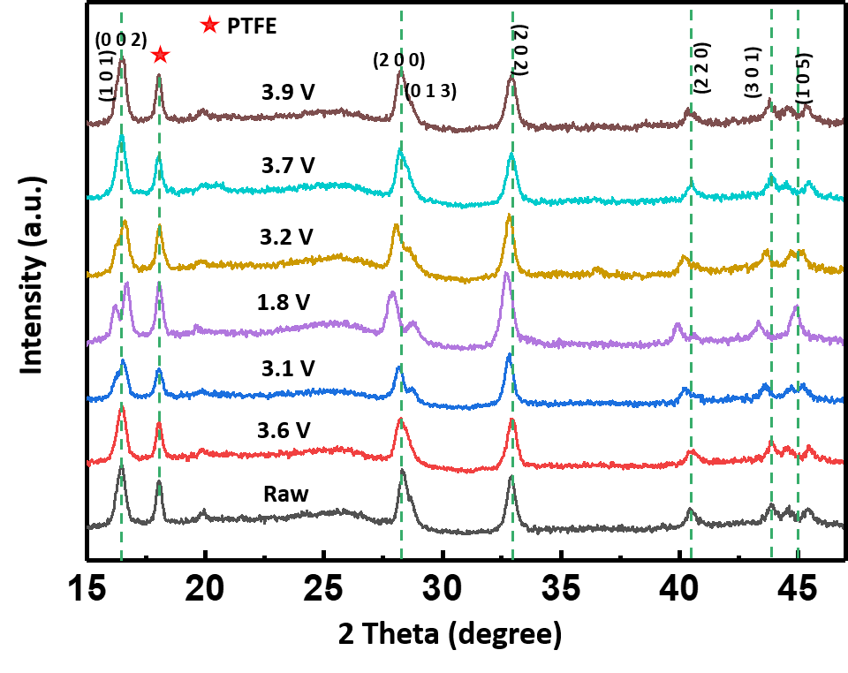
Figure S25. Ex situ XRD patterns for different states.
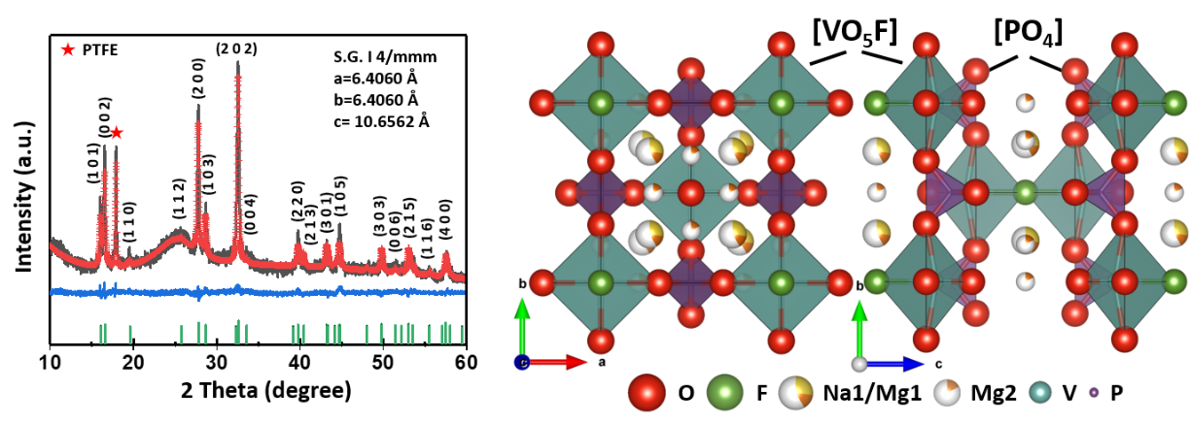
Figure S26. Rietveld refinement and crystal structure of discharged NaV₂O₂(PO₄)₂F/rGO.
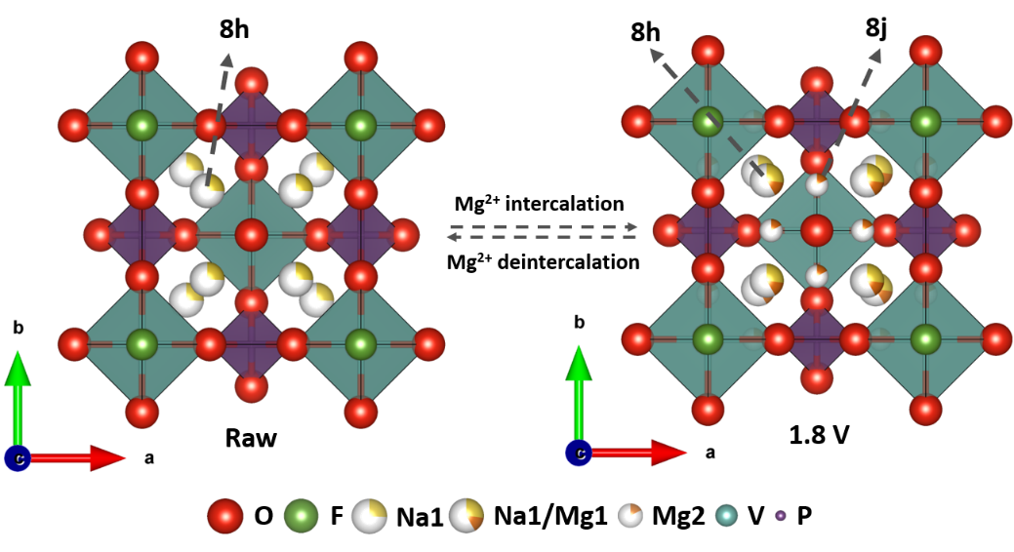
Figure S27. Distribution of Mg²⁺ in NaV₂O₂(PO₄)₂F/rGO crystal structure for 1.8 V.
Table S4. Rietveld refinement atomic coordinates for discharged NaV₂O₂(PO₄)₂F/rGO.
Atom | Site | Occupancy | x | y | z
Na1 | 8h | 0.268 | 0.2697 | 0.2697 | 0
Mg1 | 8h | 0.144 | 0.2697 | 0.2697 | 0
Mg2 | 8j | 0.170 | 0.2901 | 0.5000 | 0
V | 4e | 1.000 | 0 | 0 | 0.1997
P | 4d | 1.000 | 0 | 0.5000 | 0.2500
O1 | 16n | 1.000 | 0 | 0.3222 | 0.1666
O2 | 4e | 1.000 | 0 | 0 | 0.3192
F1 | 2a | 1.000 | 0 | 0 | 0
F1 | 2a | 1.000 | 0 | 0 | 0

To reveal the variation of vanadium oxidation state and magnesium in NaV₂O₂(PO₄)₂F/rGO at 1.8 V and 3.9 V, ex situ XPS patterns of Mg 1s and V 2p were collected as shown in Figure S28. The peak of Mg 1s at 1.8 V is apparent, and the peak of Mg 1s at 3.9 V almost disappear. The results of ex situ XPS indicate that the insertion and extraction of Mg²⁺ ions occur during discharge and charging. Compared to the raw NaV₂O₂(PO₄)₂F/rGO, the binding energy of V 2p at 1.8 V is significantly shifted to low energy, which indicates that the average valence state of vanadium decreases when Mg²⁺ ions are inserted into NaV₂O₂(PO₄)₂F/rGO. Conversely, the binding energy of V 2p at 3.9 V shifts to high energy, proving that the average valence state of vanadium increases when Mg²⁺ ions are removed from NaV₂O₂(PO₄)₂F/rGO.
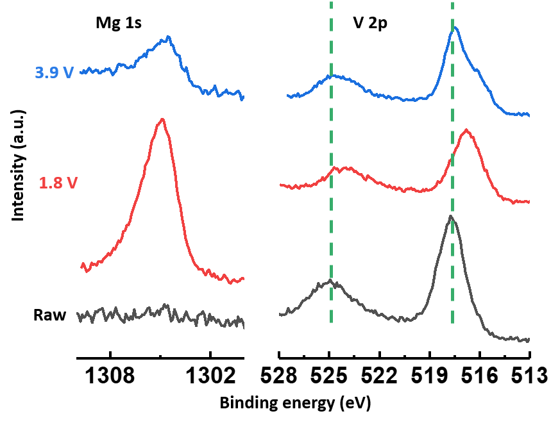
Figure S28. Ex situ XPS spectra of Mg 1s and V 2p of NaV₂O₂(PO₄)₂F/rGO in different states.
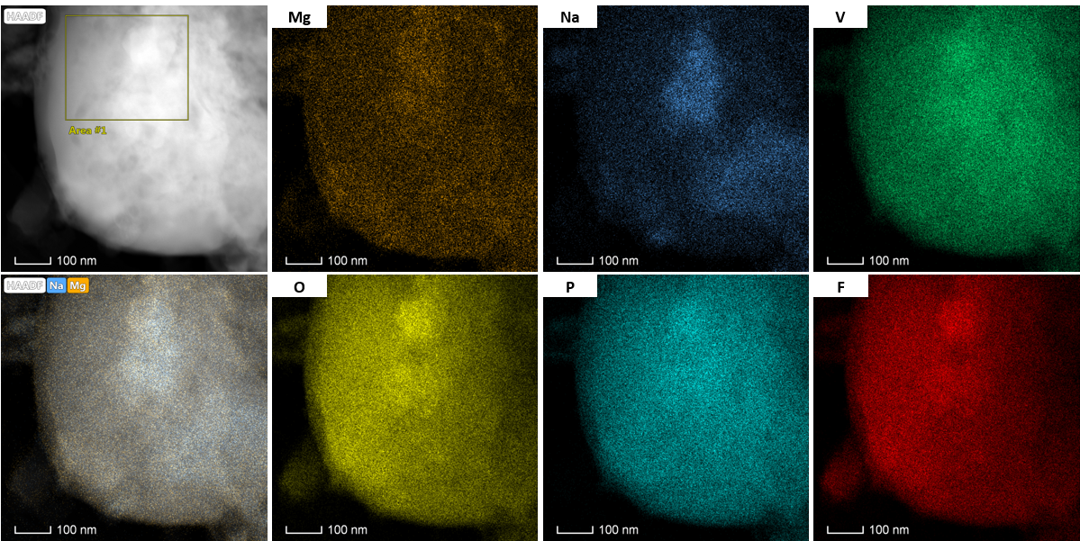

Figure S29. HAADF image with corresponding elemental maps of NaV₂O₂(PO₄)₂F/rGO at 1.8 V.
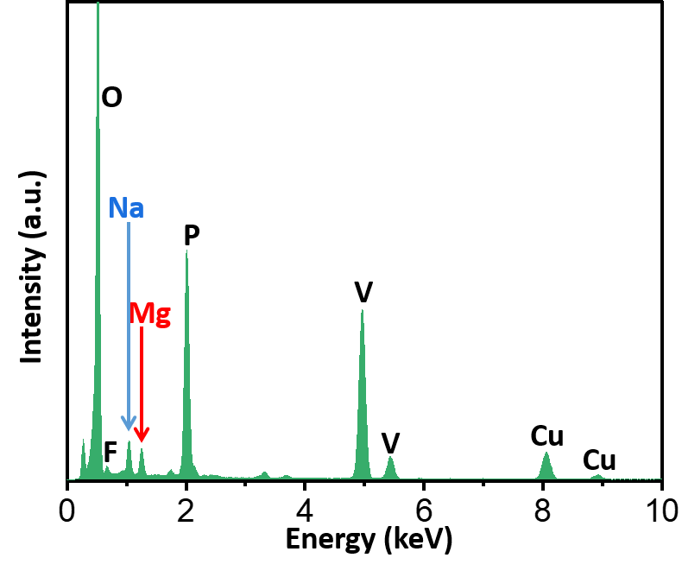
Figure S30. EDX spectrum for Area #1 in Figure S29 and percentage of atoms for corresponding elements.
Table S5. The ICP results of the NaV₂O₂(PO₄)₂F/rGO electrodes at different states.
State | Elements | Concentration (mg/mL) | Molar ratio  (Mg:Na:V)
Blank control | Mg | 0.0129
 | Na | 0.0167
 | V | 0.0926
Raw | Mg | 0.0791 | 0.0239:1.1021:2
 | Na | 2.8845
 | V | 11.6174
1.8 V | Mg | 1.6939 | 0.6250:1.0886:2
 | Na | 2.7877
 | V | 11.3685

References
- Massa, W.; Yakubovich, O. V.; Dimitrova, O. V. Crystal structure of a new sodium vanadyl (IV) fluoride phosphate Na₃{V₂O₂F[PO₄]₂}. Solid State Sci., 2002, 4: 495-501
- Sauvage, F.; Quarez, E.; Tarascon, J. M.; Baudrin, E. Crystal structure and electrochemical properties vs. Na⁺ of the sodium fluorophosphate Na_{1.5}VOPO₄F_{0.5}. Solid State Sci., 2006, 8: 1215-1221
- Deiss, E. Spurious chemical diffusion coefficients of Li⁺ in electrode materials evaluated with GITT. Electrochim. Acta, 2005, 50: 2927-2932
- Wang, R. Y.; Wessells, C. D.; Huggins, R. A.; Cui, Y. Highly reversible open framework nanoscale electrodes for divalent ion batteries. Nano Lett. 2013, 13: 5748-5752
- Huang, Z.-D.; Masese, T.; Orikasa, Y.; Mori, T. Vanadium phosphate as a promising high-voltage magnesium ion (de)-intercalation cathode host. RSC Adv., 2015, 5: 8598-8603
- Truong, Q. D.; Devaraju, M. K.; Honma, I. Nanocrystalline MgMnSiO₄ and MgCoSiO₄ particles for rechargeable Mg-ion batteries. J. Power Sources, 2017, 361: 195-202
- Kim, C.; Phillips, P. J.; Key, B.; Yi, T.; Nordlund, D.; Yu, Y. S.; Bayliss, R. D.; Han, S. D.; He, M.; Zhang, Z.; et al. Direct Observation of Reversible Magnesium Ion Intercalation into a Spinel Oxide Host. Adv. Mater., 2015, 27: 3377-3384
- Zeng, J.; Yang, Y.; Lai, S.; Huang, J.; Zhang, Y.; Wang, J.; Zhao, J. A Promising High-Voltage Cathode Material Based on Mesoporous Na₃V₂(PO₄)₃/C for Rechargeable Magnesium Batteries. Chemistry, 2017, 23: 16898-16905
- Okamoto, S.; Ichitsubo, T.; Kawaguchi, T.; Kumagai, Y.; Oba, F.; Yagi, S.; Shimokawa, K.; Goto, N.; Doi, T.; Matsubara, E. Intercalation and Push-Out Process with Spinel-to-Rocksalt Transition on Mg Insertion into Spinel Oxides in Magnesium Batteries. Adv. Sci. (Weinh), 2015, 2: 1500072
- Gershinsky, G.; Yoo, H. D.; Gofer, Y.; Aurbach, D. Electrochemical and spectroscopic analysis of Mg²⁺ intercalation into thin film electrodes of layered oxides: V₂O₅ and MoO₃. Langmuir, 2013, 29: 10964-72
- Rasul, S.; Suzuki, S.; Yamaguchi, S.; Miyayama, M. Manganese oxide octahedral molecular sieves as insertion electrodes for rechargeable Mg batteries. Electrochim. Acta, 2013, 110: 247-252
- Kaveevivitchai, W.; Jacobson, A. J. High Capacity Rechargeable Magnesium-Ion Batteries Based on a Microporous Molybdenum–Vanadium Oxide Cathode. Chem. Mater., 2016, 28: 4593-4601
- Xu, Y.; Deng, X.; Li, Q.; Zhang, G.; Xiong, F.; Tan, S.; Wei, Q.; Lu, J.; Li, J.; An, Q.; et al. Vanadium Oxide Pillared by Interlayer Mg²⁺ Ions and Water as Ultralong-Life Cathodes for Magnesium-Ion Batteries. Chem, 2019, 5: 1194-1209
- Esparcia, E. A.; Chae, M. S.; Ocon, J. D.; Hong, S.-T. Ammonium Vanadium Bronze (NH₄V₄O₁₀) as a High-Capacity Cathode Material for Nonaqueous Magnesium-Ion Batteries. Chem. Mater., 2018, 30: 3690-3696
- An, Q.; Li, Y.; Deog Yoo, H.; Chen, S.; Ru, Q.; Mai, L.; Yao, Y. Graphene decorated vanadium oxide nanowire aerogel for long-cycle-life magnesium battery cathodes. Nano Energy, 2015, 18: 265-272
- Senguttuvan, P.; Rousse, G.; Arroyo y de Dompablo, M. E.; Vezin, H.; Tarascon, J. M.; Palacin, M. R. Low-potential sodium insertion in a NASICON-type structure through the Ti(III)/Ti(II) redox couple. J. Am. Chem. Soc., 2013, 135: 3897-3903
- Xu, C.; Xu, Y.; Tang, C.; Wei, Q.; Meng, J.; Huang, L.; Zhou, L.; Zhang, G.; He, L.; Mai, L. Carbon-coated hierarchical NaTi₂(PO₄)₃ mesoporous microflowers with superior sodium storage performance. Nano Energy, 2016, 28: 224-231

