Supporting Information
Stabilizing conversion reaction electrodes by MOF derived N-doped carbon shell for highly reversible lithium storage
Fang Liu ^{a,b}, Shiyu Liu ª, Jiashen Meng ª, Fanjie Xia ^{a,b}, Zhitong Xiao ª, Ziang Liu ª, Qi Li*^{,a} , Jinsong Wu*^{,a,b}, Liqiang Maiª

ªState Key Laboratory of Advanced Technology for Materials Synthesis and Processing, Wuhan University of Technology, Wuhan 430070, China

^{b}Nanostructure Research Centre (NRC), Wuhan University of Technology, Wuhan 430070, China

*Correspondence to:wujs@whut.edu.cn; qi.li@whut.edu.cn

Table of Contents:
- Supplementary Figures S1 to S16
- Supplementary Table S1 to S2
- Supplementary Video S1 to S3
- A brief discussion on the surface confinement and heterostructure strategies

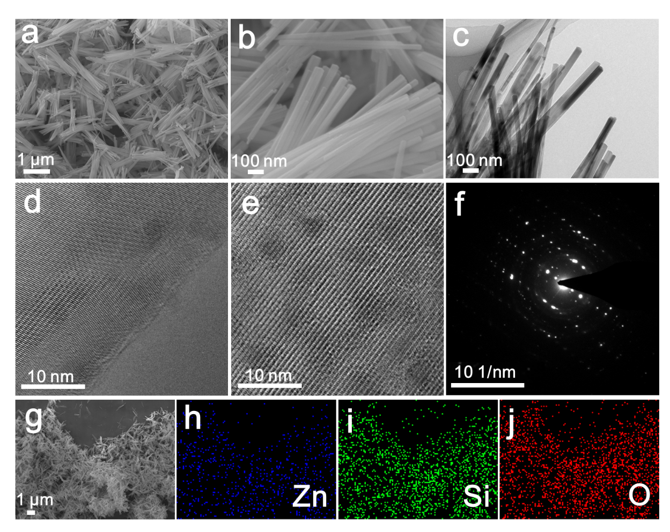
Figure S1. The characterizations of Zn₂SiO₄ nanowires: (a, b) SEM. (c-e) TEM images. (f) SAED pattern. (g-j) SEM image and the corresponding elemental mappings.

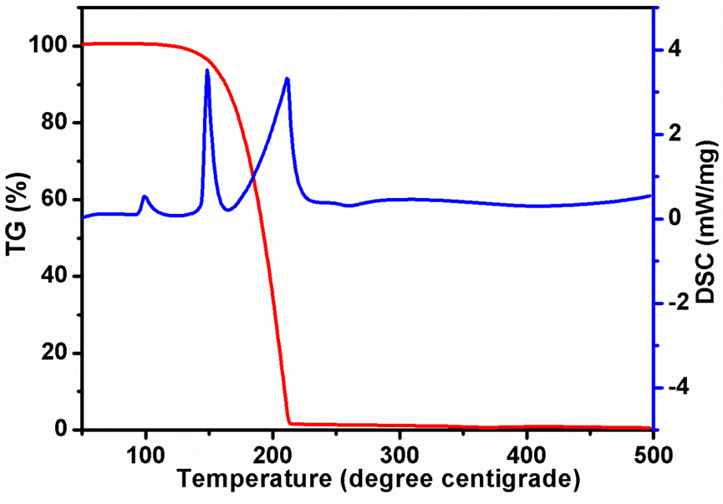
Figure S2. TG and DSC curves of the 2-MIM tested in argon conditions.

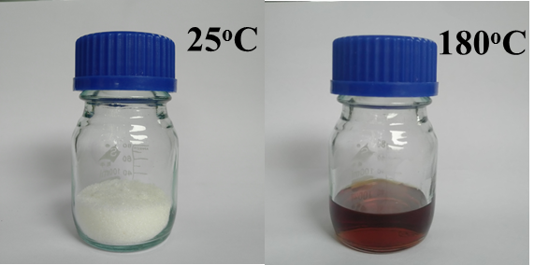
Figure S3. Optical images of 2-MIM at 25 and 180 °C. This shows the obvious tranformation from solid 2-MIM and liqiud 2-MIM when the environmental temperature increases from 25 to 180 °C.

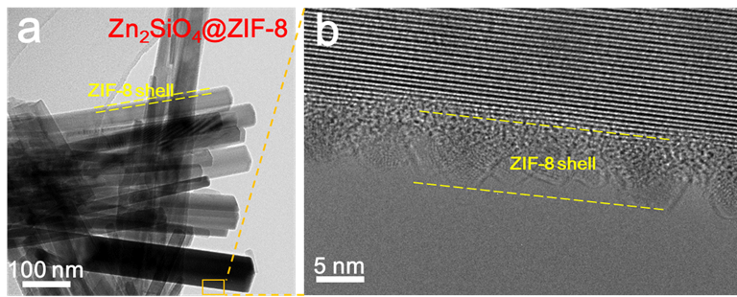
Figure S4. TEM image (a) and HRTEM image (b) of Zn₂SiO₄@ZIF-8 nanowires.

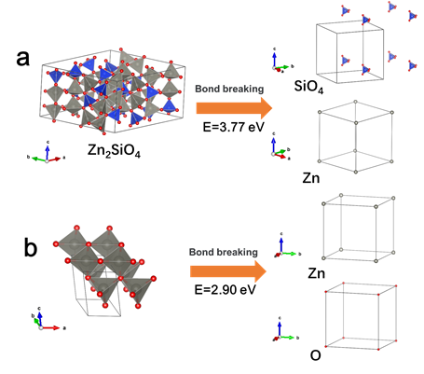
Figure S5. Structure variation of Zn₂SiO₄ (a) and ZnO (b) before and after bond breaking.

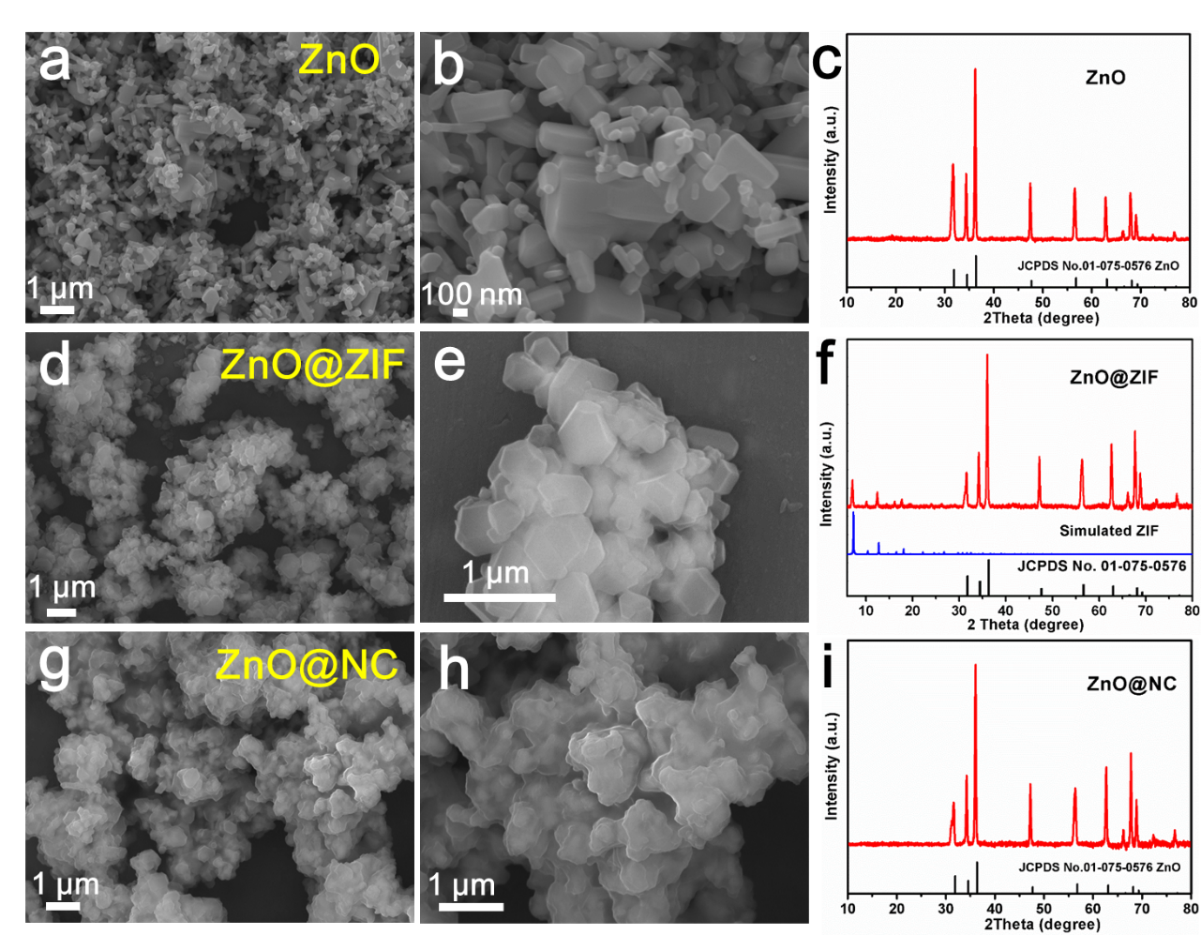
Figure S6. SEM images (a, b) and XRD pattern (c) of ZnO nanoparticals. SEM images (d, e) and XRD pattern (f) of ZnO@ZIF. SEM images (g-h) and XRD pattern (i) of ZnO@NC.

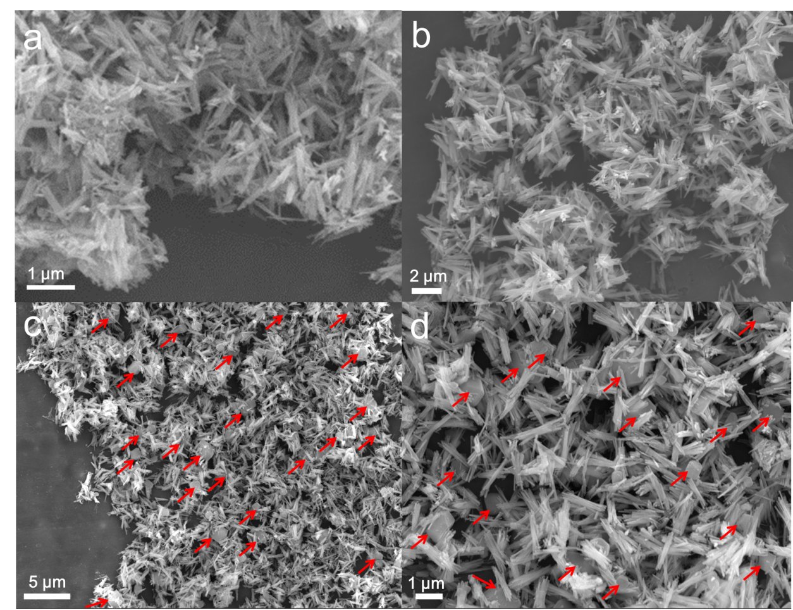
Figure S7. SEM images of Zn₂SiO₄@ZIF nanowires at 180°C. (a, b) when the reaction time of Zn₂SiO₄ and 2-Methylimidazole was 3 h. (c, d) when the reaction time of Zn₂SiO₄ and 2-Methylimidazole was 6 h.

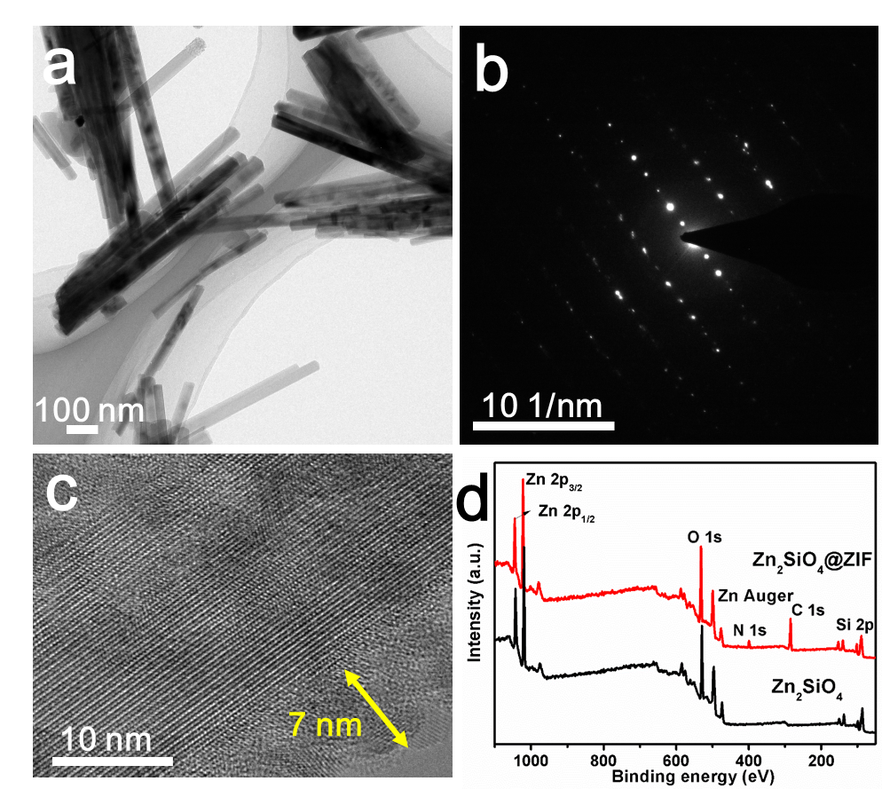
Figure S8. TEM image (a) and SAED pattern (b) of Zn₂SiO₄@ZIF nanowires. (c) HRTEM image of Zn₂SiO₄@ZIF nanowires. (d) XPS spectra of Zn₂SiO₄@ZIF and Zn₂SiO₄.
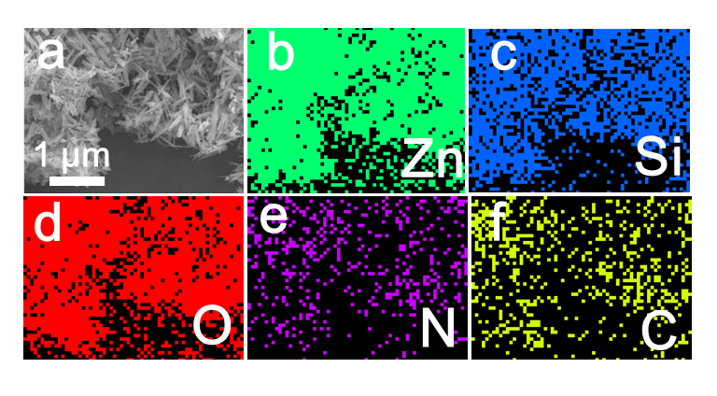
Figure S9 (a-f) SEM image and the corresponding EDX mapping images of Zn₂SiO₄@ZIF nanowires.

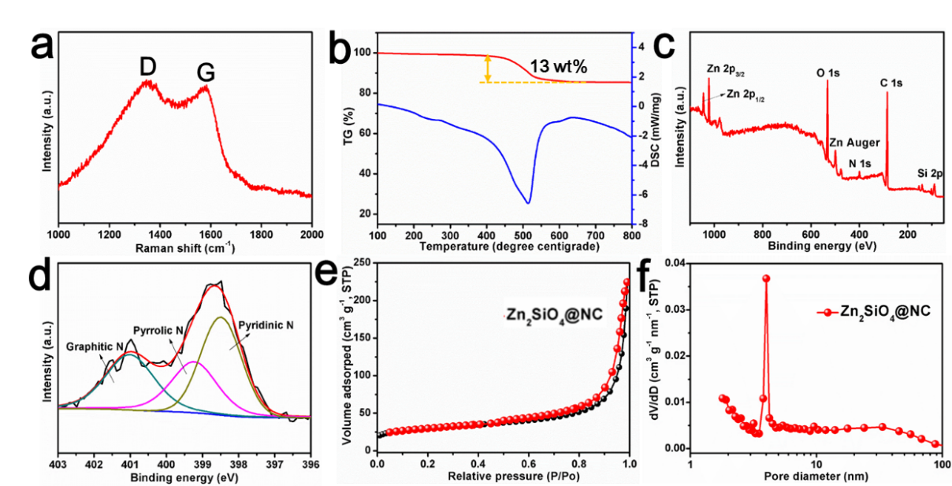
Figure S10. Structure characterizations of Zn₂SiO₄@NC nanowires. (a) Raman spectrum. (b) TG and DSC curves. (c, d) XPS and high-resolution N 1s XPS spectra. (e, f) BET and BJH curves.

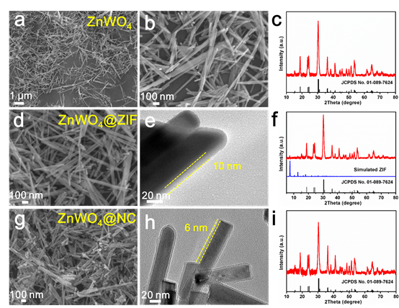
Figure S11. SEM image (a), TEM image (b) and XRD pattern (c) of ZnWO₄ nanowires. SEM image (d), TEM image (e) and XRD pattern (f) of ZnWO₄@ZIF nanowires. SEM image (g), TEM image (h) and XRD pattern (i) of ZnWO₄@NC nanowires.

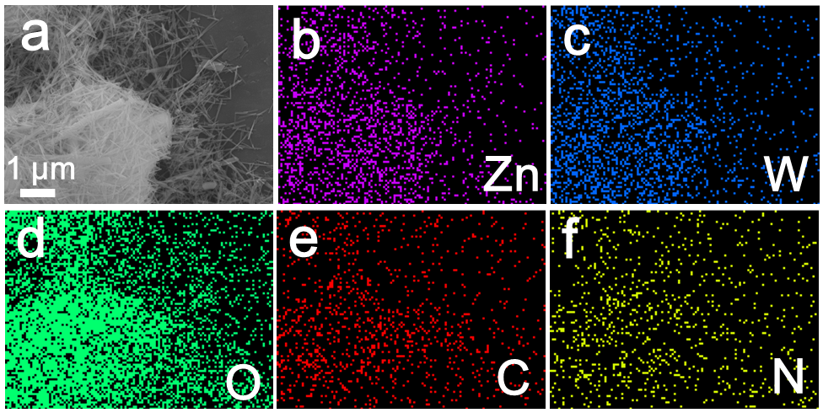
Figure S12. SEM image and the corresponding elemental mappings of ZnWO₄@NC nanowires.

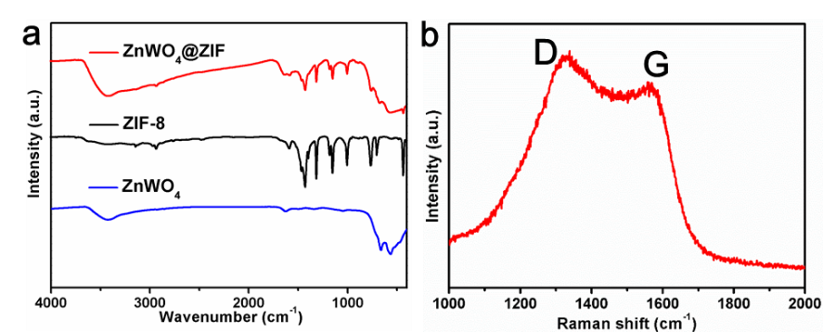
Figure S13. (a) The FTIR spectra of ZnWO₄@ZIF, ZIF-8, ZnWO₄. (b) Raman spectrum of ZnWO₄@NC.

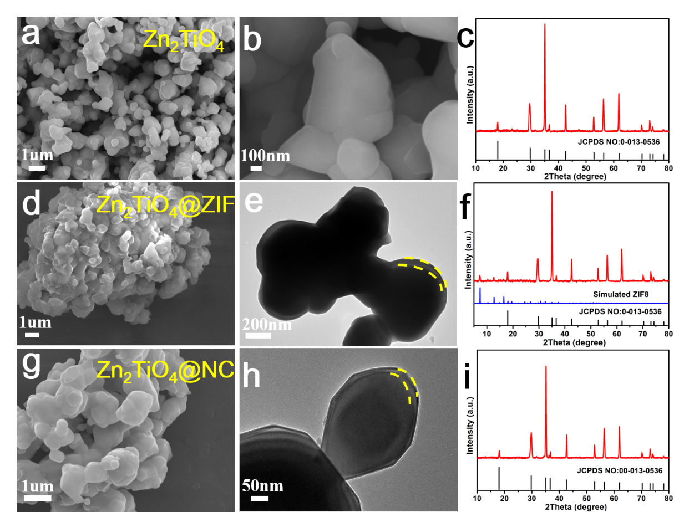

Figure S14. SEM image (a), TEM image (b) and XRD pattern (c) of Zn₂TiO₄. SEM image (d), TEM image (e) and XRD pattern (f) of Zn₂TiO₄@ZIF. SEM image (g), TEM image (h) and XRD pattern (i) of Zn₂TiO₄@NC.

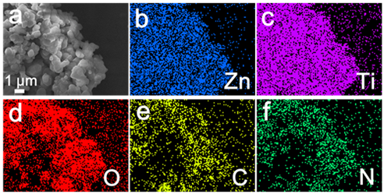
Figure S15. SEM image and the corresponding elemental mappings of Zn₂TiO₄@NC.

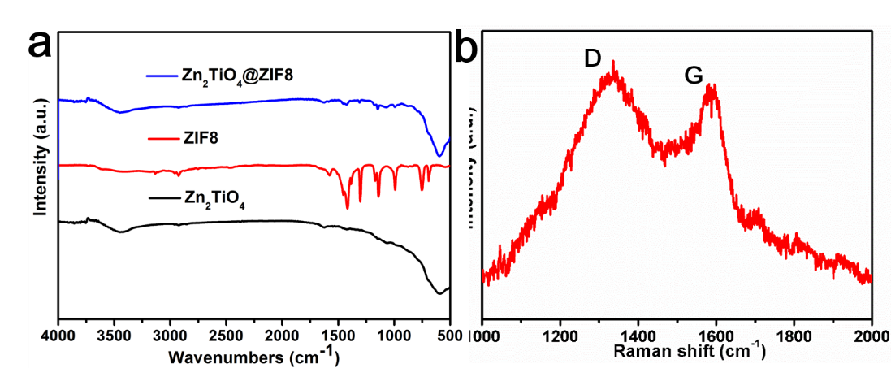
Figure S16. (a) The FTIR spectra of Zn₂TiO₄@ZIF, ZIF-8, Zn₂TiO₄. (b) Raman spectrum of Zn₂TiO₄@NC.

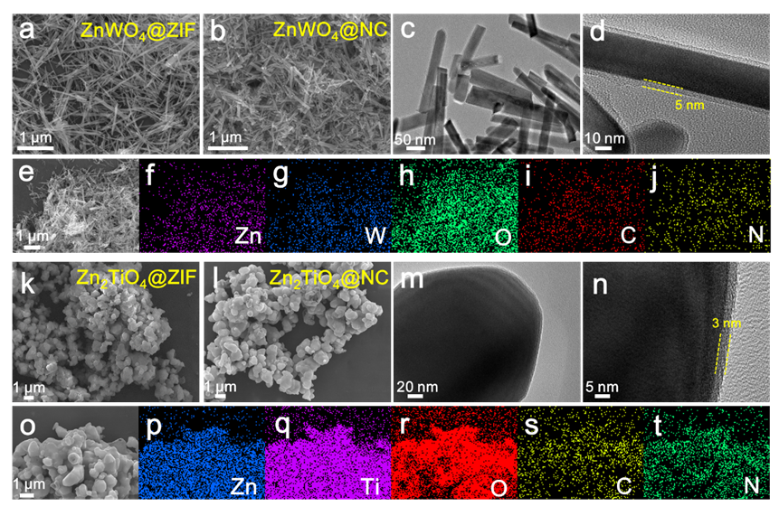
Figure S17. (a) SEM image of ZnWO₄@ZIF. SEM (b) and TEM (c, d) images of ZnWO₄@NC. (e-j) SEM image and the corresponding EDX mapping images of ZnWO₄@NC nanowire. (k) SEM image of Zn₂TiO₄@ZIF. SEM (l) and TEM (m, n) images of Zn₂TiO₄@NC. (o-t) SEM image and the corresponding EDX mapping images of Zn₂TiO₄@NC.

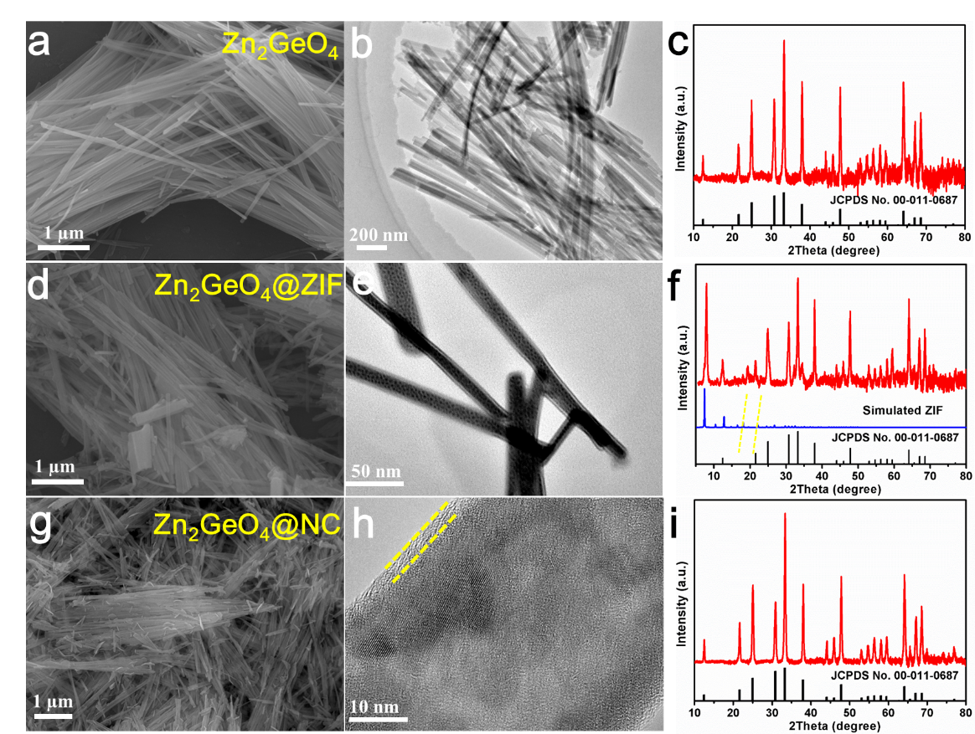
Figure S18. SEM image (a), TEM image (b) and XRD pattern (c) of Zn₂GeO₄. SEM image (d), TEM image (e) and XRD pattern (f) of Zn₂GeO₄@ZIF. SEM image (g), TEM image (h) and XRD pattern (i) of Zn₂GeO₄@NC.

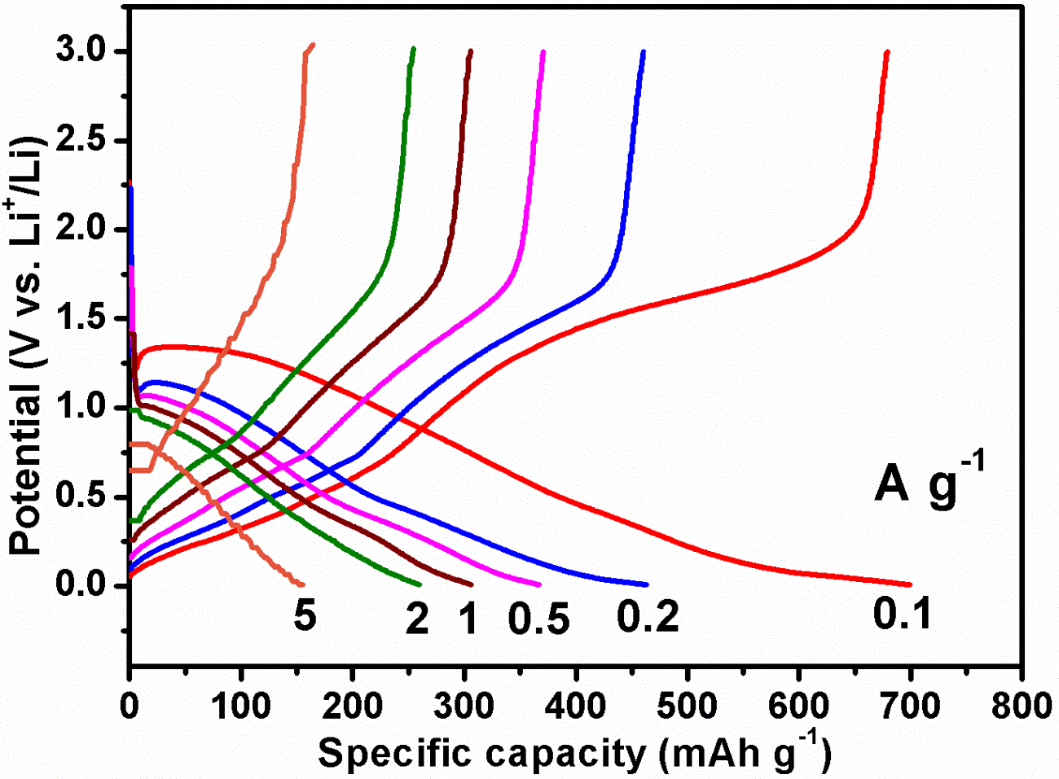
Figure S19. The corresponding charge and discharge voltage profiles of Zn₂SiO₄@NC nanowires at different current densities of 0.1, 0.2, 0.5, 1, 2, 5 A g⁻¹.

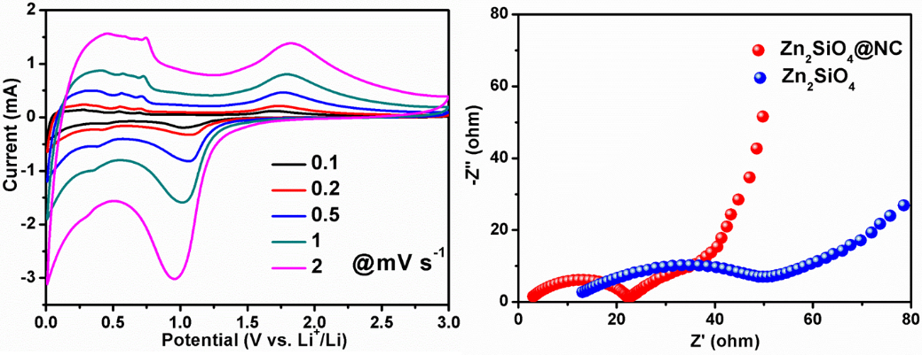
Figure S20. a) CV curves of Zn₂SiO₄@NC nanowires at different scan rates. b) The Nyquist plots of Zn₂SiO₄@NC nanowires and Zn₂SiO₄ nanowires.

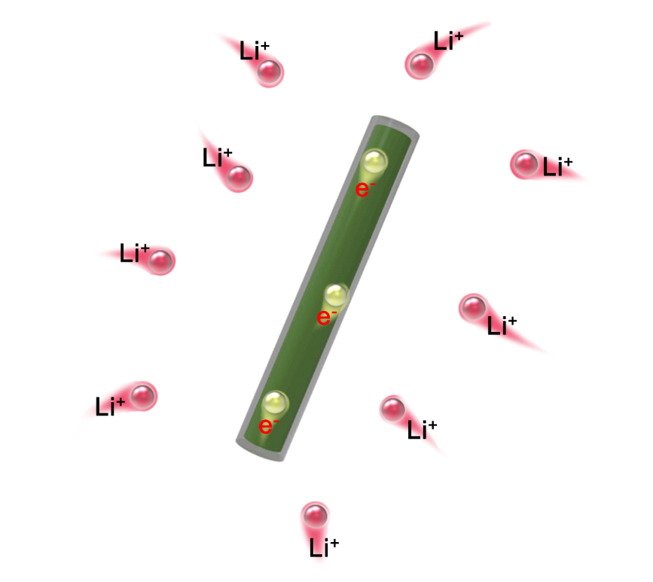
Figure S21. Schematic illustration of single Zn₂SiO₄@NC nanowires with efficient electron and Li⁺ transport and good stress accommodation.

Table S1. A comparison of the current and previous methods for carbon coatings.
Coating methods | Coating mechanisms | Coating sources | Advantages | Disadvantages | References
Low-temperature melting synthesis  method | Interfacial coordination reaction | MOFs | ● Simple manipulation  ● Solvent-free  ● High reactivity  ● Uniform coatings  ● High yield  ● Low cost | ● Selected target metal precursors | Our work
Solution-based synthesis method | Heterogeneous nucleation growth | MOFs | ● Simple manipulation  ● No substrate limitation  ● Low cost | ● Solvent consuming  ● Low yield  ● Hard control on uniform coatings | Chem, 2017, 2, 791-802.
Low-pressure vapor superassembly | Interfacial coordination reaction | MOFs | ● Simple manipulation  ● Uniform coatings  ● High yield  ● Low cost | ● Low pressure condition  ● Selected target metal precursors | Nano Lett. 2017, 17, 7773-7781.
Metal-phenolic network modification | Heterogeneous nucleation growth | MPN | ● Fast formation  ● No substrate limitation  ● Precise thickness control  ● Low cost | ● Solvent consuming  ● Low yield | J. Mater. Chem. A, 2018, 6, 18605-18614.
Chemical vapor deposition | Epitaxial growth | C₂H₂ | ● Precise thickness control  ● Uniform deposition  ● High quality coatings | ● Complex manipulation  ● High cost  ● Low yield | Adv. Mater. 2017, 29,  1605650.
Solution-based polymerization | Epitaxial in situ polymerization | Dopamine | ● Simple manipulation  ● No substrate limitation  ● Low cost | ● Solvent consuming  ● Low yield  ● Hard control on uniform coatings | Adv. Mater. 2017, 29, 1700989.

Table S2. A comparison of our work and other transition metal silicate for LIBs.
Electrode materials | Modification strategy | Current density  (mA g⁻¹) | Cycle number  (N) | Reversible capacity  (mAh g-1) | Capacity retention  (%) | Reference
Zn₂SiO₄@NC nanowire | Surface confinement | 100 | 100 | 685.2 | 102% | Our work
Co₂SiO₄ naoparticle | - | 100 | 100 | 650 | 130% | [39]
Zn₂SiO₄ nanoparticle | - | 50 | 50 | 293.6 | 85% | [40]
Zn₂SiO₄ microsphere | - | 50 | 20 | 413 | 78.9% | [33]
Mn₂SiO₄/CNT | Hereostructure | 100 | 40 | 466.9 | 119% | [41]
Fe₂SiO₄ | - | 100 | 100 | 800 | 122% | [42]
CuSiO₃ hollow sphere | - | 100 | 100 | 526 | 82.9% | [43]
Mn₂SiO₄ hollow sphere | - | 100 | 100 | 608 | 91.2% | [43]
NiSiO_{x}/RGO | Hereostructure | 50 | 50 | 797 | 100% | [44]
Co₂SiO₄ nanobelts@Carbon  composite | Surface confinement | 500 | 100 | 686.4 | 116% | [45]
CNT@NiSiOx coaxial nanocables | Hereostructure | 50 | 50 | 489 | 65% | [46]
rGO/NiSiO/Ni composites | Hereostructure | 20 | 60 | 478 | 65.4% | [47]
Cobalt @ voids @ Ni₃Si₂O₅(OH)₄ nanofibers | Hereostructure | 50 | 60 | 432 | 65.5% | [48]

Video S1. In-situ selected area electron diffraction observation of lithiation of Zn₂SiO₄ nanowire under a potential bias of -10V. The frame speed is 60-times faster than real time.

Video S2. In-situ TEM observation of lithiation of Zn₂SiO₄ nanowire under a potential bias of -10V. The frame speed is 60-times faster than real time.

Video S3. In-situ TEM observation of lithiation of Zn₂SiO₄@NC nanowire under a potential bias of -3V. The frame speed is 18-times faster than real time.

IV. A brief discussion on the surface confinement and heterostructure strategies
Besides surface confinement, heterostructures have also been widely explored for electrode materials. In terms of functions, surface confinement strategy endows the electrode materials with enhanced electric and ionic conductivity, improved materials’ integrity and controllable SEI formation. Generally, the surface confinement layers include carbon materials, Al₂O₃ and conductive polymers [Adv. Energy Mater. 2017, 7, 1601424; Chem. Commun., 2011, 47, 1384–1404; Science 2017, 358, eaao2808]. As for the heterostructures, they combine the advantages and overcome the limitations of different electrochemically active materials, since a homogeneous single-component electrode material can hardly have the characteristics of high electronic/ionic conductivity and high stability in the electrochemical environment simultaneously. Heterostructures can stabilize the whole structure, enhance high electronic/ionic conductivity and improve the reaction activity. Generally, heterostructured materials can be classified into inorganic–carbon, inorganic–polymer, carbon–polymer, and inorganic–inorganic hybrids [Angew. Chem. Int. Ed. 2016, 55, 3408-3413; Adv. Funct. Mater. 2011, 21, 2439-2445; Energy Environ. Sci. 2017, 10, 1694-1703.]. Both surface confinement and heterostructures strategies will improve electric and ionic conductivity and enhance structure stability. However, while surface confinement strategy can stabilize the SEI and surface confinement layer is generally stable during the electrochemical reaction process, all heterostructures take part in the electrochemical reactions and thus improve the reaction activity.

