Supplementary information for

Intercalation pseudocapacitance of FeVO₄·nH₂O nanowires anode for high-energy and high-power sodium-ion capacitor
Jun Dong^{a, 1}, Yi He^{a, 1}, Yalong Jiangª, Shuangshuang Tanª, Qiulong Wei^{b,}*, Fangyu Xiongª, Zhaolong Chuª, Qinyou Anª, Liqiang Mai^{a,c,*}
ª State Key Laboratory of Advanced Technology for Materials Synthesis and Processing, Wuhan University of Technology, Wuhan 430070, China
^{b} Department of Materials Science and Engineering, Fujian Key Laboratory of Materials Genome, College of Materials, Xiamen University, Xiamen, 361005 China
^{c} Foshan Xianhu Laboratory of the Advanced Energy Science and Technology Guangdong Laboratory, Xianhu hydrogen Valley, Foshan 528200, China

^{1.} These authors contribute equally to this work.
* Corresponding author
Email: qlwei@xmu.edu.cn (Prof. Qiulong Wei); mlq518@whut.edu.cn (Prof. Liqiang Mai)

The calculation of H₂O content in FeVO₄·nH₂O based on the TG result. When FeVO₄·nH₂O sample was heated in argon flow, the water molecular would be lost, as described in the follows.
$$FeVO_{4}∙nH_{2}O\underset{→}{heating}FeVO_{4}+nH_{2}O$$
The n value can be calculated by the following Equation.
$$\frac{M_{H_{2}O}×n}{M_{FeVO_{4}}+M_{H_{2}O}×n}=mass loss\%$$
Through TG test, the mass loss (Total wt.%) of FeVO₄·nH₂O is 6%.
The molecular weight is shown as follows.
$M_{H_{2}O}=18 g {mol}^{-1}$; $M_{FeVO_{4}}=170.8 g {mol}^{-1}$
Thus, the n value is 0.6.
The calculation of specific energy density and average power density
$$E=\int_{0}^{t}{IVdt}$$
$$P_{ave}=\frac{E}{t}$$
where I (A g⁻¹) is the constant current density, V (V) is working voltage, and t (h) is the time of a discharge process.

Characterization of FeVO₄·nH₂O nanowires
The FeVO₄·nH₂O nanowires were prepared by a facile hydrothermal method [1, 2]. The powder is in yellow (inset of Figure S1a) [1]. The powder XRD of FeVO₄·nH₂O nanowires is shown in Figure S1a. All the diffractions are indexed to Fervanite (FeVO₄·nH₂O, JCPDS card No. 27-0257) [1, 3]. Fourier transform infrared (FTIR) spectrum was further recorded to investigate the structure characteristic (Figure S1b). The absorption peaks at 500 cm⁻¹ and 967 are respectively attributed to Fe-O and V-O stretching. The absorption bands at 665, 768, 846 cm⁻¹ belong to bridging V—O…Fe stretching and V…O…Fe stretching modes [4, 5]. Especially, the distinct peaks at 1630 cm⁻¹ and 3408 cm⁻¹ are related to the stretching and bending modes of the O-H vibration, respectively, which demonstrates the existence of crystal water [6, 7]. The number of water molecules in FeVO₄·nH₂O is depicted by thermal gravity analysis (Figure S1c). The mass loss is about 6 wt.% at around 400 ºC, so the value of n in the FeVO₄·nH₂O product is calculated to be 0.6 (the detailed calculation is shown in the Supporting Information). Based on the above results, the chemical formula of the obtained product is FeVO₄·0.6H₂O. The scanning electron microscope (SEM) image (Figure S1d) displays nanowire morphology of FeVO₄·0.6H₂O. Transmission electron microscopy (TEM) image (Figure S1e) shows the nanowire with a width of about 100 nm and a length of several micrometers. Figure S1f shows the high-resolution TEM (HRTEM) image of FeVO₄·0.6H₂O nanowire. The measured 8.1 Å inter distance is in agreement with (100) plane of FeVO₄·0.6H₂O [8].
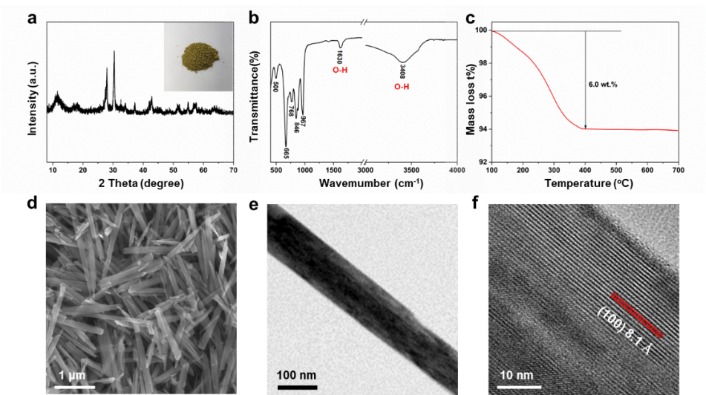
Figure S1. Characterization of the FeVO₄·0.6H₂O nanowires. (a) XRD pattern of FeVO₄·0.6H₂O nanowires. The yellow powder of FeVO₄·0.6H₂O (inset of a). FTIR spectrum (b), TG curve (c), SEM (d), TEM (e) and HRTEM (f) images of FeVO₄·0.6H₂O nanowires.
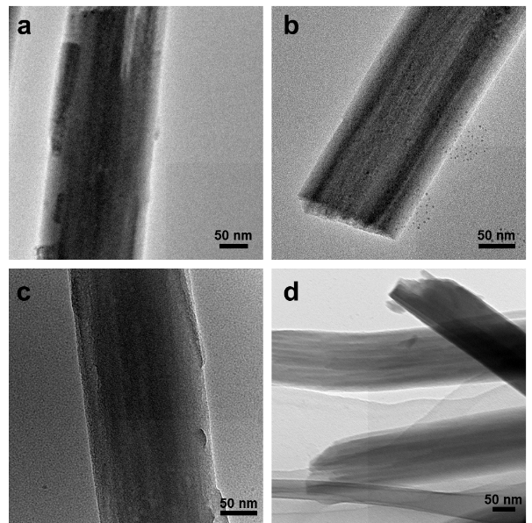
Figure S2. For Li⁺ storage in 1-3 V vs. Li⁺/Li, ex-situ TEM images of FeVO₄·0.6H₂O nanowires when discharged to 1 V vs. Li⁺/Li (a) and charged to 3 V vs. Li⁺/Li (b), respectively. For Na⁺ storage in 0.05-3 V vs. Na⁺/Na, ex-situ TEM images of FeVO₄·0.6H₂O nanowires when discharged to 0.05 V vs. Na⁺/Na (c) and charged to 3 V vs. Na⁺/Na (d), respectively.

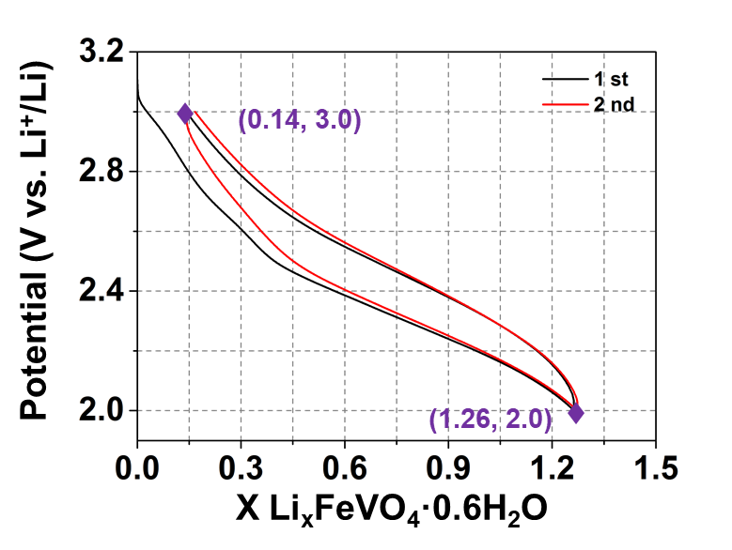
Figure S3. For Li ⁺ storage in 2-3 V vs. Li⁺/Li, potential vs. composition profiles of FeVO₄·0.6H₂O nanowires.

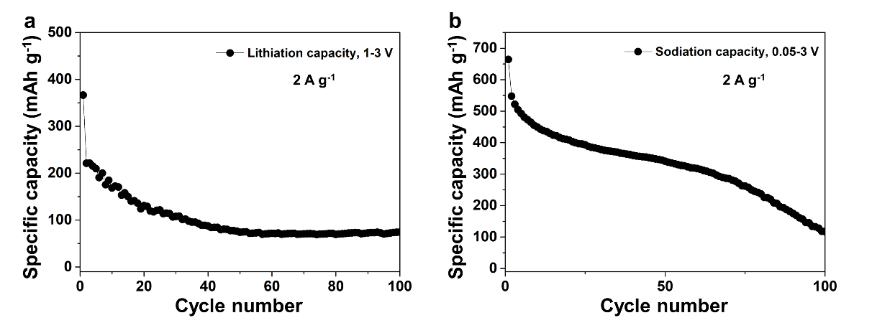
Figure S4. The cycling performance undergoing deep lithiation or sodiation at 2 A g⁻¹ of the FeVO₄·0.6H₂O nanowires for Li⁺ (a) and Na⁺ (b) storage.
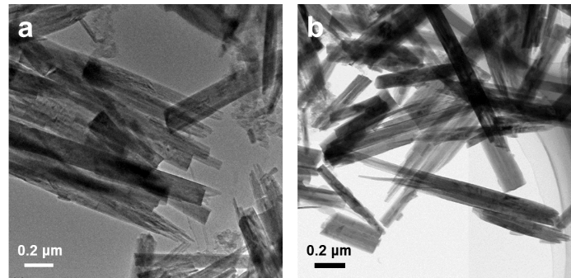
Figure S5. For Na⁺ storage in 1-3 V vs. Na⁺/Na, ex-situ TEM images of FeVO₄·0.6H₂O nanowires when discharged to 1 V vs. Na⁺/Na (a) and charged to 3 V vs. Na⁺/Na, respectively (b).

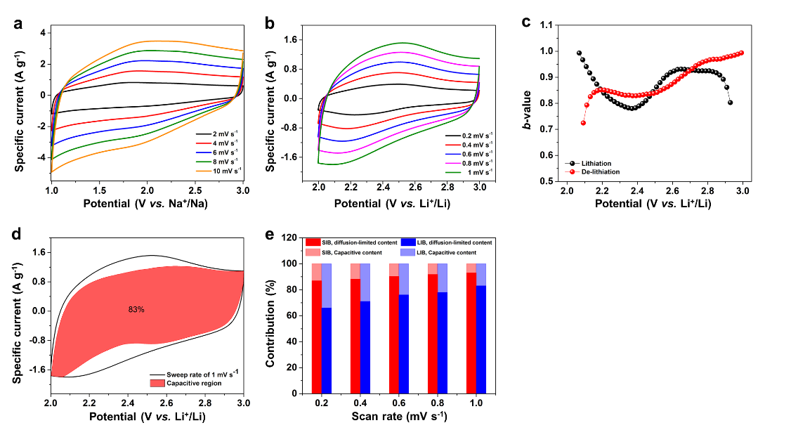
Figure S6. (a) CV curves of FeVO₄·0.6H₂O nanowires in 1-3 V vs. Na⁺/Na at different sweep rates from 2 to 10 mV s⁻¹. (b) CV curves of FeVO₄·0.6H₂O nanowires in 2-3 V vs. Li⁺/Li at different sweep rates from 0.2 to 1 mV s⁻¹. (c) Analysis of b-value at different potential for Li⁺ storage. (d) For Li⁺ storage, the separation of the capacitive and diffusion at a sweep rate of 1 mV s⁻¹. (e) The contribution ratio of the capacitive and diffusion-controlled charge versus sweep rates for Li⁺ and Na⁺ storage.

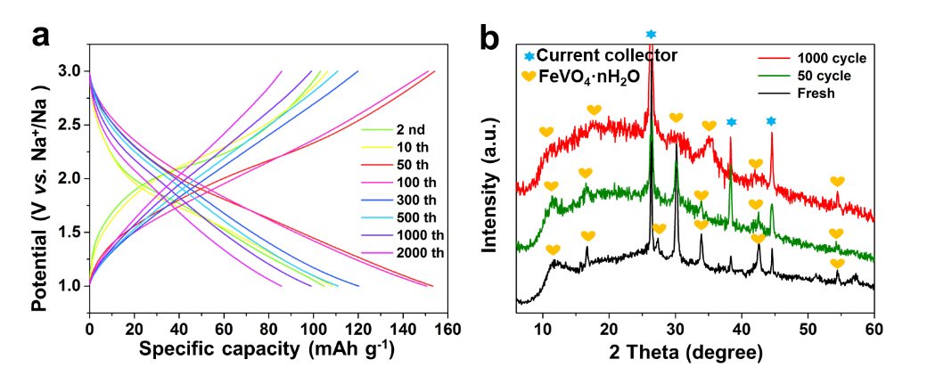
Figure S7. The charge-discharge profiles (a) and ex-situ XRD patterns (b) of different cycles at 2 A g⁻¹ in 1-3 V vs. Na⁺/Na.

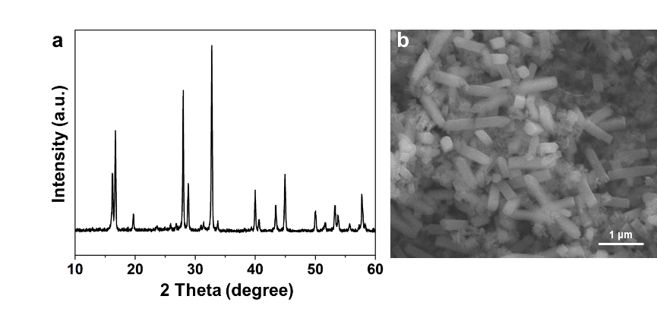
Figure S8. XRD pattern (a) and SEM image (b) of NVOPF/rGO.
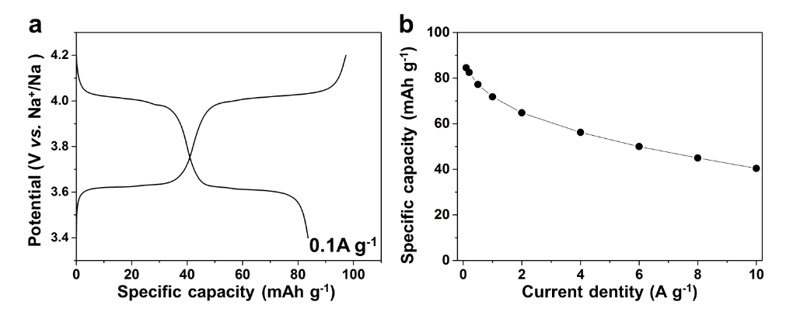
Figure S9. (a) Charge-discharge curves of NVOPF/rGO at 0.1A g⁻¹ in 3.4-4.2 V vs. Na⁺/Na. (b) Rate capability of NVOPF/rGO cathode.
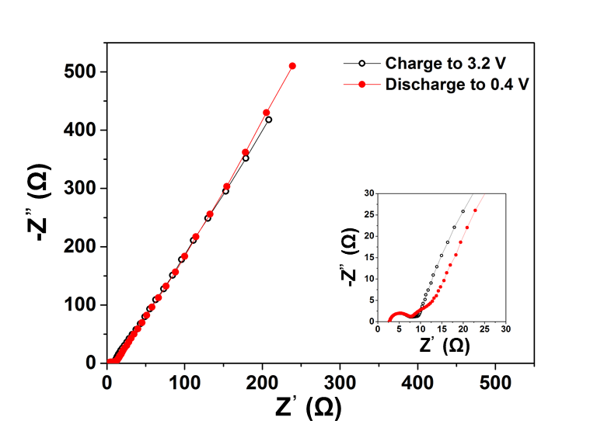
Figure S10. The EIS spectra of SIC at charge state and discharge state.
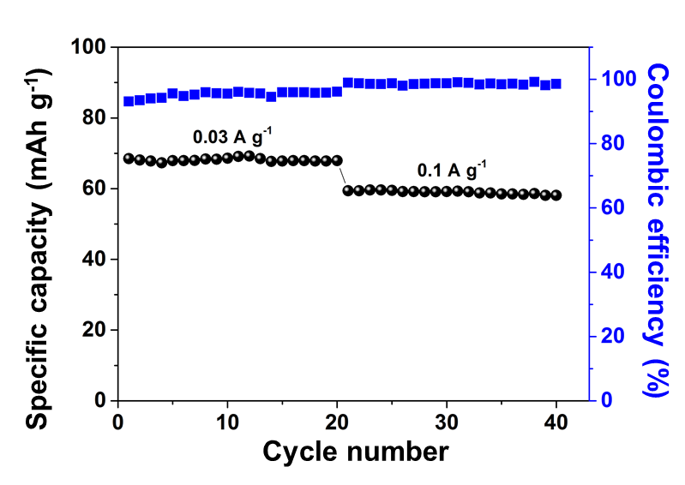
Figure S11. The activation process of SIC at small current density before cycling at 2 A g⁻¹.

References
[1] Y. V. Kaneti, Z. Zhang, J. Yue, X. Jiang, A. Yu, J. Nanopart. Res. 15 (2013) 1948.
[2] Q. An, F. Lv, Q. Liu, C. Han, K. Zhao, J. Sheng, Q. Wei, M. Yan, L. Mai, Nano Lett. 14 (2014) 6250-6256.
[3] Z. Fang, F. Fan, Z. Ding, C. Wang, L. Long, S. Hao, Mater. Res. Bull. 48 (2013) 1737-1740.
[4] X.-H. Ma, F. Zhang, Y.-Y. Wei, J.-H. Zhou, J. Wang, W. Jia, Z.-F. Zi, J.-M. Dai, J. Alloy. Compd. 768 (2018) 181-189.
[5] K. Melghit, A.S. Al-Mungi, Mater. Sci. Eng. B, 136 (2007) 177-181.
[6] J. Dong, Y. Jiang, Q. Wei, S. Tan, Y. Xu, G. Zhang, X. Liao, W. Yang, Q. Li, Q. An, Small, 15 (2019) 1900379.
[7] Q. Wei, J. Liu, W. Feng, J. Sheng, X. Tian, L. He, Q. An, L. Mai, J. Mater. Chem. A, 3 (2015) 8070-8075.
[8] P. Poizot, E. Baudrin, S. Laruelle, L. Dupont, M. Touboul, J.-M. Tarascon, Solid State Ionics, 138 (2000) 31-40.

