Supplementary Information
Novel layered K_{0.7}Mn_{0.7}Ni_{0.3}O₂ cathode material with enlarged diffusion channels for high energy density sodium-ion batteries
Jinghui Chen, Zhitong Xiao, Jiashen Meng, Jinzhi Sheng, Yanan Xu, Junjun Wang, Chunhua Han and Liqiang Mai*
State Key Laboratory of Advanced Technology for Materials Synthesis and Processing, International School of Materials Science and Engineering, Wuhan University of Technology, Hubei, Wuhan 430070, China

* Corresponding author (email: mlq518@whut.edu.cn)

Figure S1. Electrochemical performance of NMNO. (a) Cyclic voltammetry curves at a scan rate of 1.0 mV s⁻¹ during the first four cycles in the electrochemical window of 2.0 to 4.0 V vs. Na/Na⁺, (b) Charge/discharge curves at selected cycles at 0.1 A g⁻¹, (c) Charge/discharge curves at various rates ranging from 0.1 to 5 and back to 0.1 A g⁻¹.

Figure S2. Specific capacities and operation potentials of different types layered oxide cathodes for SIBs.
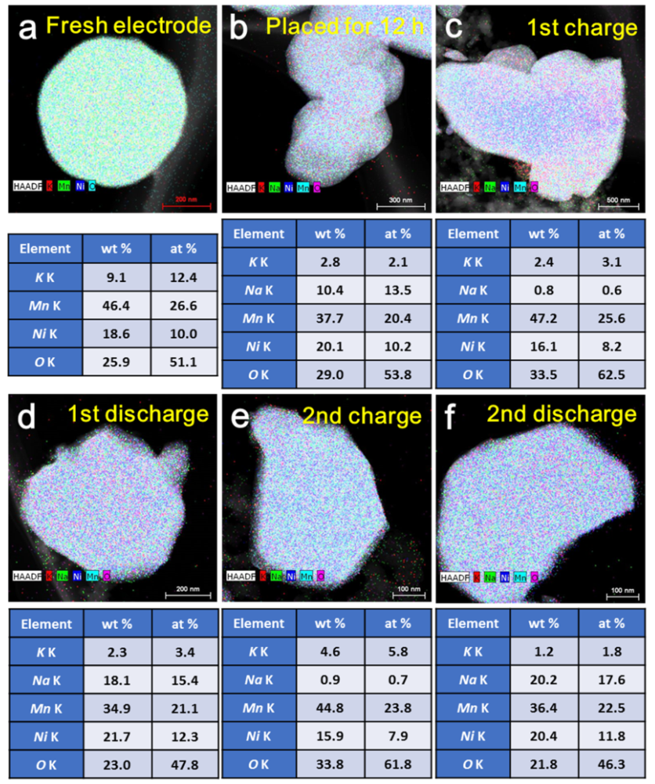
Figure S3. TEM images of KMNO at the stages (a) fresh electrode, (b) placed for 12h, (c) 1st charge, (d) 1st discharge (e) 2nd charge and (f) 2nd discharge with corresponding atomic compositions determined by EDS mapping images.

Figure S4. Interlayer spacing variations of KMNO during the first charge/discharge state at 0.1 A g⁻¹.

Figure S5. SAED of KMNO at the stages (a) fresh electrode, (b) 2nd charge and (c) 2nd discharge.

Figure S6. (a) XRD patterns of KMNO after 1st, 5th, 15th and 50th cycles tested at 0.1 A g⁻¹.

Figure S7. The 1st discharge and 2nd charge profiles of NMNO cycled in fresh NaClO₄ electrolyte after the 1st charge.

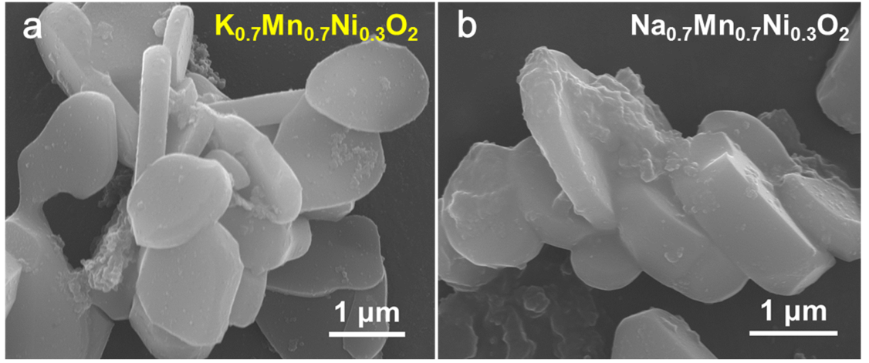

Figure S8. SEM images of KMNO (a) and NMNO (b) after 50 cycles.

Table S1. The ICP test results of the synthetic KMNO and NMNO.
 | Mass concentration |  | Ratios
K_{0.7}Mn_{0.7}Ni_{0.3}O₂ | K | 18.41% | K: Mn: Ni = 0.700:0.706:0.298
 | Mn | 18.90%
 | Ni | 19.20%
Na_{0.7}Mn_{0.7}Ni_{0.3}O₂ | Na | 24.32% | Na: Mn: Ni = 0.700:0.708:0.305
 | Mn | 18.68%
 | Ni | 24.91%

Table S2. Comparison of the electrochemical performance of layered oxide cathode materials for SIBs.
cathode | Voltage range (V) | Current density (mA g⁻¹) | Cycle number | Residual capacity (mA h g⁻¹) | Capaciy retention | Reference
K_{0.7}Mn_{0.7}Ni_{0.3}O₂ | 2-4 | 100  500 | 100  500 | 155  103 | 96%  86% | Our work
P2-Na_{0.7}Co₂O₂  microspheres | 2-3.8 | 50 | 300 | 88 | 86% | Angew. Chem. Int. Edit. 2017, 129, 5801.
P2-Na_{x}[Fe_{1/2}Mn_{1/2}]O₂ | 1.5-4.3 | 13 | 30 | 145 | 74% | Nat. Mater. 2012, 11, 512.
P2-Na_{2/3}Fe_{1/3}Mn_{2/3}O₂ | 1.5-4.1 | 14 | 75 | 63 | 67% | J. Alloy. Compd. 2017, 724, 465.
P2-Na_{0.78}Ni_{0.23}Mn_{0.69}O₂ | 2-4.5 | 12.1 | 20 | 138 | 75% | J. Am. Chem. Soc. 2017, 139, 4835.
O3-NaNi_{1/3}Mn_{1/3}Co_{1/3}O₂ | 2.5-3.75 | 12 | 50 | 120 | 93% | Chem. Mater. 2012, 24, 1846.
P2-Na_{0.7}Fe_{0.4}Mn_{0.4}Co_{0.2}O₂ | 2-4.5 | 10 | 60 | 115 | 61% | Adv. Funct. Mater. 2015, 25, 3227.
O3-NaNi_{0.5}Fe_{0.5}O₂ | 2-3.9 | 23.5 | 20 | 121 | 94% | J. Mater. Chem. A 2017, 5, 4596.
O3-Na[Ni_{0.25}Fe_{0.5}Mn_{0.25}]O₂/C | 2.1-3.9 | 13 | 130 | 99 | 76% | Nano Lett. 2014, 14, 1620.
O3-NaTi_{0.5}Ni_{0.5}O₂ | 2-4.7 | 20 | 121 | 50 | 53% | Chem. Commun. 2014, 50, 457.
O3-Na(NiCoFeTi)_{1/4}O₂ | 2-3.9 | 120 | 100 | 111 | 93% | J. Mater. Chem. A 2015, 3, 23261.

Table S3. The ex-situ ICP test results of KMNO at different electrochemical states.
State of KMNO | Ratios
Fresh electrode | K: Mn: Ni = 0.700: 0.708: 0.305
Placed for 12 h | K: Na: Mn: Ni = 0.106: 0.694: 0.709: 0.308
1st charge | K: Na: Mn: Ni = 0.698: 0.050: 0.701: 0.298
1st discharge | K: Na: Mn: Ni = 0.109: 0.701: 0.710: 0.310
2nd charge | K: Na: Mn: Ni = 0.108: 0.024: 0.709: 0.312
2nd discharge | K: Na: Mn: Ni = 0.106: 0.731: 0.680: 0.301
50 cycles | K: Na: Mn: Ni = 0.103: 0.698: 0.695: 0.303

