Supporting information for

Compact Sn/SnO2 Microspheres with Gradient Composition for High Volumetric Lithium Storage

**EXPERIMENTAL**

*Preparation of concentration gradient Sn/SnO2 microspheres:* First, 1.4 g of SnCl4 was mixed with 30 mL deionized water. After stirring for 10 min, 5.1 g sucrose was added into the solution, then transferred into an autoclave under 180 °C for 24 h. The precipitation was then collected and washed with deionized water and alcohol several times. After drying for 8 h at 60 °C, the precursor was obtained. The as-prepared SnO2/C precursor was subsequently carbonized at 700°C for 5 h under argon protective atmosphere, the Sn/C was obtained. Then, the as-prepared Sn/C was calcined in air at 500 °C for 4 h to obtain the Sn/SnO2. The SnO2 are obtained by directly annealing the precursor in air at 500 °C for 4 h.

*Material Characterization:* X-ray powder diffraction (XRD) measurements were performed on the D8 Discovery diffractometer (Bruker AXS, Karlsruhe, Germany) with a goniometer radius 217.5 mm. The microstructures were observed by a field-emission scanning electron microscopy (FESEM) (JEOL-7100F) and a transmission electron microscopy (TEM) (JEM-2100F). Brunauer Emmet-Teller (BET) surface areas were measured by using Tristar II 3020 instrument. Raman spectra were acquired using a Renishaw RM-1000 laser Raman microscopy system. Thermogravimetry is carried out on a STA449c/3/G (NETZSCH). X-ray photoelectron spectroscopy (XPS) measurements were performed using a VG MultiLab 2000 instrument. For *in situ* TEM, samples were dispersed on a glass slide first followed by touch transferring to the electron polished Pt tip, which was then fixed on the sample side of the Nanofacotry holder. Pure Li was loaded onto a tungsten tip and fixed to the piezo actuator system. This process was carried out in an Ar filled glove box and the whole setup was transferred to TEM via a home-made vacuum container. Li source was navigated to contact the electrode with a constant bias of -1.6 V to drive the electrochemical reaction. FEI Titan 80-300 ETEM with image corrector was used for *in situ* measurement.

*Electrochemical Characterization:* The electrochemical properties were characterized by assembling CR2016 coin cell and lithium metal foil as anode in a glove box filled with pure argon. The cathode electrodes consisted of 70% active material, 20% acetylene black, and 10% sodium alginate binder. A solution (1M) of LiPF6 in EC/DMC (1:1 vol/vol) was used as the electrolyte. Copper foil is used as a collector for the coating. The cells were aged for 12 hours prior to the charging/discharging process to ensure complete filtration of the electrolyte into the electrodes. The capacity was calculated based on the total mass of the composite. Galvanostatic charge/discharge measurement was performed by a multichannel battery testing system (LAND CT2001A), Cyclic voltammetry (0.01-3 V) was performed using an electrochemical workstation (CHI 760S), electrochemical impedance spectroscopy (EIS) was tested with an Autolab Potentiostat Galvanostat (PGSTAT302N). The EIS is carried out at frequency range from 0.1 to 10000 Hz at open circuit potential before cycling to avoid the influence of Li metal. In order to obtain the SEM and TEM images of Sn/SnO2 after cycling, the electrodes were taken out of the disassembled battery and immediately immersed in acetone for 24 hours to wash the residue. The samples after cycling were detached by ultrasonication and dispersed in the alcohol to form suspension. The suspension was dropped on the aluminum foil for SEM and TEM characterization.

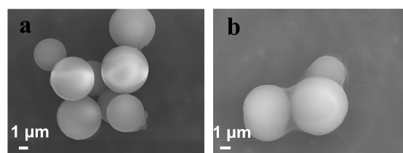

**Figure S1**. SEM images of the precursor.

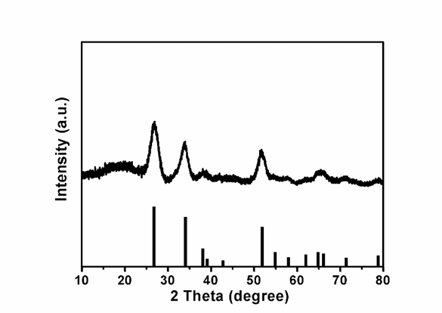

**Figure S2**. XRD pattern of the precursor.



**Figure S3**. SEM images of SnO2.

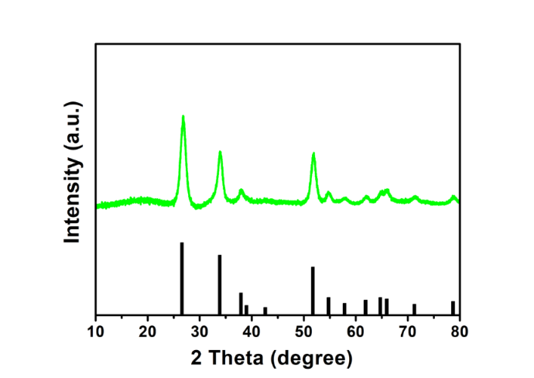

**Figure S4**. XRD pattern of SnO2.

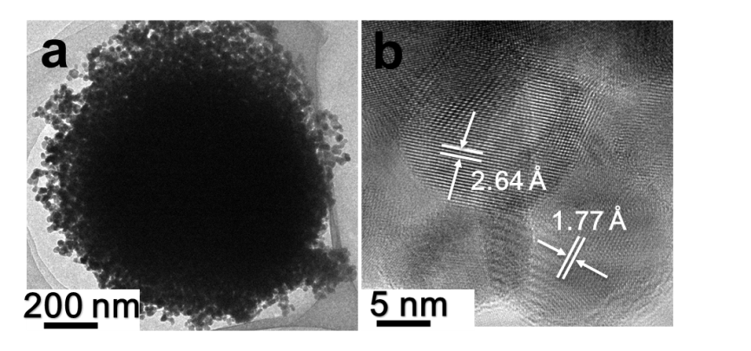

**Figure S5**. a) TEM and b) HRTEM images of SnO2, respectively.

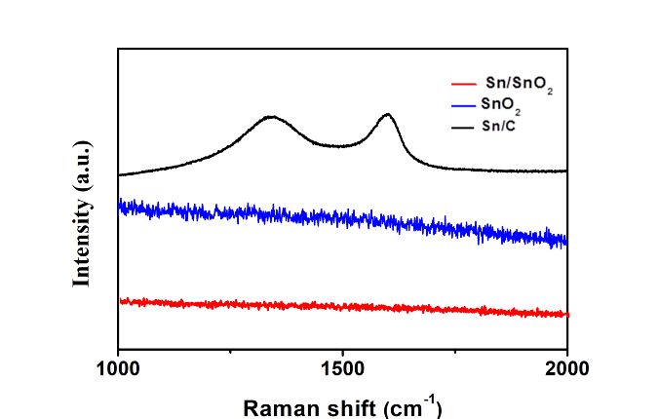

**Figure S6.** Raman spectra of Sn/C composite, Sn/SnO2, and SnO2, respectively.

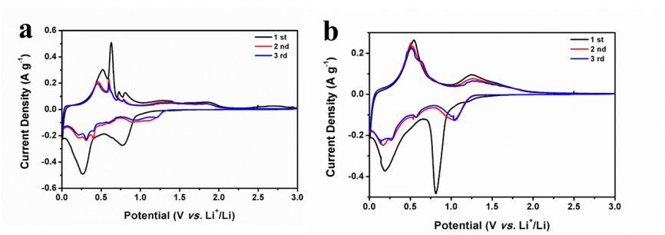

**Figure S7**. CV curves of **a)** Sn/SnO2, **b)** SnO2 at a scan rate of 0.1 mV s-1, respectively.

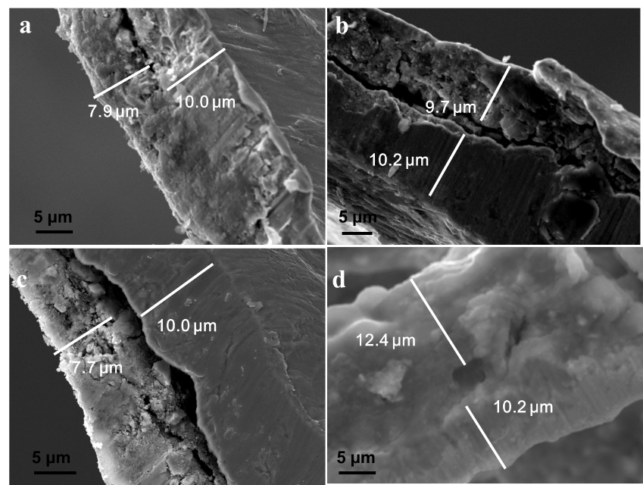

**Figure S8.** SEM images of **a)** the pristine Sn/SnO2 electrode, **b)** the lithiated Sn/SnO2 electrode (discharged to 0.01 V). SEM images of **c)** the pristine SnO2 electrode, **d)** the lithiated SnO2 electrode (discharged to 0.01 V) to compare the thickness variations.

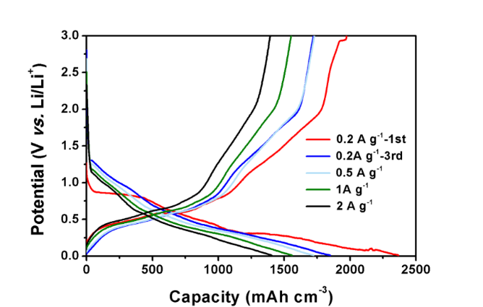

**Figure S9**. Galvanostatic charge-discharge curves of a representative Sn/SnO2 electrode at 0.2, 0.5, 1, and 2 A g-1.

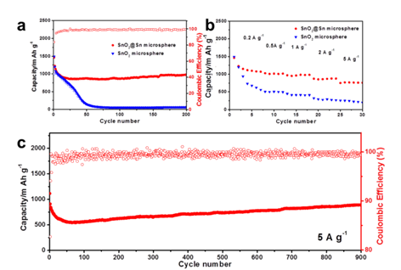

**Figure S10.** a) The cycling performances of Sn/SnO2 and SnO2 at low current density of 200 mA g-1. b) Rate performances of Sn/SnO2 and SnO2. c) The cycling performance of Sn/SnO2 at high current density of 5 A g-1. The capacity is based on the gravimetric capacity.

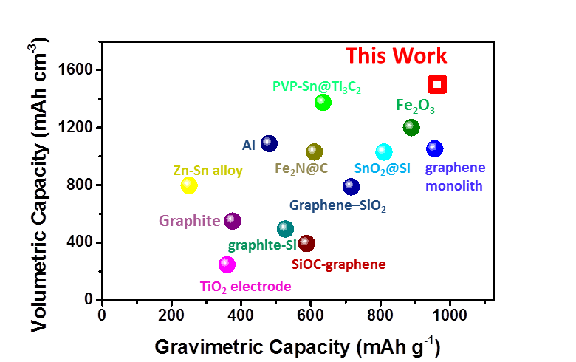

**Figure S11.** Comparison of volumetric and gravimetric capacity of Sn/SnO2 with the current literature reported electrodes.

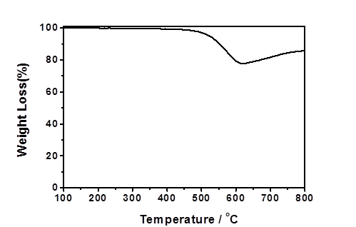

**Figure S12.** The TG curves of Sn/C composite.

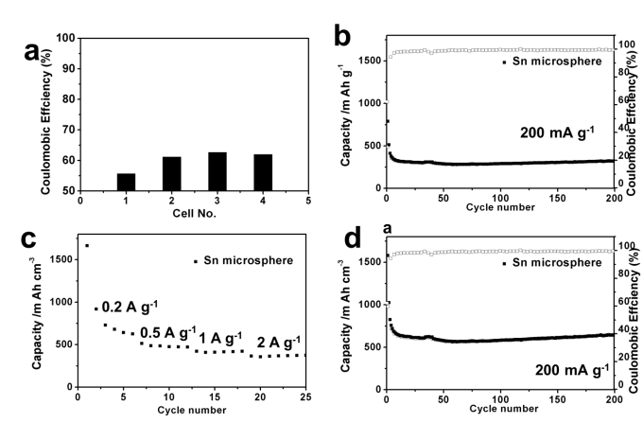

**Figure S13.** a) The initial coulombic efficiency of Sn/C composite. b) The cycling performance of Sn/C composite at low current density of 200 mA g-1. c) Rate performance of Sn/C composite. d) The cycling performance based on gravimetric capacity.

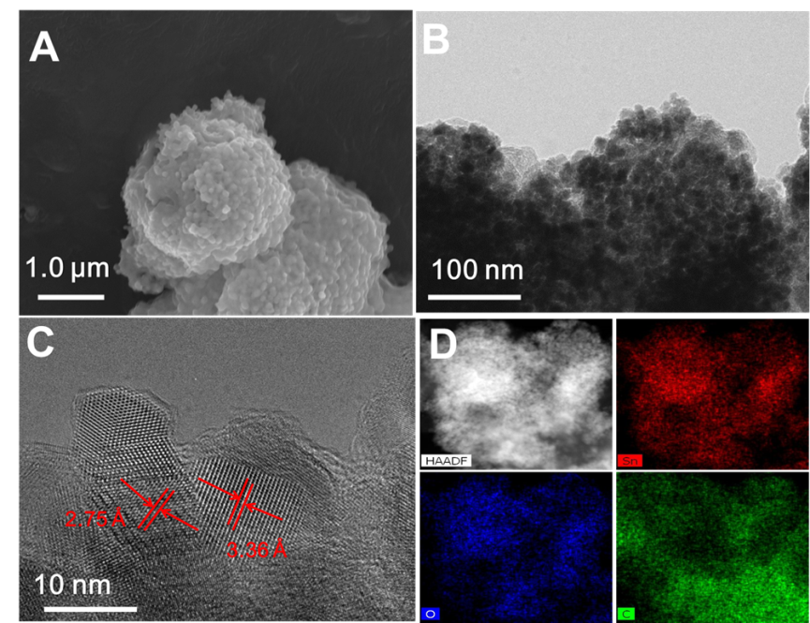

**Figure S14.** **a)** Ex-situ SEM, **b)** TEM, and **c)** HRTEMimages of the concentration gradient Sn/SnO2 microspheres after 900 cycles, respectively. **d)** Elemental mapping showing the distribution of Sn/SnO2.

Table S1. Summary of EIS fitting results.

|  |  |  |  |
| --- | --- | --- | --- |
|  | R1 (Ω) | R2 (Ω) | R3 (Ω) |
| SnO2 | 3.9 | 68.4 | 130.0 |
| Sn/SnO2 | 7 | 30 | 90.5 |