Supporting Information

Salt-Controlled Dissolution in Pigment Cathode for High-Capacity
and Long-Life Magnesium Organic Batteries
Lianmeng Cui, Limin Zhou, Kai Zhang, Fangyu Xiong, Shuangshuang Tan, Maosheng Li, Qinyou An*, Yong-Mook Kang, Liqiang Mai*

L. Cui, L. Zhou, F. Xiong, S. Tan, M. Li, Prof. Q. An, Prof. L. Mai
State Key Laboratory of Advanced Technology for Materials Synthesis and Processing, International School of Materials Science and Engineering, Wuhan University of Technology, Wuhan 430070, Hubei, P. R. China
E-mail: anqinyou86@whut.edu.cn (Q. An), mlq518@whut.edu.cn (L. Mai)
Dr. K. Zhang, Prof. Y.-M. Kang
Department of Energy and Materials Engineering, Dongguk University-Seoul, Seoul 04620, Republic of Korea

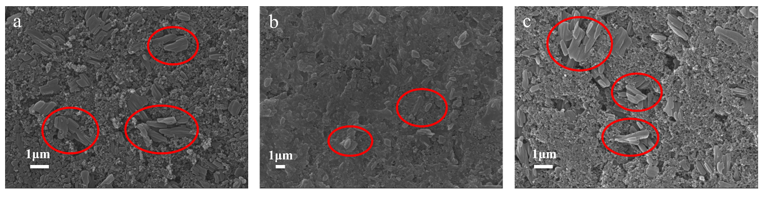
Fig. S1 Surface condition of PTCDA electrodes at (a) pristine and after soaking two days in (b) APC electrolyte and (c) APC electrolyte contains LiCl.

Fig. S2 FTIR spectrogram of PTCDA powder.

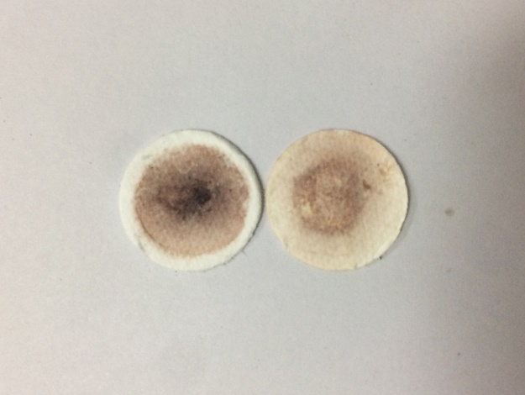

Fig. S3 Digital photograph of separators assembled in coin cells with different electrolytes, the left one is in APC electrolyte and the right one is APC electrolyte contains LiCl.

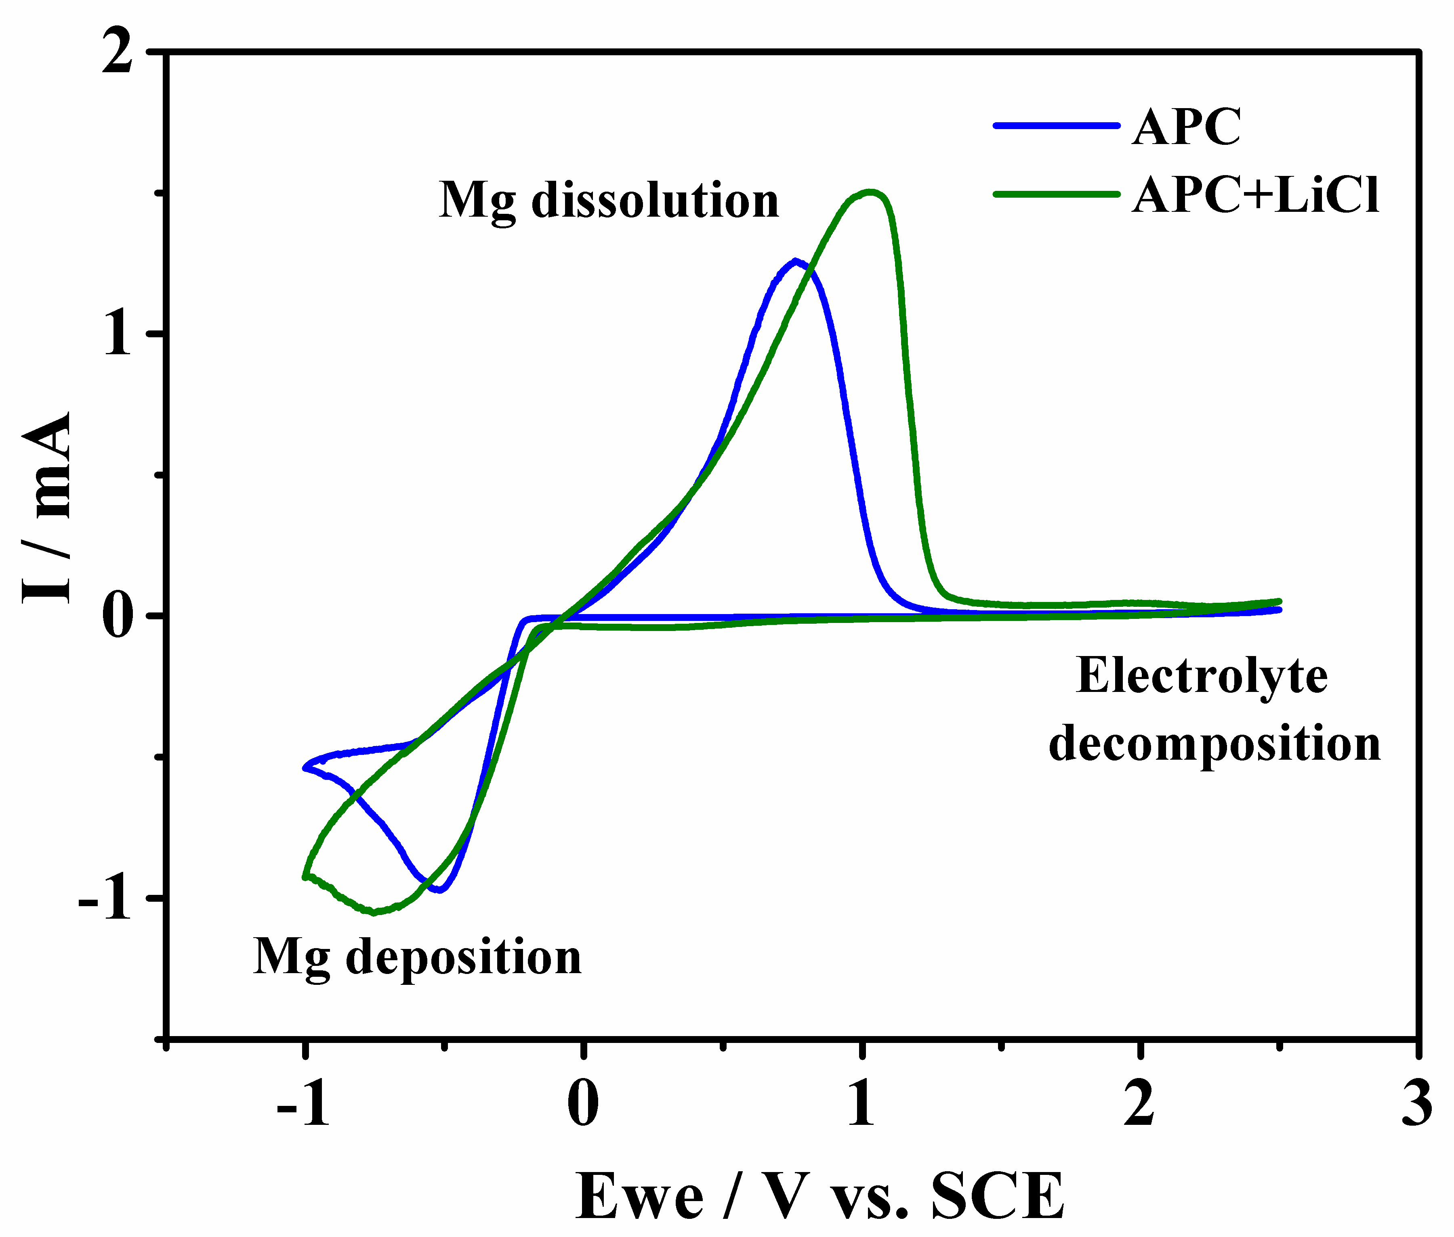
Fig. S4 Cyclic voltammetry (CV) curves of APC electrolyte with/without LiCl measurement at sweep rate of 100 mV s⁻¹ in the potential range of −1-2.5 V.

Fig. S5 The cycling stability profiles of PTCDA in APC electrolyte with/without LiCl, and the concentration of LiCl are 0.2 M, 0.5 M, 0.8 M and 1.5 M, respectively.

Fig. S6 The cyclic stability profiles of PTCDA in 0.4 M APC electrolyte.
Fig. S7 The discharge/charge plateau profiles of PTCDA in APC electrolyte with/without LiCl, and the concentration of LiCl are 0.2 M, 0.5 M, 0.8 M and 1.5 M, respectively.
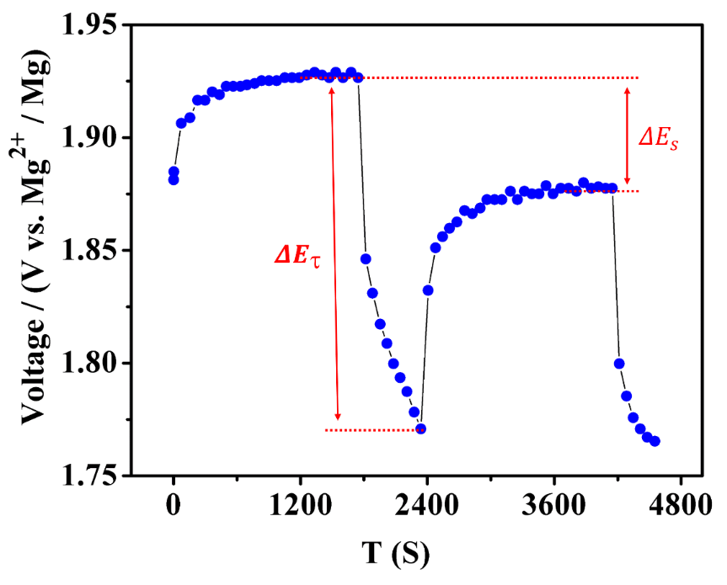
Fig. S8 GITT potential response curve with time. The GITT method consists of two parts. The first part is small current constant current pulse discharge. The second part is a long period of rest. Repeat the above process until the battery is fully discharged. And the charge process is opposite to the discharge process. ${ΔE}_{s}$ and $ΔE_{}$ are two important parameters, the calculation method as shown in illustration.
Fig. S9 Calculated activation energy to break the Mg-Cl bond from a MgCl⁺ unit.

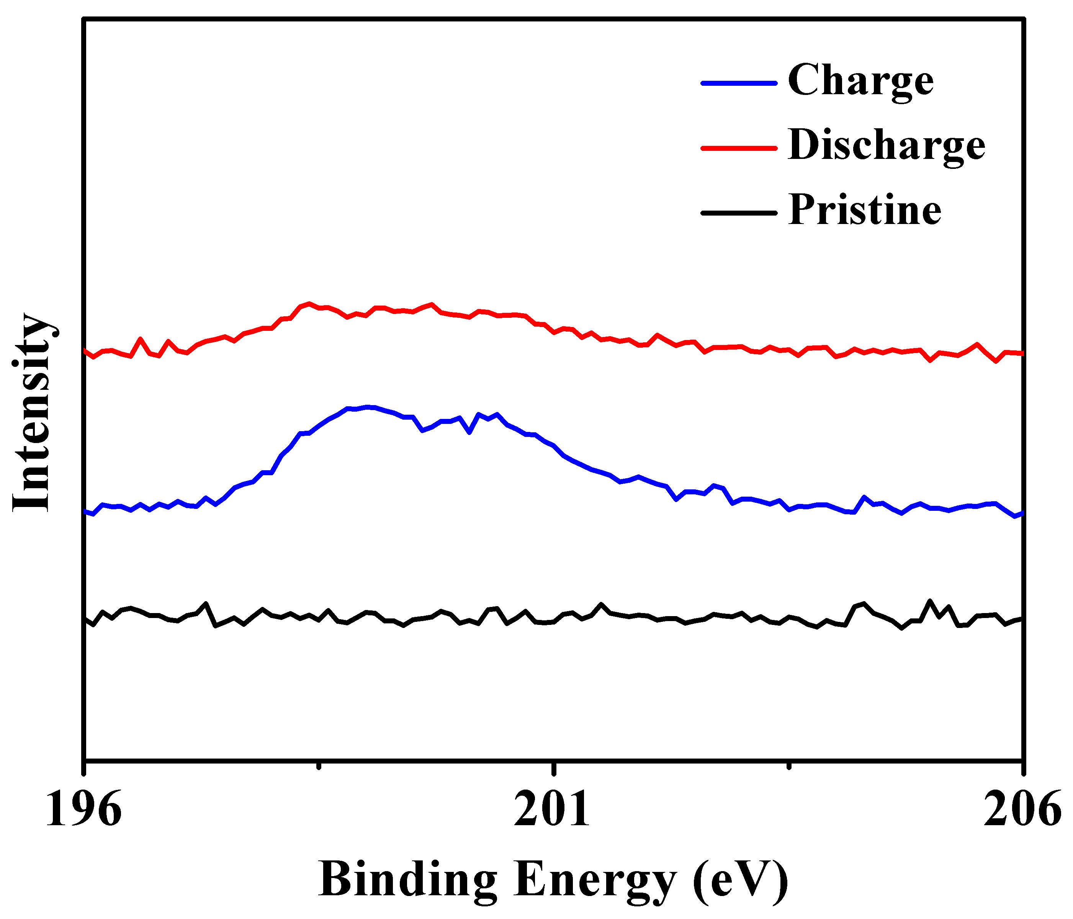
Fig. S10 The XPS spectra of Cl element of PTCDA electrodes at fully-charged (blue), fully-discharged (red) and pristine (black) states.

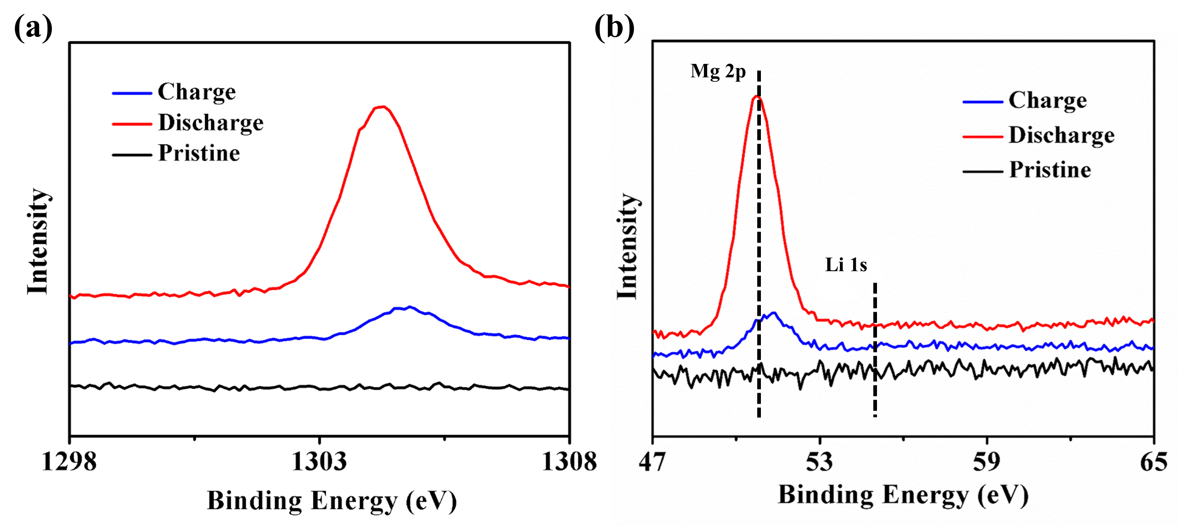
Fig. S11 The XPS spectra of (a) Mg and (b) Li elements of PTCDA electrodes at fully-charged (blue), fully-discharged (red) and pristine (black) states.
Table S1 The contents of Mg and Cl of PTCDA at different states based on XPS analysis.
Stage | XPS
 | Mg/ % | Cl/ %
Fully-charged state (2.5 V) | 0.08 | 0.05
Fully-discharged state (0.6 V) | 2.53 | 0.35

Table S2 The atom ratio between Mg and Li of PTCDA at different states based on ICP-OES analysis.
Stage | ICP-OES
 | Mg/Li ratio
Fully-charged state (2.5 V) | 4.32
Fully-discharged state (0.6 V) | 109.4

