Supporting Information for

Sisyphus effects in hydrogen electrochemistry on metal silicides enabled by silicene subunit edge
Zechao Zhuang^{a,1}, Yong Li^{b,1}, Jiazhao Huang^{a,1}, Zilan Liª, Kangning Zhaoª, Yunlong Zhao^{d}, Lin Xuª, Liang Zhouª, Lyudmila V. Moskaleva^{b,c,2}, Liqiang Mai^{a,2}

Supplementary Figures
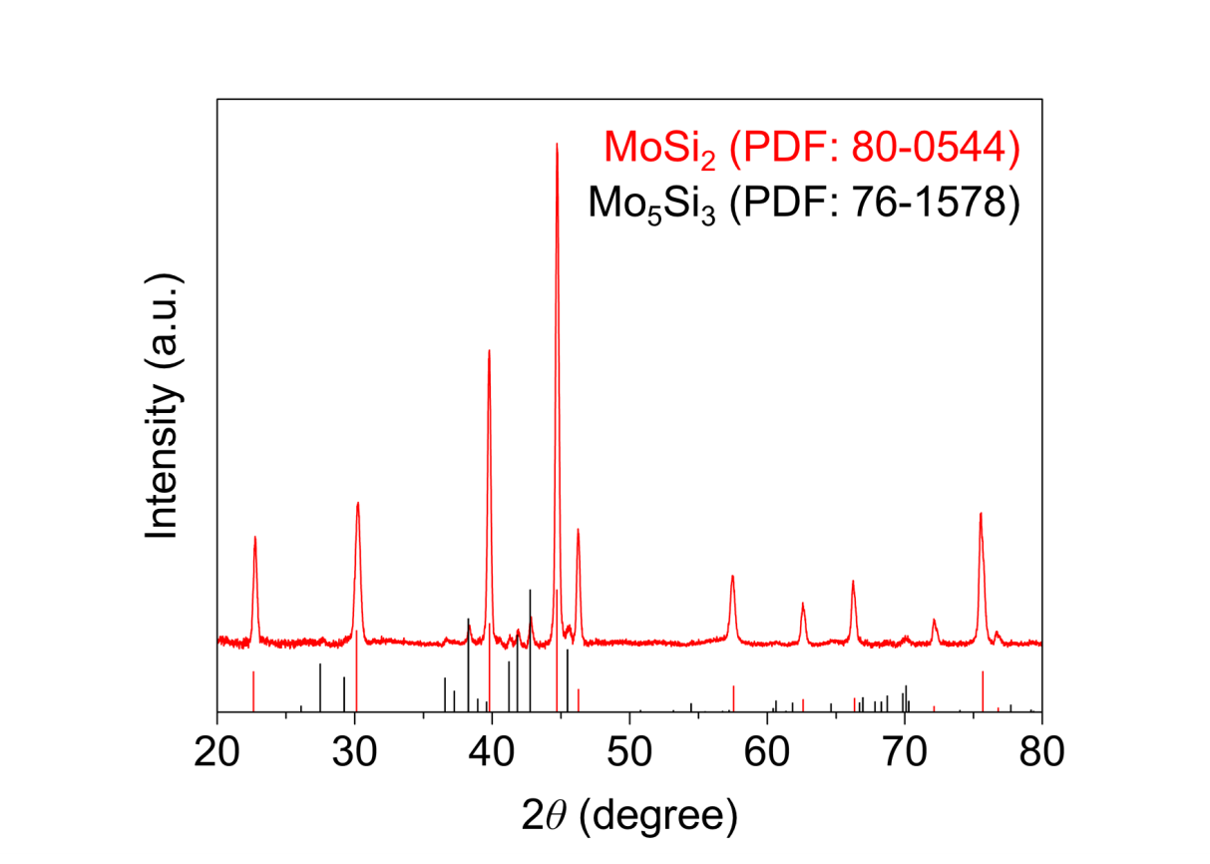
Figure S1. XRD pattern of commercial MoSi₂ powders.

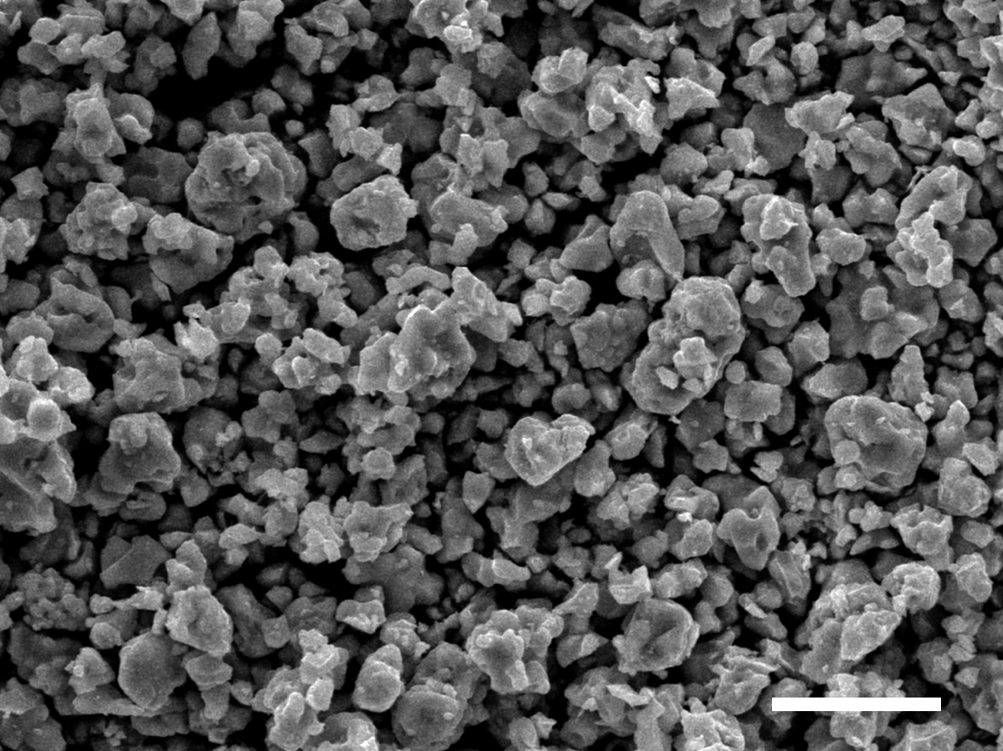
Figure S2. SEM image of commercial MoSi₂ powders. Scale bar: 10 μm.

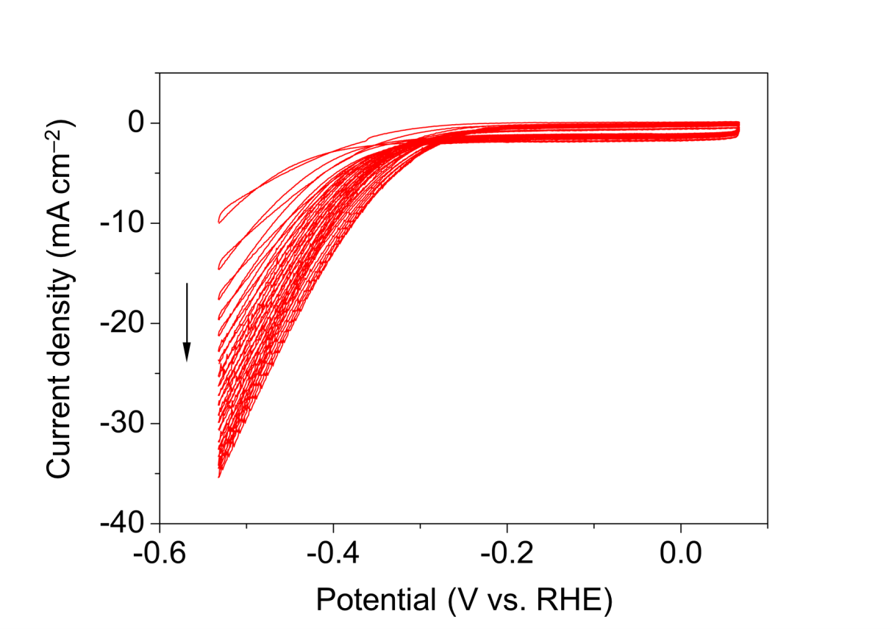
Figure S3. CVs of MoSi₂ in 1 M KOH for the second measurement.

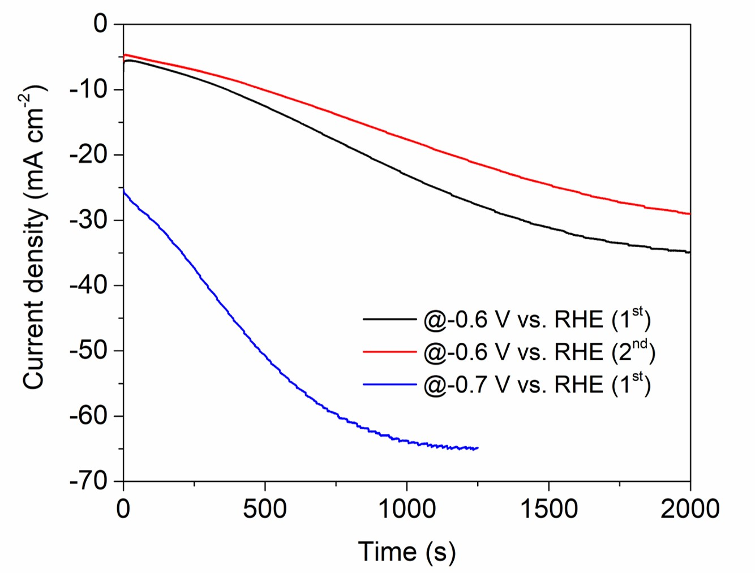
Figure S4. Chronoamperometric i–t curves of MoSi₂ at –0.6 and –0.7 V vs. RHE.

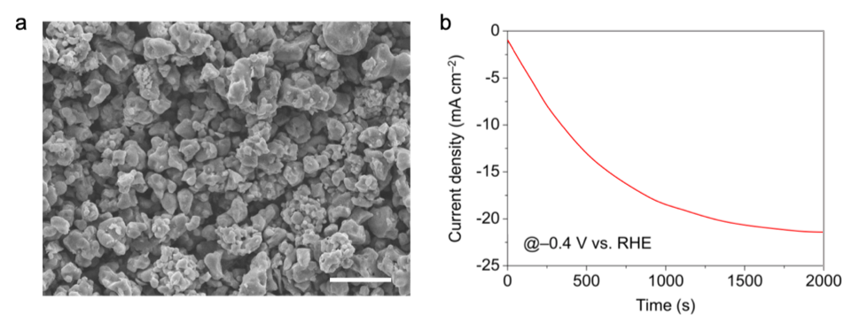
Figure S5. (a) SEM image of MoSi₂ after ball-milling and (b) its chronoamperometric i–t curve at –0.4 V vs. RHE in 1M KOH. Scale bar: 5 μm.

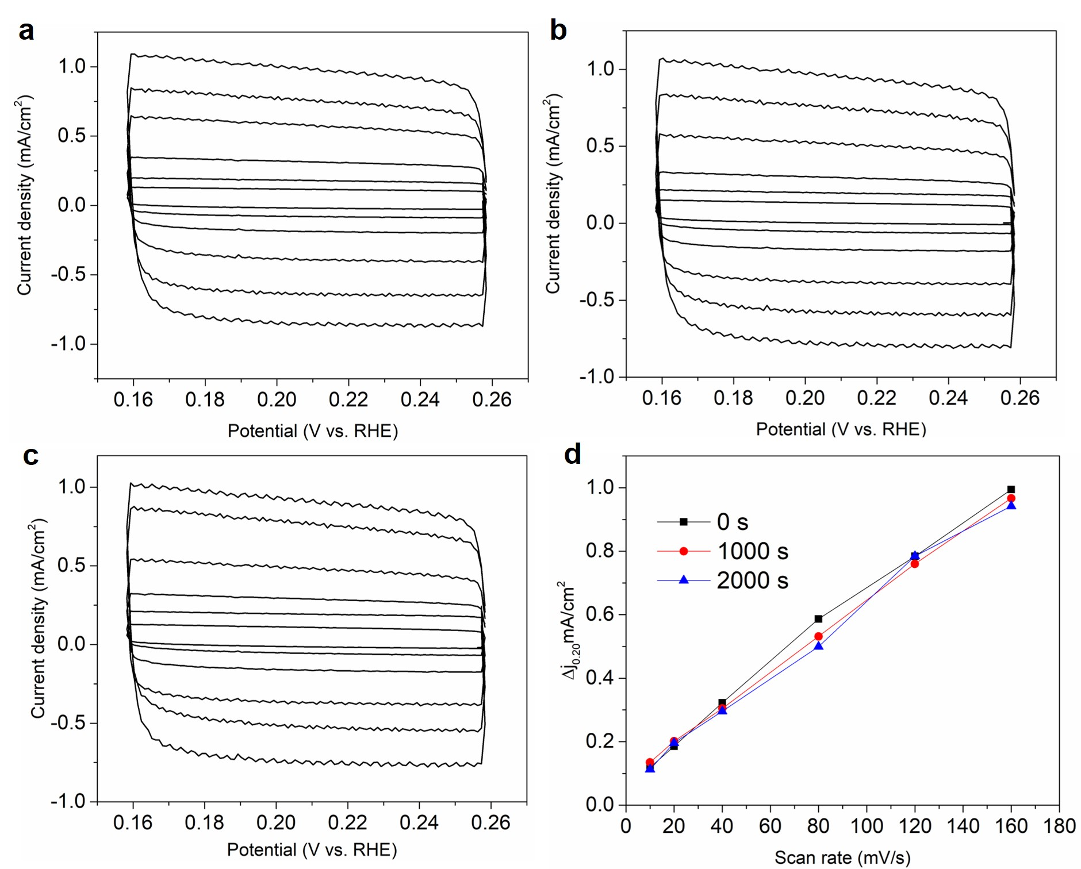
Figure S6. (a–c) CVs and (d) ECSAs of MoSi₂ under 0, 1 000, and 2 000 s activation.

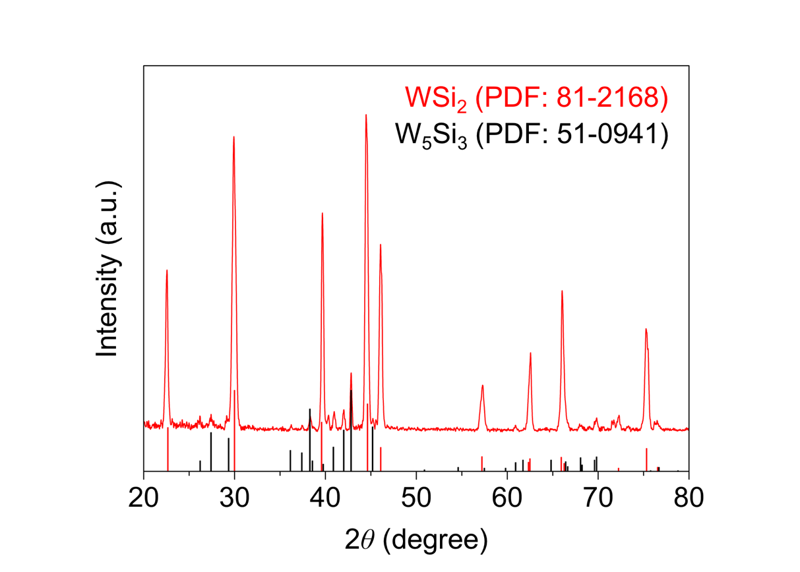
Figure S7. XRD pattern of commercial WSi₂ powders.

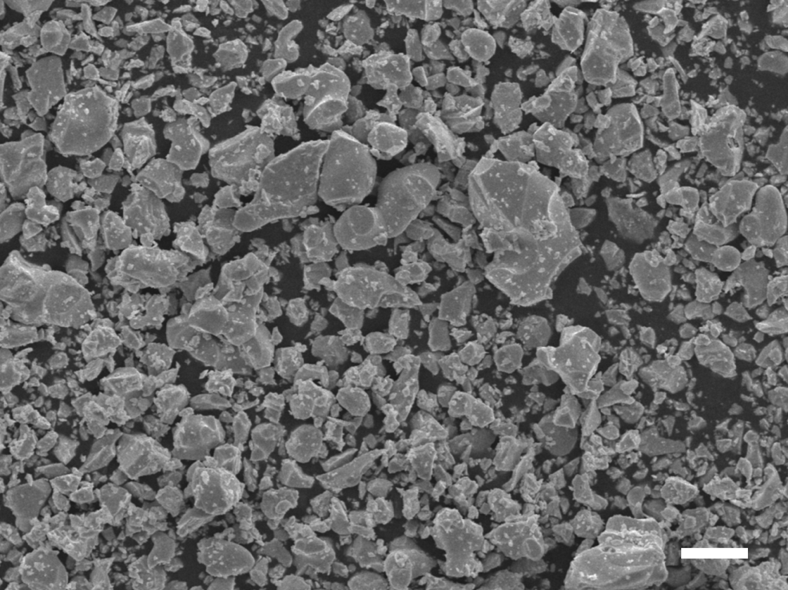
Figure S8. SEM image of commercial WSi₂ powders. Scale bar: 10 μm.

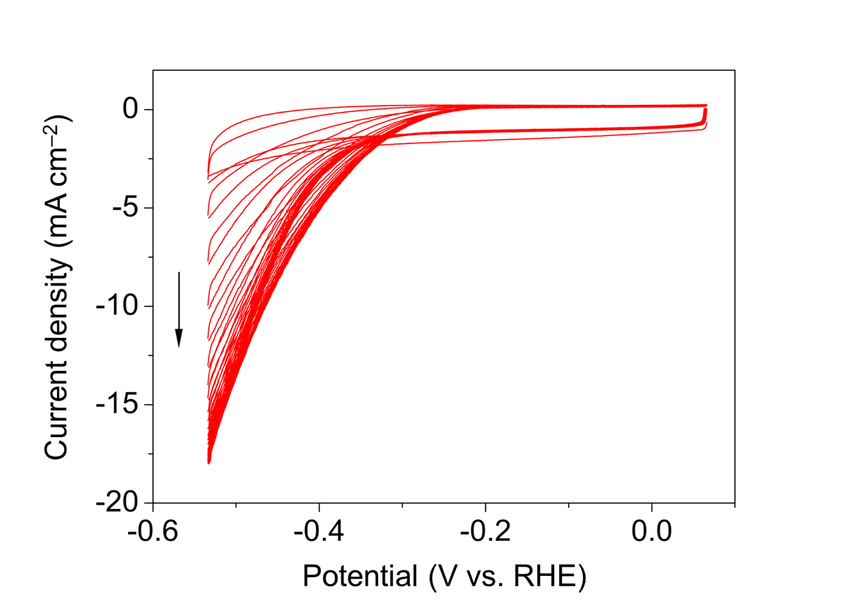
Figure S9. CVs of WSi₂ in 1 M KOH for the second measurement.

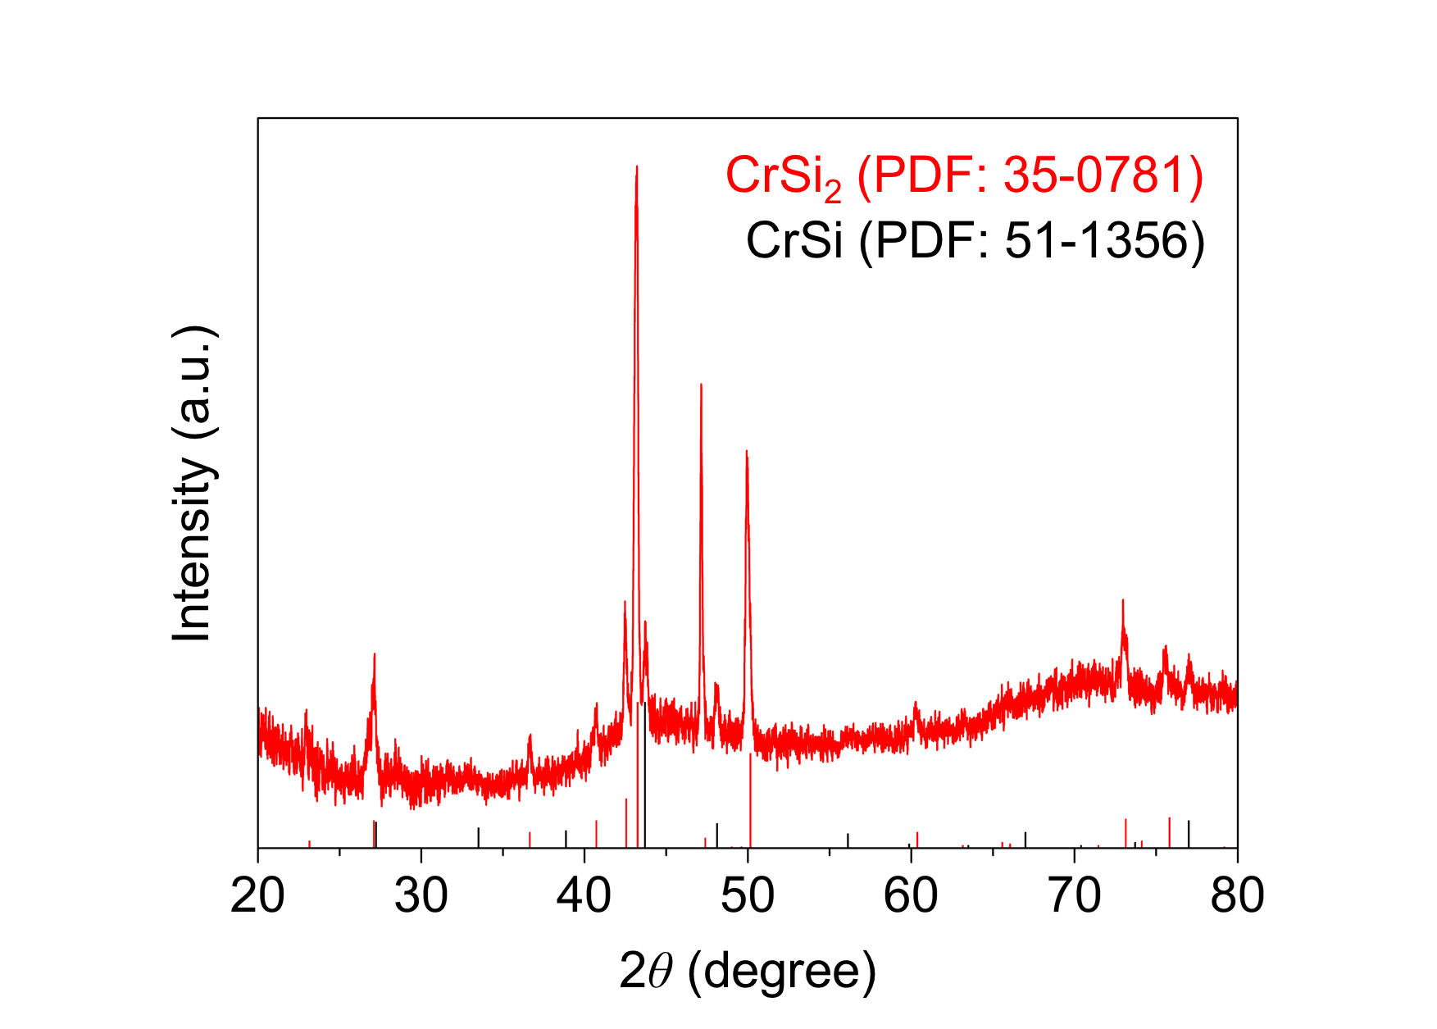
Figure S10. XRD pattern of commercial CrSi₂ powders.

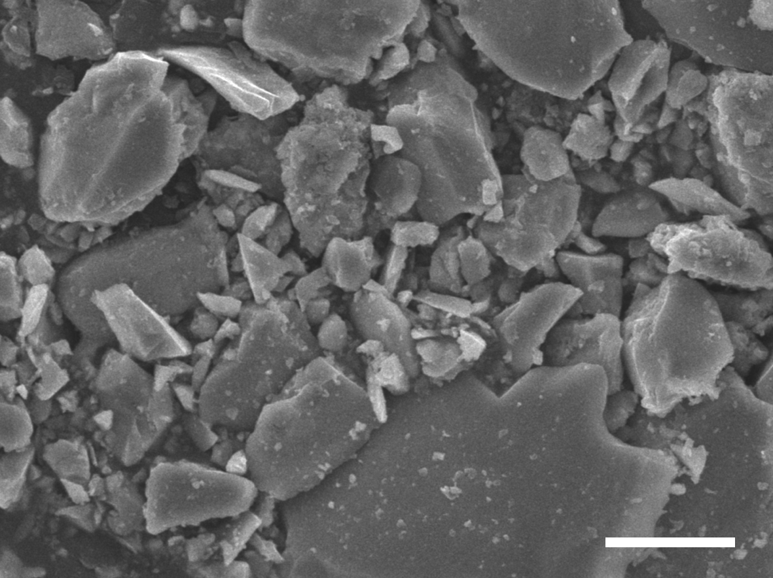
Figure S11. SEM image of commercial CrSi₂ powders. Scale bar: 10 μm.

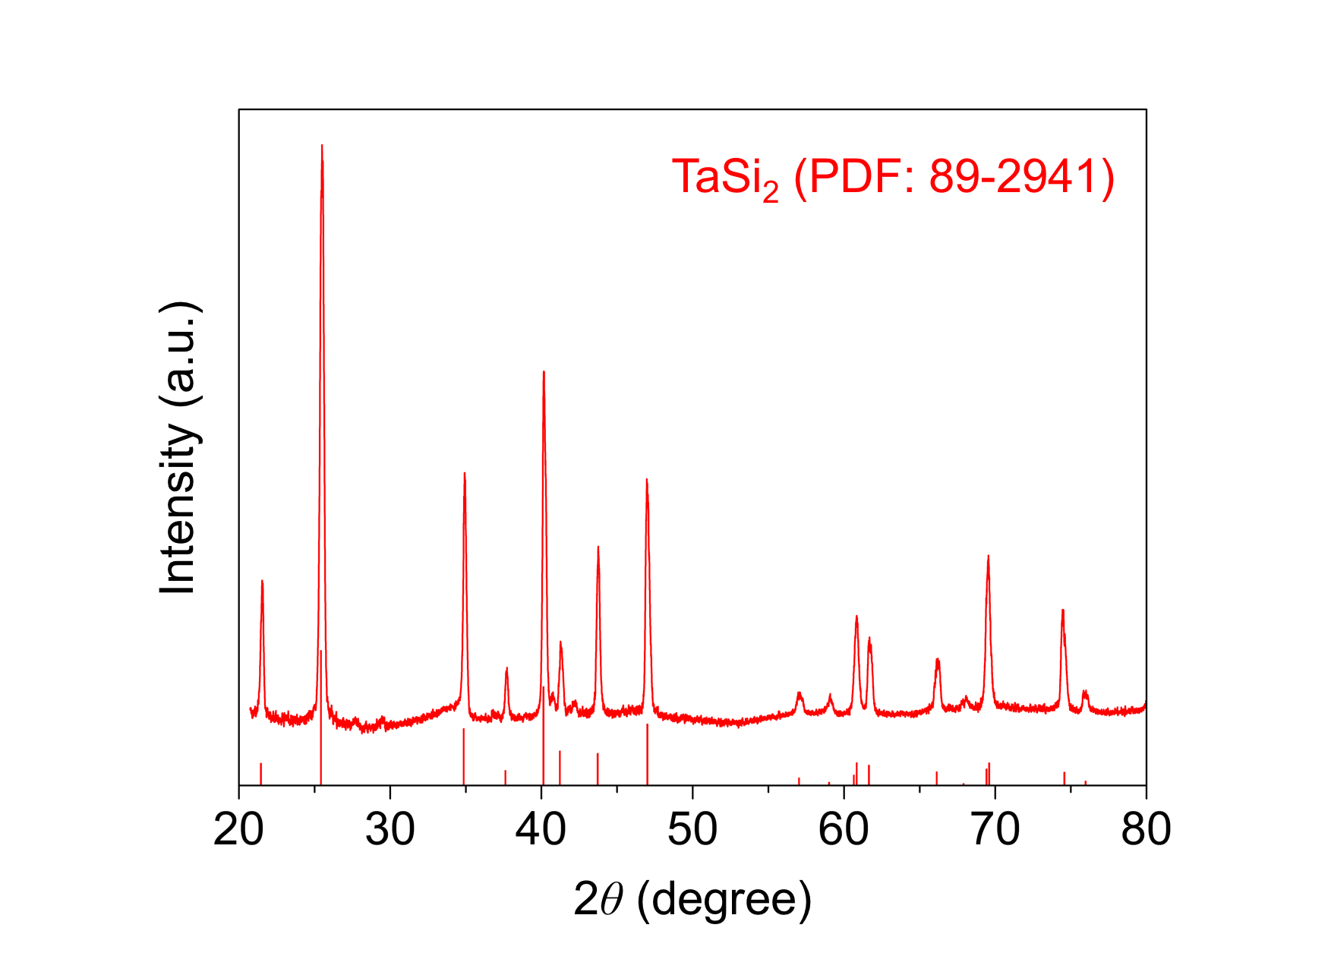
Figure S12. XRD pattern of commercial TaSi₂ powders.

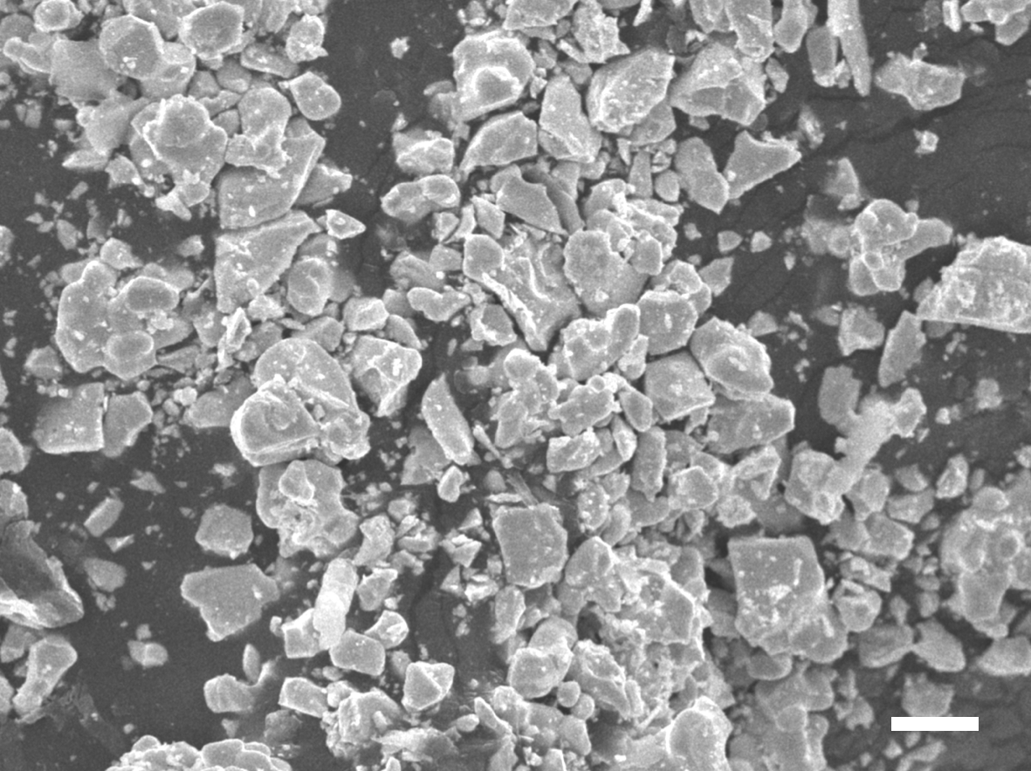
Figure S13. SEM image of commercial TaSi₂ powders. Scale bar: 10 μm.

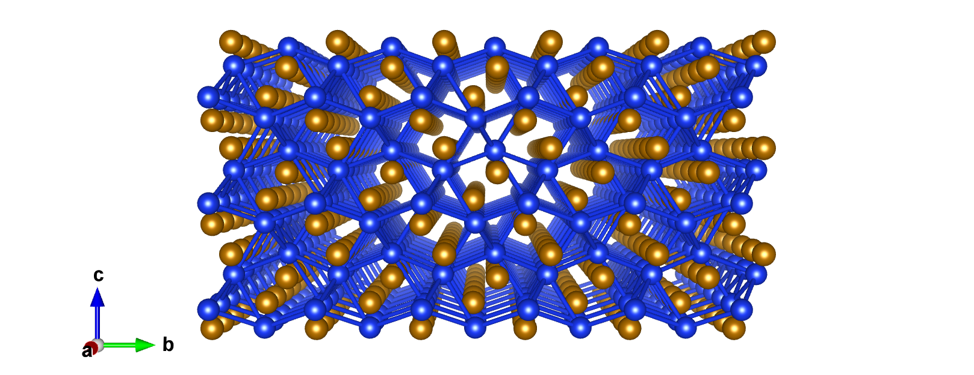
Figure S14. Crystal structure of FeSi.

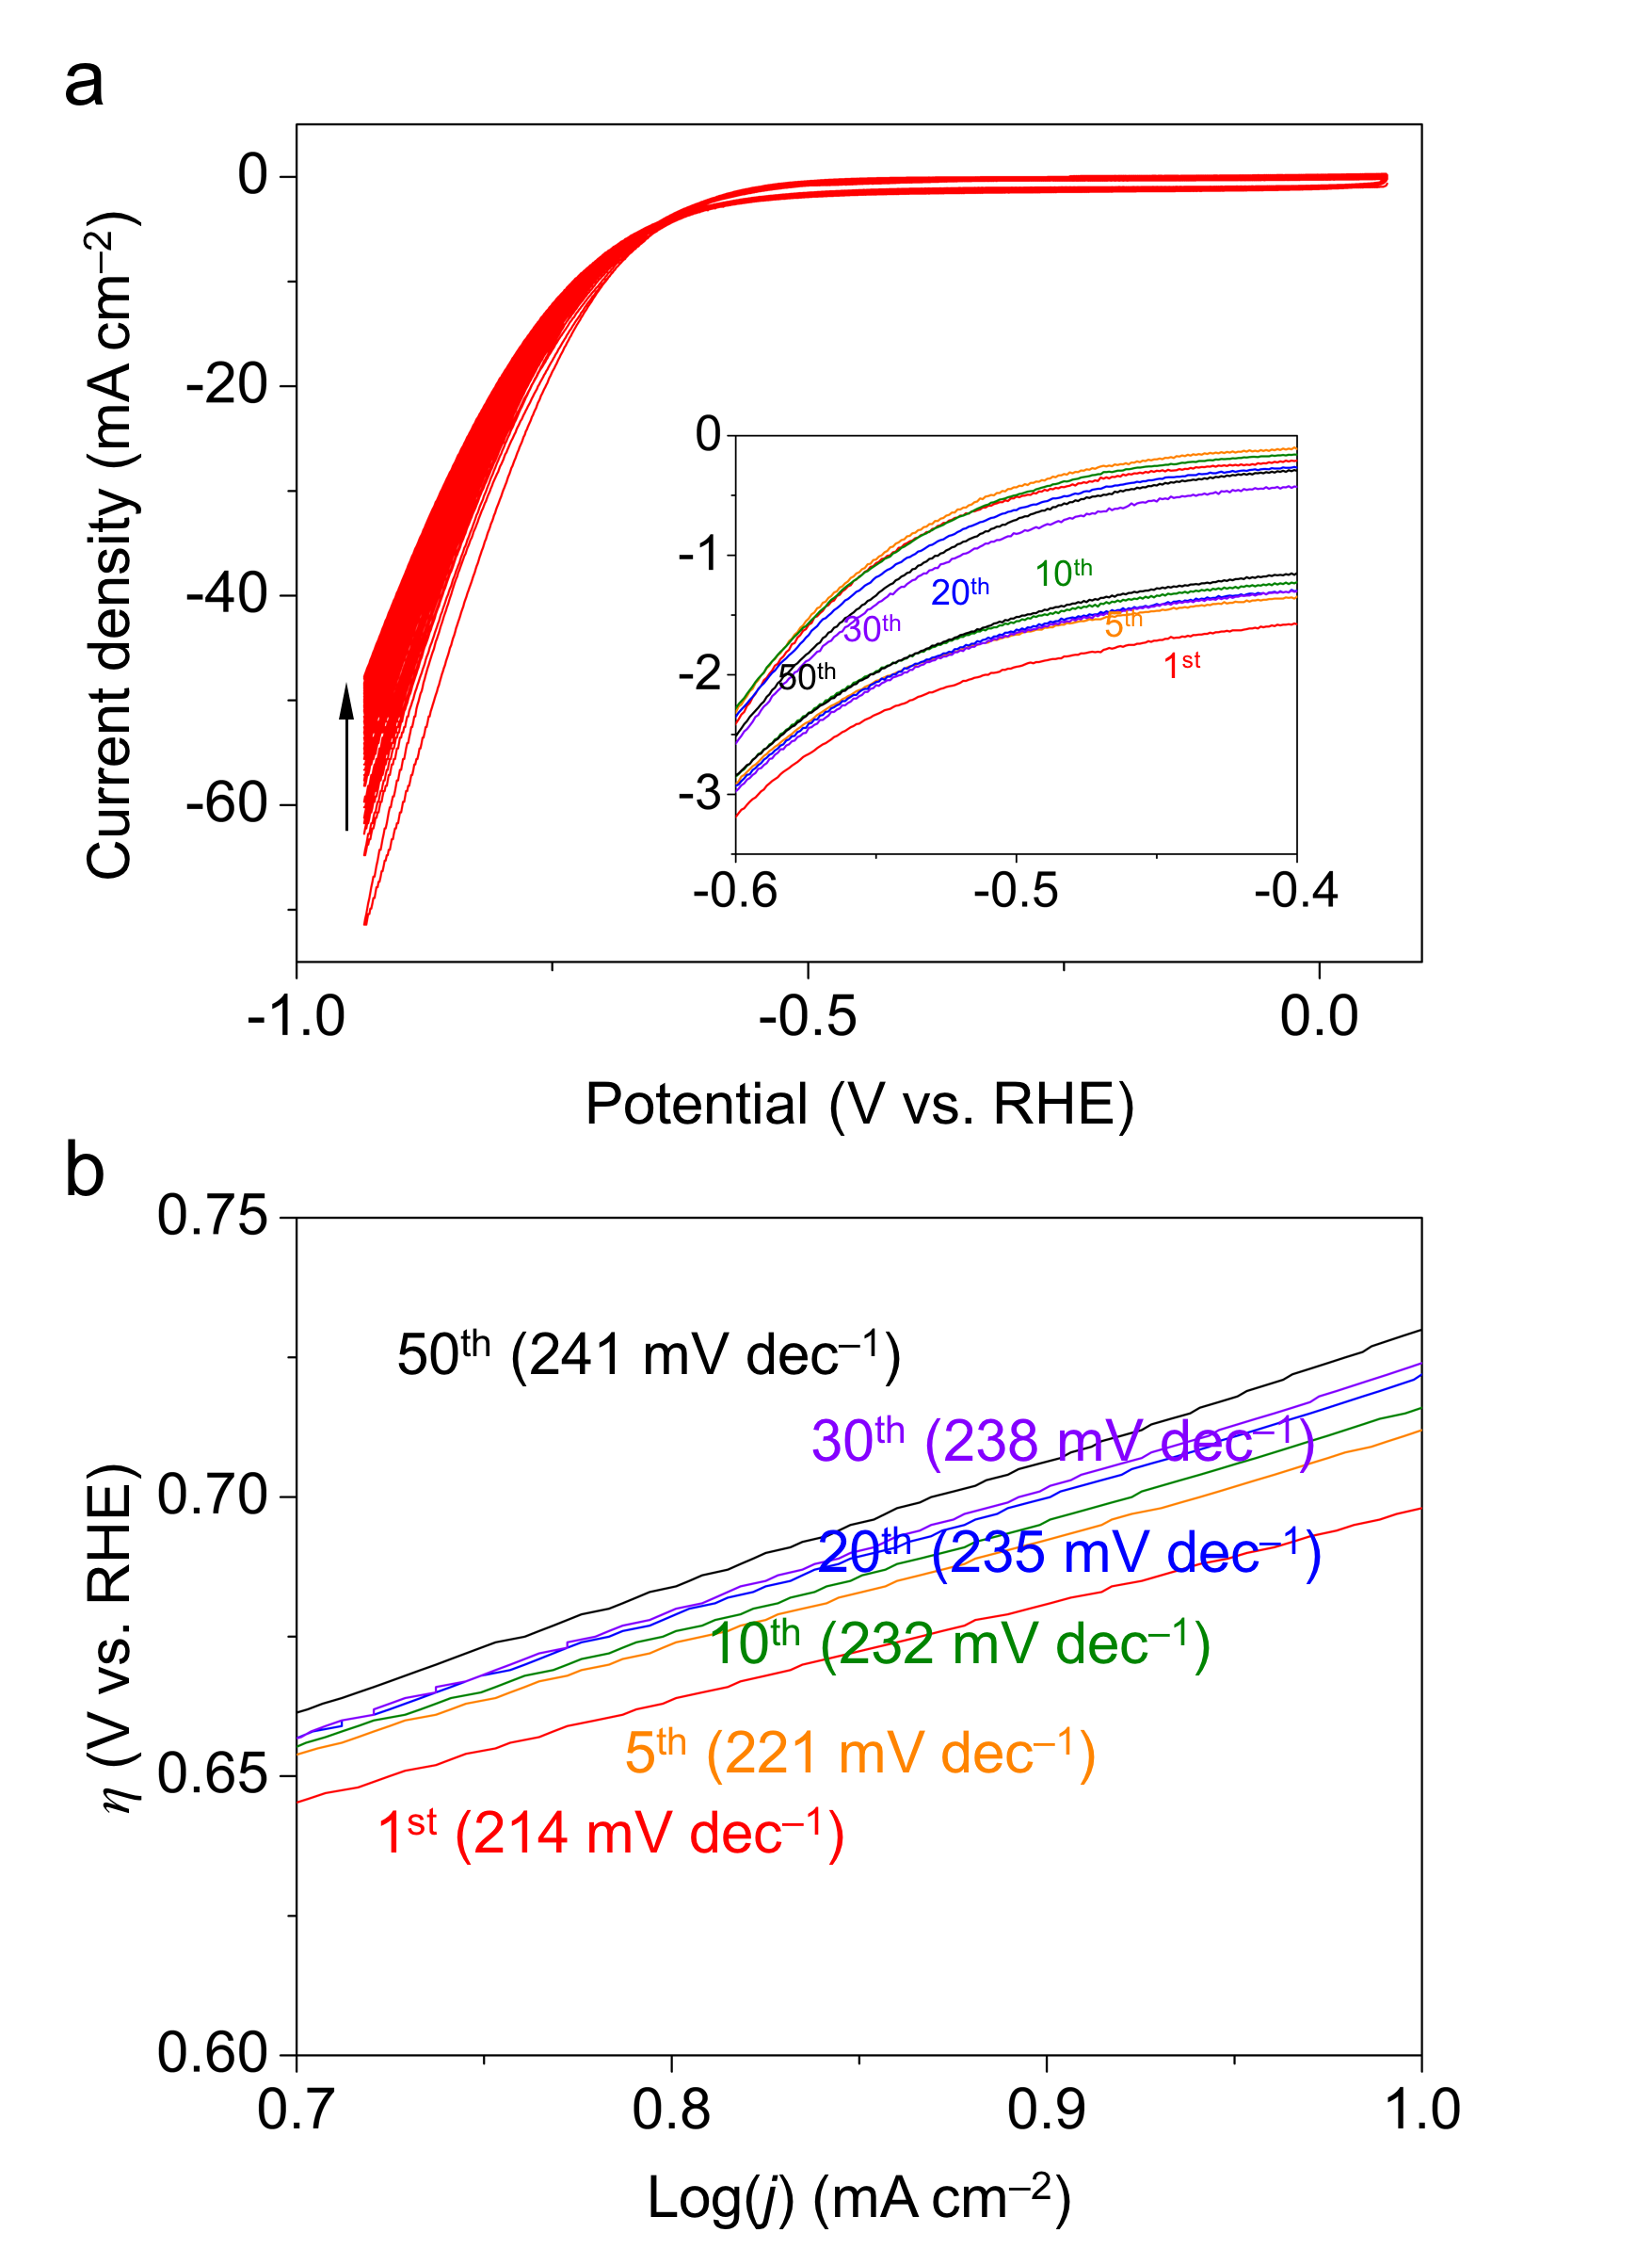
Figure S15. (a) CVs and (b) corresponding Tafel plots of FeSi in 1M KOH. Inset shows the corresponding enlarged view in (a).
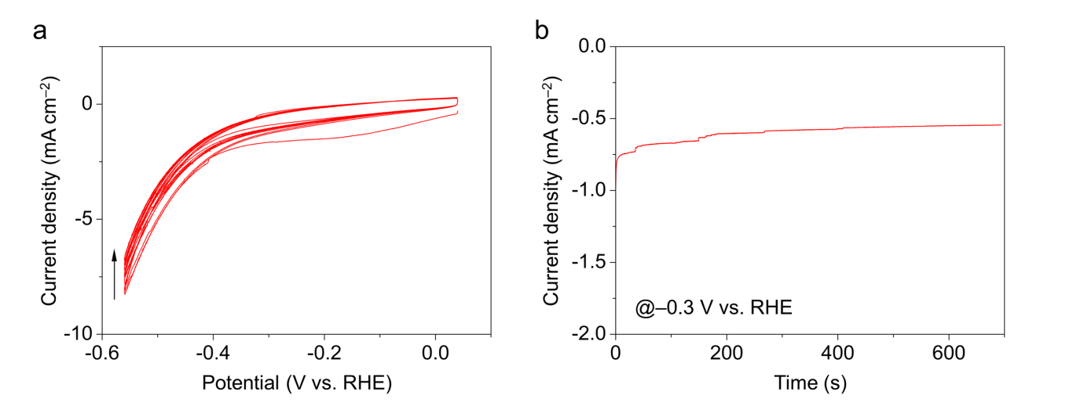
Figure S16. (a) CVs and (b) chronoamperometric i–t curve at –0.3 V vs. RHE of MoSi₂ in 0.5M H₂SO₄.

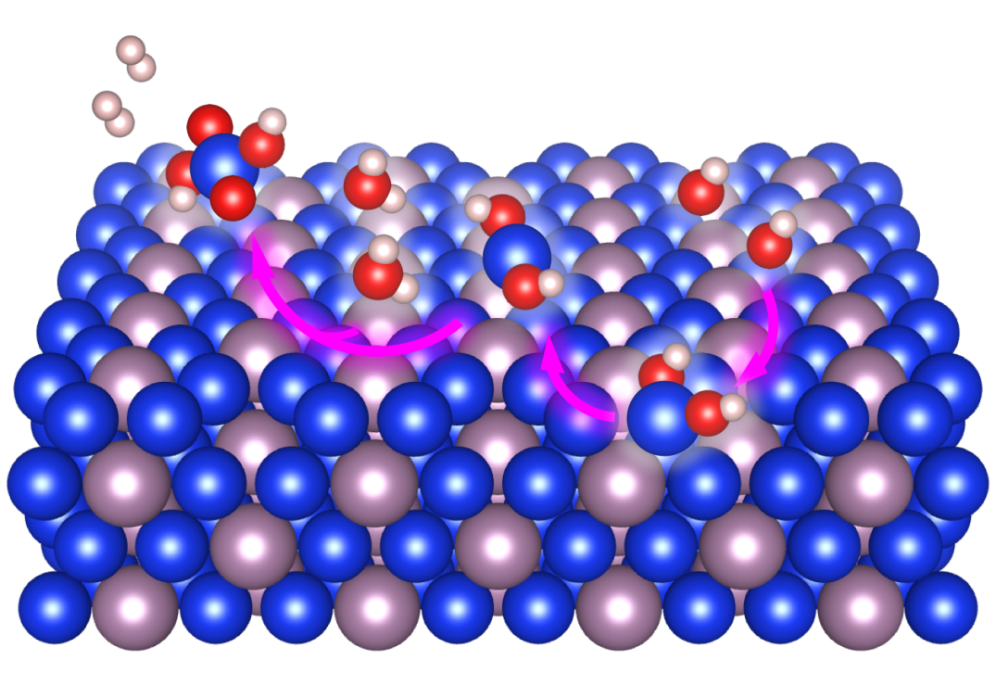
Figure S17. Schematic representation of the proposed reaction pathway for etching of silicene edges on MoSi₂ surface in alkaline solution.

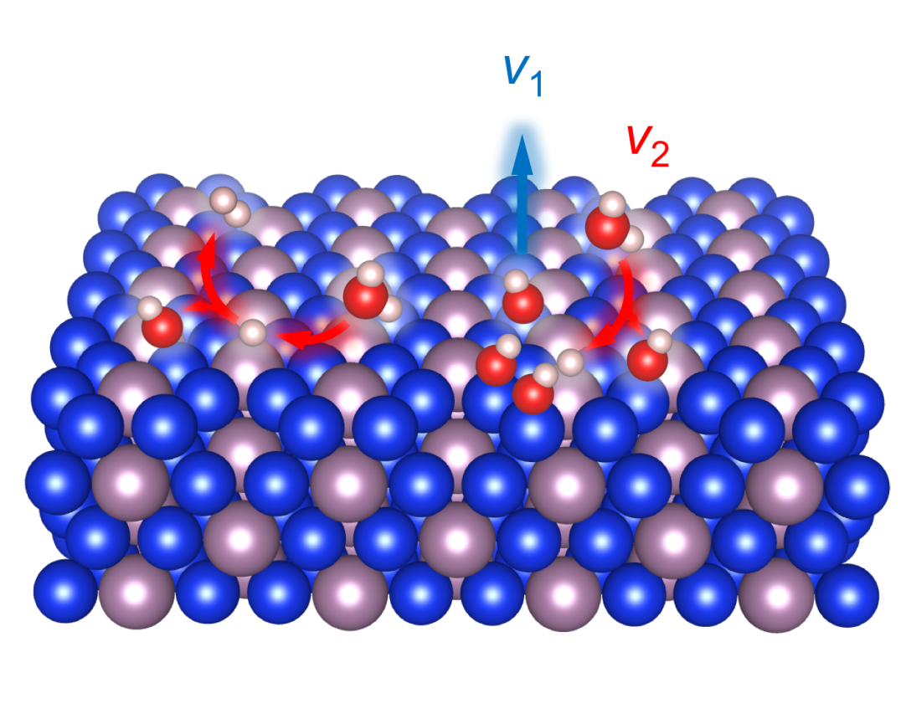
Figure S18. Schematic representation of the proposed two competing effects for cleavage (blue) and formation (red) of Si–OH bonds on MoSi₂ surface during alkaline HER.

Figure S19. (a) Side view and (b) top view of the optimized geometry of MoSi₂ (110).

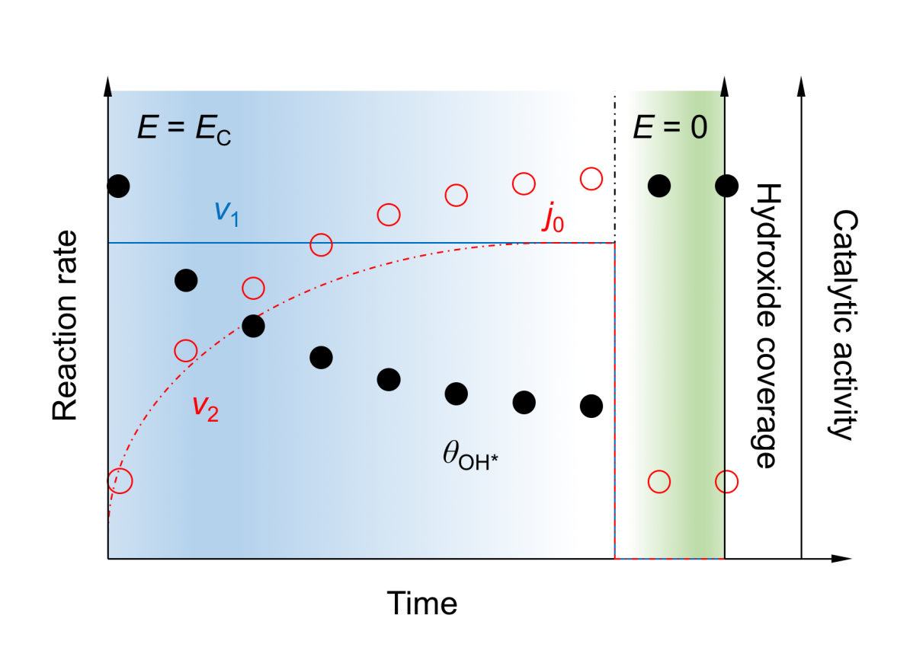
Figure S20. Schematic representation of the proposed reaction mechanism for anomalous HER on MoSi₂ surface in 1 M KOH.

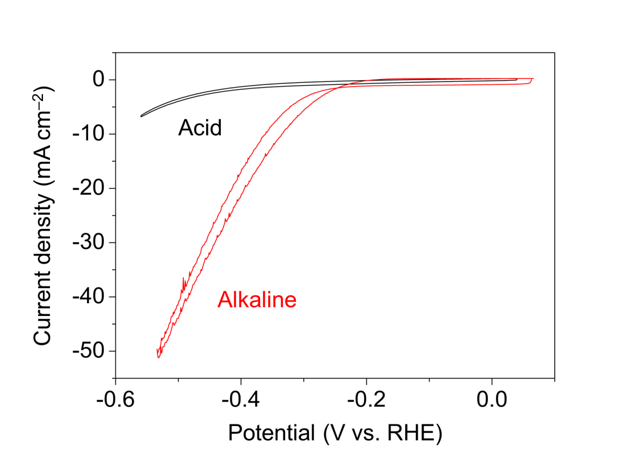

Figure S21. CVs of MoSi₂ in 1 M KOH and 0.5 M H₂SO₄.

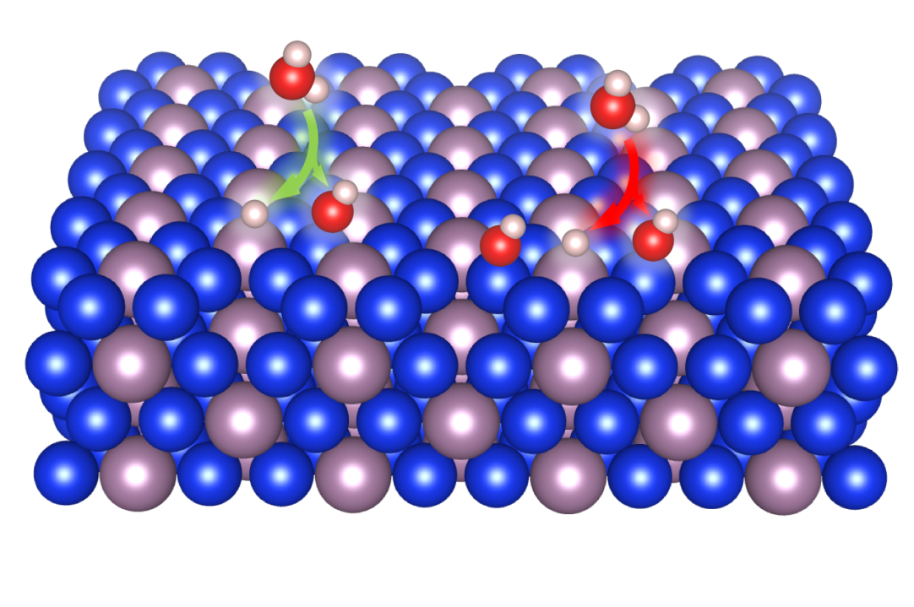
Figure S22. Schematic representation of the proposed positive (green) and negative (red) effects of Si–OH bonds on the water dissociation of alkaline HER process.

Table S1. Calculated composition of sample through a reference intensity ratio method.
 |  | MoSi₂ | Mo₅Si₃
RIR values |  | 6.48 | 4.23
Peak maximum |  | 100 | 3.7
Phases (wt.%) |  | 95 | 5

Table S2. Si concentration detected by ICP-OES on 1 M KOH before and after CV activation (ppm).
 |  | Before | After
GCE with MoSi₂ |  | 0.034 | 0.751
GCE without MoSi₂ |  | 0.032 | 0.046

Table S3. Effects of Si vacancy on energy difference between the Mo 4d and Si 2p-band centers in MoSi₂ surface.
Si-vacancy number | Mo 4d-band center | Si 2p-band center | Energy difference
0 | –0.76 eV | –1.97 eV | 1.21 eV
1 | –0.68 eV | –1.75 eV | 1.07 eV
2 | –0.59 eV | –1.59 eV | 1.00 eV

