Supporting Information

Scalable microfabrication of three-dimensional porous interconnected graphene scaffolds with carbon spheres for high-performance all carbon-based micro-supercapacitors

Yiming Chen ª, Minghao Guo ª, Liang He ^{a, b,} *, Wei Yang ª, Lin Xu ª, Jiashen Meng ª, Xiaocong Tian ^{a, c}, Xinyu Ma ª, Qiang Yu ª, Kaichun Yang ^{d}, Xufeng Hong ª, Liqiang Mai ^{a,} *

ª State Key Laboratory of Advanced Technology for Materials Synthesis and Processing, International School of Materials Science and Engineering, Wuhan University of Technology, Wuhan 430070, P. R. China.

^{b} Department of Materials Science and NanoEngineering, Rice University, Houston, TX 77005, United States.

^{c} Faculty of Materials Science & Chemistry, China University of Geosciences, Wuhan 430074, P. R. China.

^{d} Department of Civil Engineering, Rice University, Houston, TX 77005, United States.

* E-mail: hel@whut.edu.cn; mlq518@whut.edu.cn

Keywords: three-dimensional, injecting, freeze-drying, mass loading, supercapacitor

The preparation of GO dispersion
The modified Hummer’s method was used in this work. Firstly, 1 g graphite was mixed with 23 mL concentrated sulfuric acid (in 250 mL conical flask) and stirred for 24 h at room temperature. Afterwards, under water bath at 40 ^{ο}C, 100 mg NaNO₃ was added and stirred for 5 min to ensure its total dissolution. Then, 2 g KMnO₄ was added with a low speed (the temperature was kept below 45 ^{ο}C in a period of 5-10 min) and stirred for 30 min. 3 mL deionized (DI) water was added and after 5 min, 3 mL DI water was added again. After delaying for 5 min, 40 mL DI water was added and stirred for 15 min. After water bath, 140 mL DI water and 10 mL H₂O₂ (30%) were added and stirred for 5 min at room temperature to complete the reaction. Then, the mixture was centrifuged, the obtained sediment was washed with 5% hydrochloric acid for 2 times and DI water for 8-10 times (centrifugation under 10000 rpm). The obtained sediment was dispersed into 100 mL DI water, followed by ultrasonication for 60 min (keep the liquid level as the same). Last, the above dispersion was centrifuged at 5000 rpm for 5 min and the supernate was reserved. The supernate was centrifuged repeatedly until no sediment was obtained and graphene oxide dispersion was finally prepared.
The linear fitting about the low frequency region in EIS curves
The diffusion coefficient $D$ of ions in the porous micro-electrode can be calculated according to the following equation:
$D=\frac{R^{2}T^{2}}{2A^{2}n^{4}F^{4}C^{2}σ^{2}}$ (1)
$Z^{'}=R_{D}+R_{L}+σω^{-1/2}$ (2)
where R is the gas constant, and T is the absolute temperature. A is the surface area of the micro-electrode, and n is the number of electrons during adsorption/desorption. F is the Faraday constant, and $C$ is the concentration of the electrolyte ions. $σ$ is the Warburg factor. It is obvious that the diffusion coefficient $D$ is inversely proportional to the square value of $σ$.

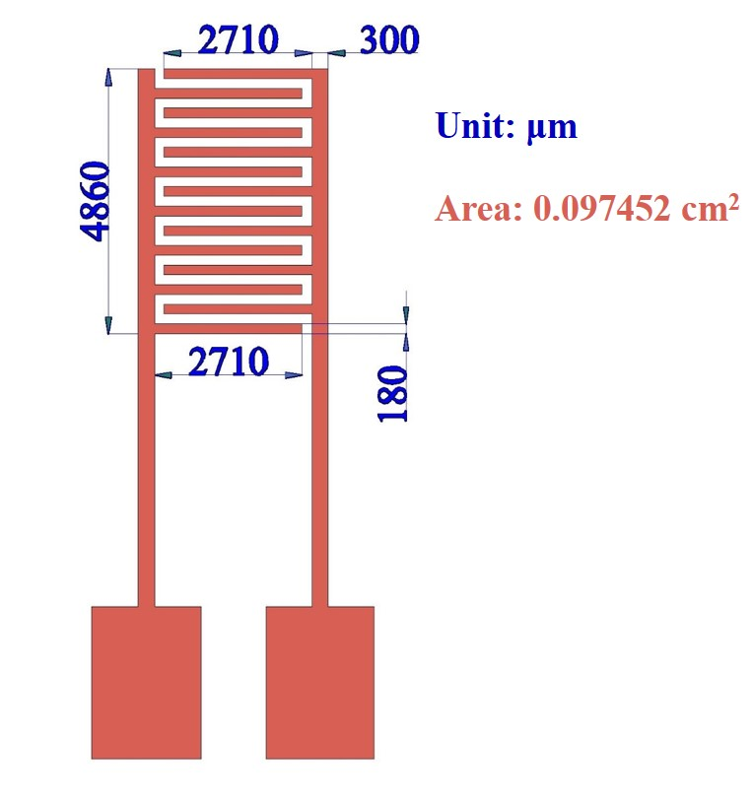
Figure S1. The schematic illustration of the detailed size of micro-supercapacitors.

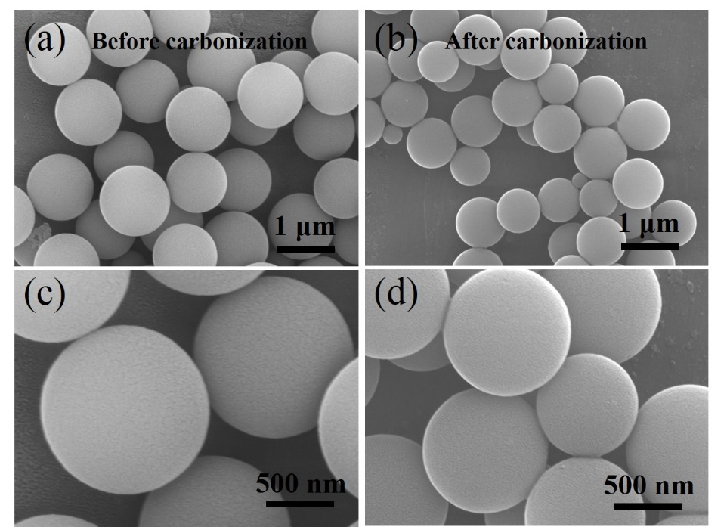

Figure S2. SEM images of the CSs a, c) before and b, d) after carbonization.

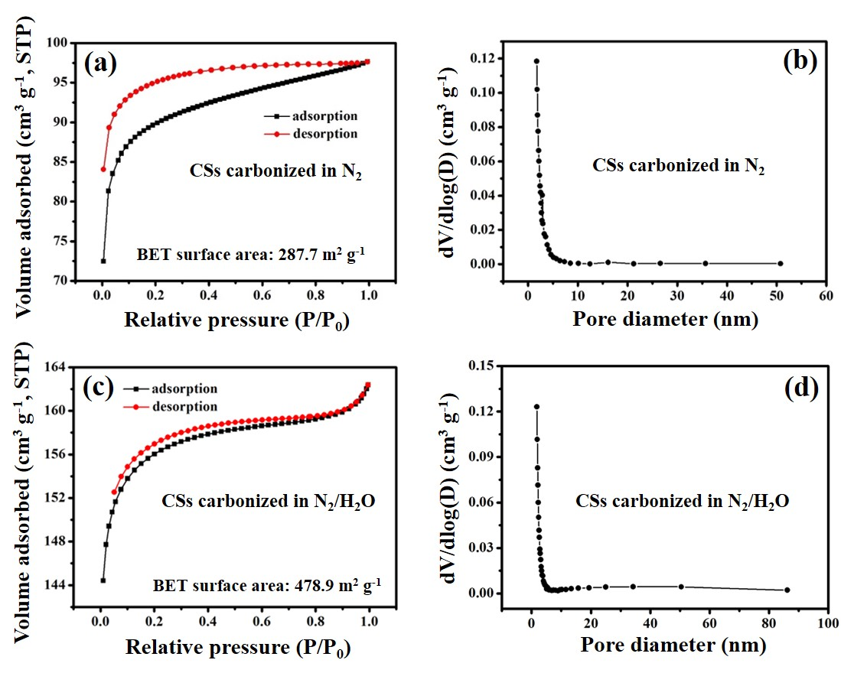

Figure S3. Nitrogen adsorption-desorption isotherms of carbon spheres annealed in a) N₂ and c) N₂/H₂O. Pore size distributions of carbon spheres annealed in b) N₂ and d) N₂/H₂O.

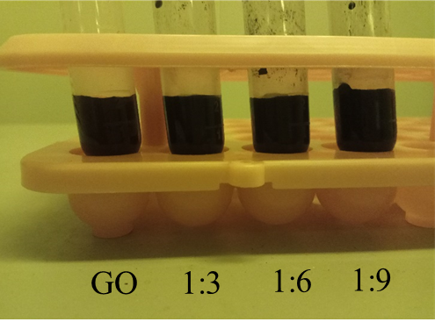

Figure S4. Digital photographs of GO dispersion and GO/CSs dispersion at the mass ratios of 1:3, 1:6 and 1:9.
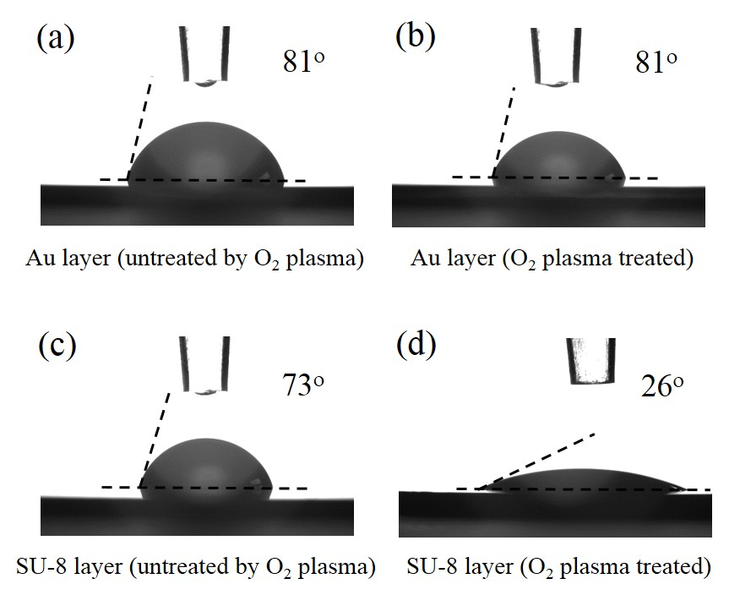
Figure S5. Contact angle test results of a) Au layer (untreated by O₂ plasma), b) Au layer (O₂ plasma treated), c) SU-8 layer (untreated by O₂ plasma) and d) SU-8 layer (O₂ plasma treated).

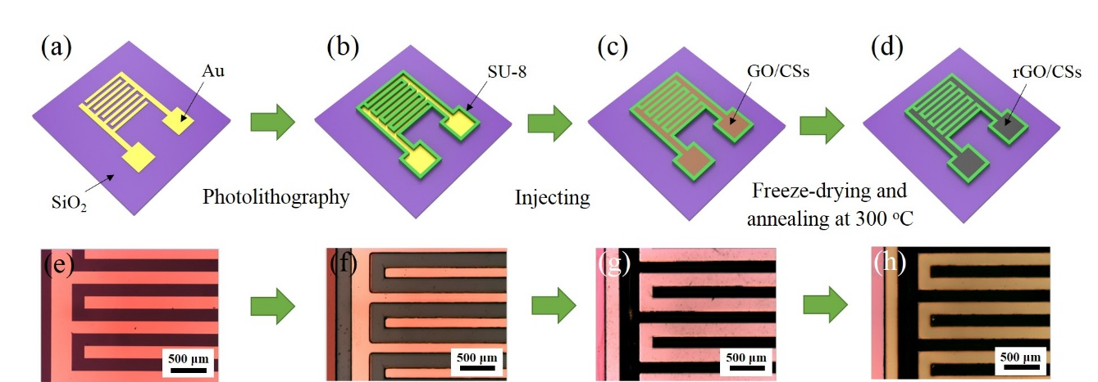

Figure S6. Schematic illustration of the microfabrication process and corresponding optical microscope images.
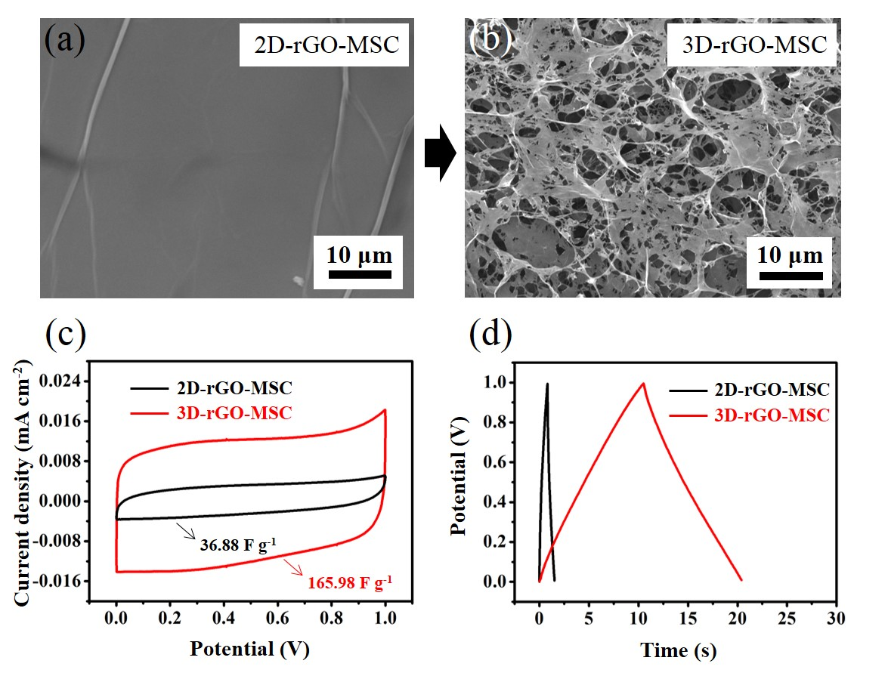
Figure S7. a, b) SEM images of the micro-electrodes in 2D-rGO-MSC and 3D-rGO-MSC. c) CV curves of 2D-rGO-MSC and 3D-rGO-MSC at the scan rate of 10 mV s⁻¹ with a potential window from 0 to 1 V. d) GCD curves of 2D-rGO-MSC and 3D-rGO-MSC at the current density of 0.1 mA cm⁻² with a potential window from 0 to 1 V.

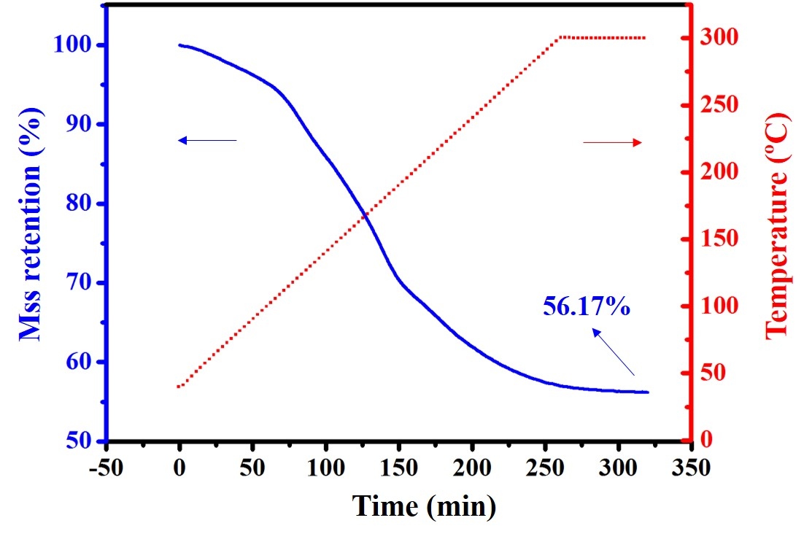
Figure S8. TG analysis of GO from 40 to 300 ^{ο}C (heating rate: 1 ^{ο}C min⁻¹) and the temperature was maintained at 300 ^{ο}C for 1 h.

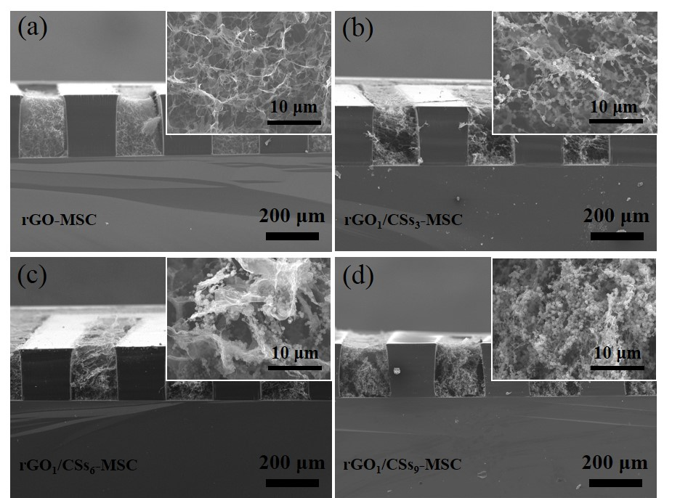
Figure S9. The cross sectional SEM images of a) rGO-MSC, b) rGO₁/CSs₃-MSC, c) rGO₁/CSs₆-MSC and d) rGO₁/CSs₉-MSC. The insert images (high magnification) show their micro-structure of cross sections of the micro-electrodes.

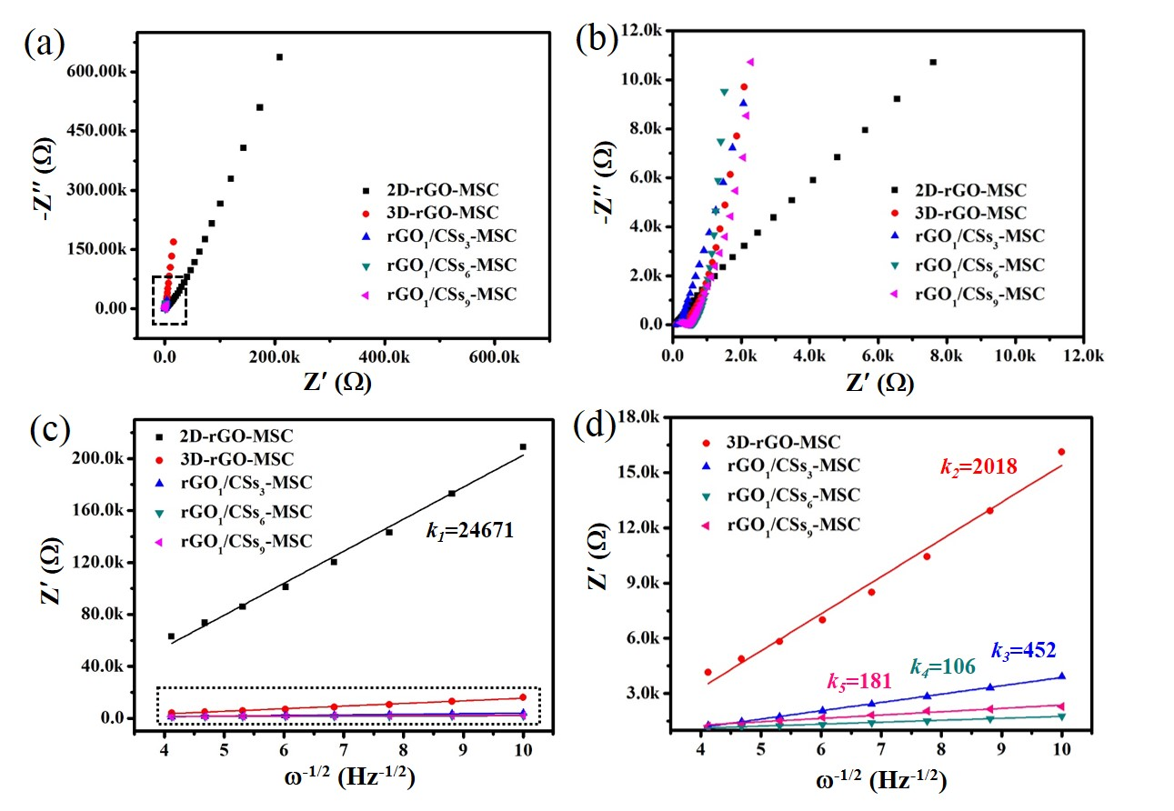
Figure S10. a, b) Nyquist plots at the frequency of 0.01-500000 Hz and c, d) linear fitting between Z′ and ω^{-1/2} of 2D-rGO-MSC, 3D-rGO-MSC, rGO₁/CSs₃-MSC, rGO₁/CSs₆-MSC and rGO₁/CSs₉-MSC.

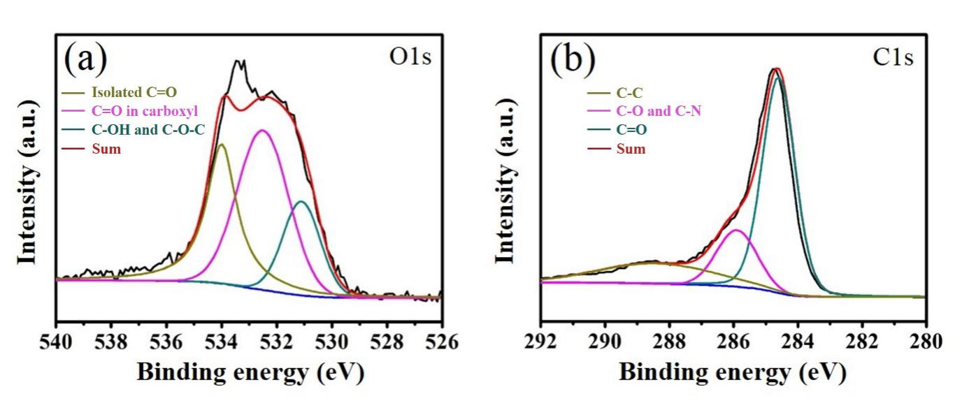
Figure S11. High-resolution XPS survey spectra a) O 1s and b) C 1s of rGO₁/CSs₉-MSC electrode.

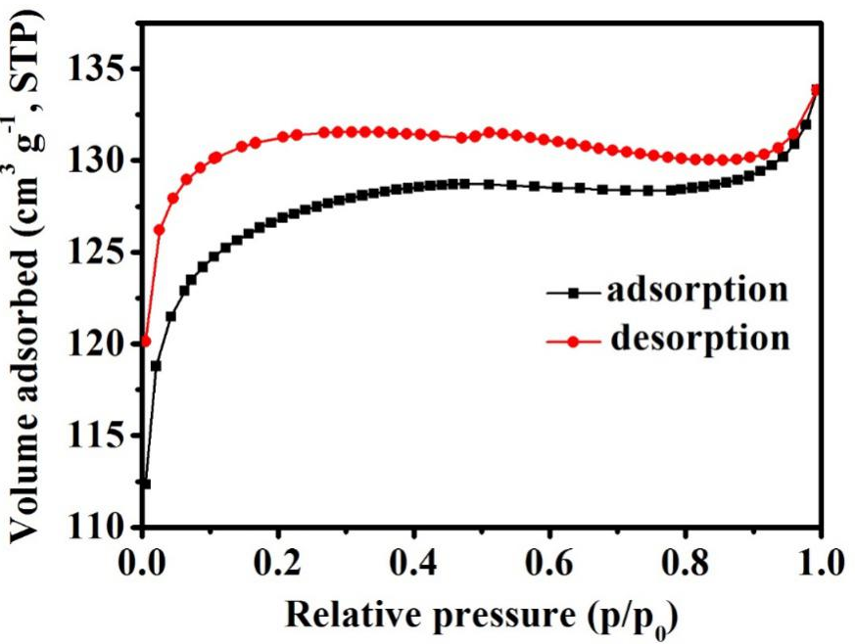
Figure S12. Nitrogen adsorption-desorption isothermals of rGO₁/CSs₉-MSC electrode.

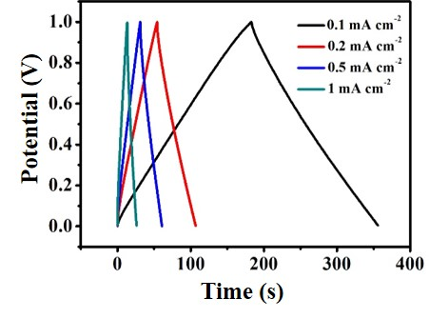
Figure S13. GCD curves of rGO₁/CSs₉-MSC at different current densities with a potential window from 0 to 1 V.

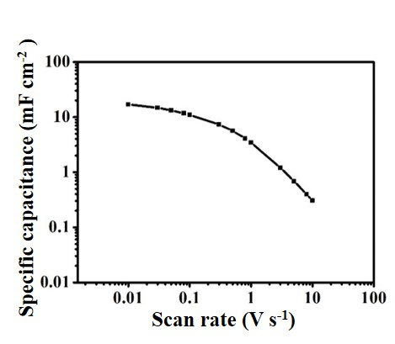
Figure S14. Evolution of capacitances at different scan rates.

