Alkali Ions Pre-intercalated Layered Vanadium Oxide Nanowires for Stable Magnesium Ions Storage

Han Tang¹, Fangyu Xiong¹, Yalong Jiang¹, Cunyuan Pei¹, Shuangshuang Tan¹, Wei Yang¹, Maosheng Li¹, Qinyou An*¹ and Liqiang Mai*¹

¹State Key Laboratory of Advanced Technology for Materials Synthesis and Processing, International School of Materials Science and Engineering, Wuhan University of Technology, Wuhan 430070, China

E-mail: anqinyou86@whut.edu.cn (Q.Y. An)
mlq518@whut.edu.cn (L.Q. Mai)

*Corresponding author

Support Information
Density Functional Theory and Crystal Structure
The present calculations were carried out by using the projector augmented wave (PAW) method within DFT, as implemented in the Vienna ab initio simulation package (VASP). The generalized gradient approximation (GGA) in the form of the Perdew-Burke-Ernzerhof (PBE) was used to treat the exchange-correlation energy. A kinetic energy cutoff of 500 eV was used for wave functions expanded in the plane wave basis. All atoms were allowed to relax until the forces were less than 0.05 eV Å⁻¹. For the Brillouin-zone sampling, 6×6×6 k-points were adopted to ensure convergence of the total energy. Ultrasoft pseudopotentials were used to describe the interactions of the ionic core and valence electrons. The valence states considered in this study were V 3d³4s², O 2s²2p⁴, Li 1s²2s¹, Na 2p⁶3s¹, K 3p⁶4s¹ and Mg 2p⁶3s². A unit cell of A-V₃O₈ (A= Li, Na, K) crystal with a periodic structure were used in the DFT calculations. The A-V₃O₈ (A= Li, Na, K) crystal had a monoclinic structure and belonged to the space group P2₁/m. DFT calculations were performed to identify the most suitable host site for Mg²⁺ ions intercalation in the A-V₃O₈ (A=Li, Na, K) crystal (space group: P2₁/m). During the discharge process, the most favorable geometry-optimized high-symmetry intercalation sites for 0.5 Mg²⁺ ions per unit formula in the A-V₃O₈ (A=Li, Na, K) cell were considered theoretically (Fig. S4). The Mg²⁺ ions intercalation energy (E_{i}) is defined as $E_{i}=E_{Mg+A-V_{3}O_{8}(A=Li,Na,K)}-E_{A-V_{3}O_{8}(A=Li,Na,K)}-E_{Mg}$, where $E_{Mg+A-V_{3}O_{8}(A=Li,Na,K)}$ are the total energies (E_{total}) of the Mg²⁺-intercalated A-V₃O₈ (A=Li, Na, K) unit cell and $E_{A-V_{3}O_{8}(A=Li,Na,K)}$ are the pristine energies (E_{pristine}) of A-V₃O₈ (A=Li, Na, K) unit cell, while E_{Mg} is the energy of isolated Mg. The corresponding E_{pristine}, E_{total} and E_{i} are listed in Table S1. DFT calculations were also performed to investigate the pre-intercalated alkali cations (Li⁺, Na⁺, K⁺) diffusion dynamics between V₃O₈ layers.

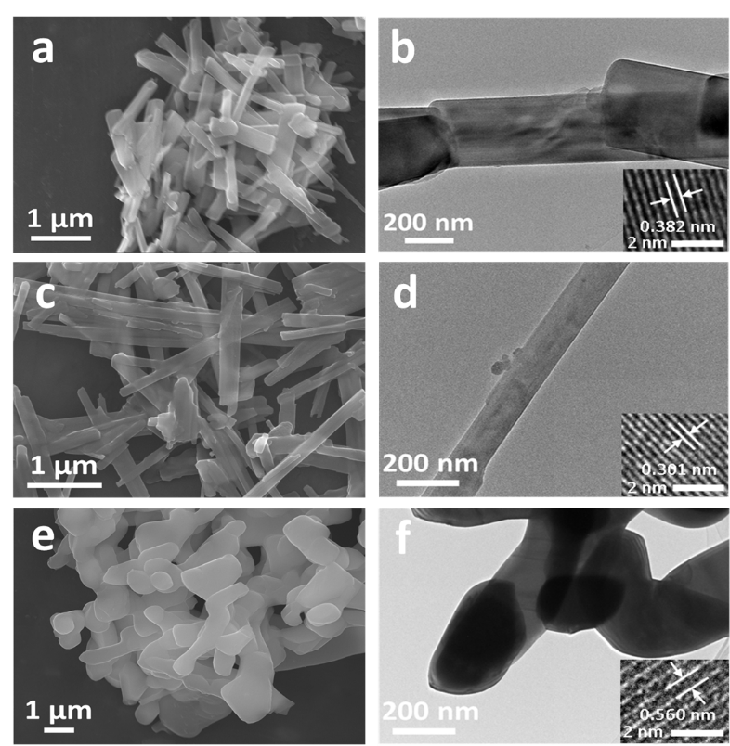
Fig. S1 SEM images, TEM images and HRTEM image (inset) of LiV₃O₈ (a-b), NaV₃O₈ (c-d), KV₃O₈ (e-f).
The morphology of LiV₃O₈ is similar to that of NaV₃O₈. Both of them are nanowires with a length of two or three micrometers (Fig. S1a, c). From TEM pattern (Fig. S1b, d), the diameter of LiV₃O₈ nanowire (~260 nm) is larger than NaV₃O₈ (~170 nm). Additionally, the lattice fringe with the spacing of 0.382 nm (matches well with (003) plane of LiV₃O₈) and 0.301 nm (matches well with (222) plane of NaV₃O₈) is revealed by HRTEM, respectively (inset of Fig. S1b, d). Fig. S1e and Fig. S1f show that the as-synthesized KV₃O₈ are nanoplate with the width about 200 nm. The HRTEM image (inset of Fig. S1f) shows the lattice fringes of 0.560 nm, which matches well with the (110) plane of KV₃O₈.

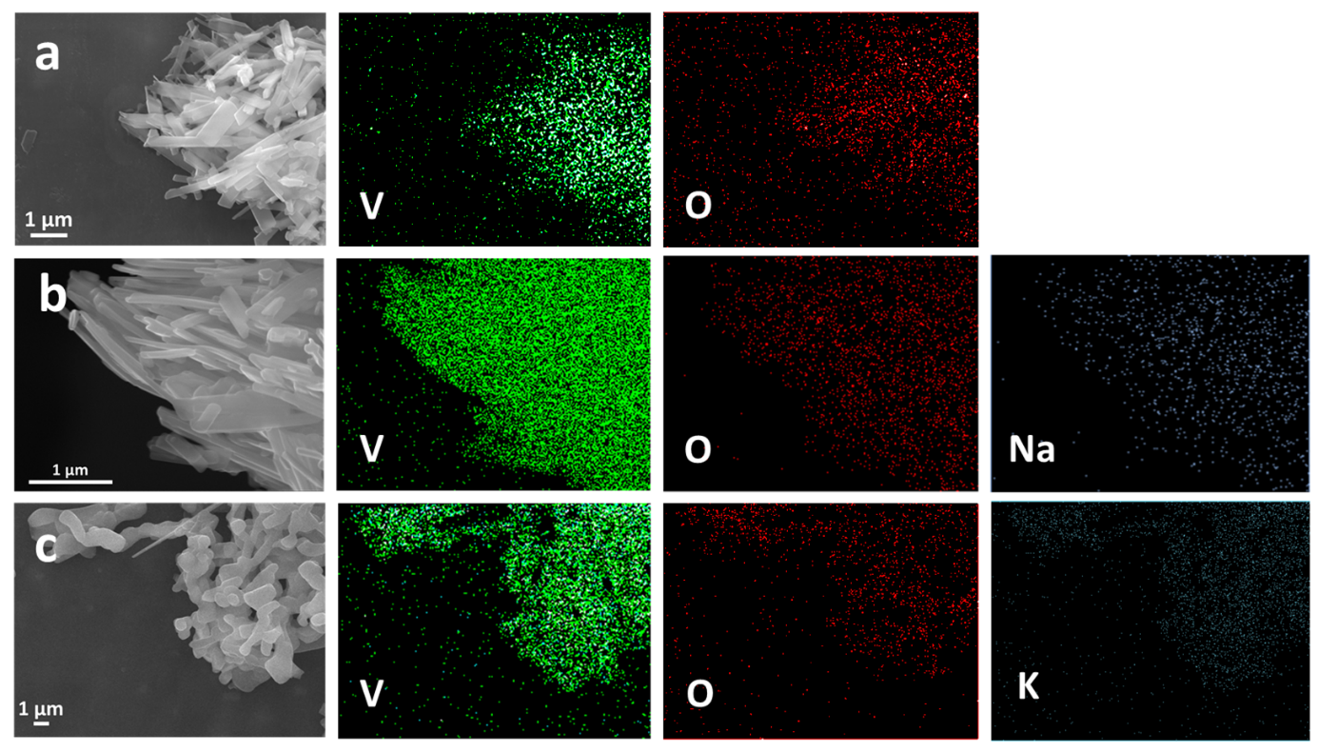
Fig. S2 (a-c) EDS-mapping of A-V₃O₈ (A=Li, Na, K).

Fig. S3 Nyquist plots of A-V₃O₈ (A=Li, Na, K) after 1 cycle.

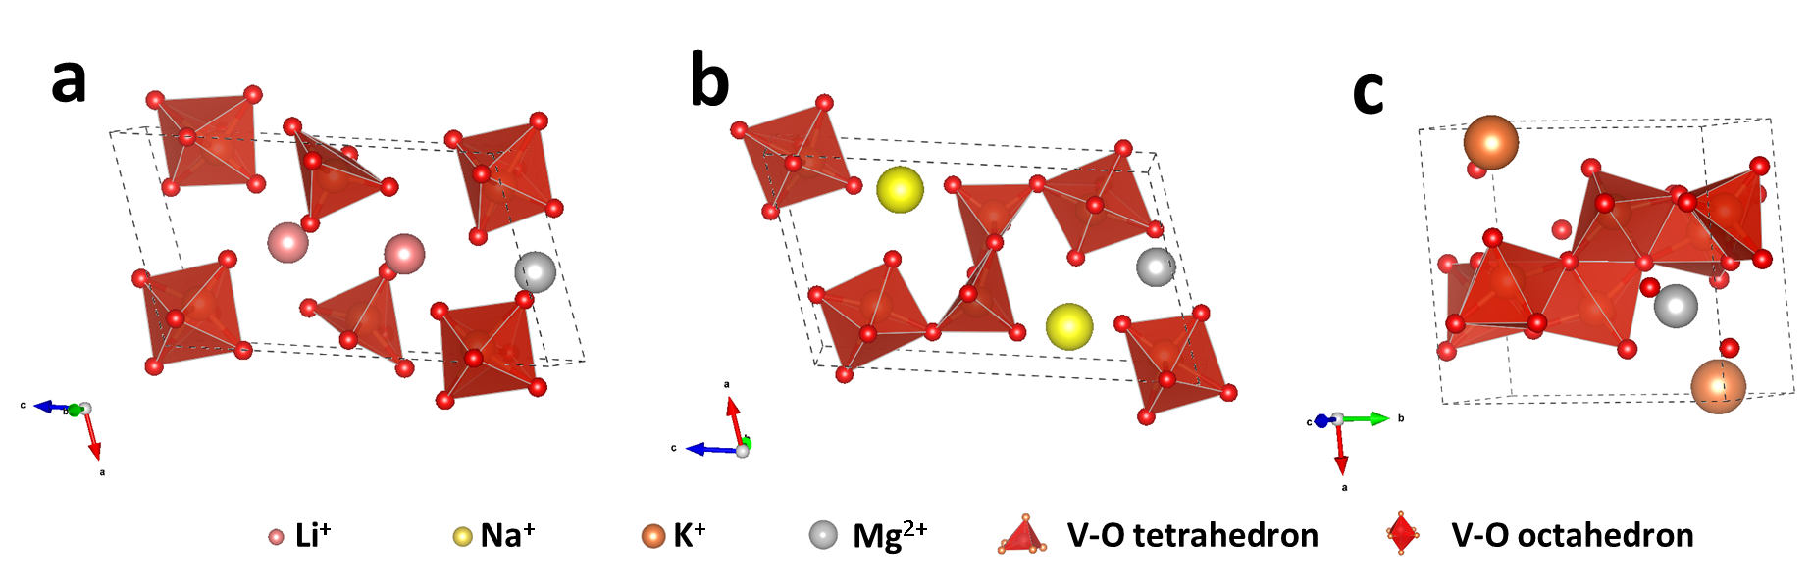
Fig. S4 (a-c) Illustration of the crystal structure of A-V₃O₈ (A=Li, Na, K) after Mg²⁺ ions intercalated.

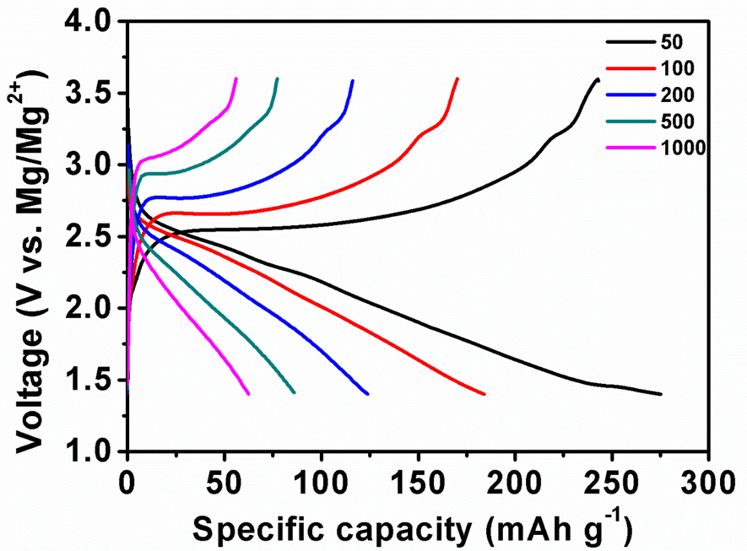
Fig. S5 Charge/discharge curves of NaV₃O₈ at the current density of 50,100, 200, 500 and 1000 mA g⁻¹.

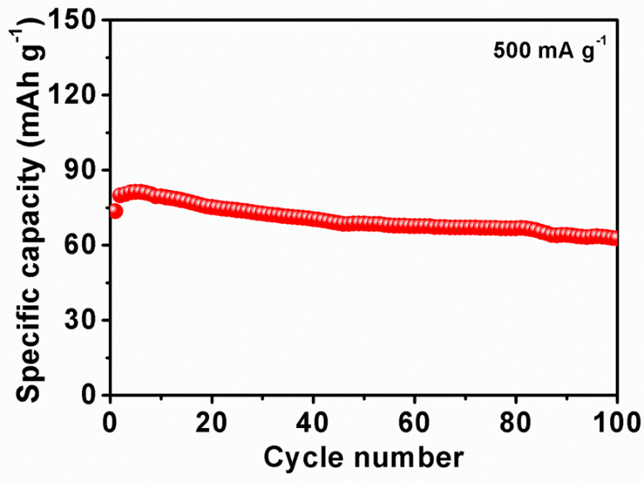
Fig. S6 Cycling performance of NaV₃O₈ at the current density of 500 mA g⁻¹.

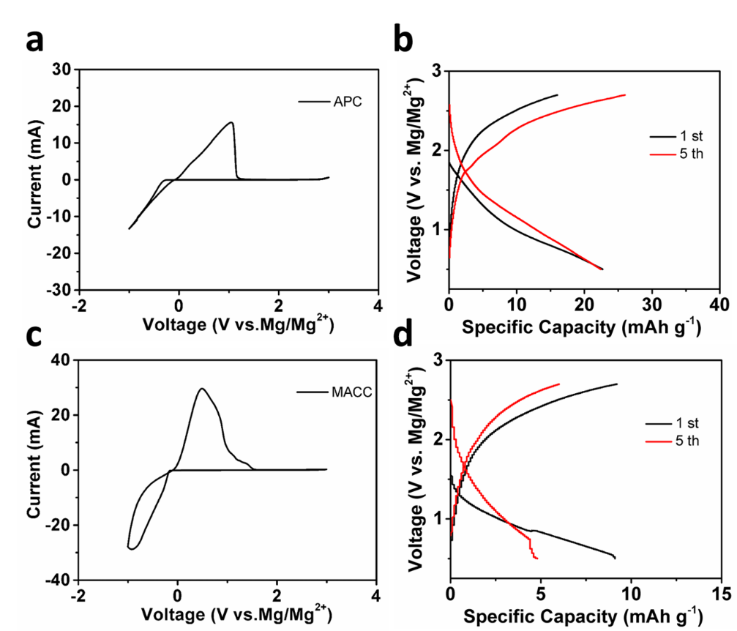
Fig. S7 (a) CV curves of APC at scan rate of 100 mV s⁻¹. (b) Charge/discharge curves of NaV₃O₈ at 1st and 5th cycle in APC. (c) CV curves of MACC at scan rate of 100 mV s⁻¹. (d) Charge/discharge curves of NaV₃O₈ at 1st and 5th cycle in MACC.

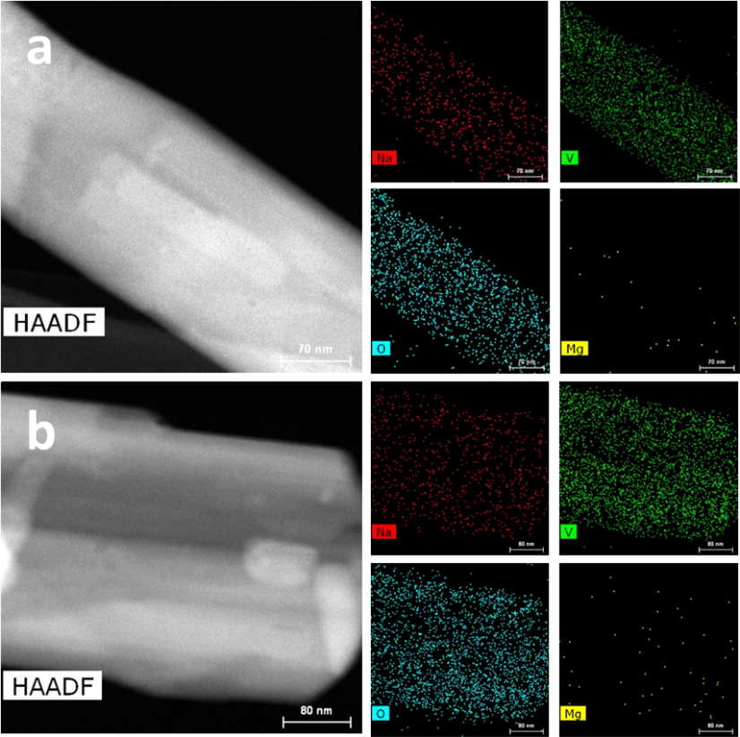

Fig. S8 HAADF image and EDS elemental mappings of NaV₃O₈ at (a) initial, (b) charge state.

Fig. S9 GITT potential feedback curve with time.

Table S1. The intercalation energy (E_{i}) of Mg²⁺ ions in A-V₃O₈ (A=Li, Na, K) and the coordinate of the intercalated Mg²⁺ ions.
Pristine | E_{pristine} | Intercalation of Mg²⁺ | The coordinate of Mg²⁺ |  |  | E_{total} | E_{i}
 |  |  | X_{Mg}²⁺ | Y_{Mg}²⁺ | Z_{Mg}²⁺
Li₂V₆O₁₆ | -190.32 | MgLi₂V₆O₁₆ | 0.58 | 0.25 | 0.05 | -195.95 | -5.63
Na₂V₆O₁₆ | -189.31 | MgNa₂V₆O₁₆ | 0.52 | 0.25 | 0.05 | -194.72 | -5.40
K₂V₆O₁₆ | -189.02 | MgK₂V₆O₁₆ | 0.66 | 0.75 | 0.57 | -193.76 | -4.74

Table S2. The ICP result of the NaV₃O₈ electrode at different states.
NaV₃O₈ | Mg(%) | V(%) | Weight ratio  (m_{Mg}/m_{V}) | Molar ratio  (M_{Mg}/M_{V})
Initial state | 0.14 | 21.75 | 0.00644 | 0.01368
Discharge state | 3.28 | 17.14 | 0.19136 | 0.40665
Charged state | 0.16 | 22.23 | 0.00720 | 0.01530

Table S3. The AAS result of the electrolyte at different cycles when NaV₃O₈ act as cathode.
Electrolyte | Na (mg L⁻¹) | Na (mmol L⁻¹) | Na:V in cathode
Initial state | 12.660 | 0.550 | 1:3
10th (charge state) | 13.660 | 0.594 | 0.934:3

$$D^{GITT}=\frac{4}{πτ}{\left(\frac{m_{B}V_{M}}{M_{B}S}\right)}^{2}{\left(\frac{∆E_{S}}{{∆E}_{τ}}\right)}^{2}$$
Scheme 1.τ is the constant current pulse time, m_{B} is mass of active materials, V_{M} refers to molar volume of H₂V₃O₈, M_{B} is the molar mass of H₂V₃O₈, S is the electrode–electrolyte interface, ΔE_{S} is the voltage difference during the open circuit time, and ΔE_{τ} is the total change of battery voltage during a constant current pulse without the IR drop.

