Supporting information
Li₃V(MoO₄)₃ as a novel electrode material with good lithium storage properties and improved initial coulombic efficiency
Jiexi Wang,^{a,c,}*^{,1} Guobin Zhang,^{b,1} Zhaomeng Liu,^{c,1} Hangkong Li,^{d} Hongmei Liang,^{c} Yong Liu,ª Xinhai Li,^{c} Kaimin Shih,^{d,}* Liqiang Mai,^{b,}*

ª Powder Metallurgy Research Institute, Central South University, 932, Lushan South Road, Changsha, 410083, P.R. China
^{b} State Key Laboratory of Advanced Technology for Materials Synthesis and Processing, Wuhan University of Technology, Wuhan 430070, China
^{c} School of Metallurgy and Environment, Central South University, 932, Lushan South Road, Changsha, 410083, P.R. China
^{d} Department of Civil Engineering, The University of Hong Kong, Hong Kong

¹ J. Wang, G. Zhang and Z. Liu contributed equally to this work.

* Corresponding author. Email address: wangjiexikeen@csu.edu.cn (J. Wang); kshih@hku.hk (K. Shih); mlq518@whut.edu.cn (L. Mai)

A definition for ICE
ICE is the abbreviation of initial coulombic efficiency. It represents charge-discharge efficiency of electrode in the first cycle. For cathode material, it is the ratio of the discharge capacity/charge capacity; For anode material, it is the ratio of charge capacity/discharge capacity.
In-situ XRD
For time-resolved in situ X-ray diffraction (XRD), the electrode was placed right behind an X-ray-transparent beryllium window which is also acted as a current collector. The in situ XRD signals were collected using the planar detector in a still mode during the discharge-charge process, and each pattern took 2 min to acquire. Using in situ XRD measurement, we can clearly elucidate the reaction mechanism and structural change of Li₃V(MoO₄)₃ during the charge-discharge process.
Figure S1 Core level XPS spectra of Li₃V(MoO₄)₃ material: (a) Total curve, (b) Mo 3d, (c) V 2p, (d) O 1s, (e) Li 1s, and (f) C 1s.
The XPS analysis is employed to elucidate the chemical composition and oxidation state of the resultant sample. As shown in Figure S1(a), the survey spectrum indicates that the sample consists of the elements C, Mo, V, Li and O. The high-resolution Mo 3d spectrum [Figure S1(b)] shows two obvious signals at 232.7 and 235.9 eV, which is attributed to the Mo 3d_{5/2} and Mo 3d_{3/2} of Mo⁶⁺, in good agreement with previous reports.¹ The high-resolution O 1s spectrum [Figure S1(c)] can be resolved into two peaks at 529.8 and 532.0 eV. The former (529.8 eV) is ascribed to the lattice-oxygen and the latter (532.0 eV) is related to the adsorbed-oxygen. Figure S1(d) shows the presence of zero-valent carbon on the surface (peak at 284.8 eV) which results from the pyrolysis of excess oxalic acid. This BE value of C 1s compares well with that of amorphous carbon. In addition, a low-density peak with a BE value of 286.3 eV is observed, which may be due to C–O–H bonds.² The high-resolution V 2p spectrum in Figure S1(e) shows two peaks with binding energies at 517.0 and 524.3 eV, which are associated with V 2p_{3/2} and V 2p_{1/2}, respectively. This indicates that the V(+5) is reduced to V(+3) by oxalic acid dehydrate during synthetic process. In Figure S1(f), the Li 1s has a BE value of 55.3 eV, indicating no obvious change of BE value for Li 1s from Li–O in CH₃COOLi (55.5 eV) to Li–O in Li₃V(MoO₄)₃. The BE value of Li 1s is similar to that in LiVPO₄F² and LiFePO₄³. These results further reflect successful fabrication of Li₃V(MoO₄)₃ with expected valence state.
Table S1 Refined length of metal-O bonds in Li₃V₂(MoO₄)₃
Atom 1 | Atom 2 | Count | d_{1,2} (Å) | Average d1,2 (Å)
Mo1 | O4 | 2x | 1.7688 | 1.7837
 | O7 | 1x | 1.7940
 | O5 | 1x | 1.8032
Mo2 | O3 | 1x | 1.7317 | 1.7617
 | O2 | 1x | 1.7516
 | O1 | 1x | 1.7701
 | O6 | 1x | 1.7934
Li1|V1 | O5 | 1x | 2.0233 | 2.0481
 | O1 | 2x | 2.0395
 | O1 | 2x | 2.0491
 | O5 | 1x | 2.0882
Li2|V2 | O4 | 1x | 2.0267 | 2.0481
 | O6 | 1x | 2.0367
 | O3 | 1x | 2.0457
 | O6 | 1x | 2.0673
 | O7 | 1x | 2.1242
 | O4 | 1x | 2.1780
Li3 | O2 | 2x | 2.0123 | 2.2119
 | O3 | 2x | 2.2532
 | O2 | 2x | 2.3700

Figure S2 rate capability of as-prepared Li₃V(MoO₄)₃

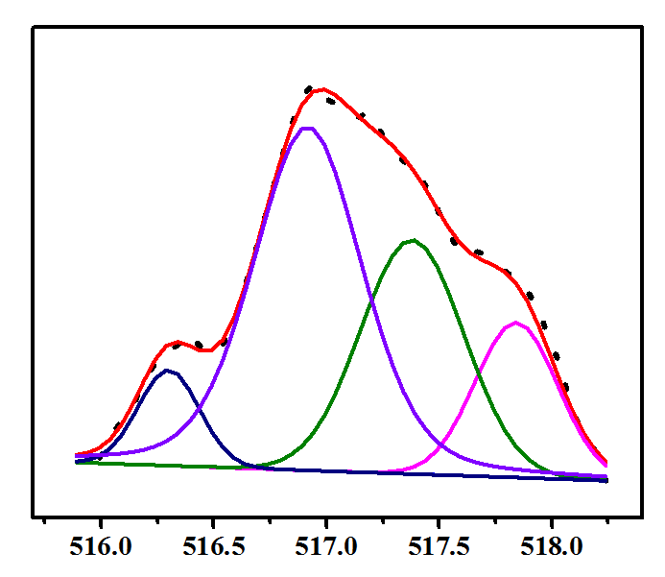
Figure S3 High-resolution XPS curve of V 2p in Li₃V(MoO₄)₃ after 1st cycle.
The high resolution XPS analysis further proved that after the reaction the single peak of the multi-valance of vanadium with binding energies at 517.0 dividing to four small peaks with a distribution of 15%, 28%, 50% and 7%, respectively. This means that higher percent of vanadium tends to higher binding energy, or higher valence state.

Figure S4 (a, b) TEM and (c) HRTEM images of Li₃V(MoO₄)₃ after 1st cycle.

Figure S5 (a) Selected galavanostatic discharge curve in the potential range of 0.01-3.0 V and charge curve in the potential range of 0.01-1.0 V at 100 mA g⁻¹; (b) Profiles of specific capacity vs. cycle number at 100 mA g⁻¹.

Figure S6 (a-d) Galavanostatic discharge curves in the potential range of 0.01-3.0 V and charge curves in the potential range from 0.01 to 1.0 V, 1.2 V, 1.5 V and 2.0 V at 100 mA g⁻¹.
Figure S7 Profiles of specific capacity vs. cycle number at 0.4V-3V at 100 mA g⁻¹.
The electrochemical reaction mechanism assumption

References
1. Z. Yin, Y. Xiao, X. Wang, W. Wang, D. Zhao and M. Cao, Nanoscale, 2015, 8, 508-516.
2. J. Wang, Z. Wang, X. Li, H. Guo, W. Xiao, S. Huang and Z. He, Journal of Solid State Electrochemistry, 2012, 17, 1-8.
3. Y.-H. Rho, L. F. Nazar, L. Perry and D. Ryan, Journal of The Electrochemical Society, 2007, 154, A283.
4. X. Yin, Z. Wang, J. Wang, G. Yan, X. Xiong, X. Li and H. Guo, Materials Letters, 2014, 120, 73-75.
5. X. Li, A. Dhanabalan, K. Bechtold and C. Wang, Electrochemistry Communications, 2010, 12, 1222-1225.
6. Q. Zhang, J. Wang, D. Xu, Z. Wang, X. Li and K. Zhang, Journal of Materials Chemistry A, 2014, 2, 3865-3874.
7. T. Li, X. Li, Z. Wang, H. Guo and Y. Li, J. Mater. Chem. A, 2015, 3, 11970-11975.
8. Q. Zhang, J. Wang, J. Dong, F. Ding, X. Li, B. Zhang, S. Yang and K. Zhang, Nano Energy, 2015, 13, 77-91.
9. C. T. Cherian, M. V. Reddy, S. C. Haur and B. V. Chowdari, ACS Appl Mater Interfaces, 2013, 5, 918-923.
10. Z. Wang, S. Madhavi and X. W. Lou, The Journal of Physical Chemistry C, 2012, 116, 12508-12513.

