Supplementary information
Self-adaptive mesoporous CoS@alveolus-like carbon yolk-shell microsphere for alkali cations storage

Qidong Li,^{a#} Li Li,^{a#} Kwadwo Asare Owusu,ª Wen Luo,^{ab} Qinyou An,ª Qiulong Wei,*^{ac} Qingjie Zhangª and Liqiang Mai*^{ad}

ª State Key Laboratory of Advanced Technology for Materials Synthesis and Processing, International School of Materials Science and Engineering, Wuhan University of Technology, Wuhan 430070, China. E-mail: mlq518@whut.edu.cn.
^{b} Laboratoire de Chimie et Physique: Approche Multi-échelles des Milieux Complexes, Institut Jean Barriol, Université de Lorraine, 57070 Metz, France.
^{c} Department of Materials Science and Engineering, University of California Los Angeles, CA 90095-1595, USA. E-mail: qlwei@ucla.edu.
^{d} Department of Chemistry, University of California, Berkeley, California 94720, United States.
# These authors contributed equally to this work.

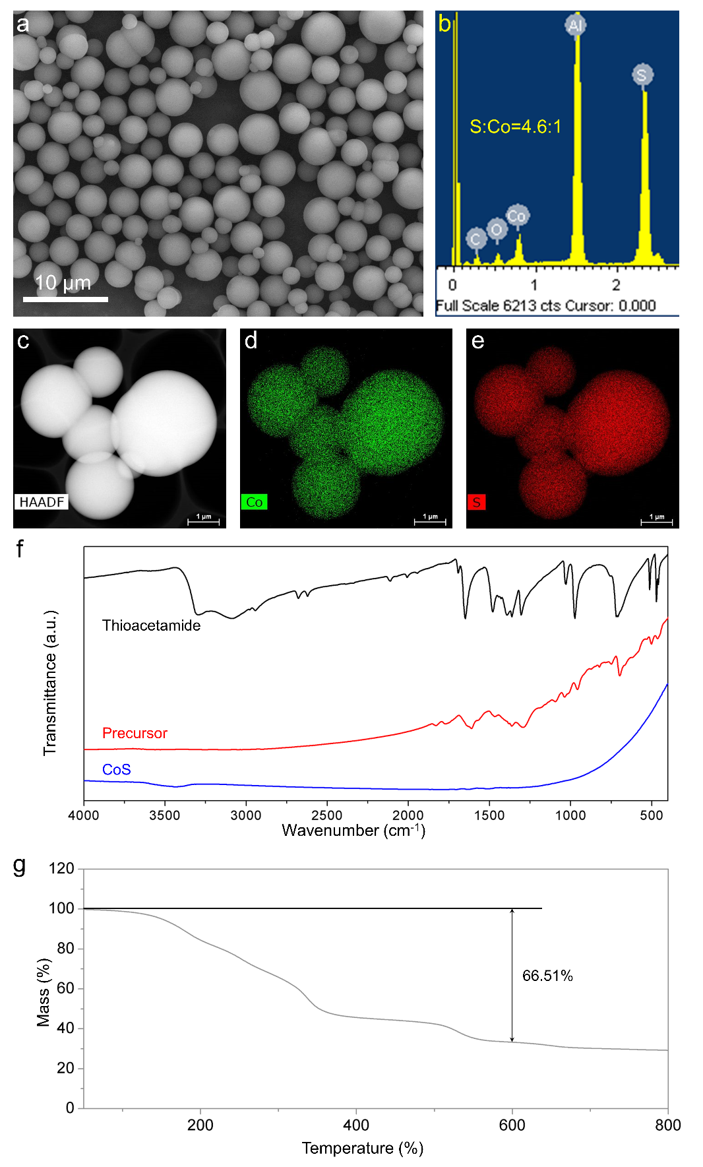
Figure S1. Physical and chemical characterization of the precursor. SEM image (a) and EDX spectrum (b) of the precursor. (c-e) Element mapping for the precursor. (f) FTIR spectra of thioacetamide, the precursor and CoS. (g) TGA result of the precursor.

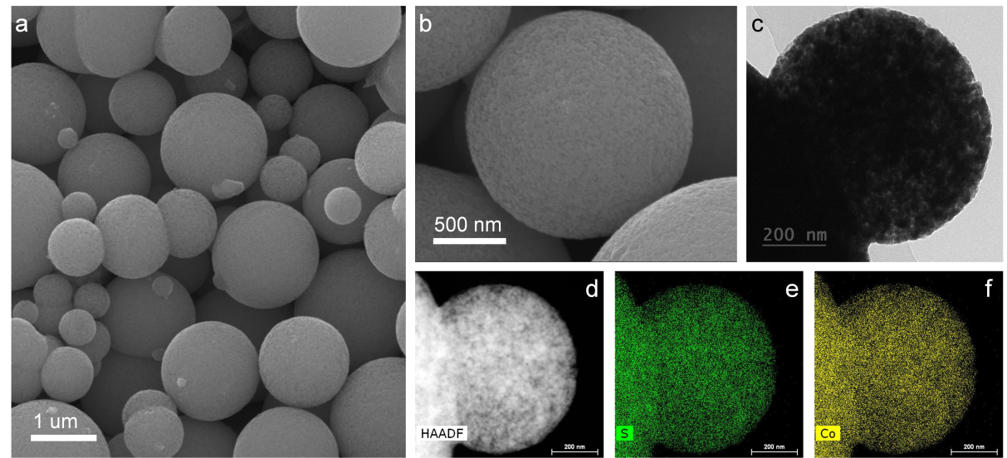
Figure S2. Morphology of the M-CoS. SEM (a, b) and TEM images (c) of the M-CoS. (c-e) Element mapping for the M-CoS.

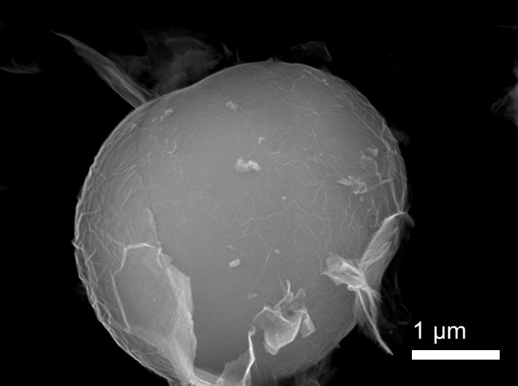
Figure S3. Morphology of the precursor@RF without the SiO₂ layer.

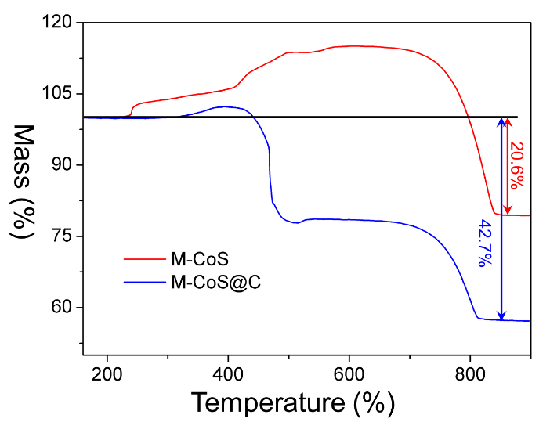
Figure S4. TGA results of the M-CoS and the yolk-shell M-CoS@C in air.

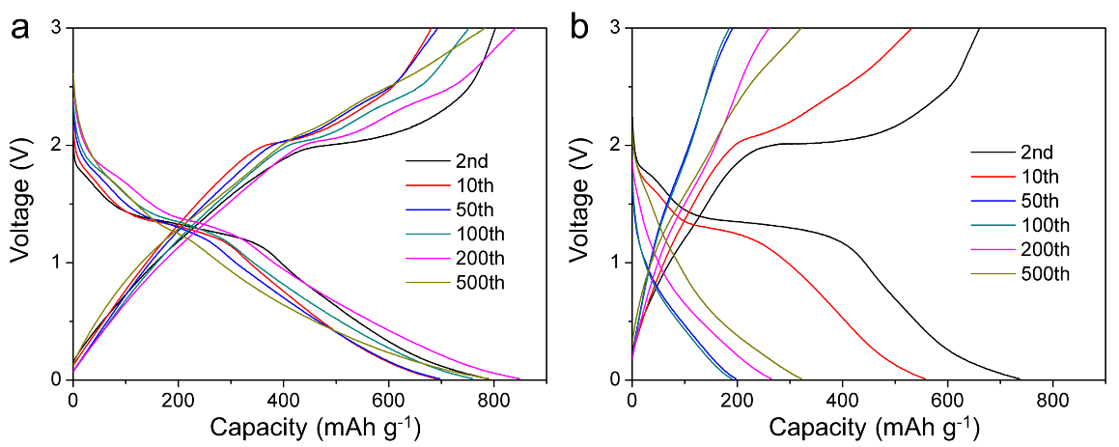
Figure S5. The corresponding discharge/charge curves of the yolk-shell M-CoS@C (a) and the M-CoS (b) at 1 A g⁻¹ for LIBs.

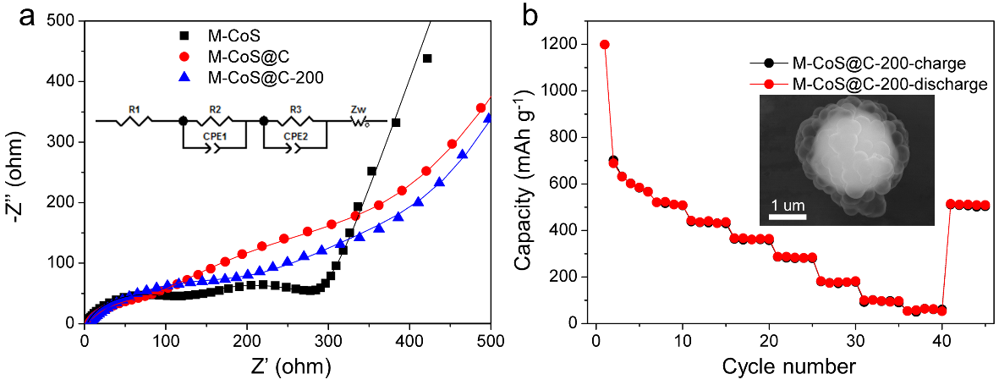
Figure S6. (a) The impedance plots of the M-CoS, the yolk-shell M-CoS@C and M-CoS@C-200. (b) The rate performance of M-CoS@C-200 and its initial SEM image (inset).

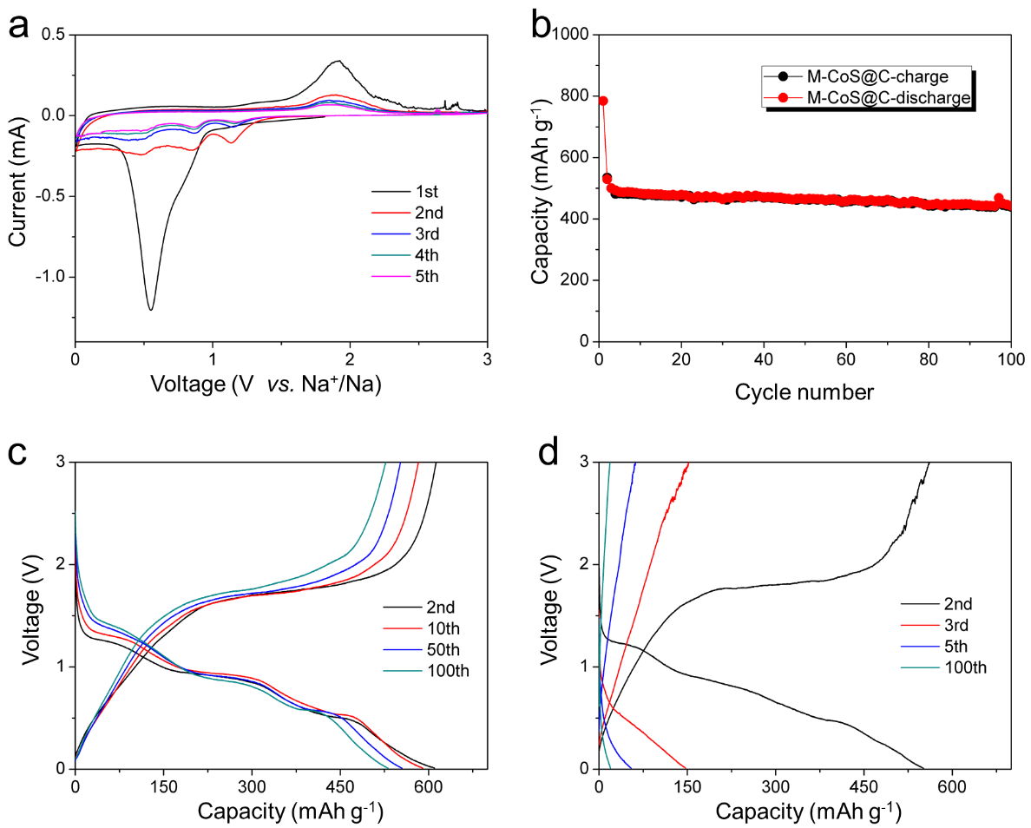
Figure S7. (a) Cyclic voltammograms of the M-CoS at the scan rate of 0.2 mV s⁻¹ between 0.01–3 V. (b) The cycling performance of M-CoS@C at 1 A g⁻¹. The corresponding discharge/charge curves of the yolk-shell M-CoS@C (c) and the M-CoS (d) at 0.2 A g⁻¹ for SIBs.
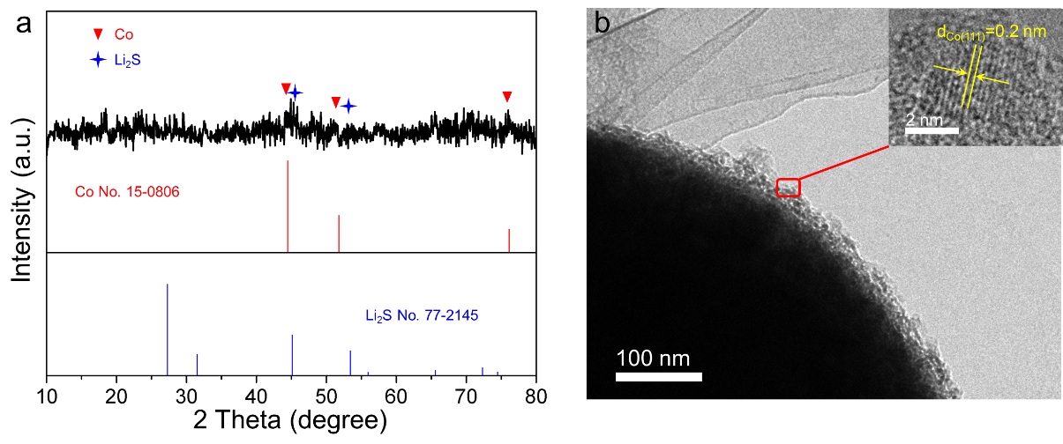
Figure S8. XRD pattern (a), TEM image (b) and HRTEM (inset) of the CoS electrode after first full discharging when applied in LIBs.

