Supplementary information
Nanoribbons and Nanoscrolls Intertwined Three-Dimensional Vanadium Oxide Hydrogels for High-Rate Lithium Storage at High Mass Loading Level

Yuhang Dai,^{a,#} Qidong Li,^{a,#} Shuangshuang Tan,^{a,#} Qiulong Wei,*^{a,b} Yexin Pan,ª Xiaocong Tian,^{d} Kangning Zhao,ª Xu Xu,ª Qinyou An,ª Liqiang Mai,*^{a,c} and Qingjie Zhangª

ª State Key Laboratory of Advanced Technology for Materials Synthesis and Processing, International School of Materials Science and Engineering, Wuhan University of Technology, Wuhan 430070, China. E-mail: mlq518@whut.edu.cn
^{b} Department of Materials Science and Engineering, University of California, Los Angeles, California 90095, USA. E-mail: qlwei@ucla.edu
^{c} Department of Chemistry, University of California, Berkeley, California 94720, USA.
^{d} Singapore Centre for 3D Printing, School of Mechanical and Aerospace Engineering, Nanyang Technological University, 639798 Singapore, Singapore.
# These authors contributed equally to this work.

Table S1. Comparison with other vanadium oxide cathode electrode, major focusing on the mass loading level and rate capability.
Samples | Loading level (mg cm⁻²) | Rate capability (mAh g⁻¹ at A g⁻¹) | Potential (V) | Citations
H₂V₃O₈ hydrogels/CNTs | 3.1  13 | 313.3 at 0.1  143.8 at 12  295.6 at 0.1  127.3 at 2 | 1.5-3.5 | Our work
V₂O₅ nanowires-graphene | ~1.0 | 414.4 at 0.1  255.5 at 10 | 1.7-3.8 | [1]
Hierarchical porous V₂O₅ nanofibers | 2.0 | 276.3 at 0.1  50.3 at 3 | 2.0-4.0 | [2]
VO₂ nanoribbons/graphene | 1.2 | 141 at 0.16  54 at 1.12 | 2.0-3.5 | [3]
Porous V₂O₅ nanosheets | 2.0 | 142.1 at 0.0734  88.6 at 1.176 | 2.5-4.0 | [4]
V₂O₅ nanobelt arrays | 1.0~2.0 | 146 at 0.0734  87 at 2.352 | 2.5-4.0 | [5]
VO₂@Graphene Quantum Dots nanoarrays | 0.6 | 421 at 0.1  151 at 36 | 1.5-3.5 | [6]

References
[1] J.W. Lee, S.Y. Lim, H.M. Jeong, T.H. Hwang, J.K. Kang, J.W. Choi, Energy Environ. Sci., 5 (2012) 9889-9894.
[2] B. Yan, X. Li, Z. Bai, M. Li, L. Dong, D. Xiong, D. Li, J. Alloys Compd., 634 (2015) 50-57.
[3] Y. Sun, S.-B. Yang, L.-P. Lv, I. Lieberwirth, L.-C. Zhang, C.-X. Ding, C.-H. Chen, J. Power Sources, 241 (2013) 168-172.
[4] Y. Su, A. Pan, Y. Wang, J. Huang, Z. Nie, X. An, S. Liang, J. Power Sources, 295 (2015) 254-258.
[5] M. Qin, Q. Liang, A. Pan, S. Liang, Q. Zhang, Y. Tang, X. Tan, J. Power Sources, 268 (2014) 700-705.
[6] D. Chao, C. Zhu, X. Xia, J. Liu, X. Zhang, J. Wang, P. Liang, J. Lin, H. Zhang, Z.X. Shen, H.J. Fan, Nano Lett., 15 (2015) 565-573.

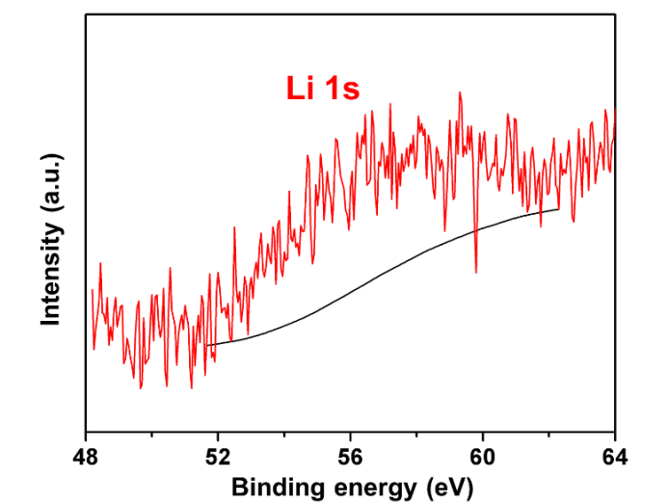
Figure S1. XPS Li 1s spectrum of H₂V₃O₈ hydrogels.

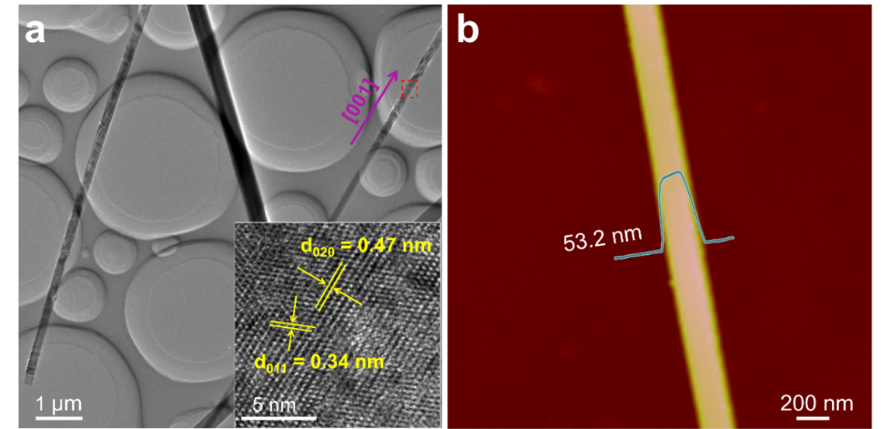
Figure S2. (a) TEM and HRTEM (inset a) images of H₂V₃O₈ NWs. (b) AFM image of a NW.

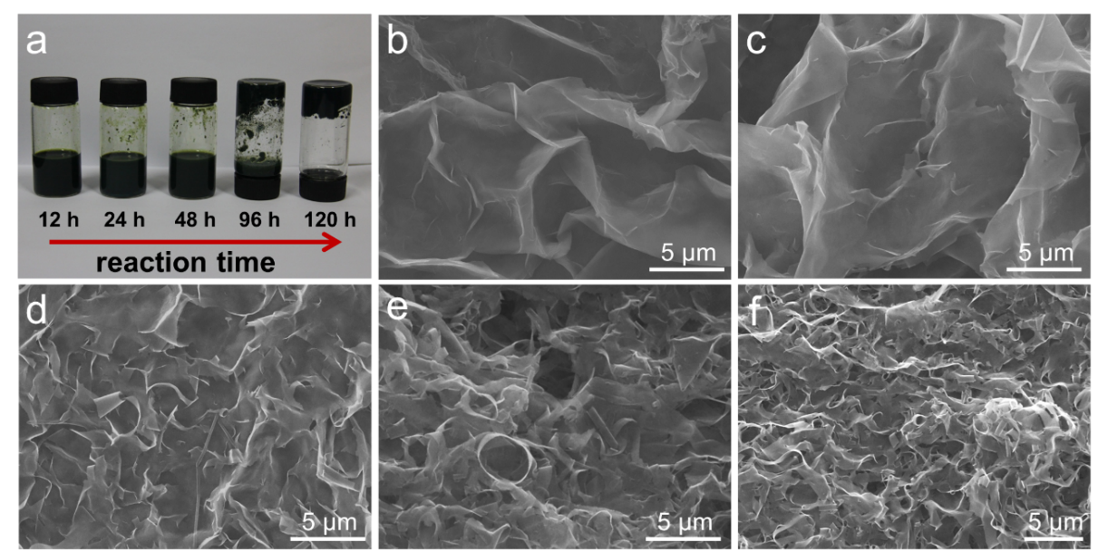
Figure S3. Time-dependent experiments of the formation process for hydrogels. (a) Photograph of the products obtained at various hydrothermal reaction times. SEM images of the products with a hydrothermal reaction time of 12 h (b), 24 h (c), 48 h (d), 96 h (e) and 120 (h), respectively.

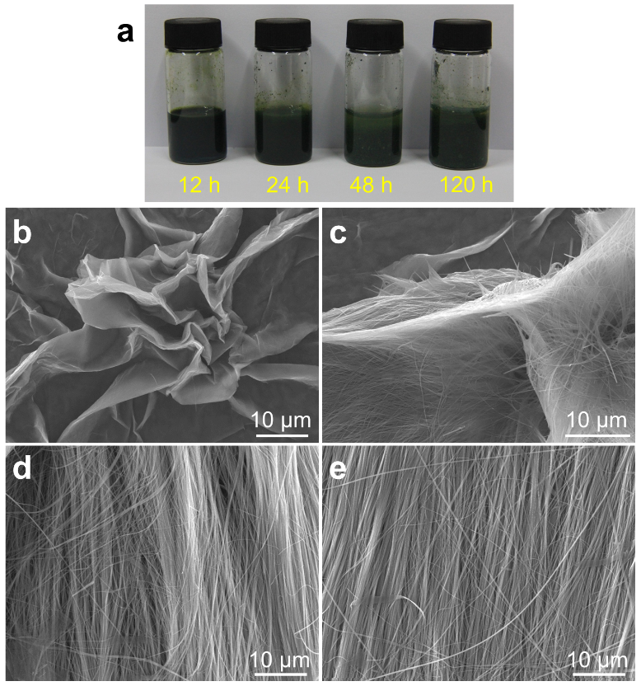
Figure S4. Time-dependent experiments of the formation process for NWs. (a) Photograph of the products obtained at various hydrothermal reaction times. SEM images of the products with a hydrothermal reaction time of 12 h (b), 24 h (c), 48 h (d), and 120 (e), respectively.

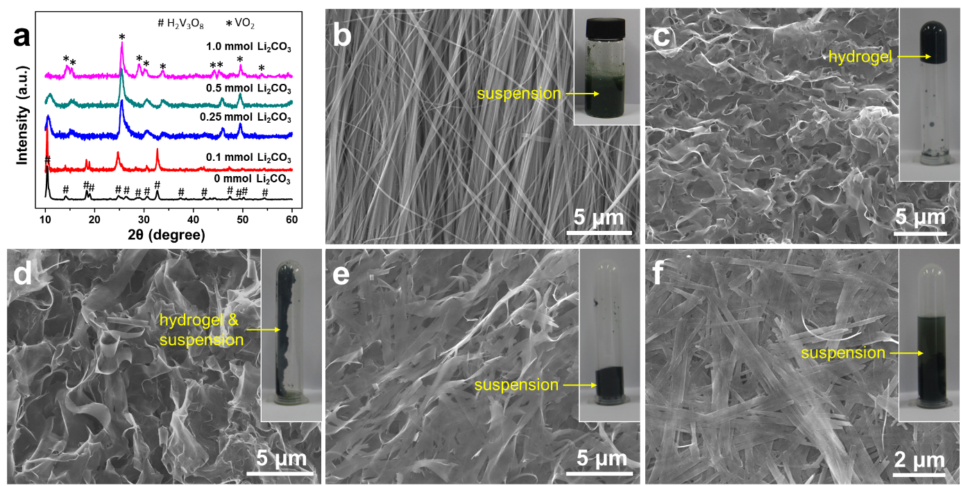
Figure S5. The influence of the pre-added amount of Li₂CO₃ for the finial morphology. (a) XRD patterns. (b-f) The morphology of the samples with different amount of Li₂CO₃: 0 mmol (b), 0.1 mmol (c), 0.25 mmol (d), 0.5 mmol (e), and 1.0 mmol (f), respectively.

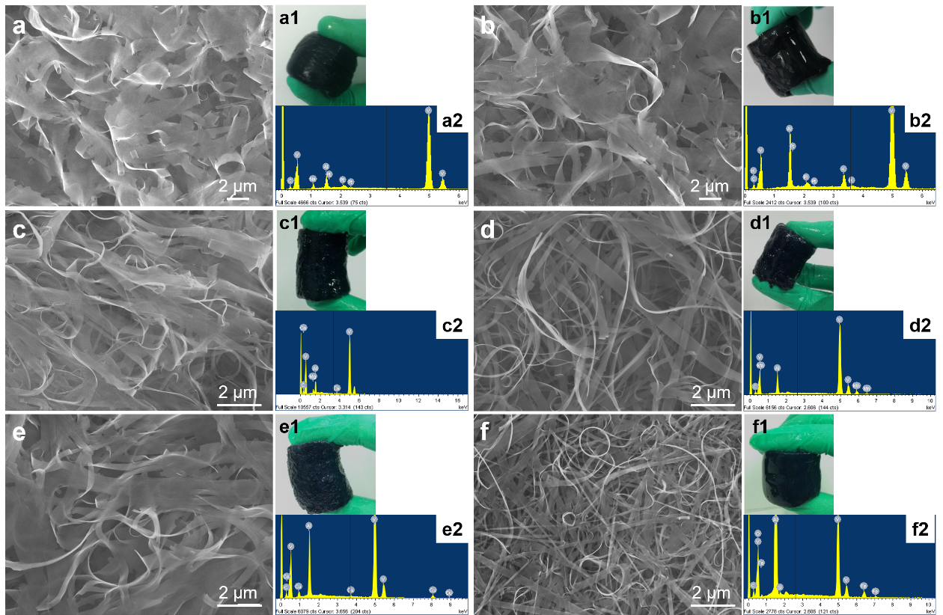
Figure S6. The SEM images, photographs, EDX spectra of the samples with the addition of Na₂CO₃ (a), K₂CO₃ (b), MgCl₂ (c), MnCO₃ (d), CuCl₂ (e), and NH₄Fe(SO₄)₂ (f), respectively.

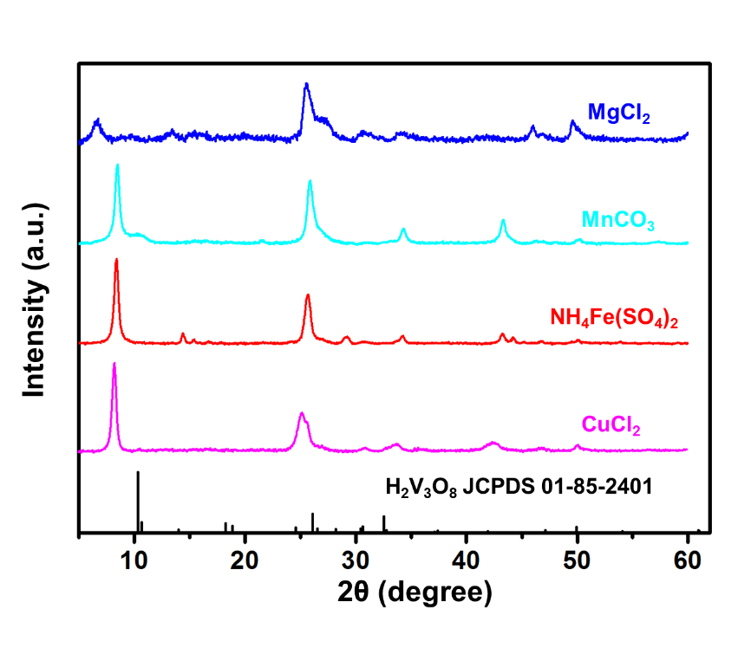
Figure S7. XRD patterns of the samples with the addition of MgCl₂, MnCO₃, NH₄Fe(SO₄)₂ and CuCl₂. The slight shift to lower angle of the peaks may be due to the pre-intercalated cations into the vanadium oxide layers.

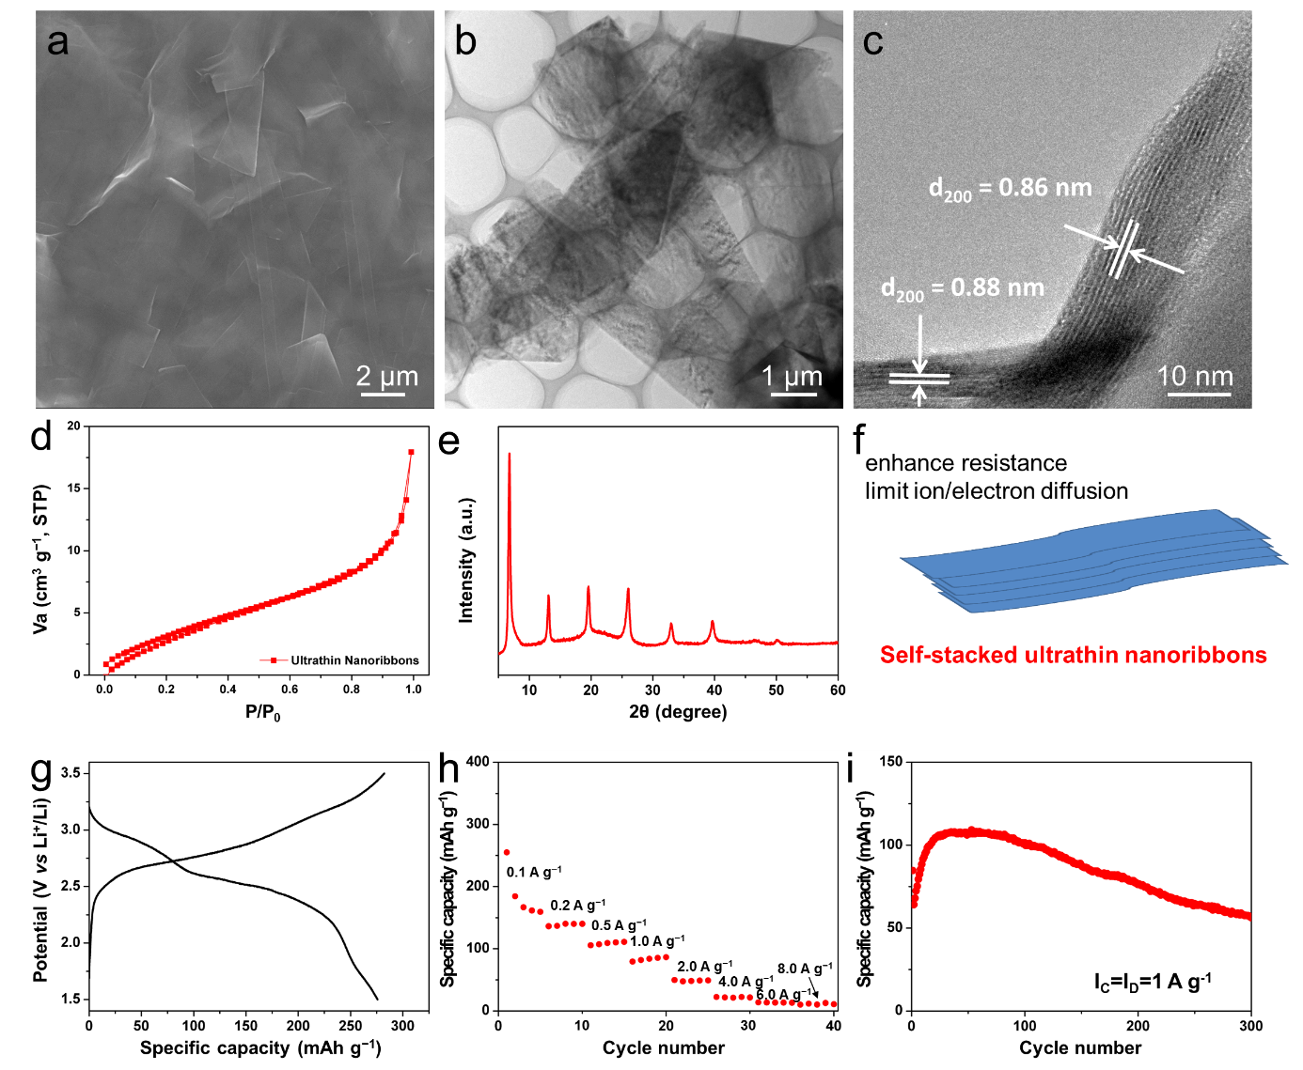
Figure S8. Characterization and electrochemical performance of pure ultrthin nanoribbons. SEM (a), TEM (b), HRTEM (c) images, nitrogen adsorption/desorption curve (d) and XRD pattern (e) of pure ultrathin nanoribbons. (f) Schematic of the self-stacked nanoribbons. The SEM and TEM images show the stacked ultrathin nanoribbons, the nitrogen adsorption/desorption curve indicates no porous structure, and further the XRD pattern shows very strong order multiple reflections, demonstrating the self-stacked behavior of nanoribbons. Charge-discharge curve at 0.1 A g⁻¹ at 1.5-3.5 V (g), rate performance (h) and cycling performance at 1.0 A g⁻¹ (i). The charge-discharge curve is different from the H₂V₃O₈ NWs, which may be due to the ultrathin feature of the nanoribbons that with more surface atoms and less layers. The unsatisfied electrochemical performance is owing to the self-stacked nanoribbons that without any spacing between themselves, which enhances the resistance and limits ion/electron diffusion.

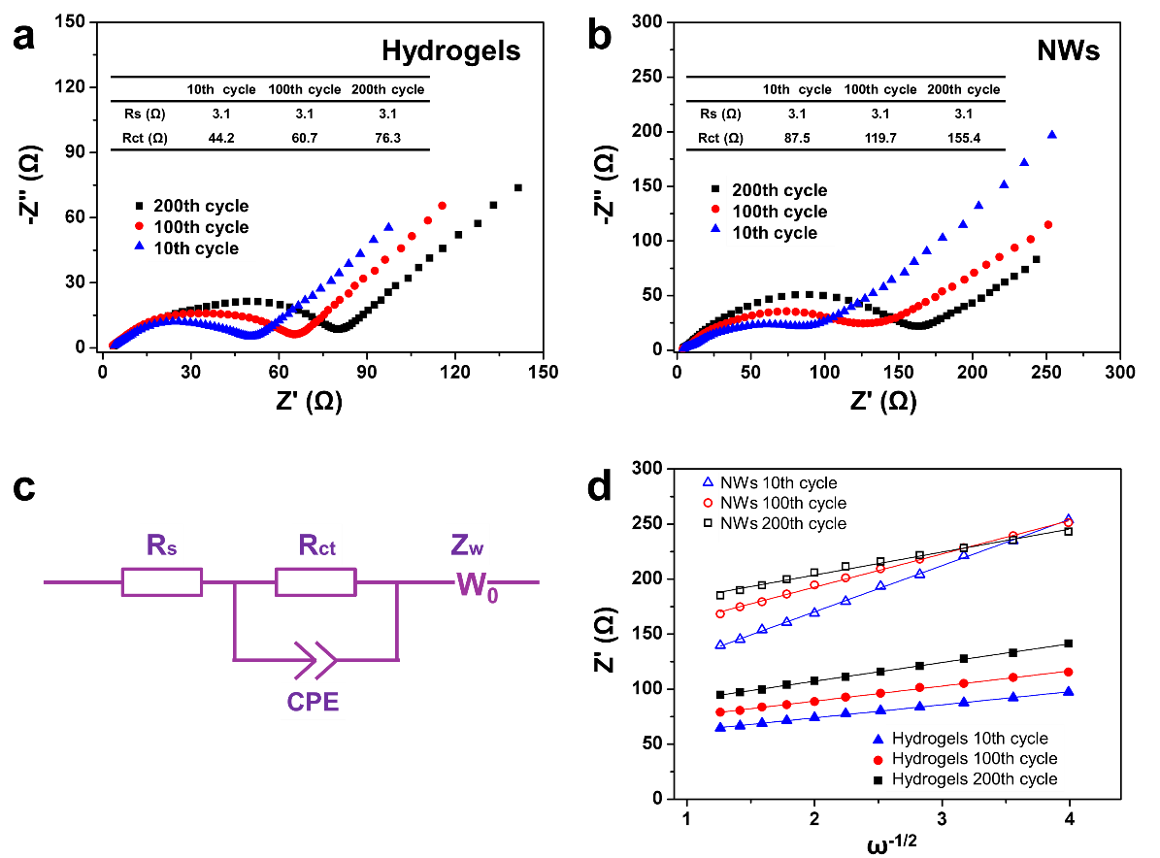
Figure S9. EIS analysis. The Nyquist plots of the (a) H₂V₃O₈ hydrogels and (b) NWs after various cycles, respectively. (c) The fitting equivalent circuit. (d) Z' vs. ω^{−1/2} plots. The diffusion coefficient values of the Li⁺ ions (D) can be calculated based on the EIS spectra by using the Equations 1 and 2. Based on the Equation 2, the linear fitting of Z' and ω^{-1/2} is displayed in d. From the fitting results, the σ value can be calculated for the slope. The smaller Warburg factor (σ) indicates higher diffusion coefficient values (D), which demonstrates the faster and more stable Li⁺ ion diffusion kinetics for the hydrogels.

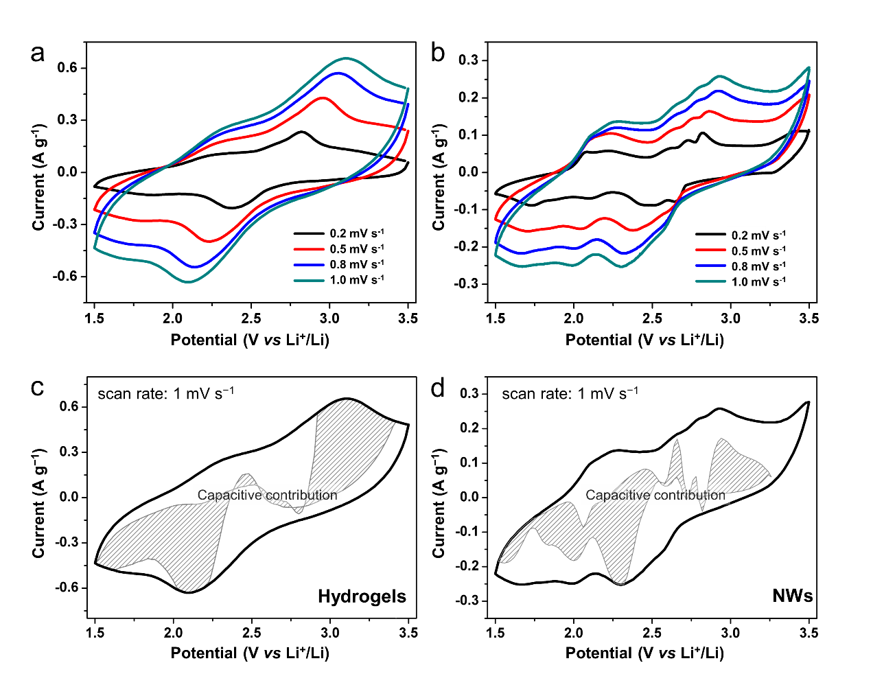
Figure S10. CV curves of hydrogels (a) and NWs (b) at various scan rates, respectively. CV curves of H₂V₃O₈ hydrogels (c) and NWs (d) at a scan rate of 1 mV s^{–1}, respectively. The shaded area represents capacitive contribution.

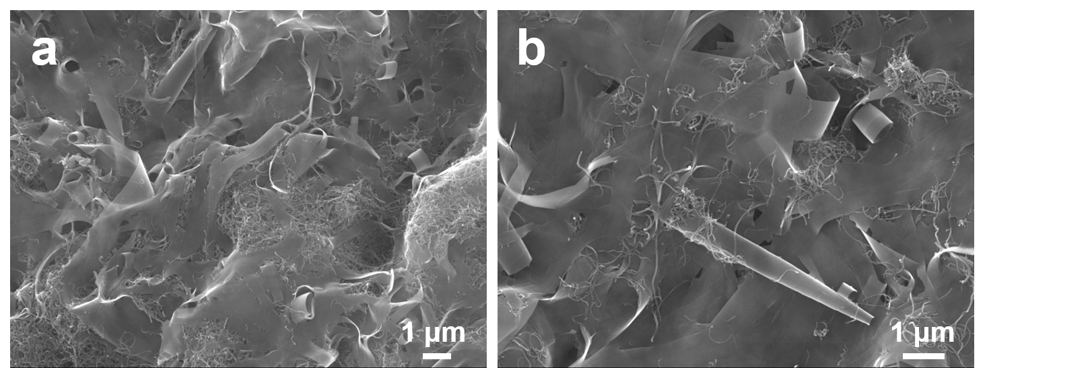
Figure S11. (a, b) SEM images of H₂V₃O₈ hydrogels/CNTs.

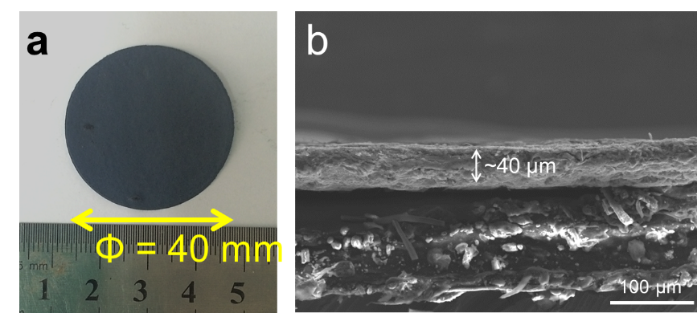
Figure S12. (a) Photograph of the hydrogels/CNTs film. (b) Cross-section SEM image of hydrogels/CNTs film.

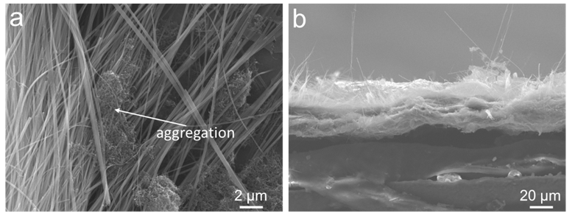
Figure S13. (a) SEM image of NWs/CNTs composites. (b) Cross-section SEM image of NWs/CNTs films. The ununiformed distribution of CNTs with NWs is not ideal to provide effective electron transport.

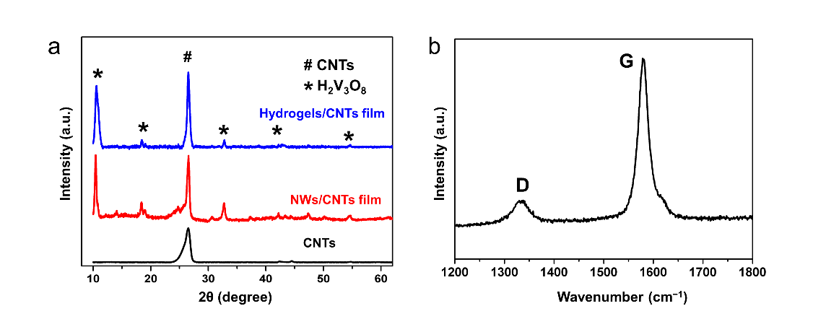
Figure S14. XRD patterns (a) and Raman spectra (b) of the hydrogels/CNTs film.
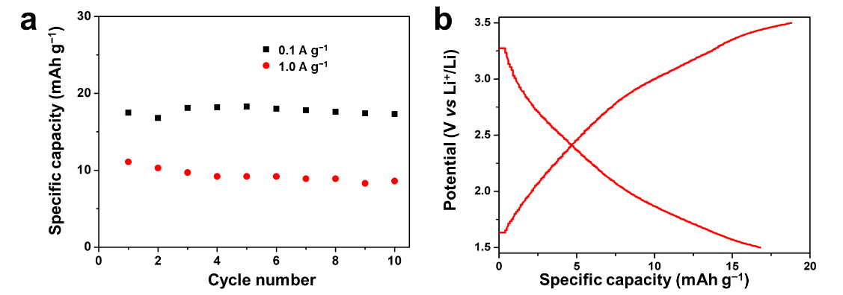
Figure S15. Electrochemical performance of CNTs tested at the potential window of 1.5 to 3.5 V. (a) Cycling performance at 0.1 and 1.0 A g⁻¹. (b) The charge-discharge curves at 0.1 A g⁻¹.

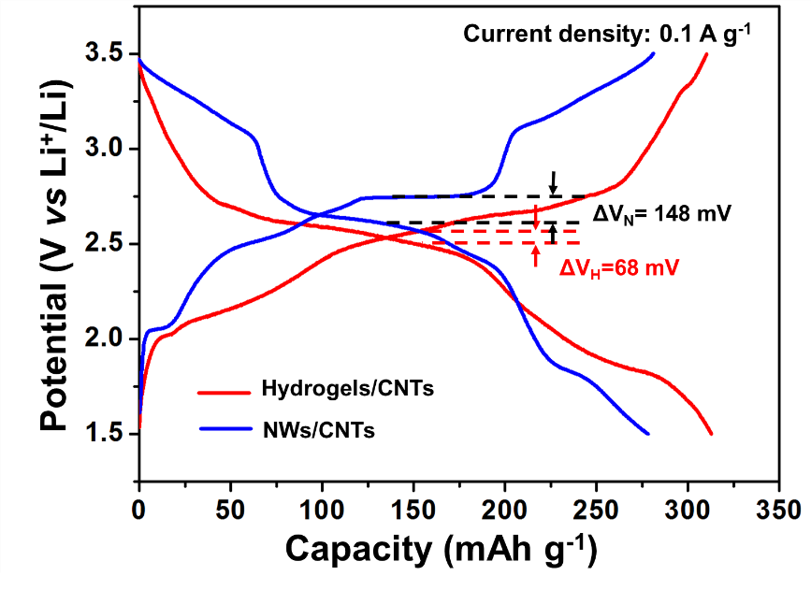
Figure S16. Charge-discharge curves and corresponding overpotentials of hydrogels/CNTs and NWs/CNTs at 0.1 A g^{–1}.

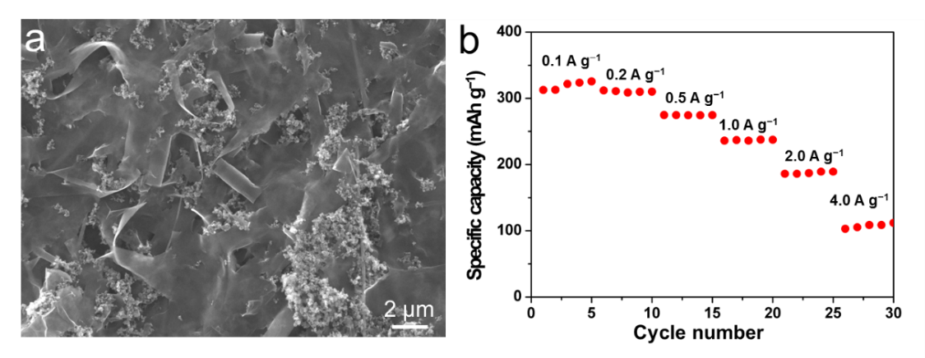
Figure S17. (a) SEM image and (b) rate performance of hydrogels/acetylene black film. The dispersive acetylene black nanoparticles is unable to provide continuous electron transport, thus leading to poor rate performance.
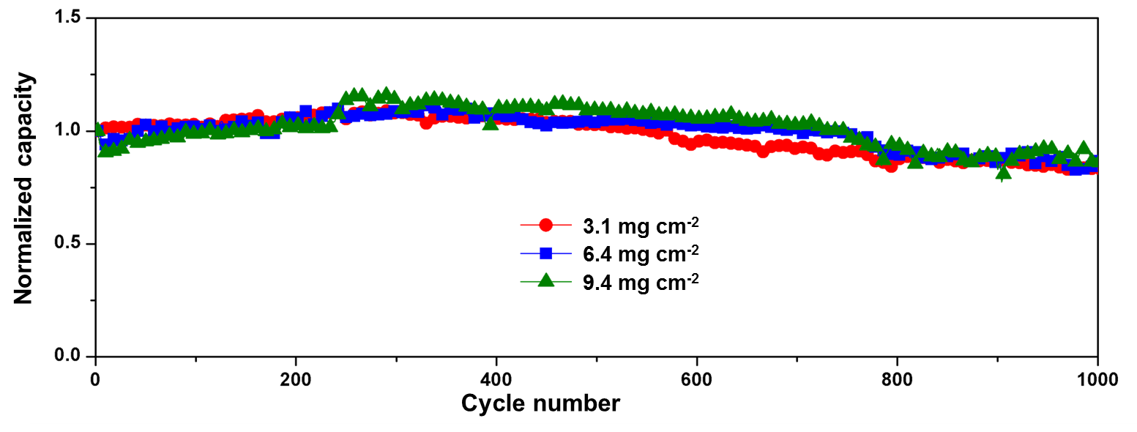
Figure S18. The cycling performance of the hydrogels/CNTs films with different mass loading at the charge and discharge specific current of 4.0 A g⁻¹.

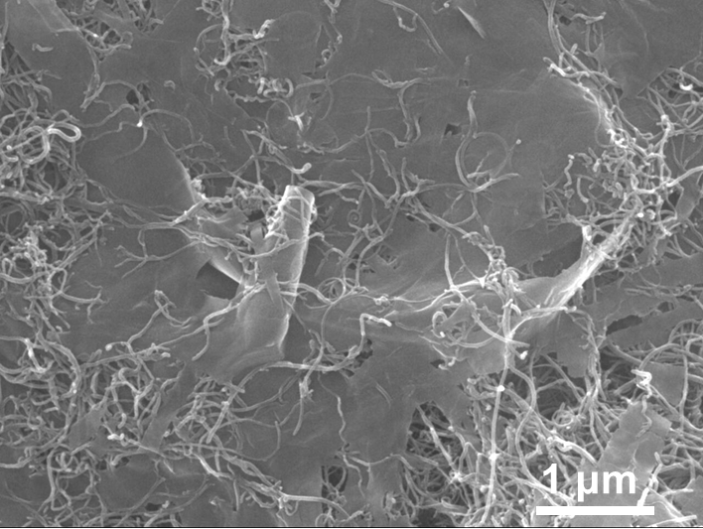
Figure S19. SEM image of H₂V₃O₈ hydrogels/CNTs after 1000 cycles at 4.0 A g⁻¹.

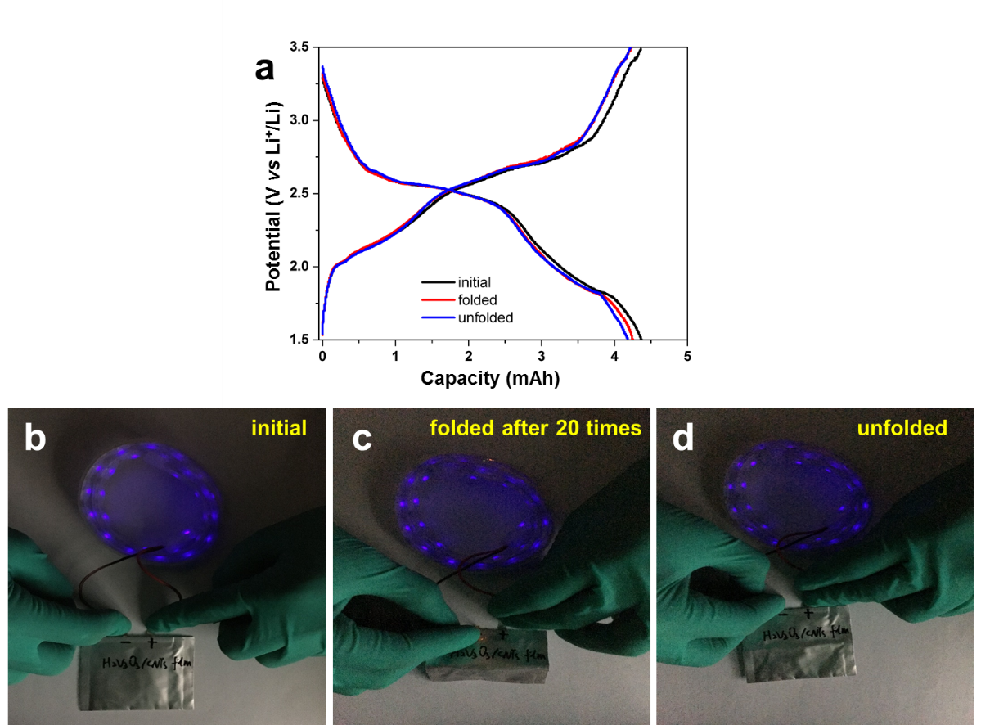
Figure S20. Reversibility and durability testing of the flexible H₂V₃O₈/CNTs pouch cell. (a) The charge-discharge curves of pouch cell at initial, folded and unfolded states. The photograph of pouch cell lighting the LED at initial (b), folded (c), and unfolded (d) states.

