Supplementary Information

Three-dimensional graphene frameworks wrapped Li₃V₂(PO₄)₃ with reversible topotactic sodium-ion storage
Fangyu Xiong, Shuangshuang Tan, Qiulong Wei, Guobin Zhang, Jinzhi Sheng, Qinyou An* and Liqiang Mai*

State Key Laboratory of Advanced Technology for Materials Synthesis and Processing, Wuhan University of Technology, Wuhan, 430070 (P. R. China).
E-mail: (anqinyou86@whut.edu.cn, mlq518@whut.edu.cn)

Table S1. The lattice parameters of fresh LVP-G-FD and LVP-G-FD after first charge/discharge process (2.5-4.2 V).
Sample | a [Å] | b [Å] | c [Å] | β [°]
Fresh LVP-G-FD | 8.62 | 8.60 | 12.05 | 90.47
LVP-G-FD after first cycle | 8.67 | 8.72 | 12.16 | 91.22

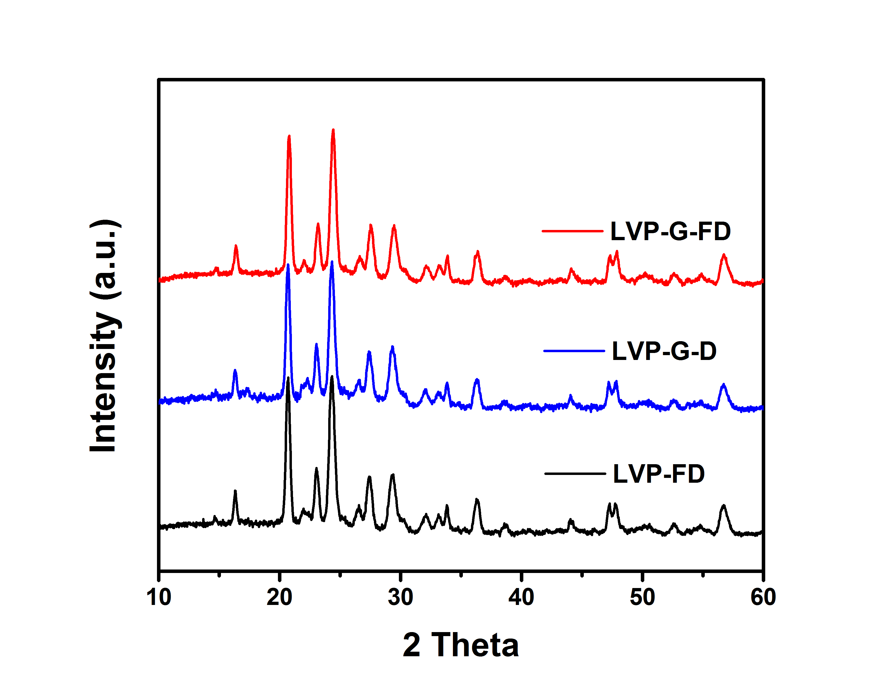
Fig. S1. The XRD patterns of LVP-G-FD, LVP-G-D and LVP-FD.
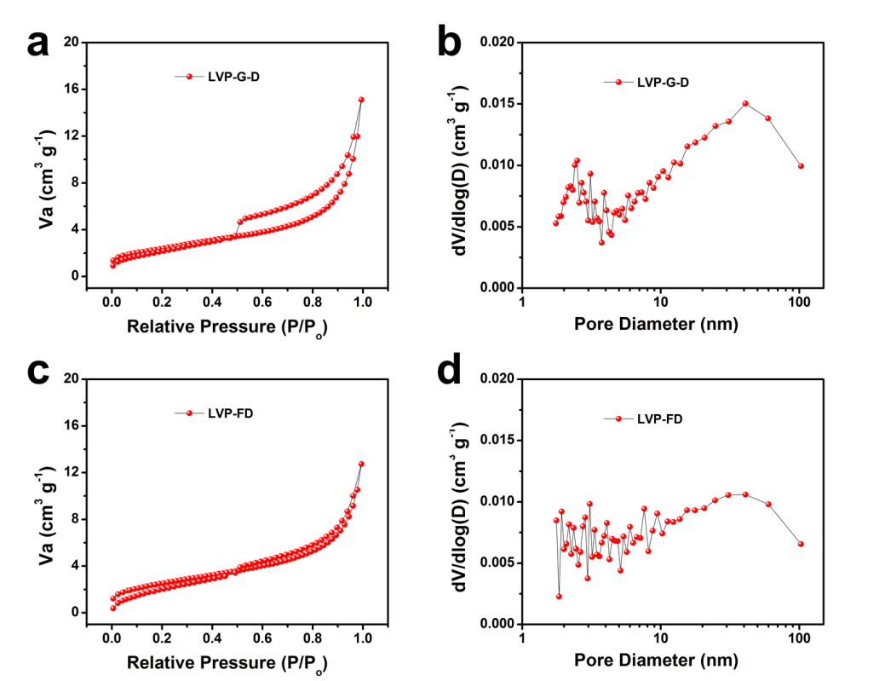
Fig. S2. (a) Nitrogen adsorption-desorption isotherms of LVP-G-D and (b) corresponding pore size distribution. (c) Nitrogen adsorption-desorption isotherms of LVP-FD and (d) corresponding pore size distribution.

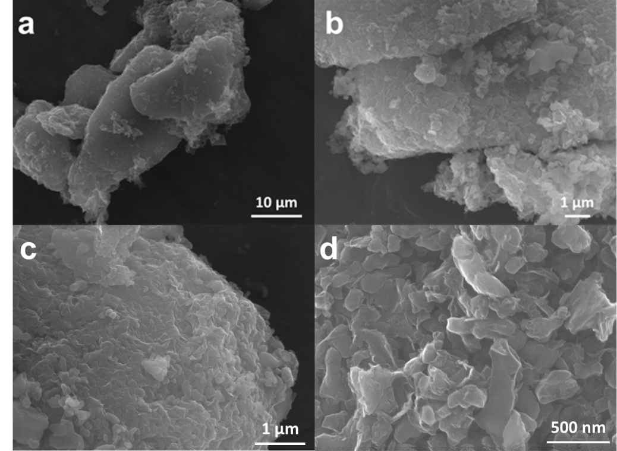
Fig. S3. FESEM images of LVP-G-FD.

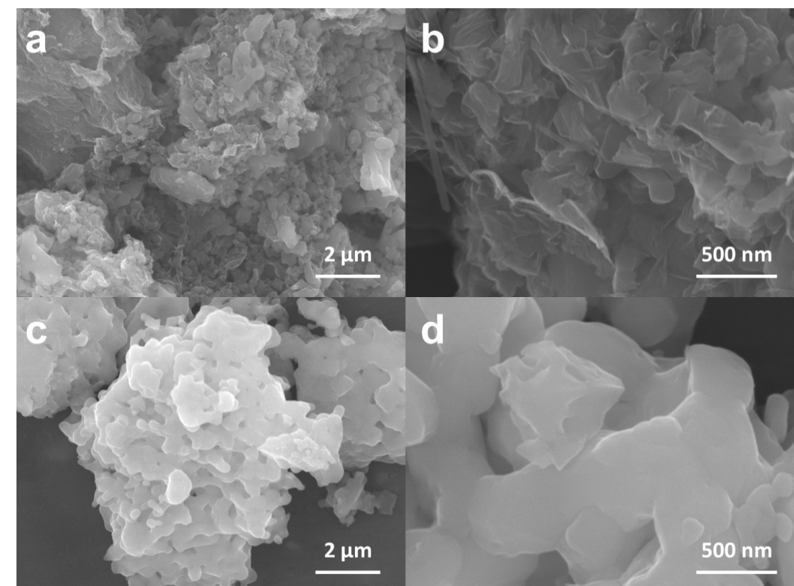
Fig. S4. FESEM images of LVP-G-D (a, b) and LVP-FD (c, d).

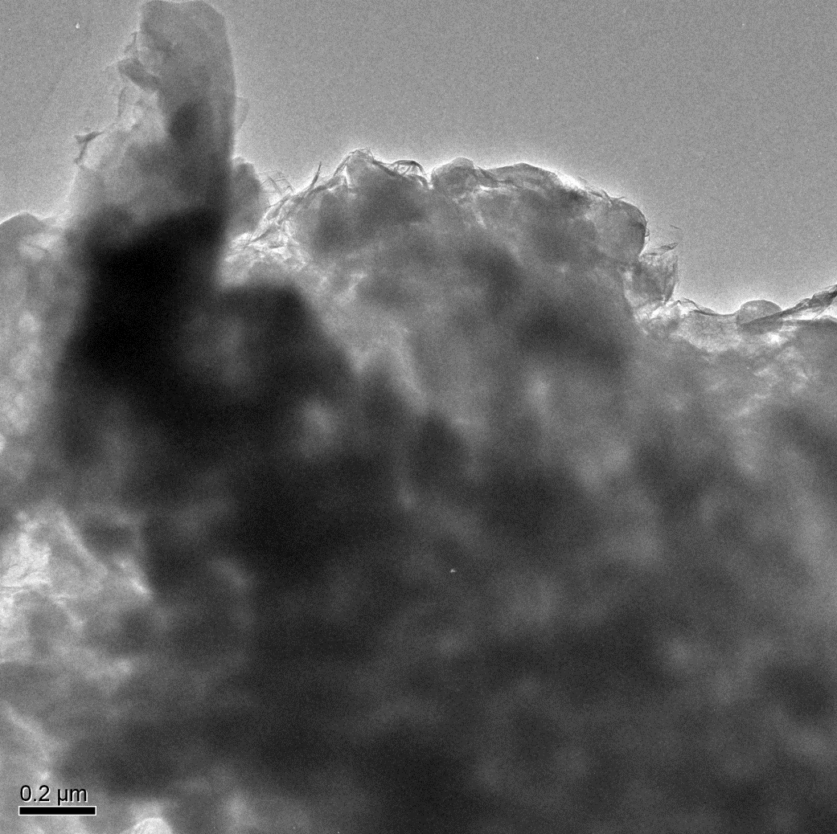
Fig. S5. TEM images of LVP-G-FD.

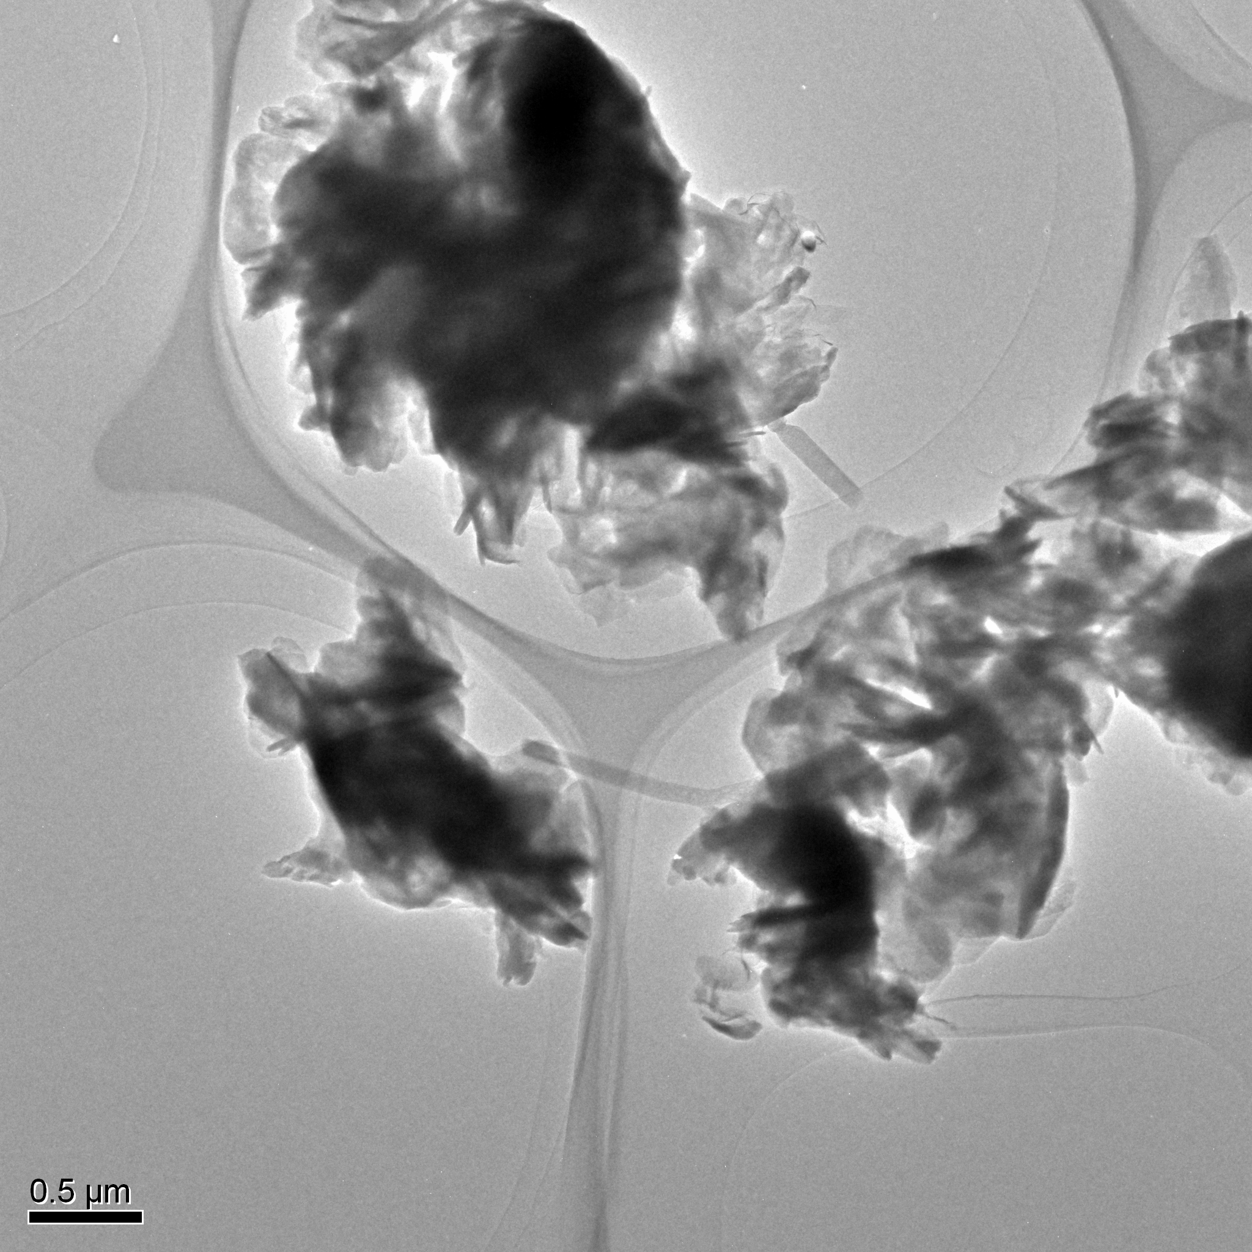
Fig. S6. TEM images of LVP-G-D.
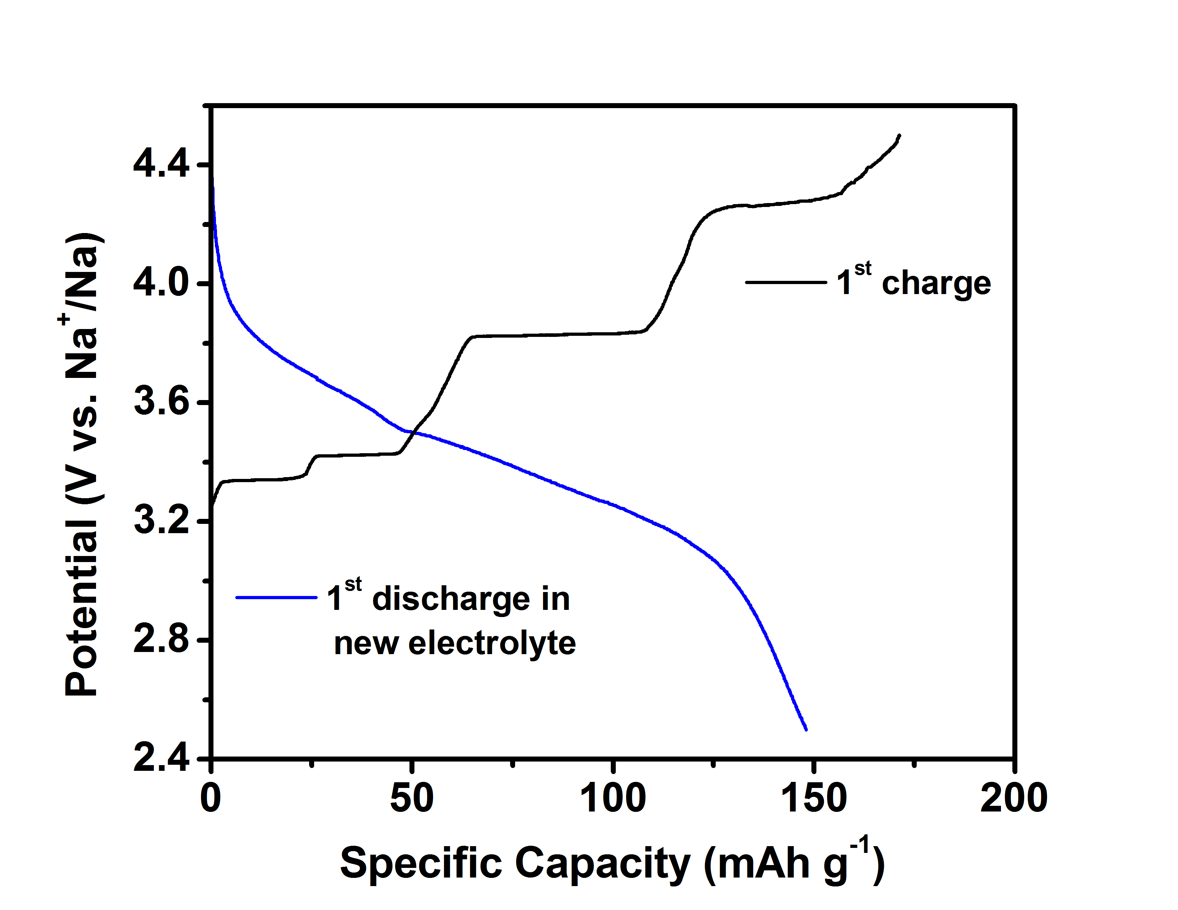
Fig. S7. Charge/discharge curves of LVP-G-FD at the potential range from 2.5 to 4.5 V.
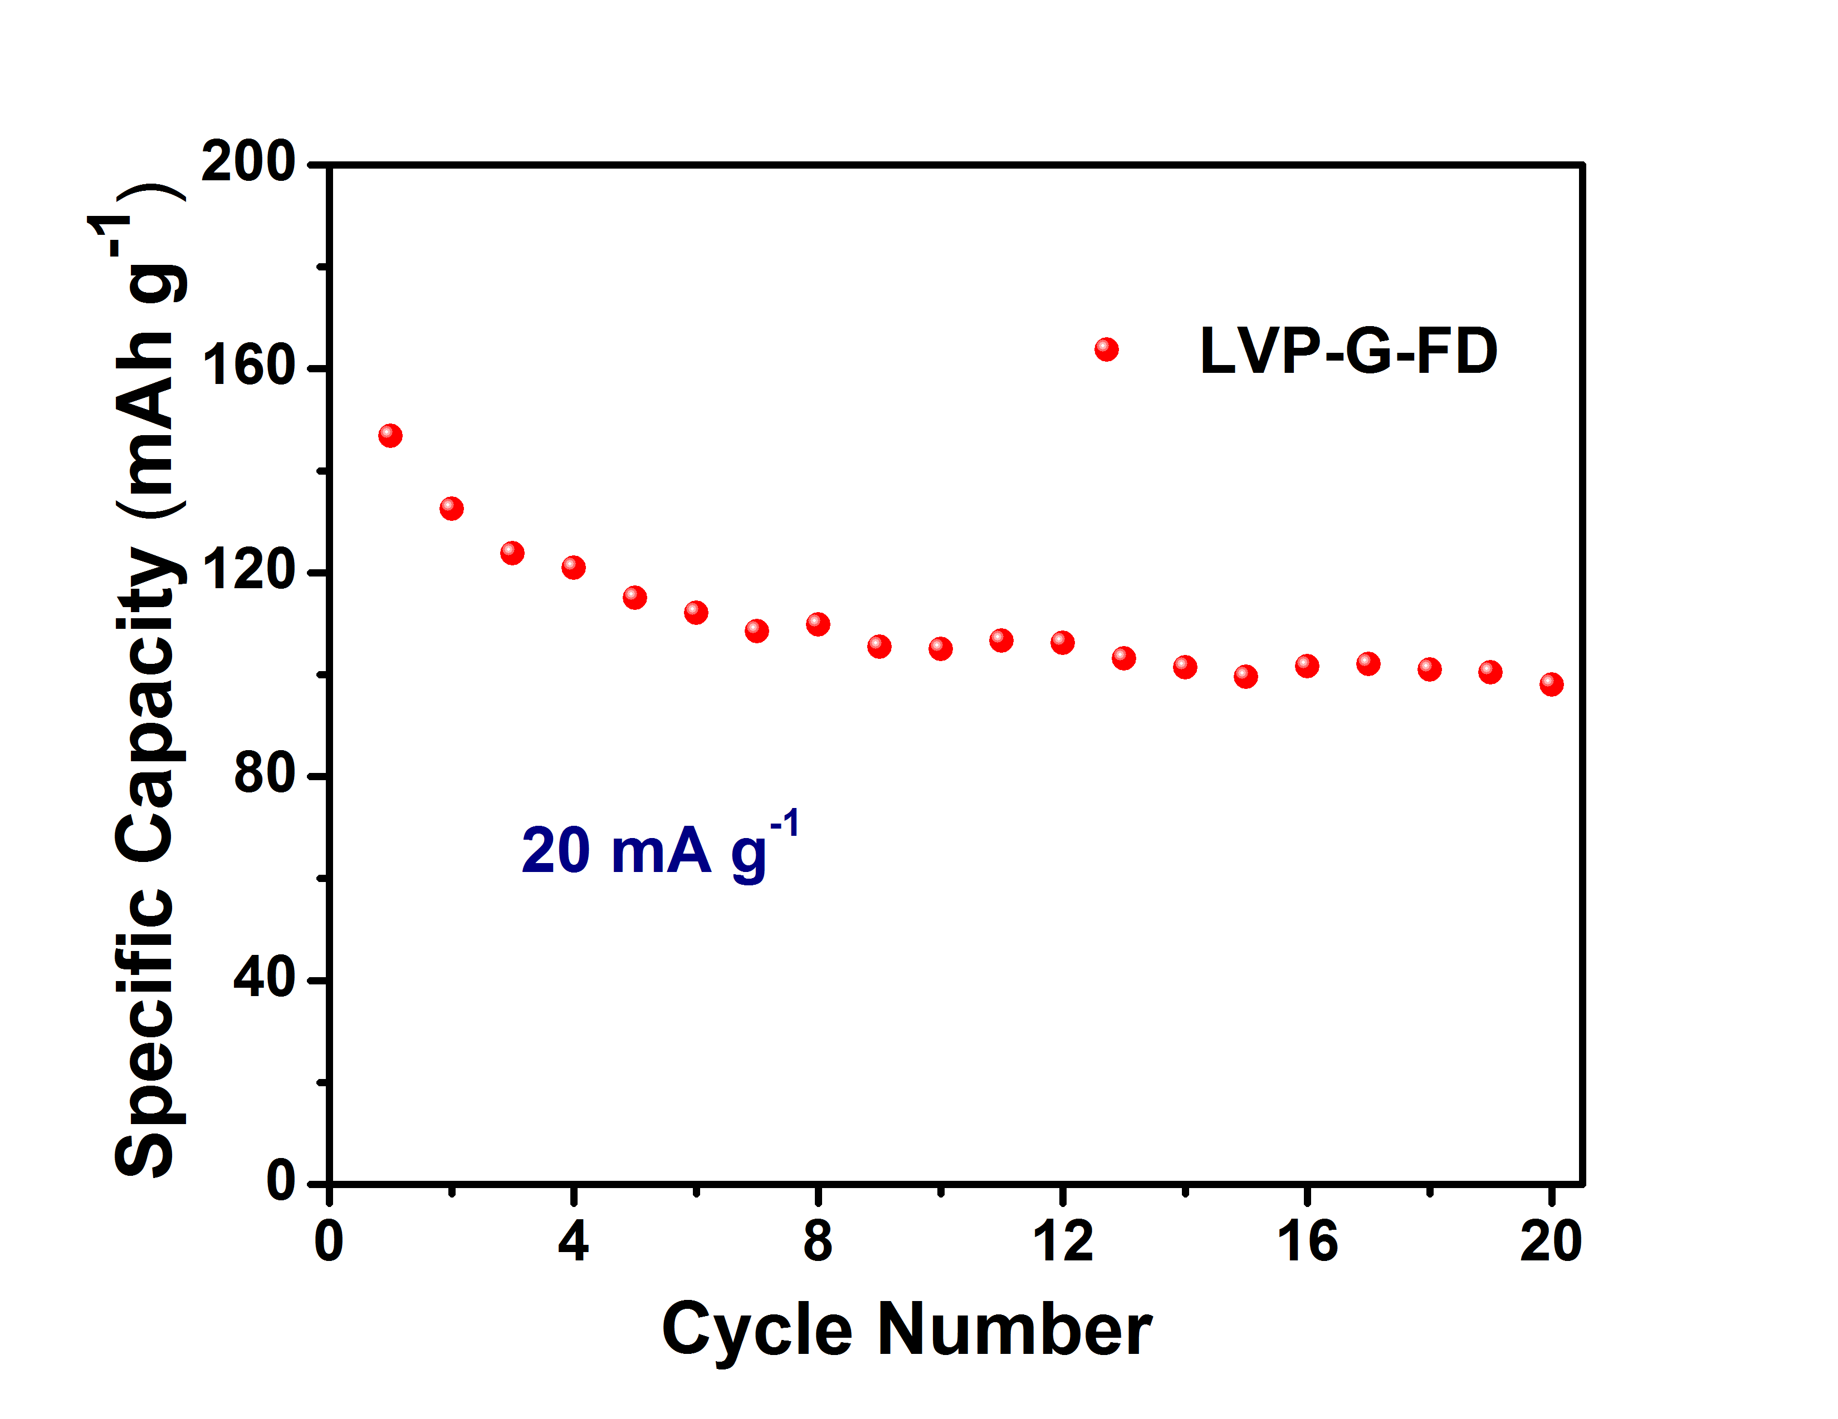
Fig. S8. The cycling performance of LVP-G-FD at 20 mA g⁻¹ in the potential range from 2.5 to 4.5 V.

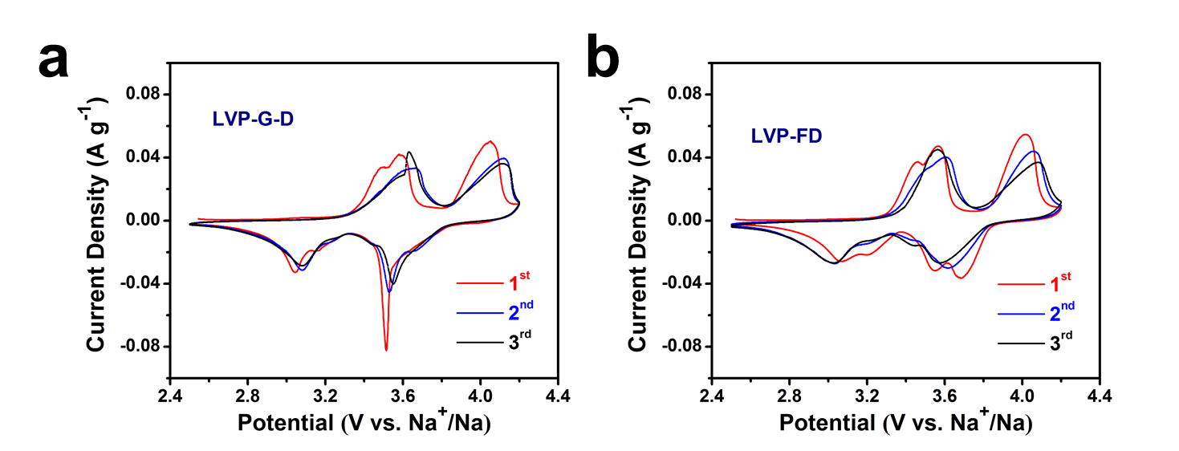
Fig. S9. The CV curves of LVP-G-D (a) and LVP-FD (b) in first three cycles at a scan rate of 0.1 mV s⁻¹ in the potential range from 2.5 to 4.2 V.

