Supporting Information

All-Flexible Lithium Ion Battery Based on Thermally-Etched Porous Carbon Cloth Anode and Cathode
Muhammad-Sadeeq Balogun, ª Feiyi Lyu, ª Yang Luo, ª Weitao Qiu, ª Hui Meng, ^{c} Jiantao Li, ^{b} Wenjie Mai,* ^{c} Liqiang Mai,* ^{b} and Yexiang Tong* ª
ª MOE of the Key Laboratory of Bioinorganic and Synthetic Chemistry, KLGHEI of Environment and Energy Chemistry, The Key Lab of Low-carbon Chem & Energy Conservation of Guangdong Province, School of Chemistry and Chemical Engineering, Sun Yat-Sen University, Guangzhou 510275, People’s Republic of China; E-mail: chedhx@mail.sysu.edu.cn; Tel: +86-20-84110071; Fax: +86-20-84112245.
^{b} State Key Laboratory of Advanced Technology for Materials Synthesis and Processing, Wuhan University of Technology, Wuhan 430070, China; E-mail: mlq518@whut.edu.cn
^{c} Department of Physics and Siyuan Laboratory, Jinan University, Guangzhou 510632, P. R. China; E-mail: wenjiemai@gmail.com

Capacity contribution of the CC in the CC-Fe₃O₄ electrode
We calculated the contribution of the modified CC in the CC-Fe₃O₄. The total mass of the electrode on 1×1 cm² area is around 10.16 mg (~10 mg CC and ~0.16 mg Fe₃O₄ NPs). The experimental areal capacity delivered by the CC-Fe₃O₄ electrode is 1.82 mAh/cm² and mass capacity delivered by the CC-Fe₃O₄ electrode is 185 mAh/g. Therefore, the ratio of the areal capacity to that of the total mass is 180 mAh/g, i.e.
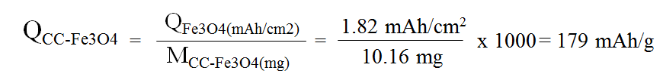
where Q represents discharge capacity in mAh/g and M is the mass loading in mg. This capacity is almost the same with the experimental mass capacity of the CC-Fe₃O₄ electrode at 185 mAh/g.
Since the theoretical capacity of the CC-FeD is 171 mAh/g with mass loading of about 10 mg, the total contribution of carbon cloth is therefore roughly 1.71 mAh/cm², i.e.
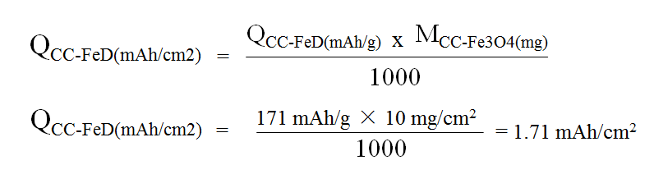
where Q represents discharge capacity in mAh/cm². This capacity is also close to the experimental capacity around 1.69 mAh/cm².
Therefore, the capacity percentage of the porous CC is;
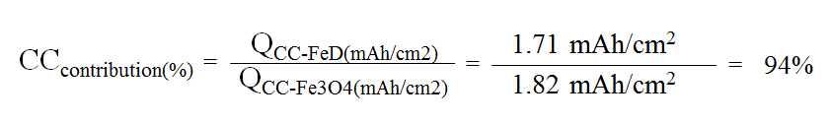
Since the capacity of the CC-FeD is 171 mAh/g, the total contribution of carbon cloth is therefore roughly 171 mAh/g × 10 mg/cm² = 1.71 mAh/cm², which is also close to the experimental capacity around 1.69 mAh/cm². This means that the porous CC constitute about 94% of the total capacity of the CC-Fe₃O₄ electrode.
Supplementary Figures
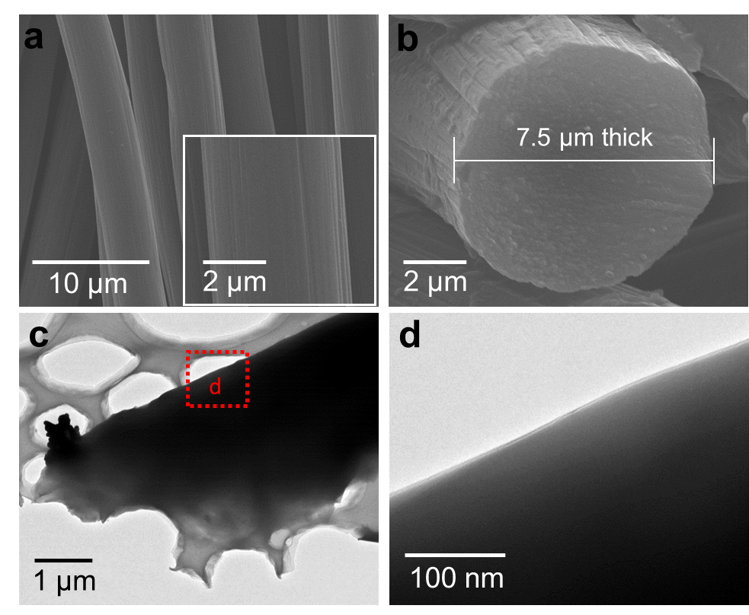
Figure S1. (a) SEM image the PCC. Inset is the low magnification SEM image. (b) SEM image of the CC displaying its thickness. (c) TEM image of the carbon cloth and (d) HRTEM of the PCC sample displaying the smooth surface carbon fiber.

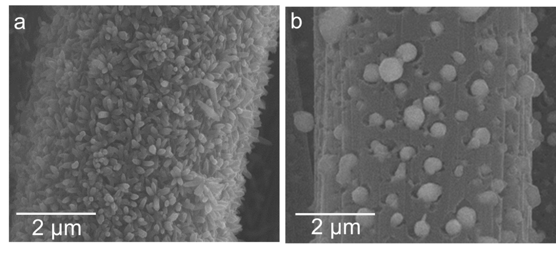
Figure S2. Enlarge SEM images of a) CC-FeOOH NRs and b) porous CC-Fe₃O₄ NPs.

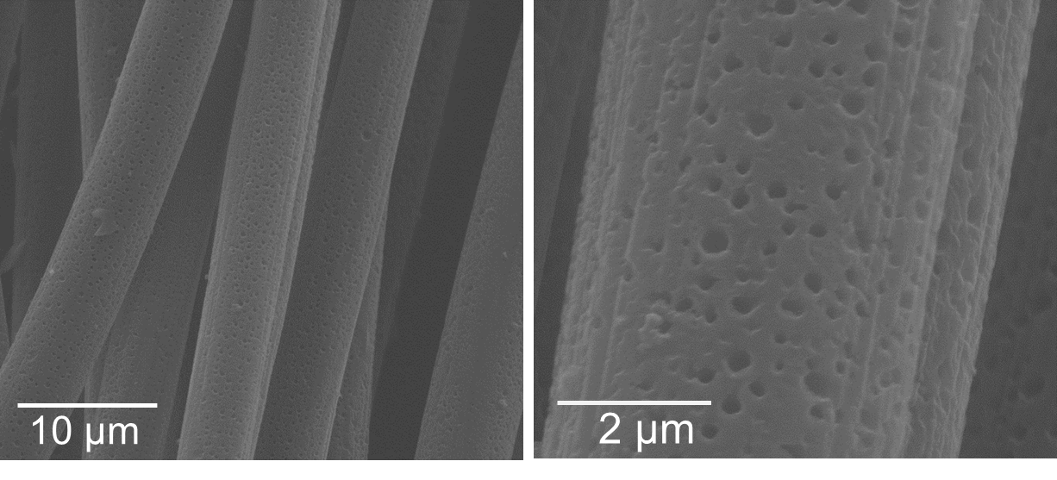
Figure S3. Enlarge SEM images of the Porous CC-FeD.

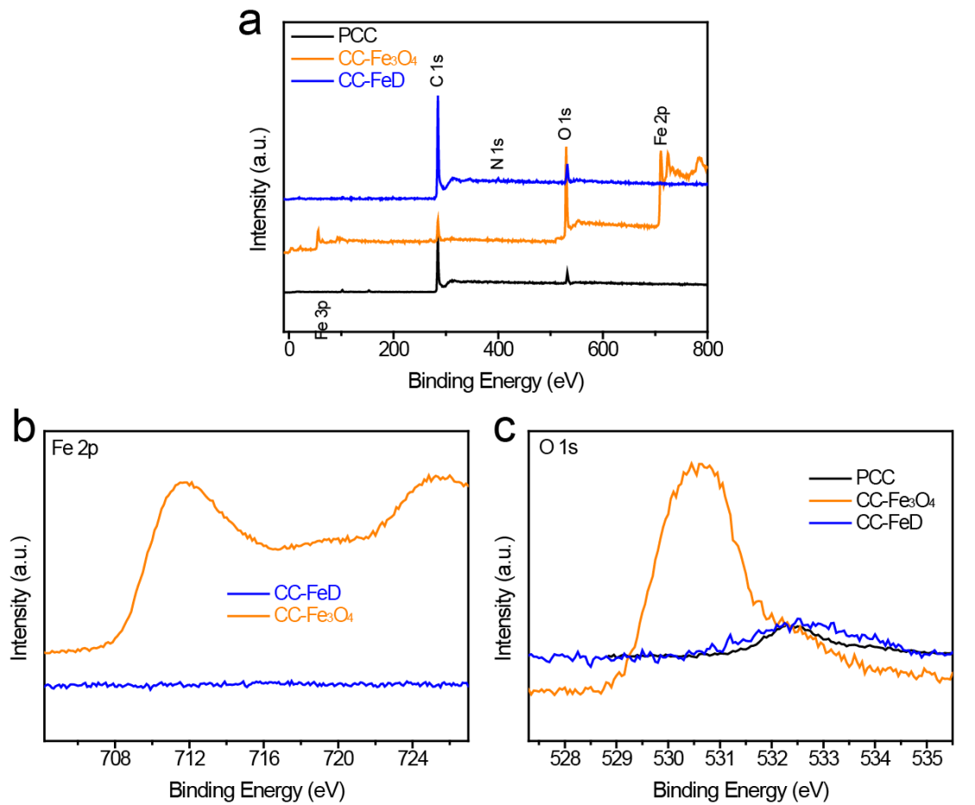
Figure S4. (a) XPS survey spectra of the PCC, CC-Fe₃O₄ and CC-FeD samples displaying only the presence of C peak, O peak and N-heteroatom peak in the CC-FeD samples. b) Fe 2p core-level spectra of the CC-FeD and CC-Fe₃O₄ showing no trace of Fe peaks in the CC-FeD samples. e) O 1s core-level spectra of the PCC, CC-Fe₃O₄ and CC-FeD samples, which indicate the low content of oxygen in the modified CC samples justifying the absence of iron oxides.

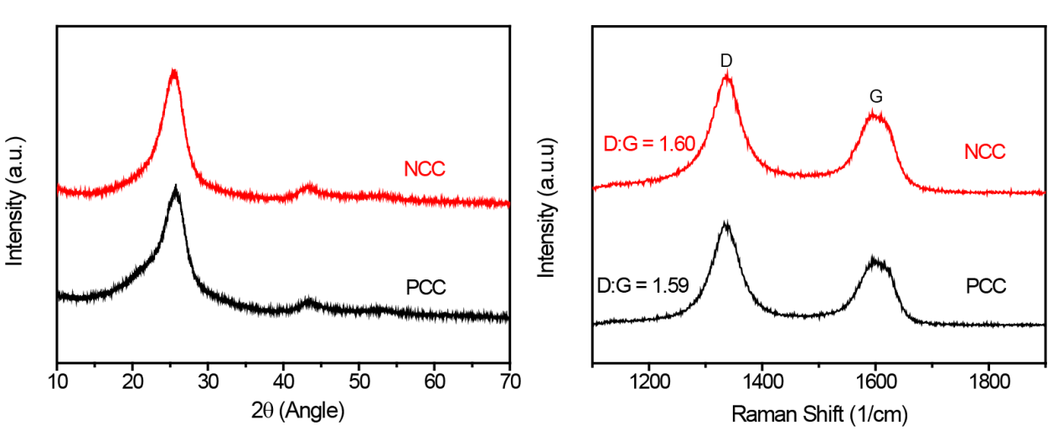
Figure S5. XRD and Raman spectra of the PCC and NCC displaying the same phases.

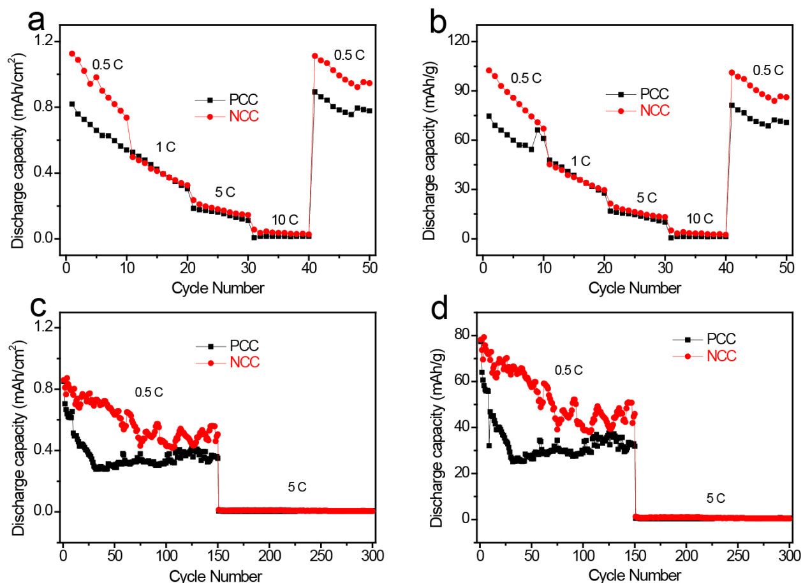
Figure S6. Lithium storage properties of the PCC and NCC showing no obvious difference upon N₂ treatment of the carbon cloth, which further indicates that the N2 has positive effect on the untreated carbon cloth.

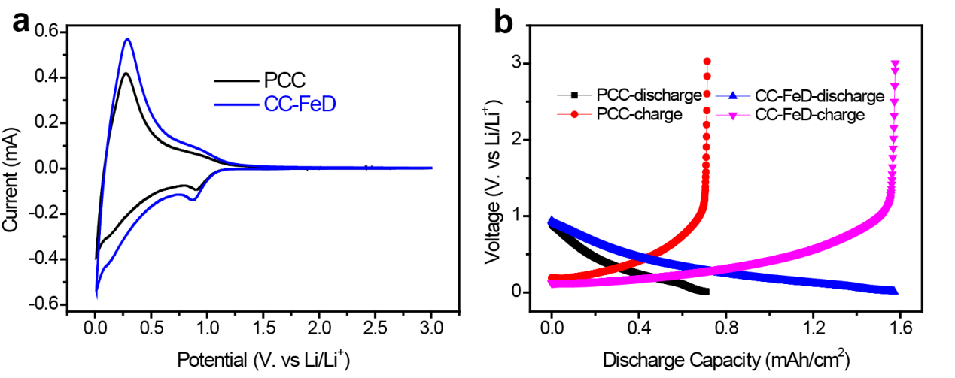
Figure S7. (a) CV curves and (b) charge/discharge profiles of the PCC and CC-FeD electrodes during the second cycle.
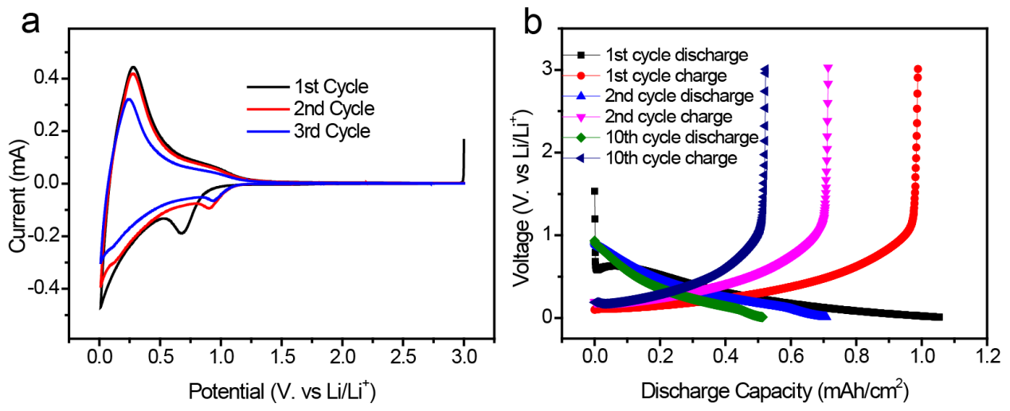
Figure S8. a) 1st-3rd CV curves and b) 1st-10th charge/discharge profiles of the PCC electrode.
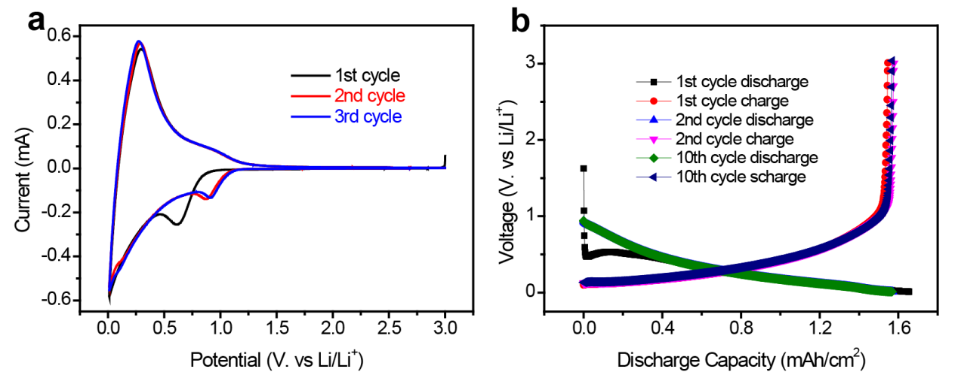
Figure S9. a) 1st-3rd CV curves and b) 1st-10th charge/discharge profiles of the CC-FeD electrode.
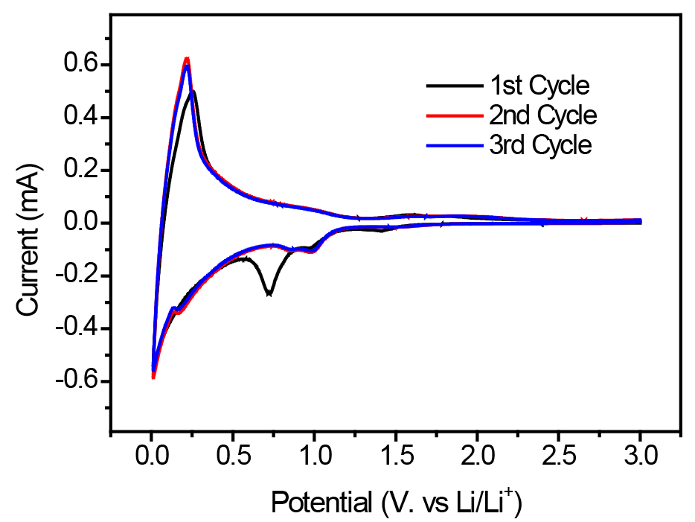
Figure S10. 1st-3rd CV curves of the CC-Fe₃O₄ electrode.

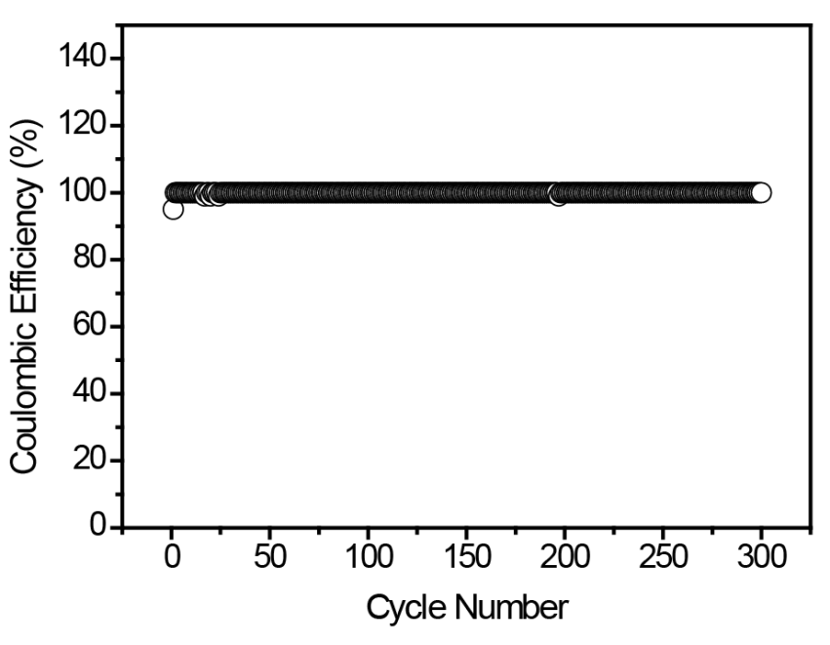
Figure S11. 1st to 100th coulombic efficiency of the CC-FeD electrode displaying an initial coulombic efficiency of 95% and rise to 100% in the following cycles up to 100 cycles.
Figure S12. (a) The equivalent circuit use to fit the plot. (b) Nyquist plot of the CC-FeD electrode before and after cycling. It depicted a reduction in the resistance of the electrode after continuously repeated cycling.
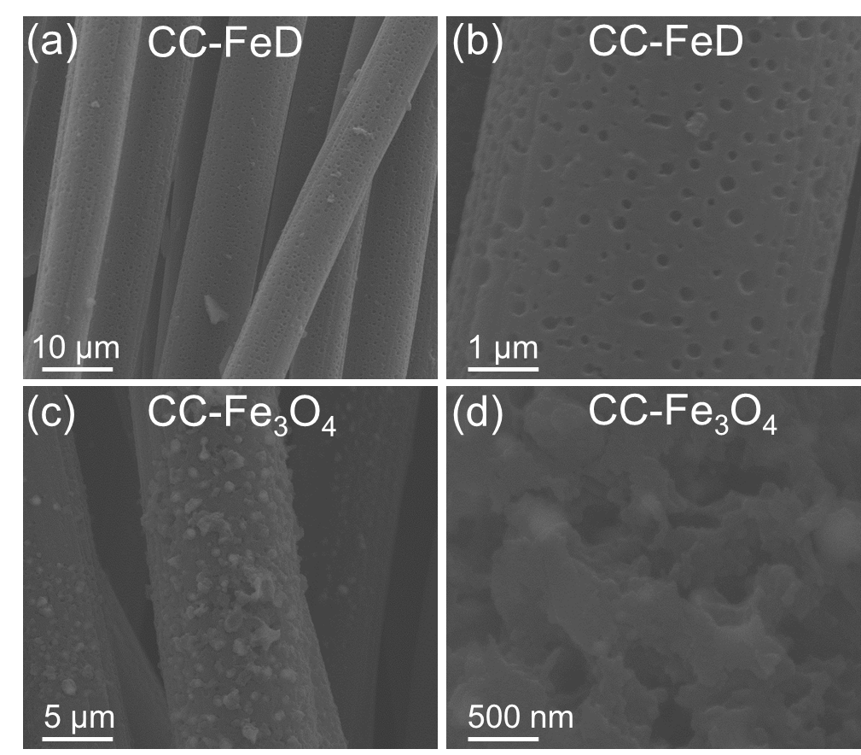
Figure S13. SEM images of the (a-b) Porous CC-FeD electrode and (c-d) porous CC-Fe₃O₄ NPs after cycling. The images show that the porous structure can still maintain their original morphology after long time cycling.

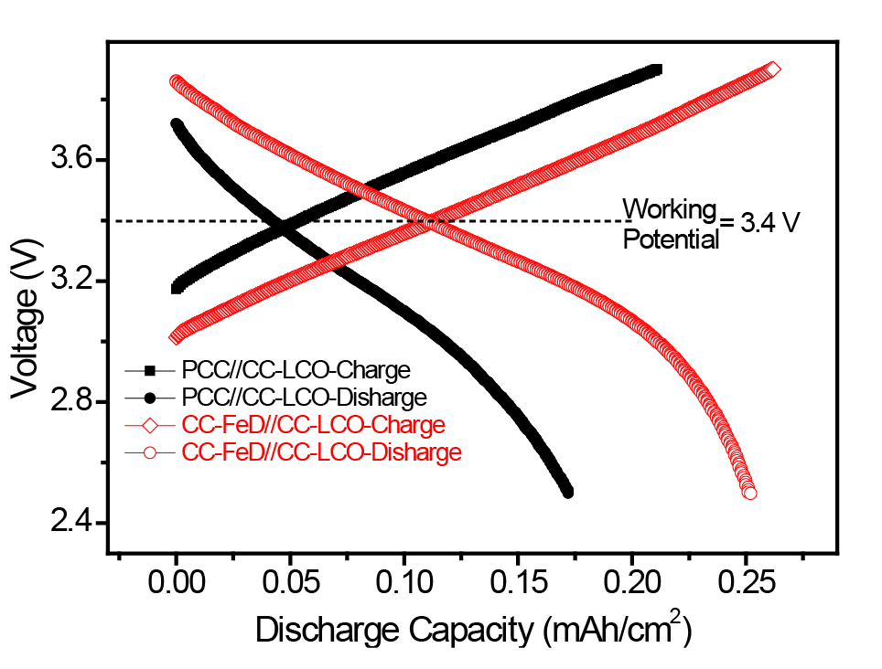
Figure S14. Discharge-charge curves of the PCC//CC-LCO and CC-FeD//CC-LCO coin cell LIB showing a working voltage of 3.4 V.
Figure S15. Steps in assembling the CC-FeD//CC-LCO all-flexible LIB device.

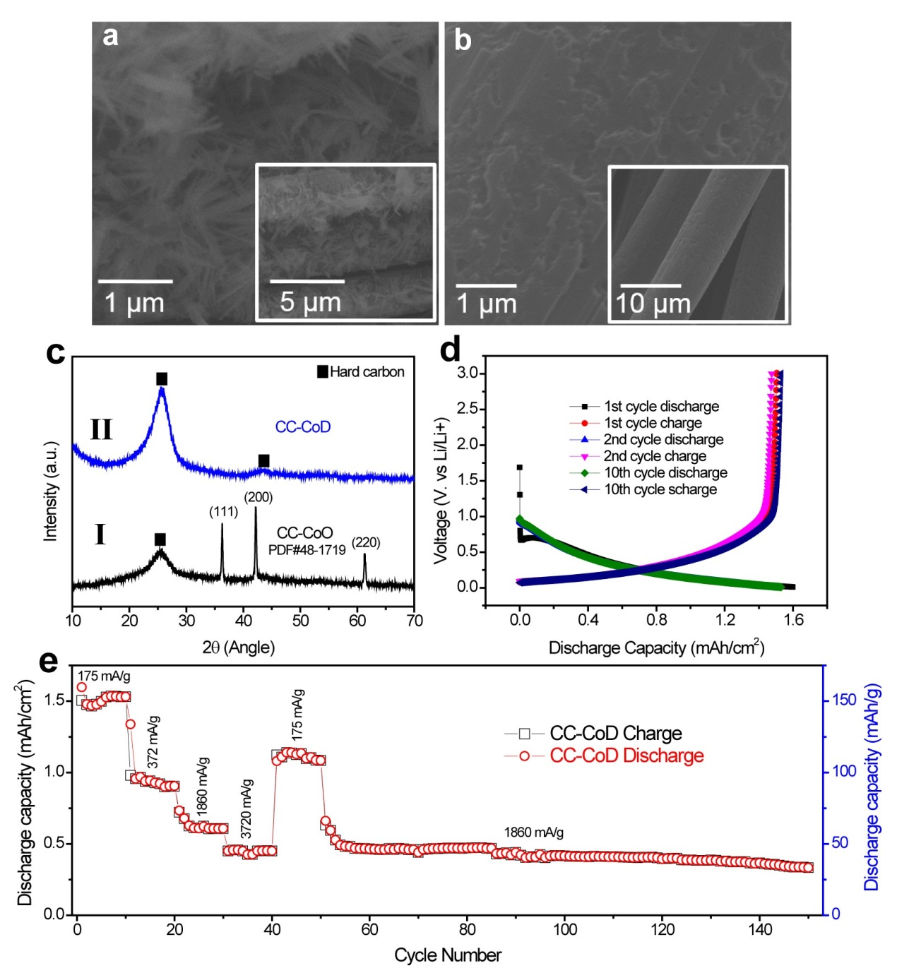
Figure S16. (a) SEM images of the Co nanowires precursor before annealing. Inset is the low magnification SEM image. (b) SEM image of the CC-CoD sample. Inset is the low magnification SEM image. (c) XRD pattern, d) discharge-charge profile at 175 mA/g and (e) lithium storage performance of the CC-CoD electrode.

