Supporting information

**Graphene Wrapped NASICON-type Fe2(MoO4)3 Nanoparticles as a Ultra-high Rate** **Cathode for Sodium Ion Batteries**

Jinzhi Shenga,1, Han Zanga,1, Chunjuan Tanga,b,1­­­, Qinyou Ana,*, Qiulong Weia, Guobin Zhanga, Lineng Chena, Chen Penga and Liqiang Maia,*

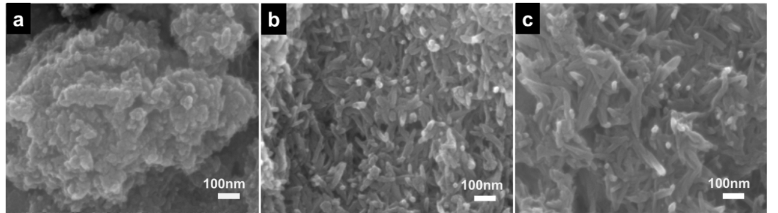

**Figure S1** SEM images of the precursor under stiring after 10 min (a), 30 min (b) and 60 min (c).

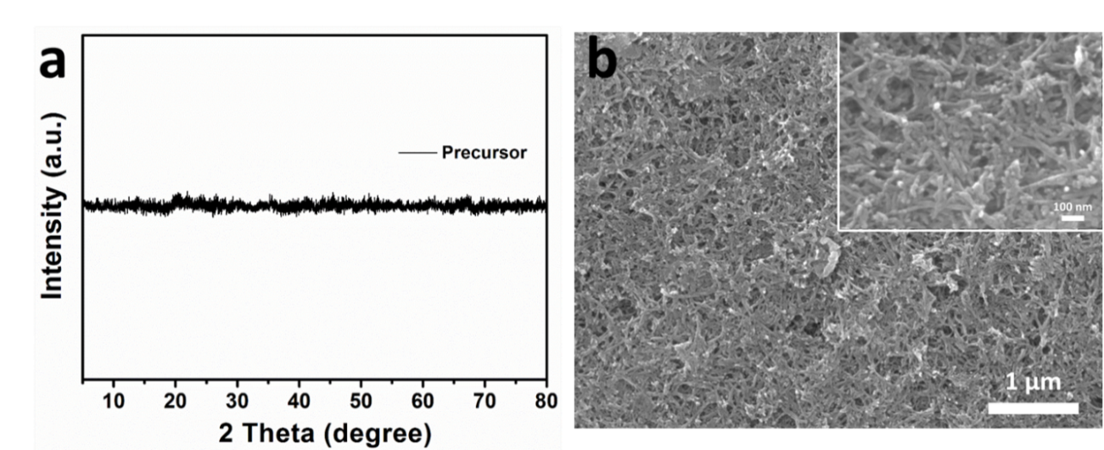

**Figure S2** XRD pattern (a) and SEM images (b) of the precursor.

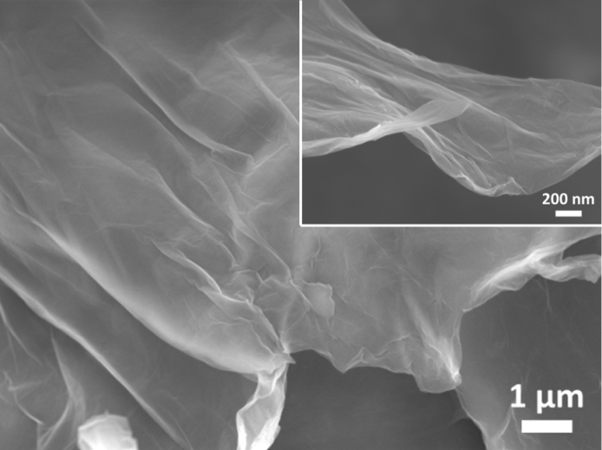

**Figure S3** SEM images of pure graphene.

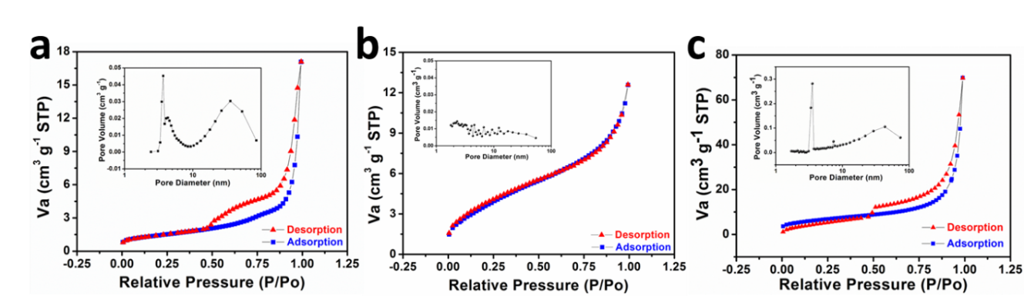

**Figure S4** Nitrogen adsorption-desorption isotherms of FMO-H (a), FMO-M (b), FMO-MG (c) and the corresponding pore size distribution (insets).

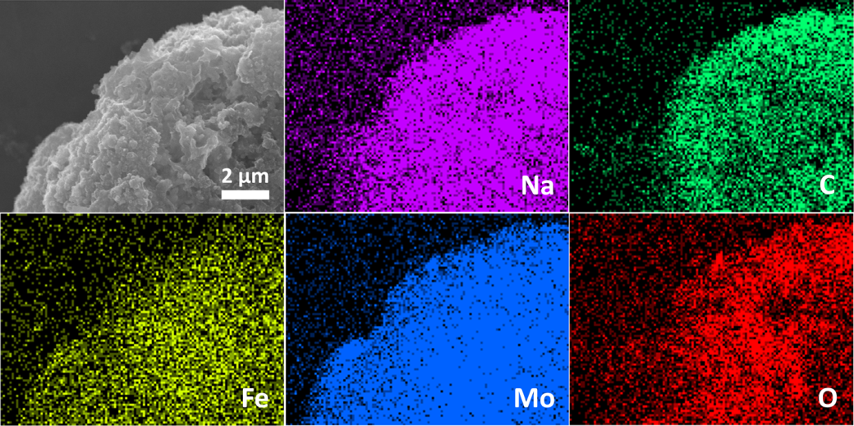

**Figure S5** EDS-mapping of FMO-MG after discharged to 1.5 V.

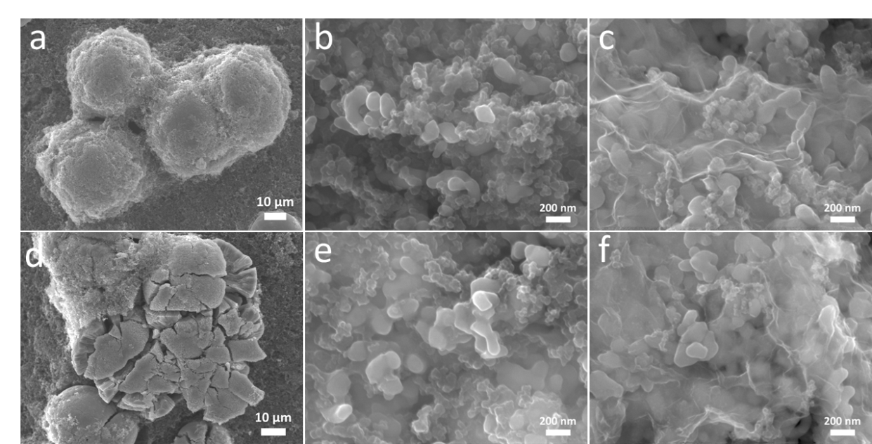

**Figure S6** SEM images of electrode slices made by FMO-H (a), FMO-M (b), FMO-MG (c) before cycling; and electrode slices made by FMO-H (d), FMO-M (e), FMO-MG (f) after 20 cycles.

C:\Users\Administrator\Desktop\CD-10C xin.tif

**Figure S7** Charge-discharge curves of FMO-MG in different cycles.

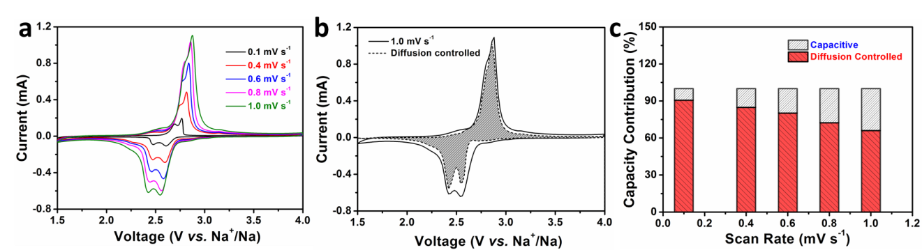

**Figure S8** (a) Cyclic voltammogram curves of FMO-MG at different scan rates; (b) CV curve for FMO-MG at a scan rate of 1 mV s-1, the estimated diffusion controlled capacity contribution is shown in the shaded region; (c) capacity contributions of FMO-MG under different scan rates.

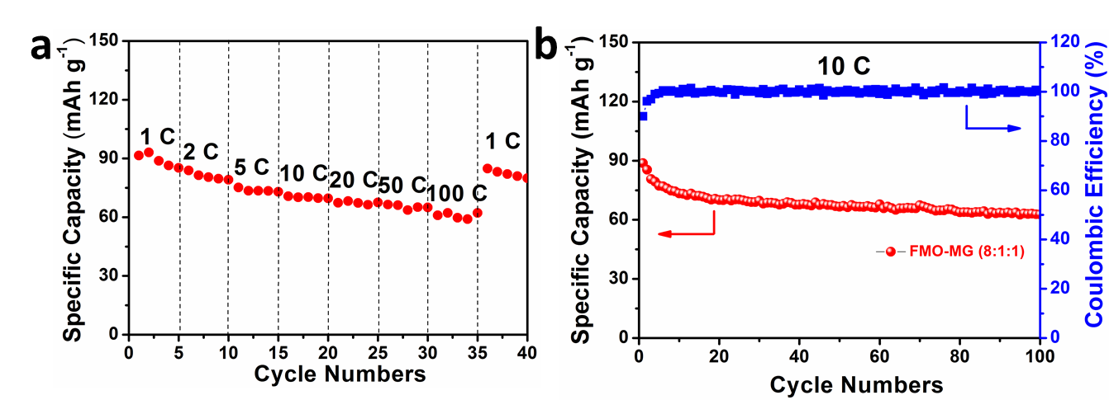

**Figure S9** Rate performance (a) and cycling performance (b) of the electrode prepared by mixing the active materials, acetylene black and PTFE in a weight ratio of 8:1:1.

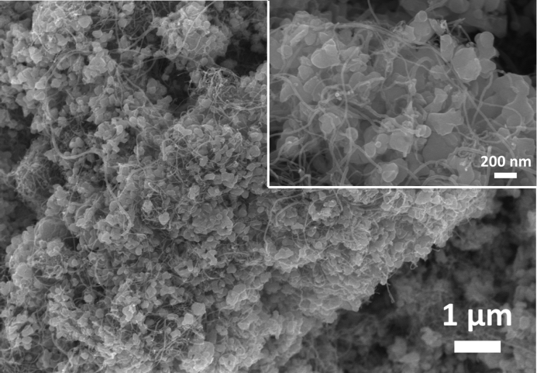

**Figure S10** SEM images of FMO-CNTs.

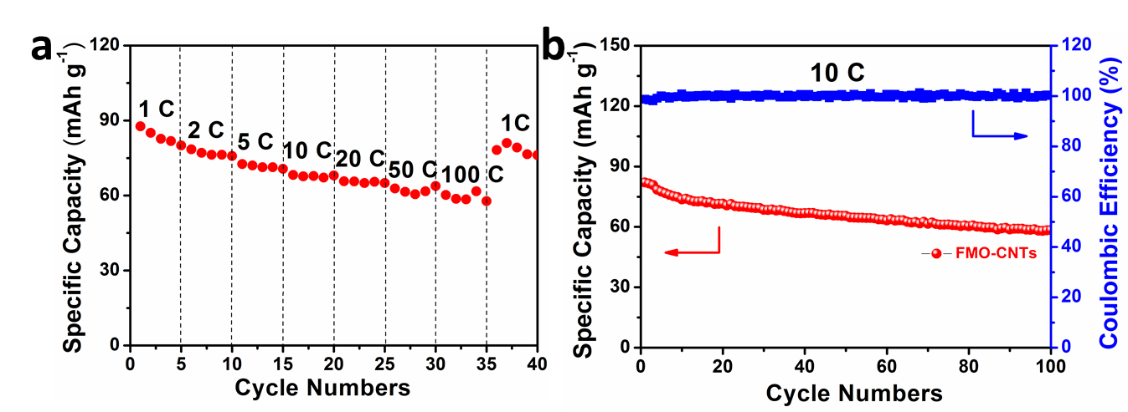

**Figure S11** Rate performance (a) and cycling performance (b) of FMO-CNTs.

**Equation S1**



C ---- Specific capacity;

n ---- Transfer electronic number in a molecular;

F ---- Faraday constant;

M ---- The molecular weight

**Table S1.** Comparison of the Fe2(MoO4)3 SIB electrodes in the references.

|  |  |  |  |  |
| --- | --- | --- | --- | --- |
| **FMO samples** | **Voltage window** | **Specific**  **capacity** | **Rate capacity** | **Electrode composition** |
| Fe2(MoO4)3 thin film[19] | 1.5-4.0 V | 94 mAh g-1 at 1 C | / | / |
| Pure Fe2(MoO4)3[20] | 2.5-3.1 V | 89.5 mAh g-1 at C/20 | / | Active material: carbon black: PVDF=8:1:1 |
| Fe2(MoO4)3/nanosilver composite[21] | 1.8-3.2 V | 92 mAh g-1 at 0.1 C | / | Active material: acetylene black: PTFE=80:15:5 |
| Fe2(MoO4)3/carbon  nanotubes nanocomposite[22] | 1.5-3.5 V | 91 mAh g-1 at 0.1 C | 85 mAh g-1 at 1 C | Active material: acetylene black: PTFE=80:15:5 |
| Fe2(MoO4)3/RGO Nanocomposite[23] | 1.8-3.5 V | 90.6 mAh g-1 at 0.1 C | 80 mAh g-1 at 1.5 C | Active material: acetylene black: PTFE=80:15:5 |
| **This work** | **1.5-4.0 V** | **98.4 mAh g-1 at 2 C** | **64.1 mAh g-1 at 100 C** | **Active material: acetylene black: PTFE=6:3:1** |
| **This work** | **1.5-4.0 V** | **90.7 mAh g-1 at 10 C** | **60.9 mAh g-1 at 100 C** | **Active material: acetylene black: PTFE=8:1:1** |

**Table S2.** Resistances fitted by the EIS results.

|  |  |  |  |
| --- | --- | --- | --- |
|  | **FMO-H** | **FMO-M** | **FMO-MG** |
| **Rs (Ω)** | **7.3** | **6.2** | **5.1** |
| **Rct (Ω)** | **850** | **770** | **45** |