Supporting Information

Carbon-coated hierarchical NaTi₂(PO₄)₃ mesoporous microflowers with superior sodium storage performance

Chang Xu^{a,1}, Yanan Xu^{a,1}, Chunjuan Tang^{a,b}, Qiulong Weiª, Jiashen Mengª, Lei Huangª, Liang Zhou^{a,}*, Guobin Zhangª, Liang Heª, Liqiang Mai^{a,}*

ª State Key Laboratory of Advanced Technology for Materials Synthesis and Processing, Wuhan University of Technology, Wuhan 430070, PR China
^{b} Department of Mathematics and Physics, Luoyang Institute of Science and Technology, Luoyang 471023, PR China
* Corresponding authors.
E-mail addresses: liangzhou@whut.edu.cn (L. Zhou), mlq518@whut.edu.cn (L. Mai).
¹ These authors contributed equally to this work.

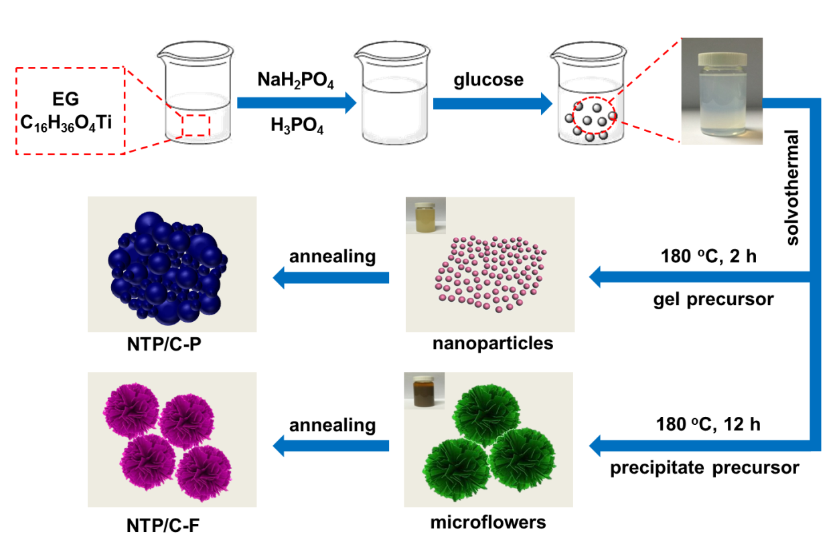
Figure S1 Schematic illustration of the fabrication process for the NTP/C-P and NTP/C-F.

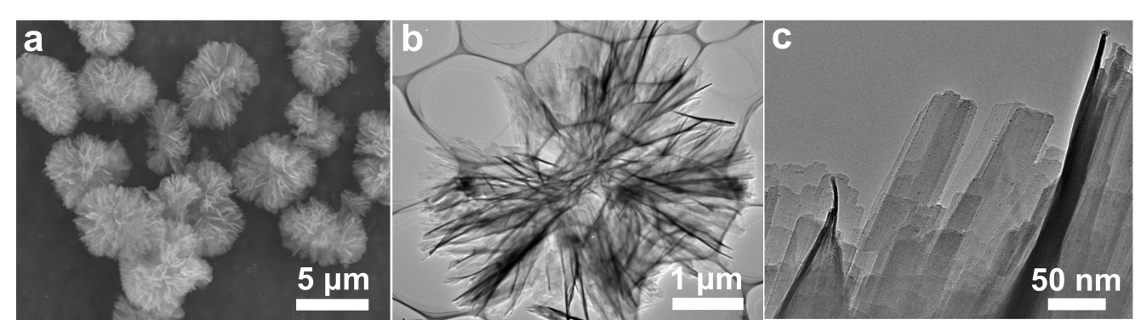
Figure S2 (a) FESEM image and (b, c) TEM images of NTP/C-F precursor.
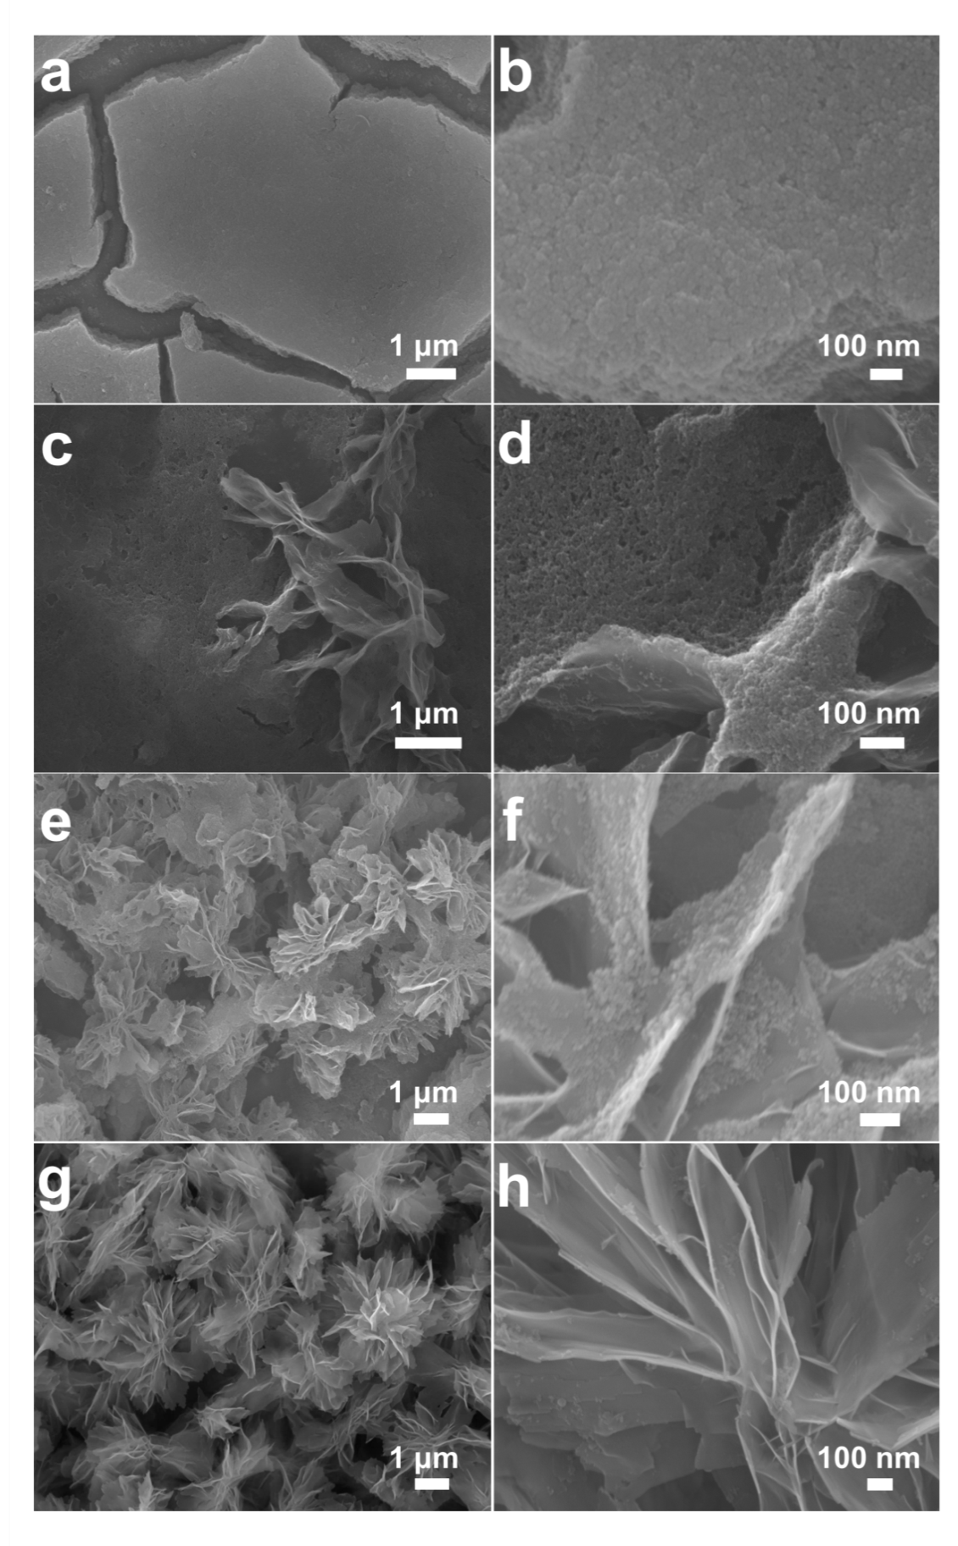
Figure S3 FESEM images of NTP precursors prepared with different solvothermal reaction time: (a, b) 2 h, (c, d) 3 h, (e, f) 4 h, (g, h) 8 h.

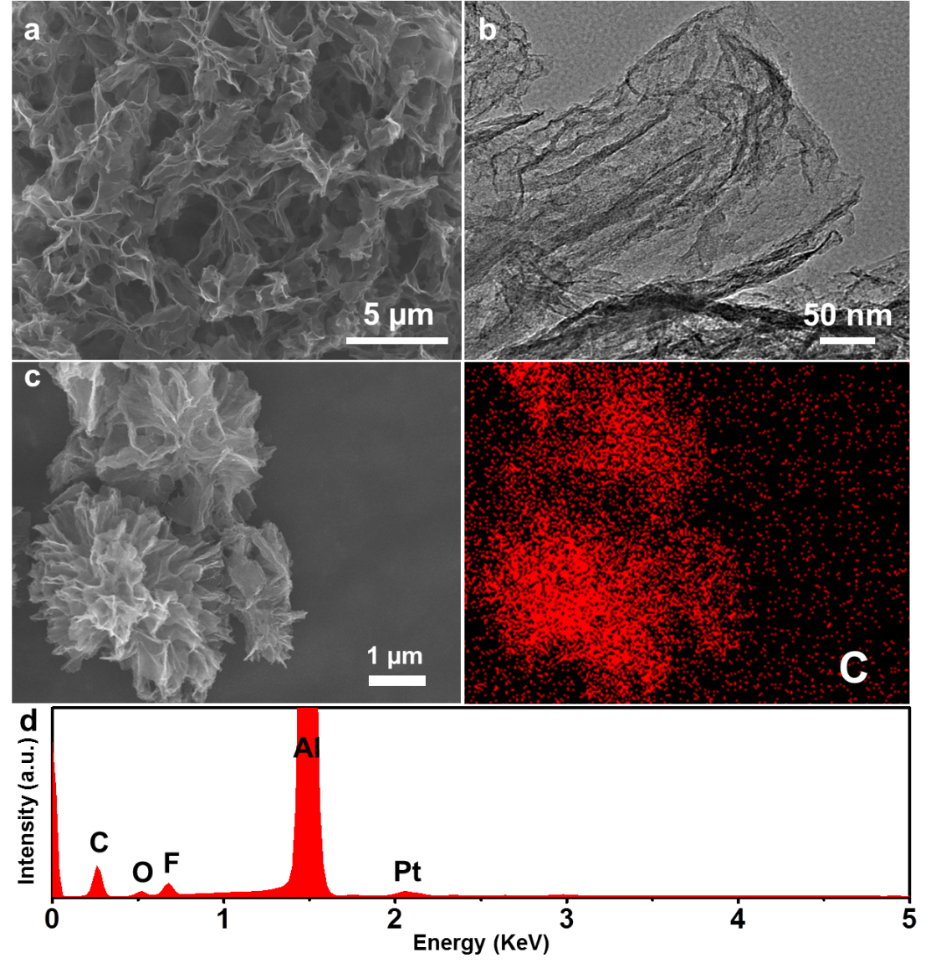

Figure S4 (a) SEM image, (b) TEM image, (c) EDS elemental mappings, and (d) EDS spectrum of the residual carbon skeleton after etching the NTP from NTP/C-F.

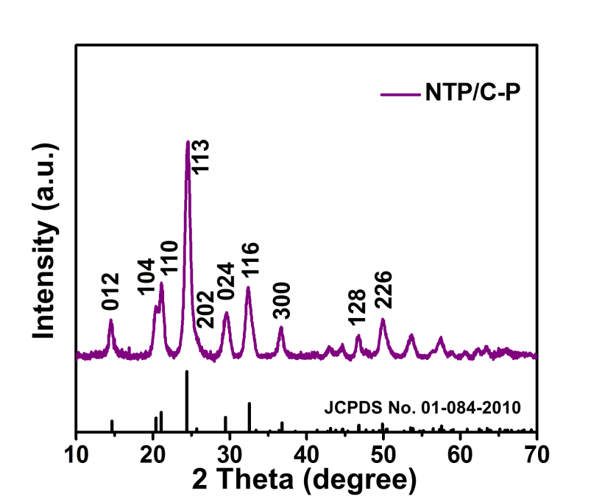
Figure S5 The XRD pattern of NTP/C-P.
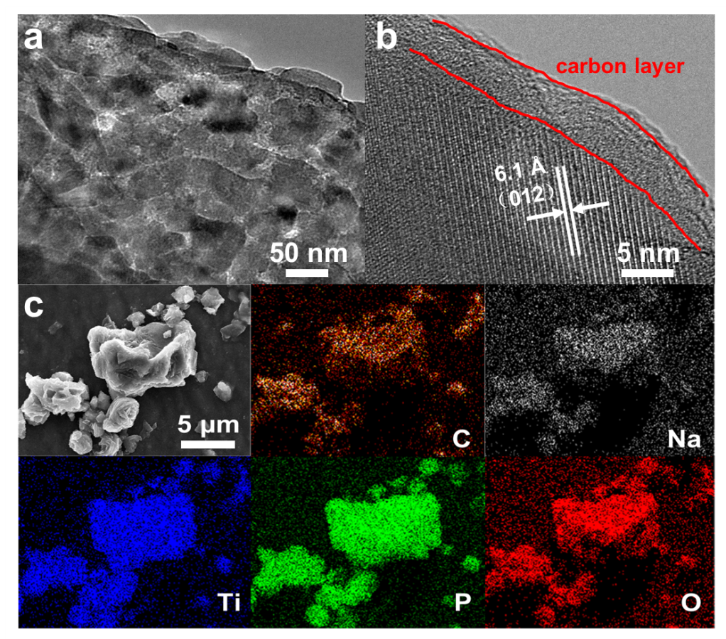
Figure S6 (a) TEM image, (b) HRTEM image, and (c) EDS elemental mappings of NTP/C-P.
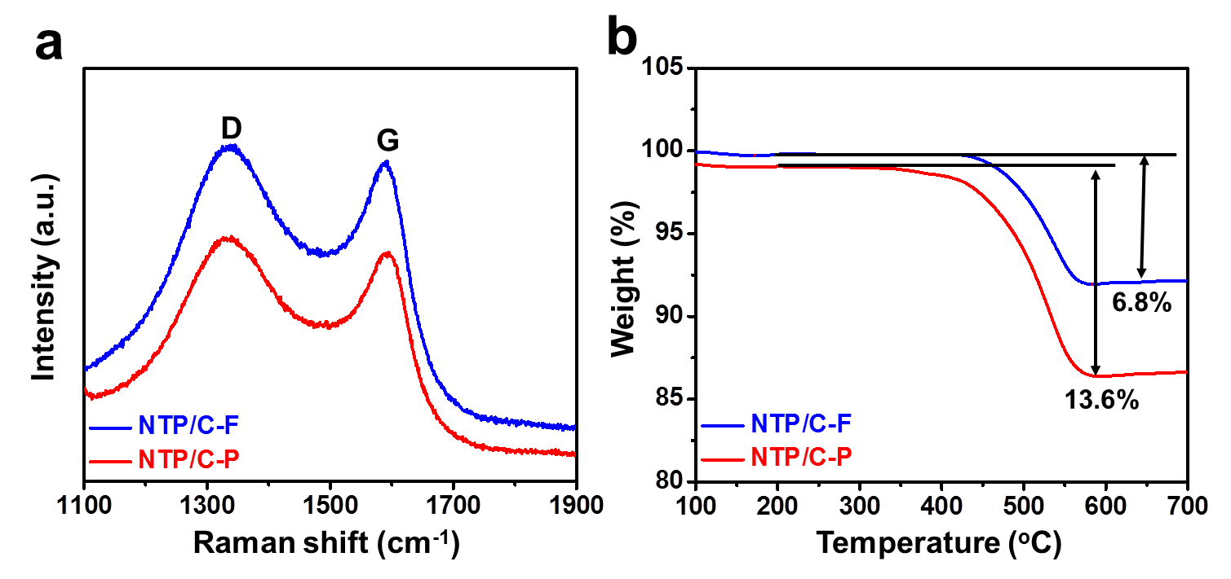Figure S7 (a) Raman spectra and (b) TGA curves of NTP/C-F and NTP/C-P.
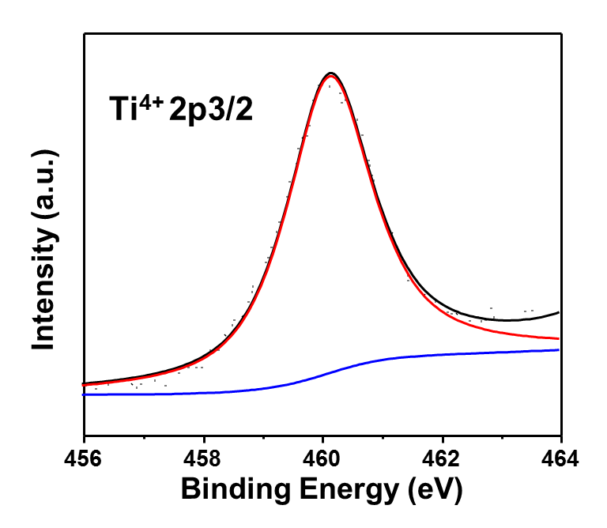
Figure S8 XPS spectra of the Ti 2p3/2 core level region of NTP/C-F.

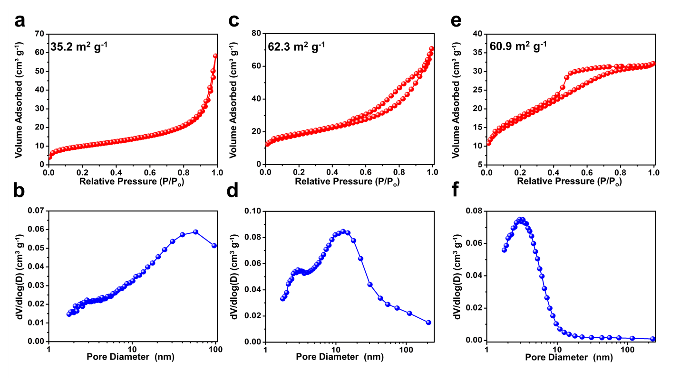
Figure S9 Nitrogen adsorption-desorption isotherms and corresponding pore size distributions of NTP/C-F precursor (a, b), NTP/C-F (c, d), and NTP/C-P (e, f).

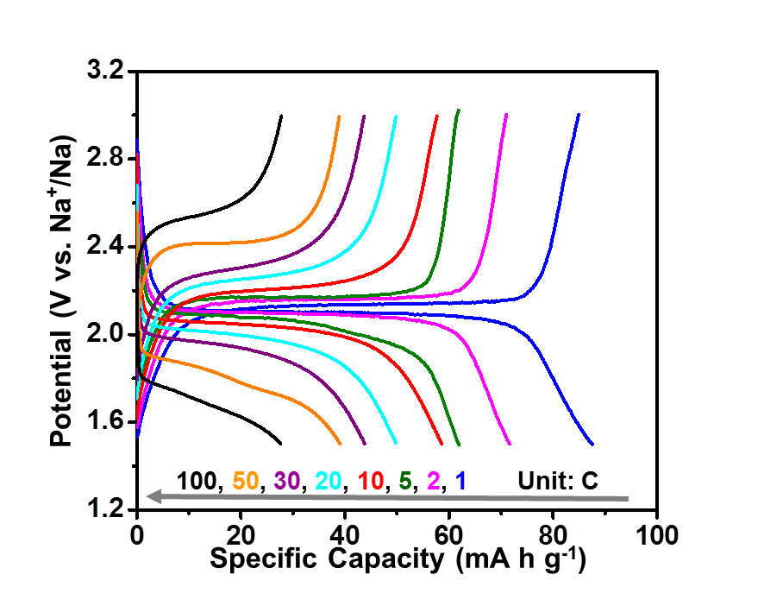
Figure S10 Discharge-charge curves of the NTP/C-P at different rates (1–100 C).

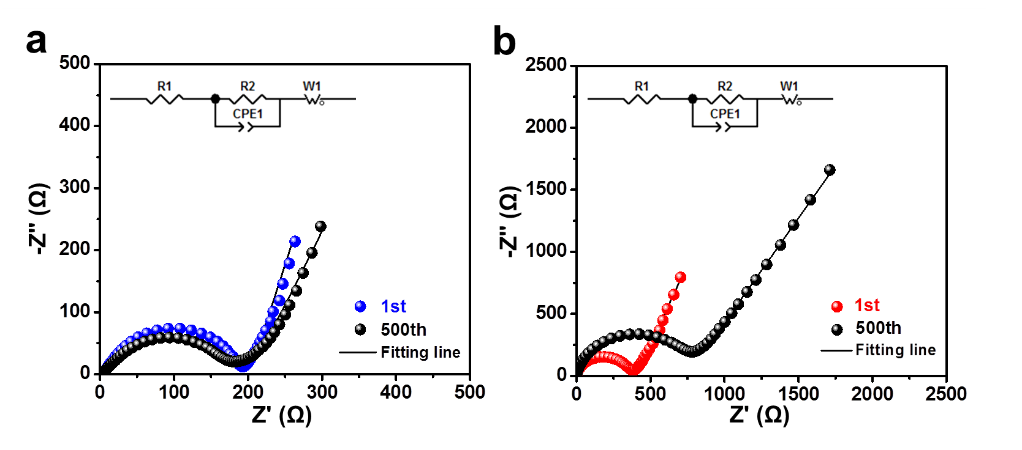
Figure S11 The Nyquist plots of the fully charged NTP/C-F (a) and NTP/C-P (b) after different cycles at 5 C with equivalent circuit inset.

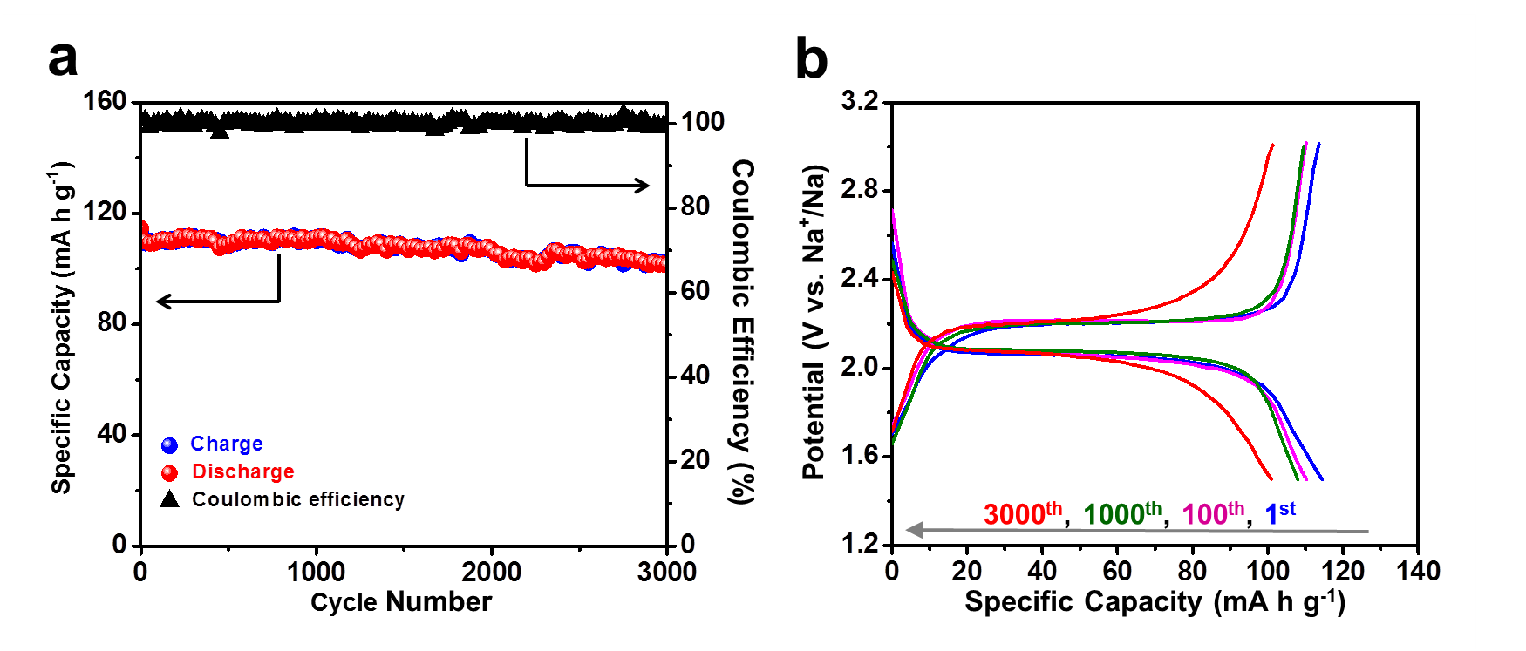
Figure S12 (a) Capacity retention and coulombic efficiency through 3000 cycles of the NTP/C-F at 10 C. (b) The 1st, 100th, 1000th, and 3000th discharge-charge profiles of the NTP/C-F at 10 C.

Table S1. Comparison of the long-cycling performance of the NTP/C-F with the recently reported NTP electrode materials for nonaqueous SIBs.
NTP Samples | Cycles | Rate  (C) | Initial capacity  (mA h g⁻¹) | Final capacity  (mA h g⁻¹) | Capacity retention  (%)
NTP⊂GN^{[18]} | 1000 | 10 | 96 | 77 | 80
C/NTP-RT^{[19]} | 10,000 | 10 | 81 | 72.3 | 89.3
NTP/CMK-3^{[21]} | 1000 | 0.5 | 110 | 62.9 | 57.1
NTP-NBA^{[22]} | 10,000 | 10 | 115 | 87 | 75.5
NTP@C@PC^{[24]} | 6000 | 10 | 110 | 76 | 69
This work | 10,000 | 20 | 110 | 85 | 77.3

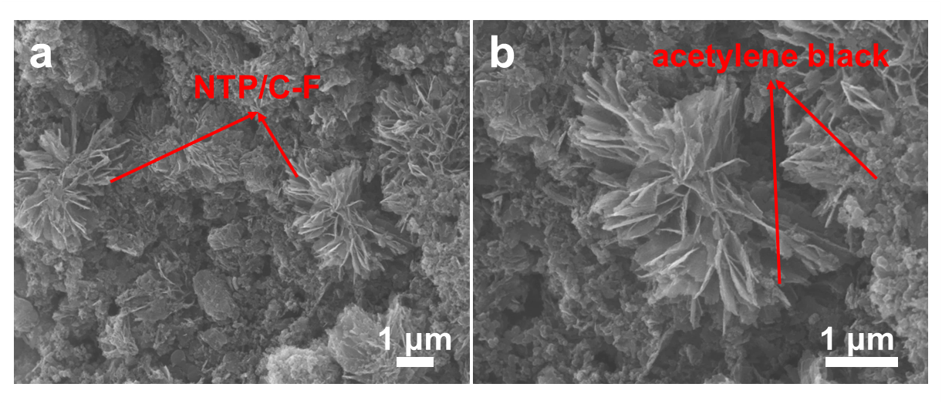
Figure S13 (a, b) SEM images of the NTP/C-F electrode after 5000 cycles at 20 C.

