Supporting Information

Cathodic polarization suppressed sodium-ion full cell with a 3.3 V high-voltage
Wenhao Ren,‡ Xuhui Yao,‡ Chaojiang Niu, Zhiping Zheng, Kangning Zhao, Qinyou An,* Qiulong Wei, Mengyu Yan, Lei Zhang and Liqiang Mai*
State Key Laboratory of Advanced Technology for Materials Synthesis and Processing, Wuhan University of Technology, Wuhan 430070, China
*Correspondence authors: anqinyou@whut.edu.cn; mlq518@whut.edu.cn

Fig. S1. The mass production experiments of NVP-NP with a final product of about 53 g.

Fig. S2. SEM image of NVP-Bulk and the accompanying diagram is the corresponding EDS elemental mappings.

Fig. S3. SEM images of NVP-Bare and the accompanying diagram is the corresponding EDS elemental mappings.

Fig. S4. SEM images of NVP-NP and the accompanying diagram is the corresponding EDS elemental mappings.

Fig. S5. Raman spectrum of NVP-NP, NVP-Bulk and NVP-Bare.

Fig. S6. Charge/discharge curves of the NVP-N cycled at 15 C rate.

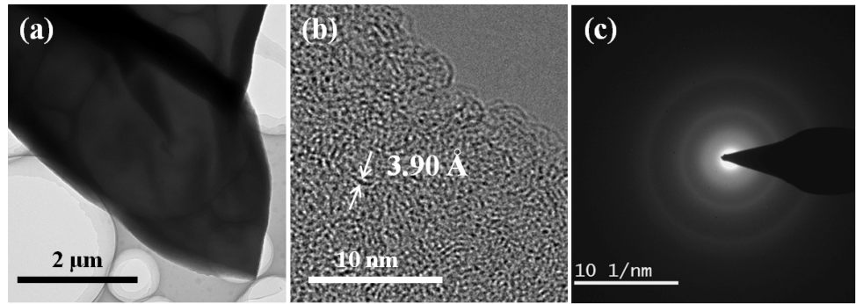
Fig. S7. TEM (a), HRTEM (b) and SAED pattern (c) of the HC-1200.

Fig. S8. Raman spectra of the HC-1200.

Table S1. The assembly illustrations of the representative full cells with respective to the mass of cathode. The capacity of cathode materials is set as 115 mAh g⁻¹ to realize a capacity ratio of cathode/anode to about 1.05:1 before full cell fabrication.
Cell Number | 115 mAh g⁻¹ * Mass (mg) = Capacity (μAh)  (cathode) | Specific Capacity (mAh g⁻¹) * Mass (mg) = Capacity (μAh)  (anode) | Calculated Capacity Ratio | Current Density
Full-1 | 115 * 1.12 = 129.9 | 303 * 0.40 = 121 | 1.07 | 0.2 C
Full-2 | 115 * 1.19 = 135.7 | 298 * 0.44 = 131.1 | 1.03 | 0.2 C
Full-3 | 115 * 1.05 = 121.8 | 295 * 0.40 = 118 | 1.03 | 0.2 C
Full-4 | 115 * 0.98 = 111.7 | 207 * 0.52 = 107.6 | 1.04 | 0.5 C
Full-5 | 115 * 0.91 = 101.9 | 198 * 0.50 = 99.0 | 1.03 | 0.5 C
Full-6 | 115 * 1.12 = 128.8 | 210 * 0.56 = 117.6 | 1.10 | 0.5 C

Fig. S9. The capacity-potential illustrations of the recently published sodium-ion full cells based on the mass of cathode.
The detailed calculation process is as follows:
$$E=\frac{Ca * V}{M_{o}}$$
E: Specific gravimetric energy.
Ca: Capacity of the cell.
V: Average operating voltage.
M₀: Mass of active material.
References
1. C. Zhu, P. Kopold, P. A. van Aken, J. Maier and Y. Yu, Adv. Mater., 2016.
2. Y. Dong, S. Li, K. Zhao, C. Han, W. Chen, B. Wang, L. Wang, B. Xu, Q. Wei, L. Zhang, X. Xu and L. Mai, Energy Environ. Sci., 2015, 8, 1267-1275.
3. S. Guo, H. Yu, P. Liu, Y. Ren, T. Zhang, M. Chen, M. Ishida and H. Zhou, Energy Environ. Sci., 2015, 8, 1237-1244.
4. C. Y. Yu, J. S. Park, H. G. Jung, K. Y. Chung, D. Aurbach, Y. K. Sun and S. T. Myung, Energy Environ. Sci., 2015, 8, 2019-2026.
5. Y. Wang, X. Yu, S. Xu, J. Bai, R. Xiao, Y. S. Hu, H. Li, X. Q. Yang, L. Chen and X. Huang, Nat. Commun., 2013, 4, 2365.
6. S. Guo, P. Liu, Y. Sun, K. Zhu, J. Yi, M. Chen, M. Ishida and H. Zhou, Angew. Chemie, 2015, 54, 11701-11705.
7. Y. Li, Z. Yang, S. Xu, L. Mu, L. Gu, Y. S. Hu, H. Li and L. Chen, Adv. Sci., 2015, 2.
8. Z. Yuan, L. Si and X. Zhu, J. Mater. Chem. A, 2015, 3, 23403-23411.
9. L. Wang, J. Song, R. Qiao, L. A. Wray, M. A. Hossain, Y. D. Chuang, W. Yang, Y. Lu, D. Evans, J. J. Lee, S. Vail, X. Zhao, M. Nishijima, S. Kakimoto and J. B. Goodenough, J. Am. Chem. Soc., 2015, 137, 2548-2554.
10. D. Kim, E. Lee, M. Slater, W. Lu, S. Rood and C. S. Johnson, Electrochem. Commun., 2012, 18, 66-69.
11. S. M. Oh, S. T. Myung, C. S. Yoon, J. Lu, J. Hassoun, B. Scrosati, K. Amine and Y. K. Sun, Nano Lett., 2014, 14, 1620-1626.
12. J. Song, L. Wang, Y. Lu, J. Liu, B. Guo, P. Xiao, J. J. Lee, X. Q. Yang, G. Henkelman and J. B. Goodenough, J. Am. Chem. Soc., 2015, 137, 2658-2664.

Fig. S10. Galvanostatic charge/discharge measurements of the full cell at 0.2 C. The full cell is cathode limited type and the mass ratio of cathode to anode is consistent with Table S1.

