Supplementary material
Three Dimensional V₂O₅/NaV₆O₁₅ Hierarchical Heterostructures: Controlled Synthesis and Synergistic Effect Investigated by in Situ X-ray Diffraction
Chaojiang Niu#, Xiong Liu#, Jiashen Meng#, Lin Xu*, Mengyu Yan, Xuanpeng Wang, Guobin Zhang, Ziang Liu, Xiaoming Xu, Liqiang Mai*
#These authors contributed equally to this work.

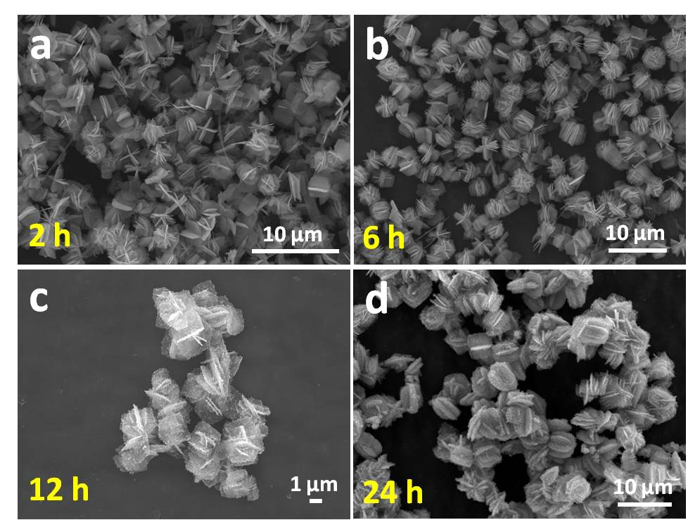
Figure S1. (a-d) Low-magnification SEM images of 3D V₂O₅/NaV₆O₁₅ hierarchical heterogeneous microspheres prepared at 2 (a), 6 (b), 12 (c) and 24 h (d), respectively.

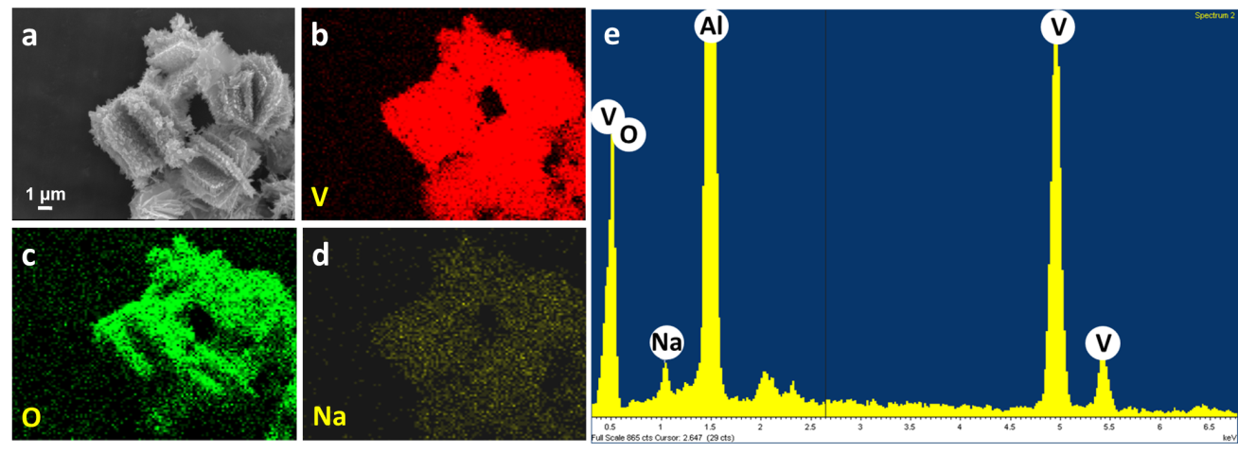
Figure S2. SEM image (a) and EDS mapping images of V (b), O (c), and Na (d) in 3D V₂O₅/NaV₆O₁₅ hierarchical heterogeneous microspheres. (e) The corresponding EDS spectrum of 3D V₂O₅/NaV₆O₁₅hierarchical heterogeneous microspheres.

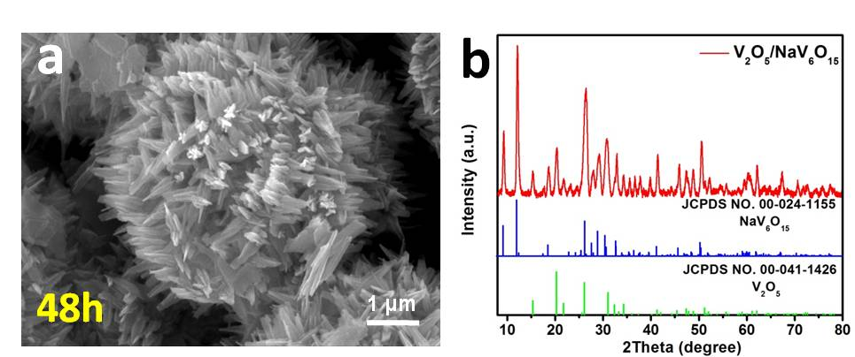
Figure S3. SEM image and the corresponding XRD pattern of 3D V₂O₅/NaV₆O₁₅ hierarchical heterogeneous microspheres prepared over a period of 48 h.

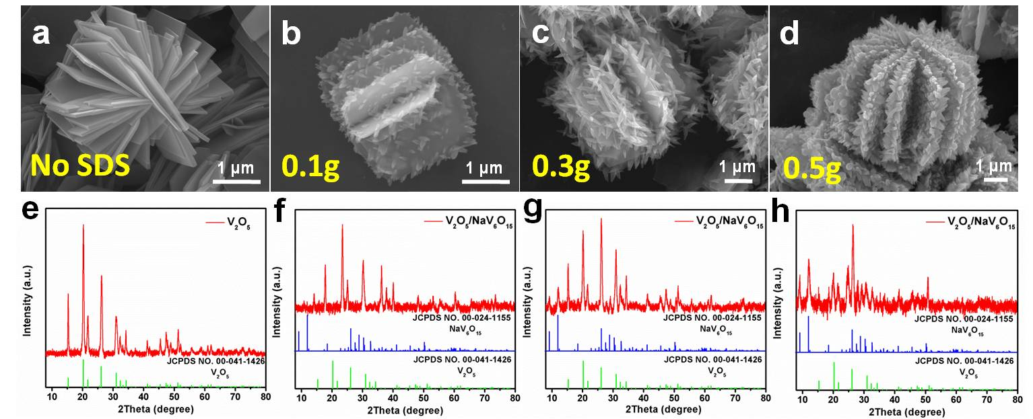
Figure S4. SEM images of samples prepared with 0 (a), 0.1 (b), 0.3 (c) and 0.5 g (d) of C₁₂H₂₅SO₄Na (SDS) over a period of 24 h, and their corresponding XRD patterns (e-h) after annealing in air for 5 h at 450 °C.

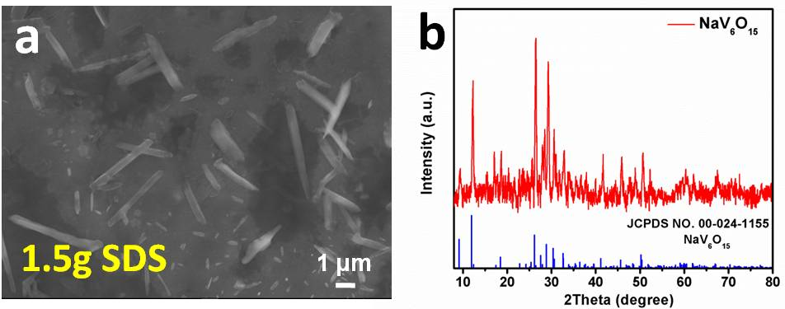
Figure S5. SEM image of NaV₆O₁₅ nanorods prepared with 1.5 g of SDS (a) and the corresponding XRD pattern (b) after annealing in air for 5 h at 450 °C.

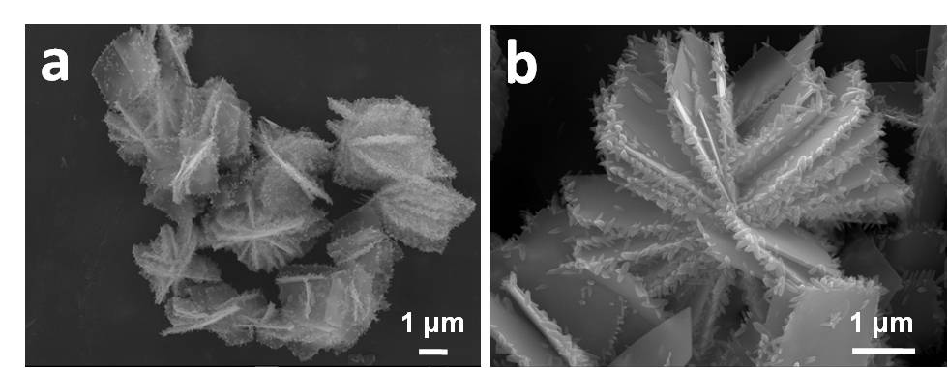
Figure S6. SEM images of 3D V₂O₅/NaV₆O₁₅ hierarchical heterogeneous microspheres synthesized by substituting SDS with C₁₈H₂₉NaO₃S (SDBS).
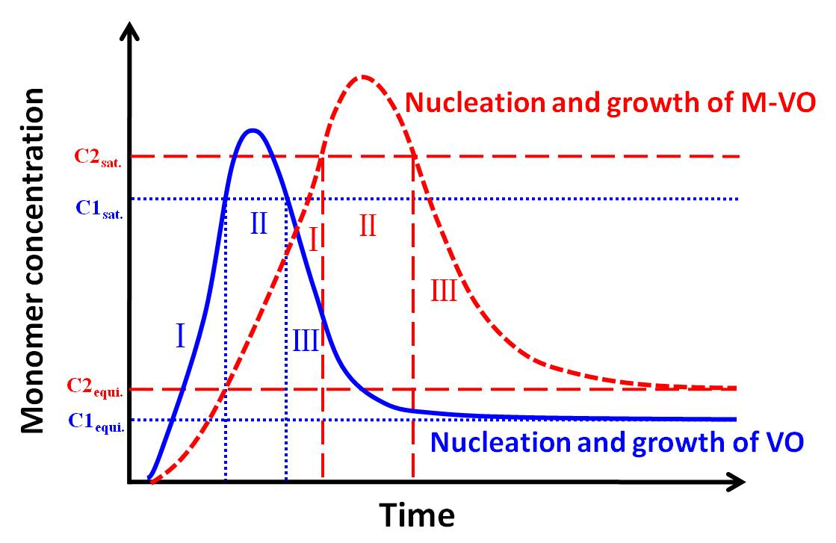
Figure S7. Crystal nucleation and growth diagrams of hierarchical heterostructures. C1_{sat.} and C2_{sat.} represent the saturation concentrations of different monomers (VO and M-VO); C1_{equi.} and C2_{equi.} represent the corresponding equilibrium concentrations.

Table S1 Different morphologies of hydrothermal products in different reaction systems
Vanadium source | Sodium  source | 6 h | 12 h | 24 h
1.2 mmol NH₄VO₃ | 0 mmol SDS | V₂O₅ nanogears | V₂O₅  nanogears | V₂O₅  nanogears
1.2 mmol NH₄VO₃ | 1 mmol SDS | V₂O₅ nanogears | 3D  V₂O₅/NaV₆O₁₅ | 3D  V₂O₅/NaV₆O₁₅
1.2 mmol NH₄VO₃ | 1.5 mmol SDS | V₂O₅ nanogears | 3D  V₂O₅/NaV₆O₁₅ | 3D  V₂O₅/NaV₆O₁₅
1.2 mmol NH₄VO₃ | 5 mmol SDS | -- | -- | NaV₆O₁₅ Nanorods
1.2 mmol NH₄VO₃ | 1 mmol SDBS | V₂O₅ nanogears | 3D  V₂O₅/NaV₆O₁₅ | 3D  V₂O₅/NaV₆O₁₅
1 mmol NH₄VO₃ | 0.1 mmol Zn(CH₃COO)₂ | V₂O₅ microspheres | 3D  V₂O₅/ZnV₂O₆ | 3D  V₂O₅/ZnV₂O₆
1 mmol NH₄VO₃ | 0.1 mmol Co(CH₃COO)₂ | V₂O₅ microspheres | V₂O₅ microspheres | 3D  V₂O₅/CoV₂O₆
Where SDS is C₁₂H₂₅SO₄Na, SDBS is C₁₈H₂₉NaO₃S, and 3D refers to the three-dimensional hierarchical heterostructure.

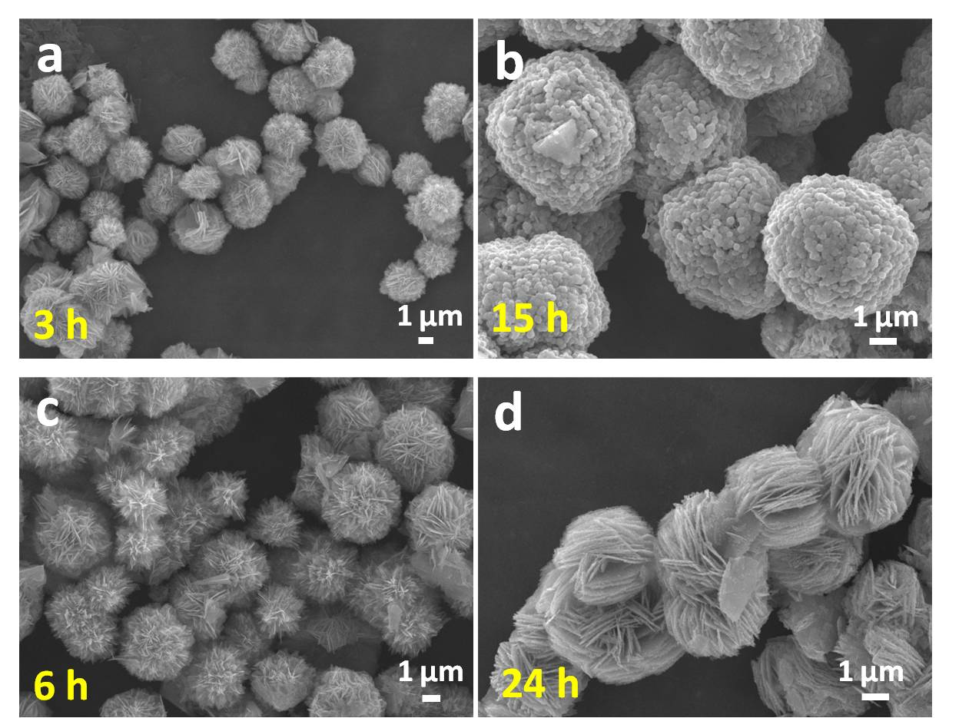
Figure S8. (a-b) Low-magnification SEM images of 3D V₂O₅/ZnV₂O₆ hierarchical heterogeneous microspheres prepared at 3 and 15 h, respectively. (c-d) Low-magnification SEM images of 3D V₂O₅/CoV₂O₆ hierarchical heterogeneous microspheres prepared at 6 and 24 h, respectively.

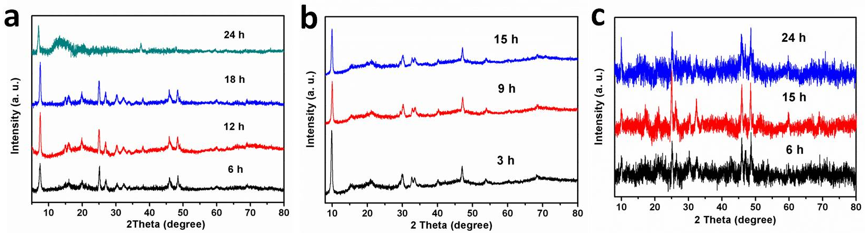
Figure S9. XRD patterns of the precursors for V₂O₅/NaV₆O₁₅ (a), V₂O₅/ZnV₂O₆ (b) and V₂O₅/CoV₂O₆ (c) heterogeneous microspheres prepared at different reaction times.

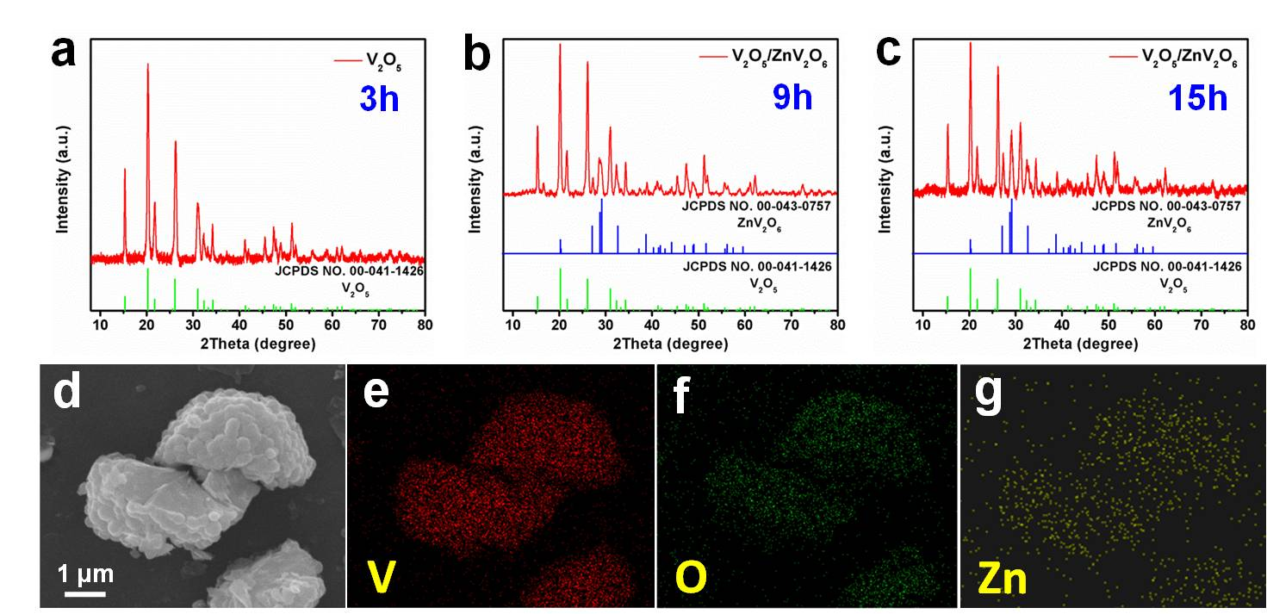
Figure S10. XRD patterns (a-c) of 3D V₂O₅/ZnV₂O₆ hierarchical heterogeneous microspheres prepared over 3, 9 and 15 h, respectively, after annealing in air for 5 h at 450 °C. SEM image (d) and EDS mapping images of V (e), O (f) and Zn (d) in 3D V₂O₅/ZnV₂O₆ hierarchical heterogeneous microspheres prepared at 15 h.

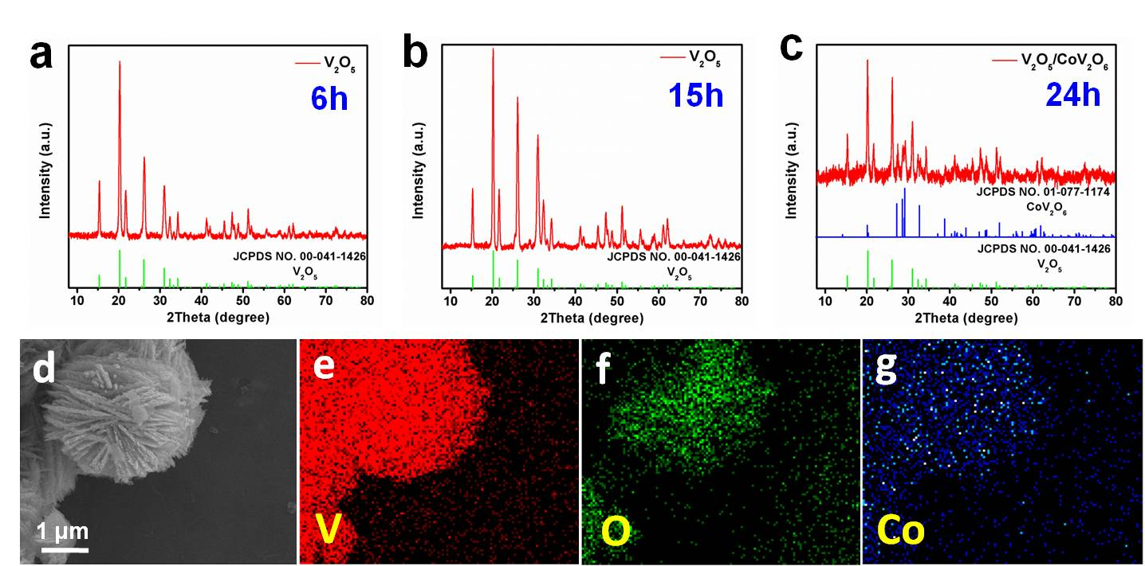
Figure S11. XRD patterns (a-c) of 3D V₂O₅/CoV₂O₆ hierarchical heterogeneous microspheres prepared over 6, 15 and 24 h, respectively, after annealing in air for 5 h at 450 °C. SEM image (d) and EDS mapping images of V (e), O (f) and Co (g) in 3D V₂O₅/CoV₂O₆ hierarchical heterogeneous microspheres prepared at 24 h.

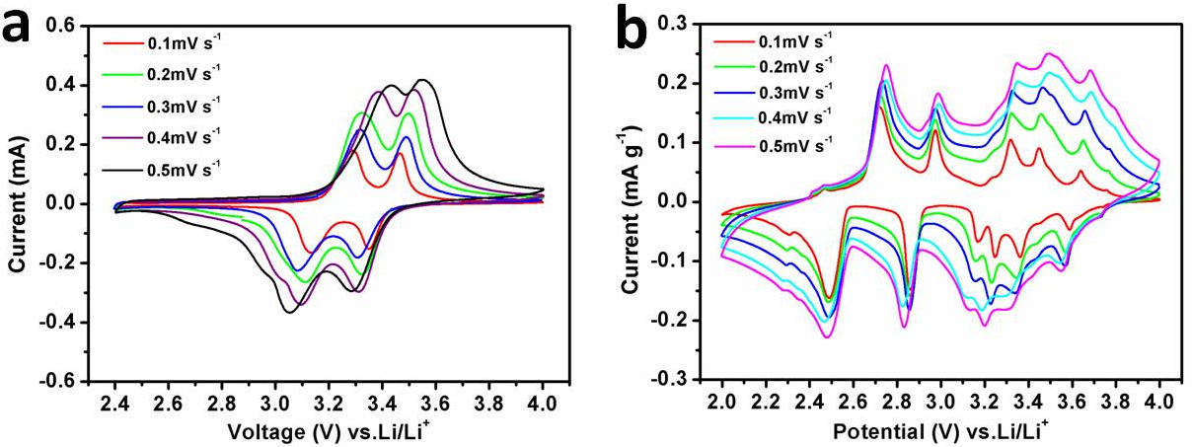
Figure S12. The CV curves of pure V₂O₅ nanogears (a) and 3D V₂O₅/NaV₆O₁₅ hierarchical heterogeneous microsphere (b) tested at different scan rates ranging from 0.1 to 0.2, 0.3, 0.4 and 0.5 mV s⁻¹, respectively. 3D V₂O₅/NaV₆O₁₅ hierarchical heterogeneous microspheres exhibit smaller peaks shift and polarization than pure V₂O₅ nanogears.

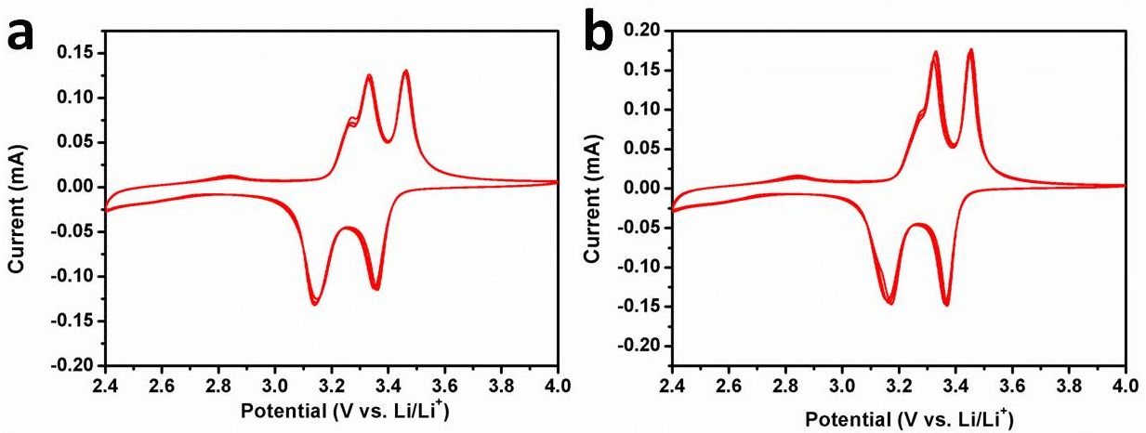
Figure S13. CV curves of 3D V₂O₅/ZnV₂O₆ (a) and V₂O₅/CoV₂O₆ (b) hierarchical heterogeneous microspheres.

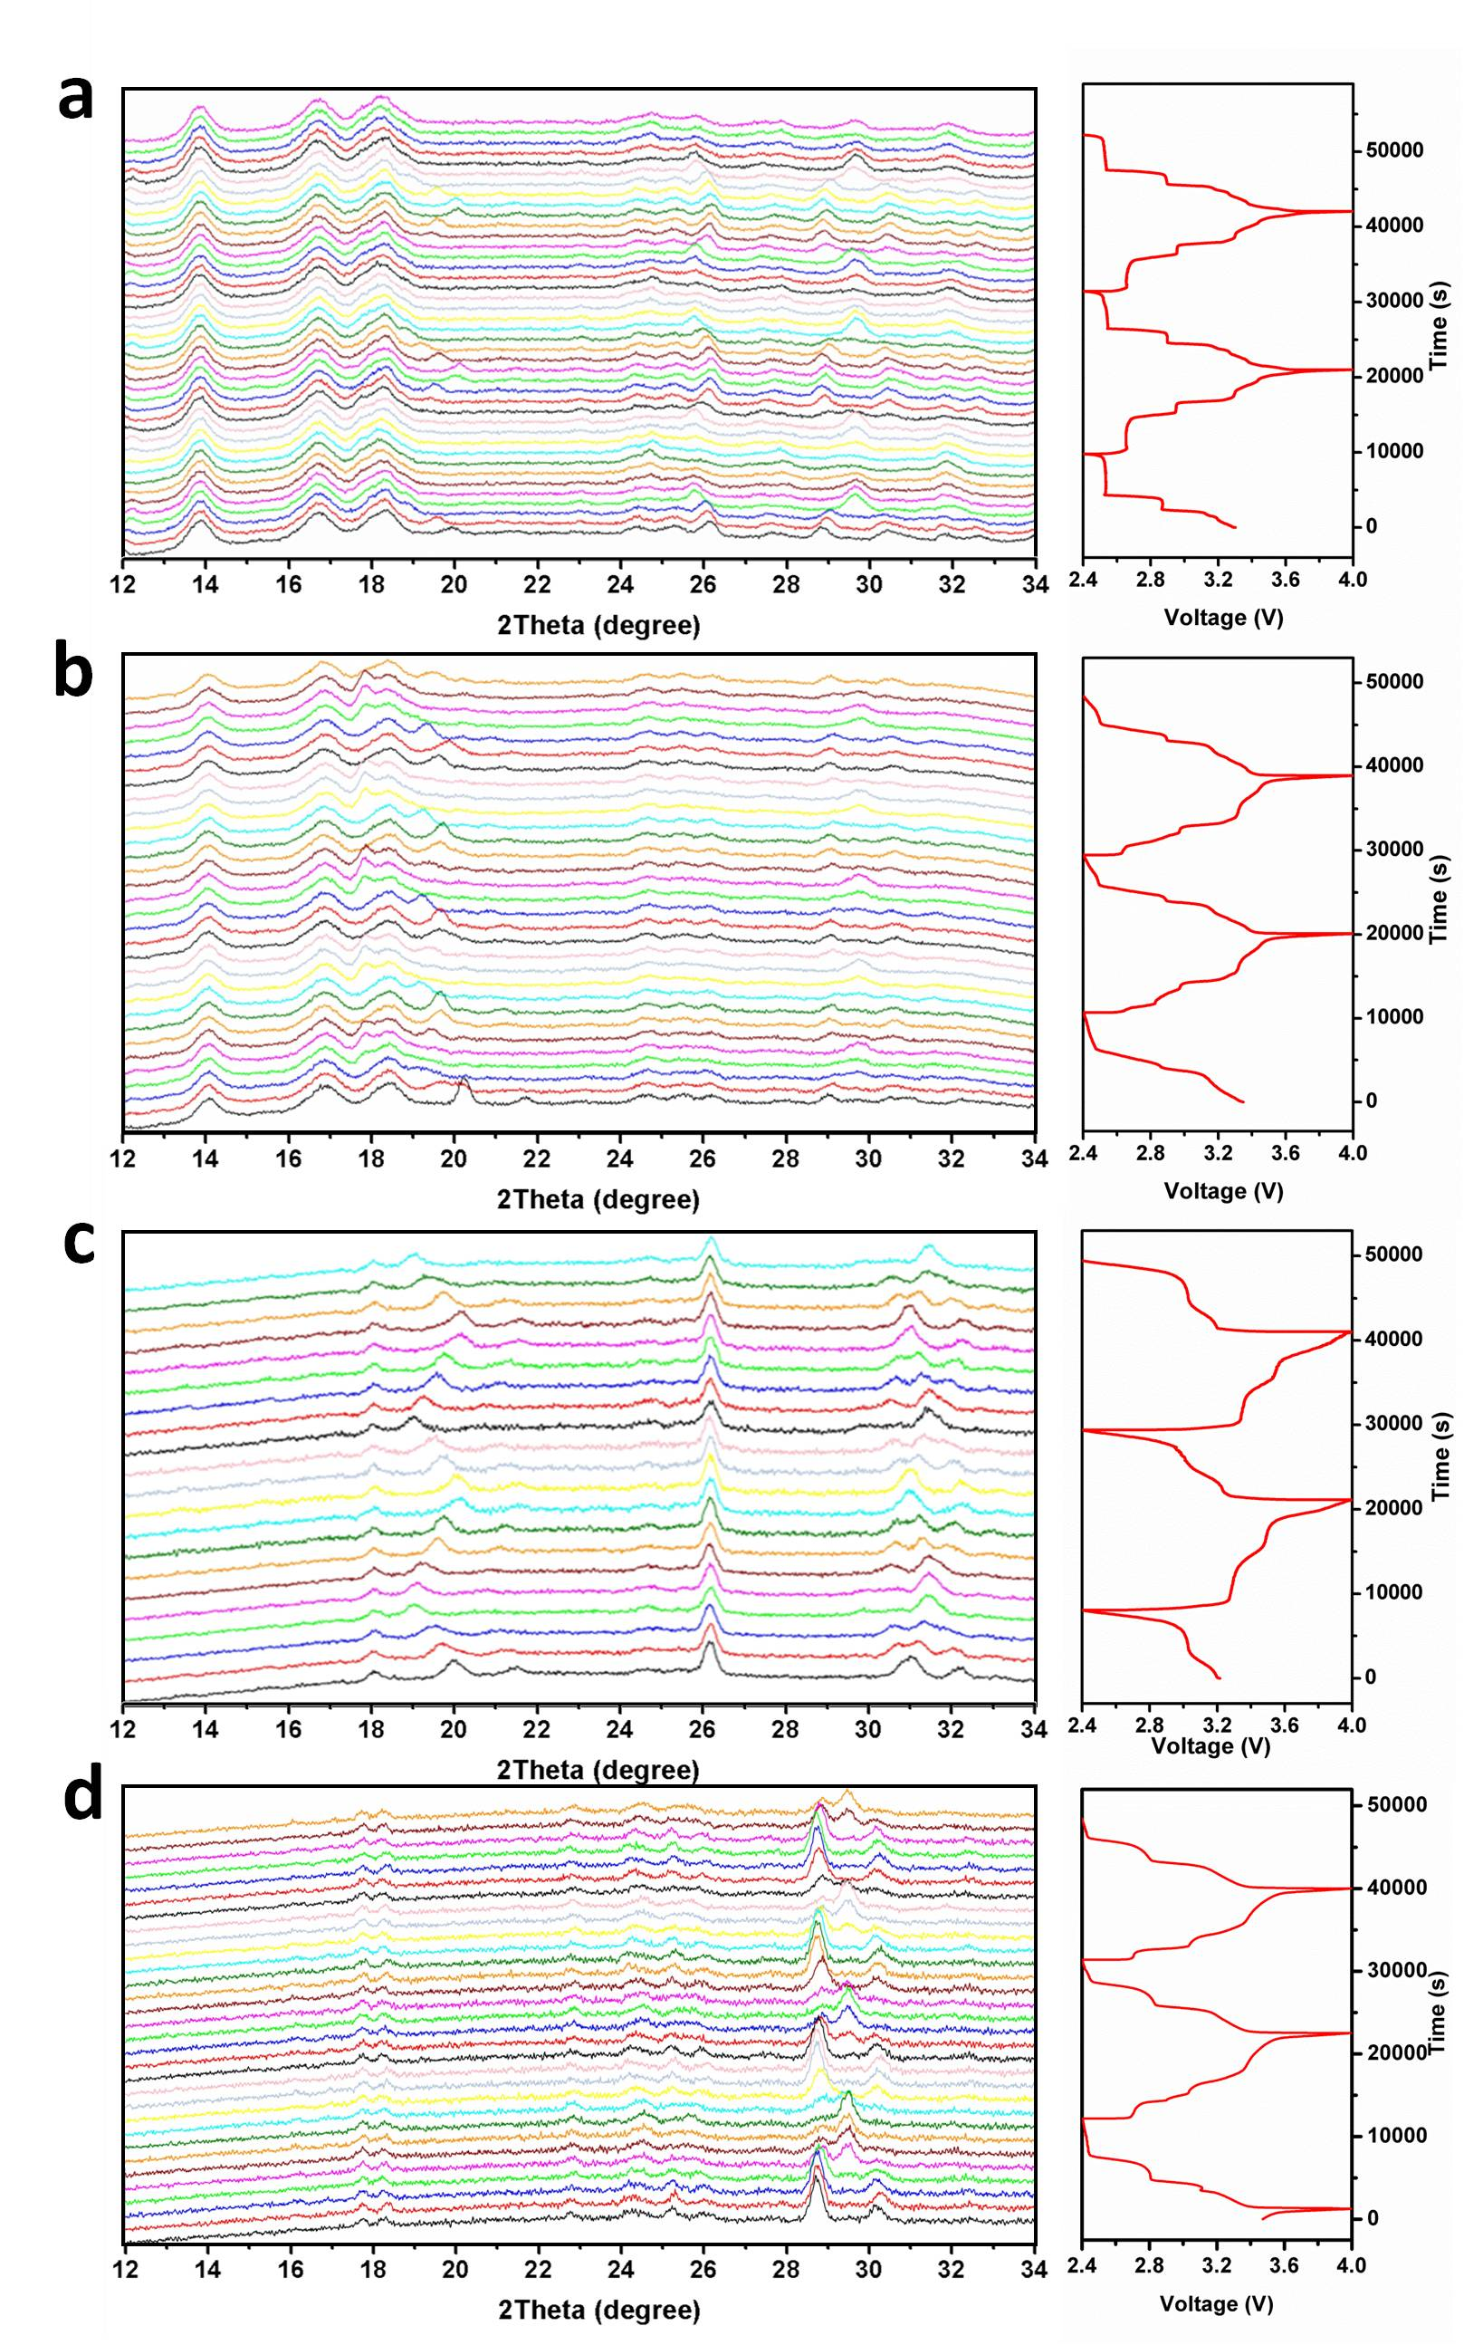
Figure S14. The corresponding selected individual diffraction patterns of 3D V₂O₅/NaV₆O₁₅ hierarchical heterogeneous microspheres (a), V₂O₅/NaV₆O₁₅ physical mixture (b), pure V₂O₅ nanogears (c) and pure NaV₆O₁₅ nanospindles (d), during galvanostatic charge and discharge at 50 mA g⁻¹. The horizontal axis represents the selected 2θ regions from 12° to 34°, and time is plotted on the vertical axis.

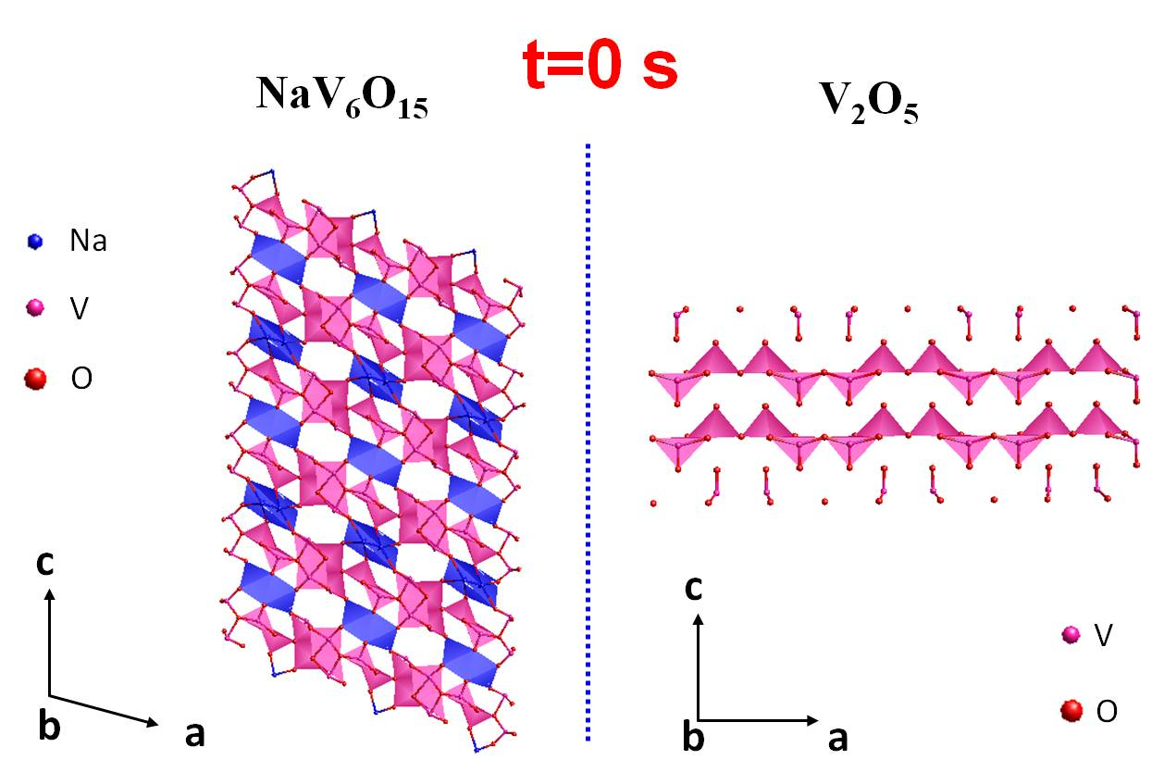
Figure S15. Illustration of the initial crystal structures of NaV₆O₁₅ and V₂O₅ along the b-axis.

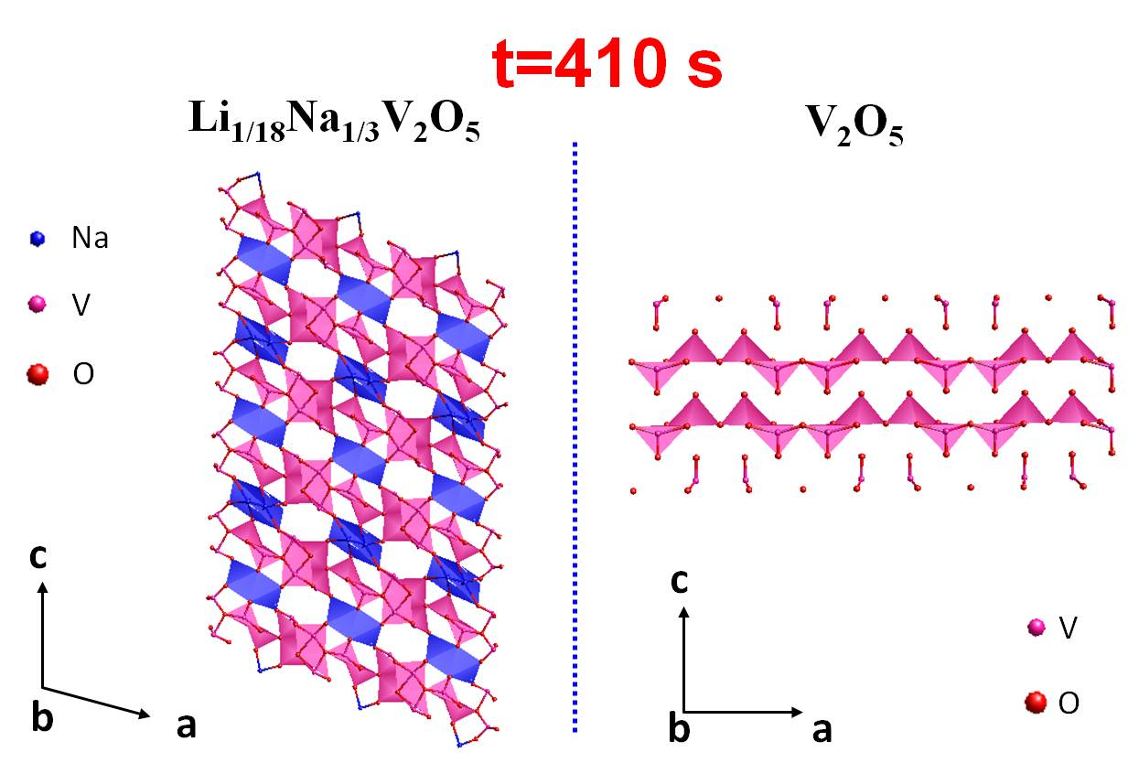
Figure S16. Illustration of the crystal structures of Li_{1/18}Na_{1/3}V₂O₅ and V₂O₅ at 410 s along the b-axis.

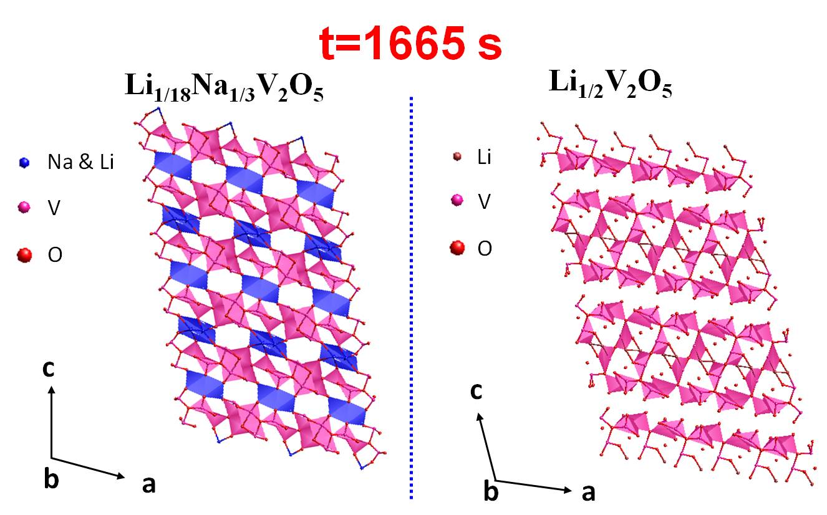
Figure S17. Illustration of the crystal structures of Li_{1/18}Na_{1/3}V₂O₅ and Li_{1/2}V₂O₅ at 1665 s along the b-axis.
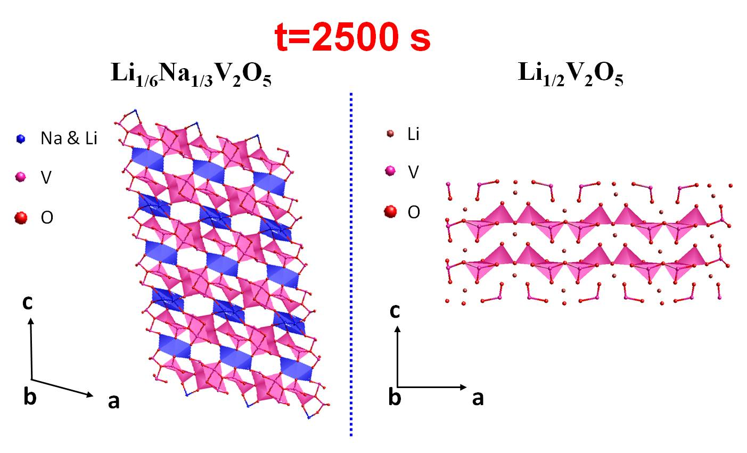
Figure S18. Illustration of the crystal structures of Li_{1/6}Na_{1/3}V₂O₅ and Li_{1/2}V₂O₅ at 2500 s along the b-axis.

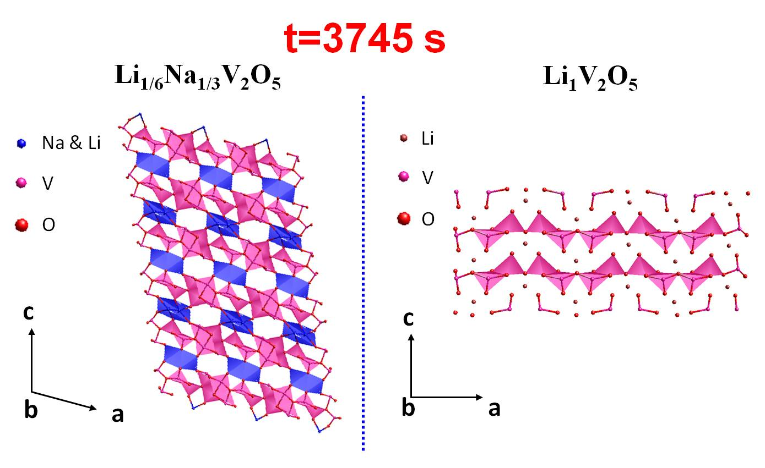
Figure S19. Illustration of the crystal structures of Li_{1/6}Na_{1/3}V₂O₅ and Li₁V₂O₅ at 3745 s along the b-axis.

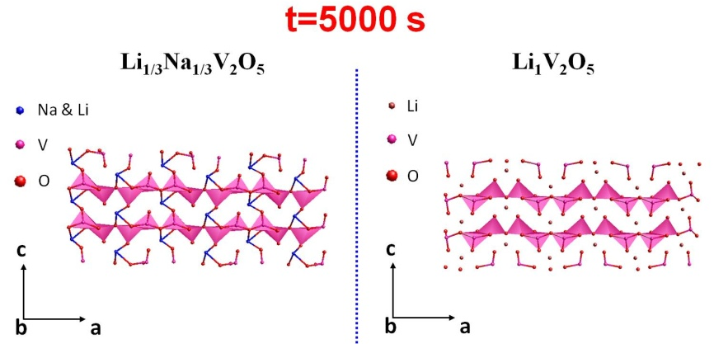
Figure S20. Illustration of the crystal structures of Li_{1/3}Na_{1/3}V₂O₅ and Li₁V₂O₅ at 5000 s along the b-axis.

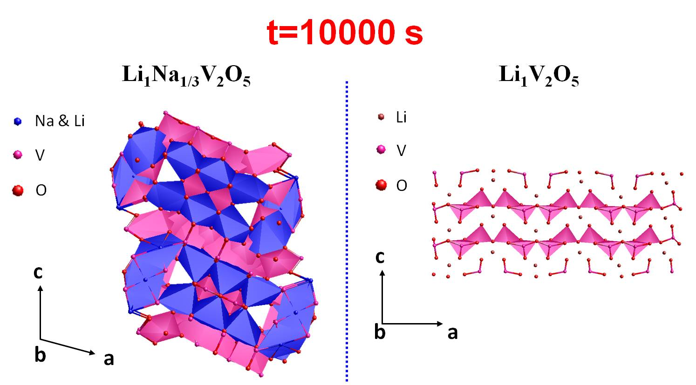
Figure S21. Illustration of the crystal structures of Li₁Na_{1/3}V₂O₅ and Li₁V₂O₅ at 10,000 s along the b-axis.
These illustrations from Figure S12 to Figure S18 are analyzed by Total pattern solution (TOPAS) structure refinement.

Figure S22. Kinetics calculations based on the frequency (ω^{-1/2}) and Z′ values at low frequency region of 3D V₂O₅/NaV₆O₁₅ hierarchical heterogeneous microspheres, V₂O₅ nanogears and V₂O₅/NaV₆O₁₅ physical mixture before cycling.
Calculation of the Lithium-ion Diffusion Kinetics
D_{Na}=R ²T ²/2A ²n ⁴F ⁴C ²σ ² (1)
Z' =R_{D}+R_{L}+σω ^{-1/2} (2)
Where D_{Na} is the sodium-ion diffusion coefficient, R is the gas constant, T is the absolute temperature, A is the surface area of cathode, n is the number of electrons per molecule during oxidization, F is the number of electrons per molecule during oxidization, C is the concentration of sodium-ion and σ is the Warburg factor which could be obtained by equation (2). By linear fitting of Z' and ω ^{-1/2}, the slope is described as σ value. Combining with equation (1), the square of σ value has an inverse relationship with D_{Na}. According to equations (1) and (2), the slope in fitting line of ω ^{-1/2} (ω is frequency) and Z' is defined as Warburg factor and its square values have an inverse relationship with D_{Na}.

Figure S23. EIS curves of 3D V₂O₅/NaV₆O₁₅ hierarchical heterogeneous microspheres under different depth during the discharge process.

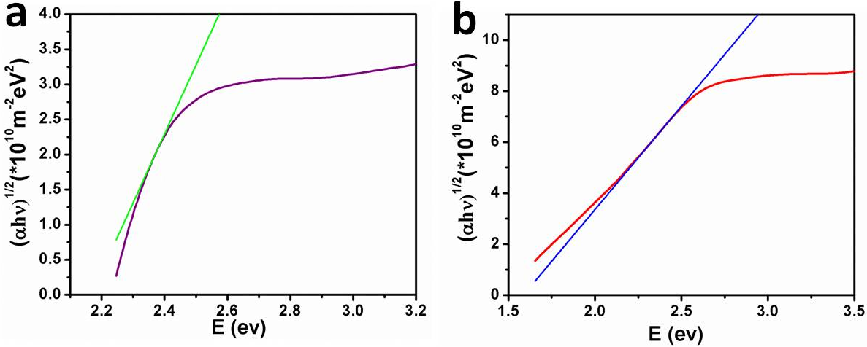
Figure S24. UV-VIS diffuse reflectance spectra of V₂O₅ (a) and NaV₆O₁₅ (b).

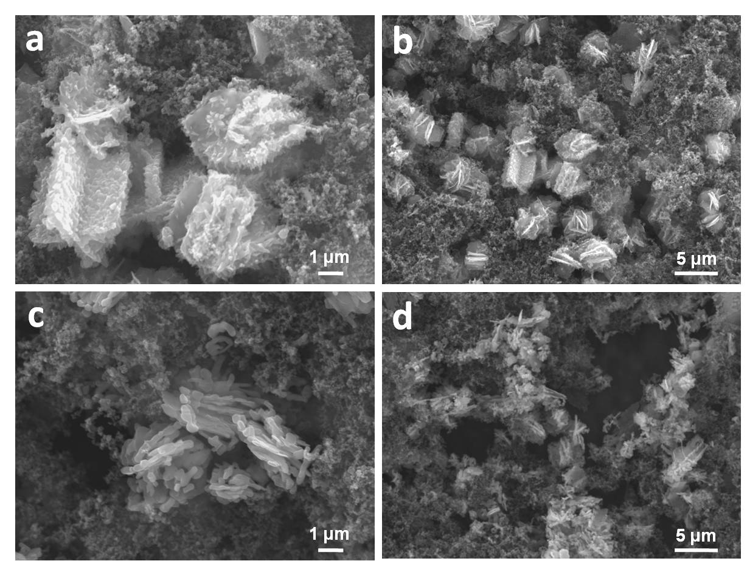
Figure S25. SEM images of 3D V₂O₅/NaV₆O₁₅ hierarchical heterogeneous microspheres (a-b) and pure V₂O₅ nanogears (c-d) after cycling 50 times at the current density of 500 mA g⁻¹.

