Supporting Information

**Self-sacrificed synthesis of three-dimensional Na3V2(PO4)3 nanofiber network for high-rate sodium-ion full batteries**

Wenhao Ren, Zhiping Zheng, Chang Xu, Chaojiang Niu, Qiulong Wei, Qinyou An,* Kangning Zhao, Mengyu Yan, Mingsheng Qin and Liqiang Mai*

State Key Laboratory of Advanced Technology for Materials Synthesis and Processing, Wuhan University of Technology, Wuhan 430070, China

*Correspondence authors: mlq518@whut.edu.cn; anqinyou@whut.edu.cn

**Synthesis of NaTi2(PO4)3/C anode:**

First, C10H14O5Ti (2 mmol) were added in 20 ml EG with stirring for 0.5 h to form uniform light yellow solution. Then, CH3COONa (4 mmol), H3PO4 (0.19 ml), citric acid (2 mmol) and 20 ml water were dissolved in above solution with stirring at 80°C for 24 h. The solution was then dried at 70 °C in an air oven to get the gray power. In the end, the NaTi2(PO4)3/C was obtained from the precursor via preheating it at 400 °C for 4 h followed by annealing at 700 °C for 8 h in argon atmosphere with a heating rate of 5 °C min-1.

**Figure S1.** SEM images of the samples with pure water (a) and pure DMF (b) as the solvent and the other experiment conditions are the same.

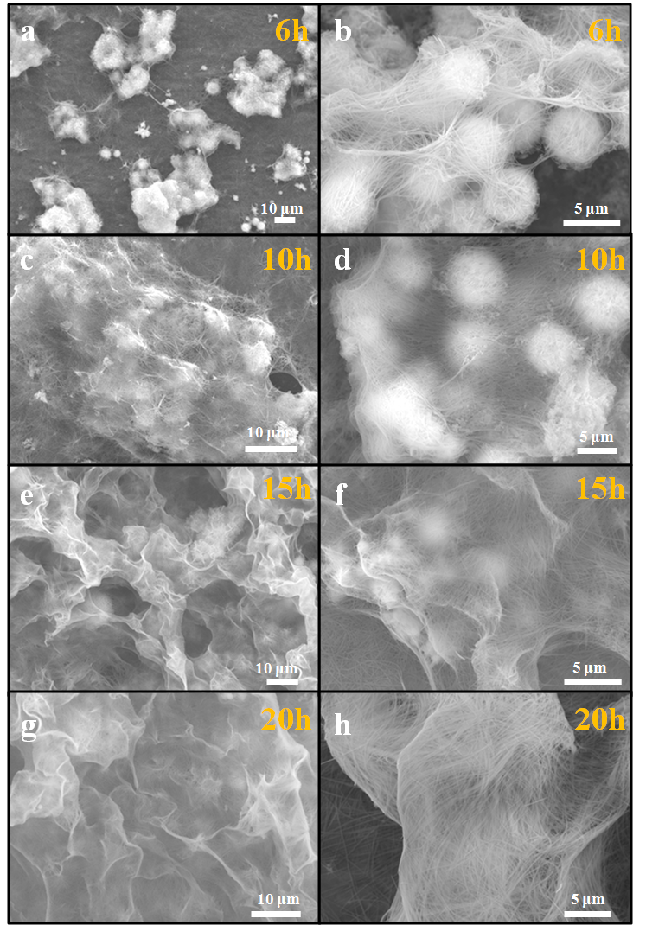

**Figure S2.** The detailed morphological evolution process from microflower to 3D nanofiber network. SEM images of the samples with low and high magnification after solvothermal reaction for 6 (a,b), 10 (c,d), 15 (e,f) and 20 h (g,h).

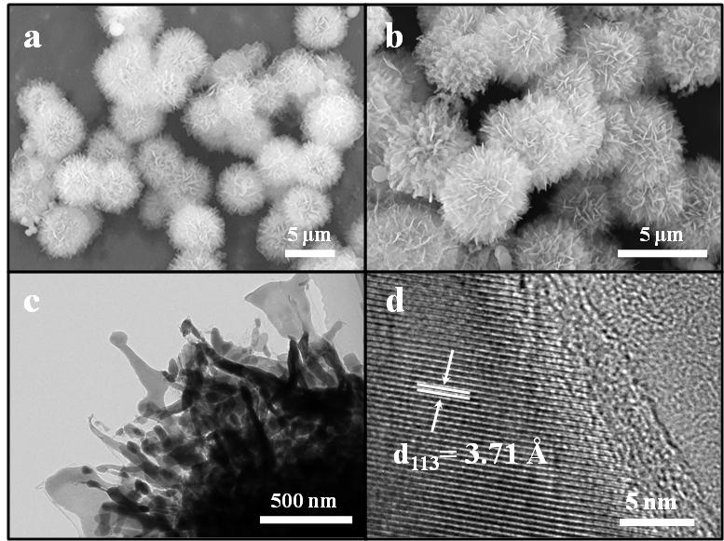

**Figure S3.** SEM images of the NVP-M before (a) and after (b) annealing at 700 ºC. The TEM (c) and HRTEM (d) images of the NVP-M after annealing at 700 ºC.

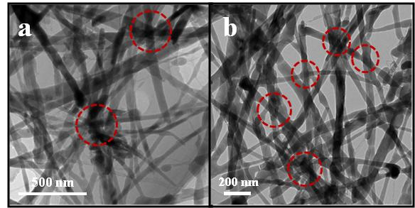

**Figure S4**. TEM images of the NVP-F after annealing at 700 ºC. The red circle presents the connected region of nanofiber.

C:\Users\Administrator\Desktop\论文图片\XRD-前.tif

**Figure S5**. XRD patterns of the samples after solvothermal reaction for 3, 10 and 20 h.

C:\Users\Administrator\Desktop\BET-M.tif

**Figure S6.** Nitrogen adsorption–desorption isotherm of NVP-M.

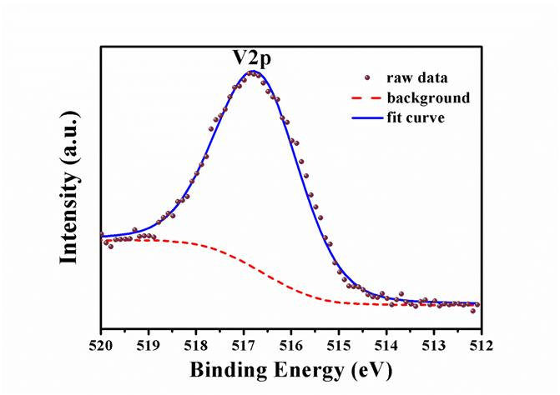

**Figure S7.** XPS pattern of NVP-F after calcination at 700 °C in argon atmosphere.

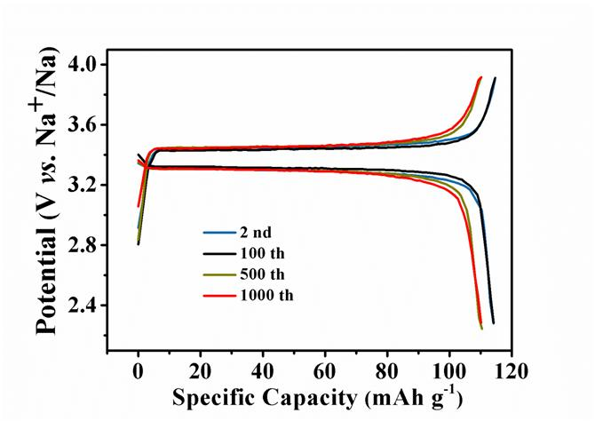

**Figure S8**. The charge-discharge curves of NVP-F at different cycles at 10 C.

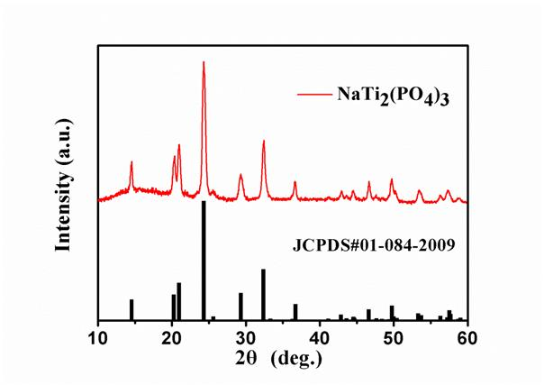

**Figure S9.** XRD patterns of homemade NaTi2(PO4)3.

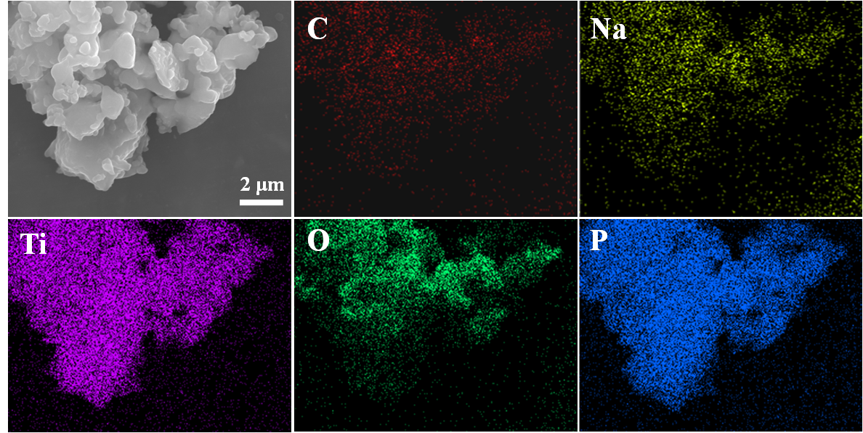

**Figure S10.** SEM image of homemade NaTi2(PO4)3 and the corresponding EDS elemental mapping.

**Figure S11.** (a) Cycling performance and coulombic efficiency of homemade NaTi2(PO4)3. (b) Galvanostatic charge-discharge curves of NVP-F at different cycles.

**Table S1.** The fitting values based on the EIS data.

|  |  |  |
| --- | --- | --- |
| **Cell state** | **Rs(ohm)** | **Rct(ohm)** |
| **NVP-F full cell after 2 cycles** | **4.49** | **39.64** |
| **NVP-F full cell after 10 cycles** | **4.00** | **41.45** |
| **NVP-F full cell after 50 cycles** | **3.69** | **42.60** |
| **NVP-F full cell after 100 cycles** | **3.61** | **48.99** |
| **NVP-F full cell after 200 cycles** | **2.87** | **53.93** |

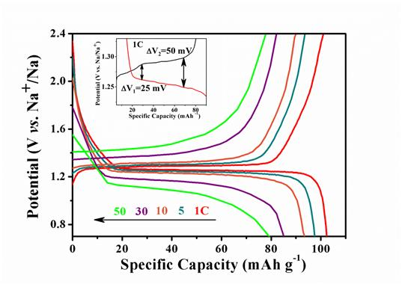

**Figure S12.** Charge-discharge curves of NVP‖1 M NaClO4 /EC + DMC + FEC‖NTP full cell as the current densities increase from 1 C to 50 C at a potential window between 0.7 and 2.4 V versus Na+/Na.

C:\Users\Administrator\Desktop\Ragon.tif

**Figure S13.** Ragone plots of the NVP-F based full cell.

**Figure S14.** (a) Overcharge tolerance test of the NVP-F cycled at 5 C. (b) The corresponding charge-discharge curves.



**Figure S15.** Schematic illustration of the Na ion insertion/deinsertion process in 3D nanofiber network (a) and microflower structure (b).

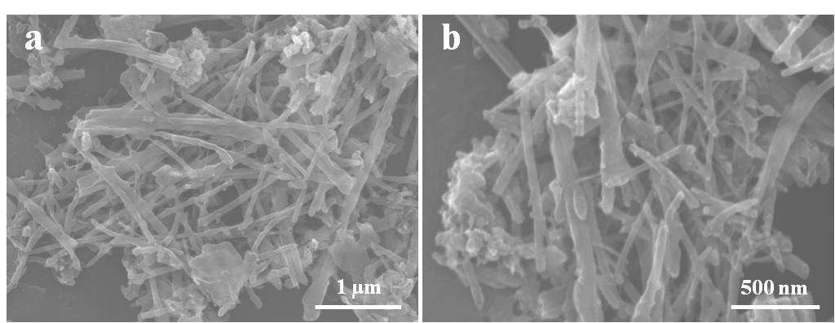

**Figure S16.** The SEM images of NVP-F after cycled at 5 C for 100 times.