Supporting Information

In operando observation of temperature-dependent phase evolution in lithium-incorporation olivine cathode
Mengyu Yan^{a,1}, Guobin Zhang^{a,1}, Qiulong Weiª, Xiaocong Tianª, Kangning Zhaoª, Qinyou An^{a,}*, Liang Zhouª, Yunlong Zhao^{a,b}, Chaojiang Niuª, Wenhao Renª, Liang Heª, Liqiang Mai^{a,}*
ªState Key Laboratory of Advanced Technology for Materials Synthesis and Processing, Wuhan University of Technology, Wuhan 430070, China
^{b}Department of Chemistry and Chemical Biology, Harvard University, Cambridge, Massachusetts 02138, USA
¹These authors contributed equally to this work.
*Correspondence authors: mlq518@whut.edu.cn (L. Mai); anqinyou86@whut.edu.cn (Q. An)

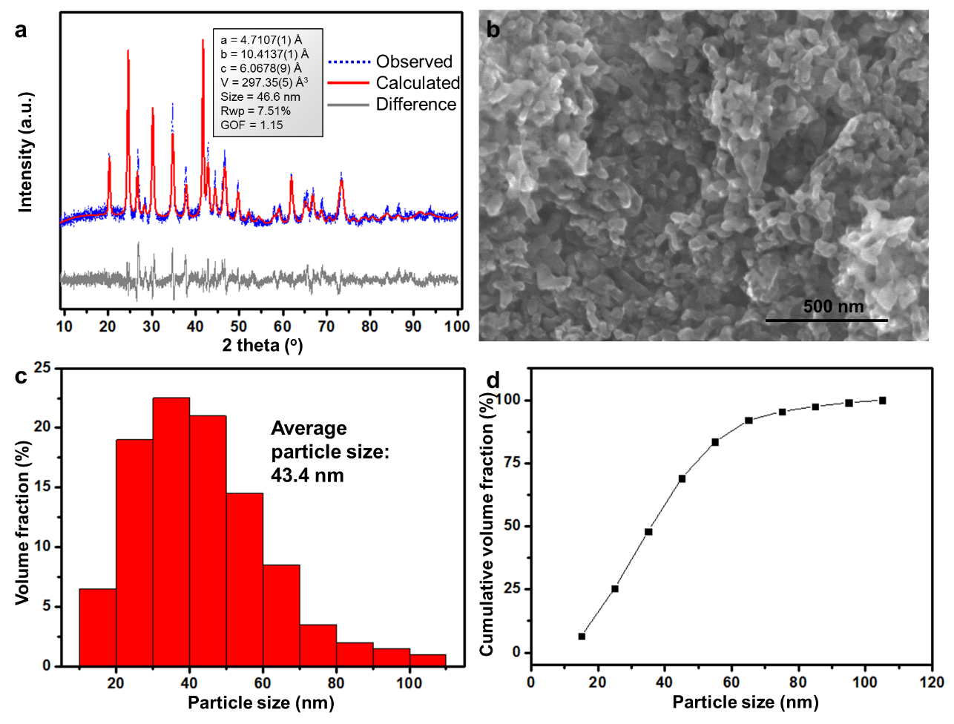
Figure S1. (a) Rietveld refinement of the X-ray diffraction data for the pristine LiFePO₄/C. (b )The SEM image of LiFePO₄/C. (c, d) the particle size distribution based on an analysis of 200 particles observed in the SEM images.

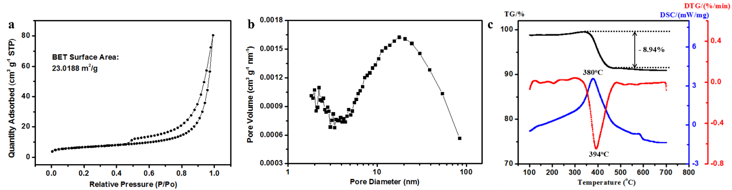
Figure S2. (a) nitrogen adsorption and desorption isotherms and (b) pore size distribution of the LiFePO₄/C. (c) The TG (black line), DSC (blue line) and DTG (red line) curves of LiFePO₄/C.

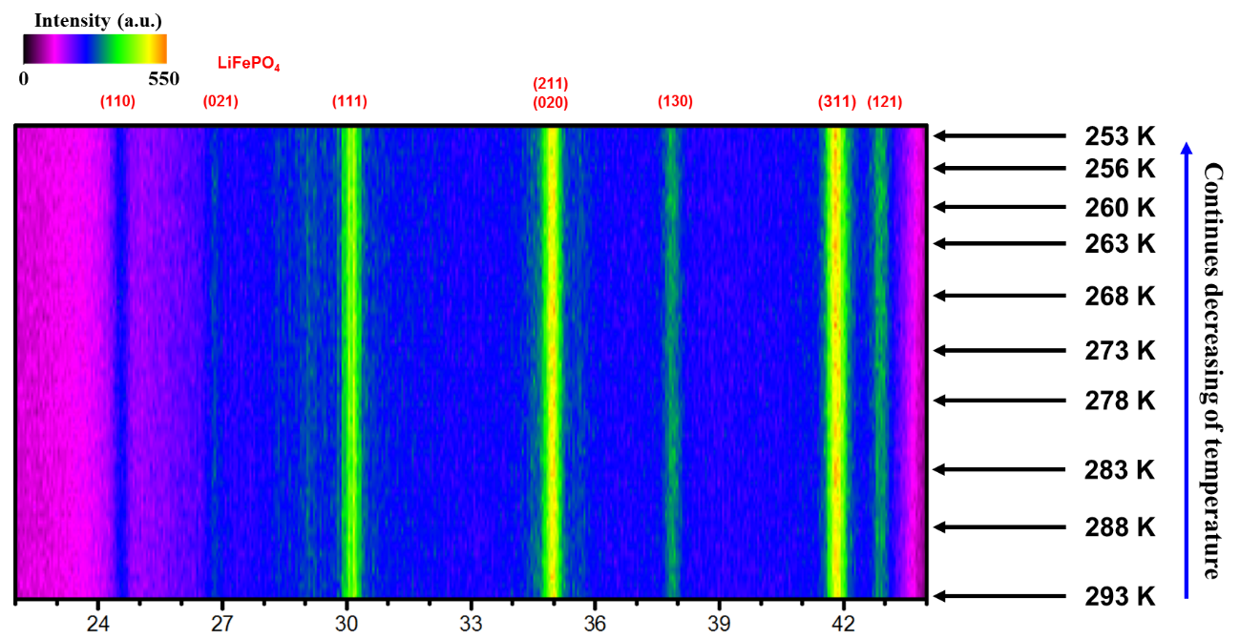
Figure S3. The XRD patterns of LiFePO₄ at different temperatures.

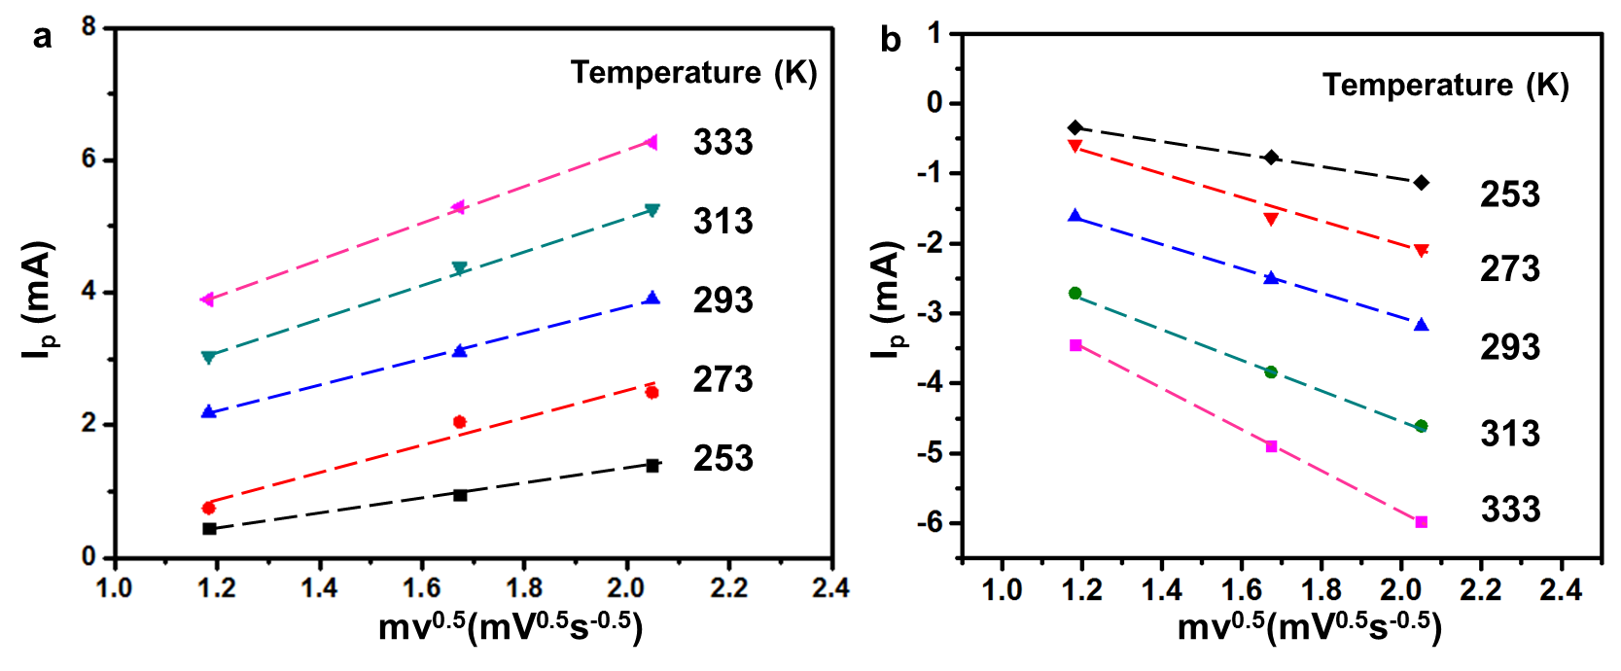
Figure S4. Linear fitting of I_{p} vs v^{1/2} curves for the oxidation and reduction peaks in Figure 1a-c.

Table S1. Ion diffusion coefficients and corresponding degrade percentage per decreasing 20 K with different temperatures

Temperature (K) | 333 | 313 | 293 | 273 | 253 | Average
Diffusion coefficients (cm²/s;  calculated from the oxidation peak) | 4.65E-13 | 3.84E-13 | 2.16E-13 | 2.14E-13 | 5.50E-14 | 2.67E-13
Diffusion coefficient degrade percentage per decreasing 20 K (calculated from the oxidation peak) | — | 17% | 43% | 0.93% | 74% | 34%
Diffusion coefficients (cm²/s;  calculated from the reduction peak) | 4.32E-13 | 2.45E-13 | 1.65E-13 | 1.56E-13 | 4.21E-14 | 2.68E-13
Diffusion coefficient degrade percentage per decreasing 20 K (calculated from the reduction peak) | — | 43% | 33% | 5.4% | 73% | 39%

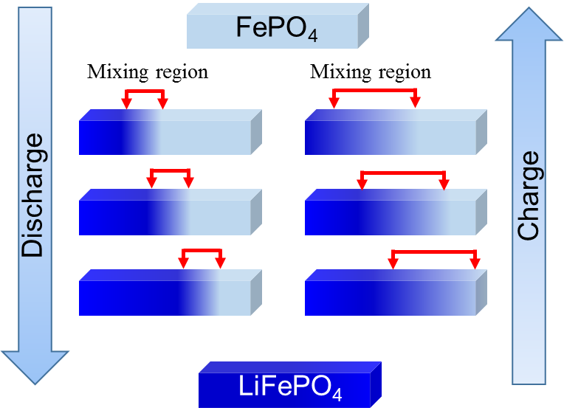
Figure S5. The schematic of the transformation of FePO₄ and LiFePO₄. The light blue, dark blue and the mixing region from light blue to dark blue represents the FePO₄, LiFePO₄ and solid solution between these phases, respectively.

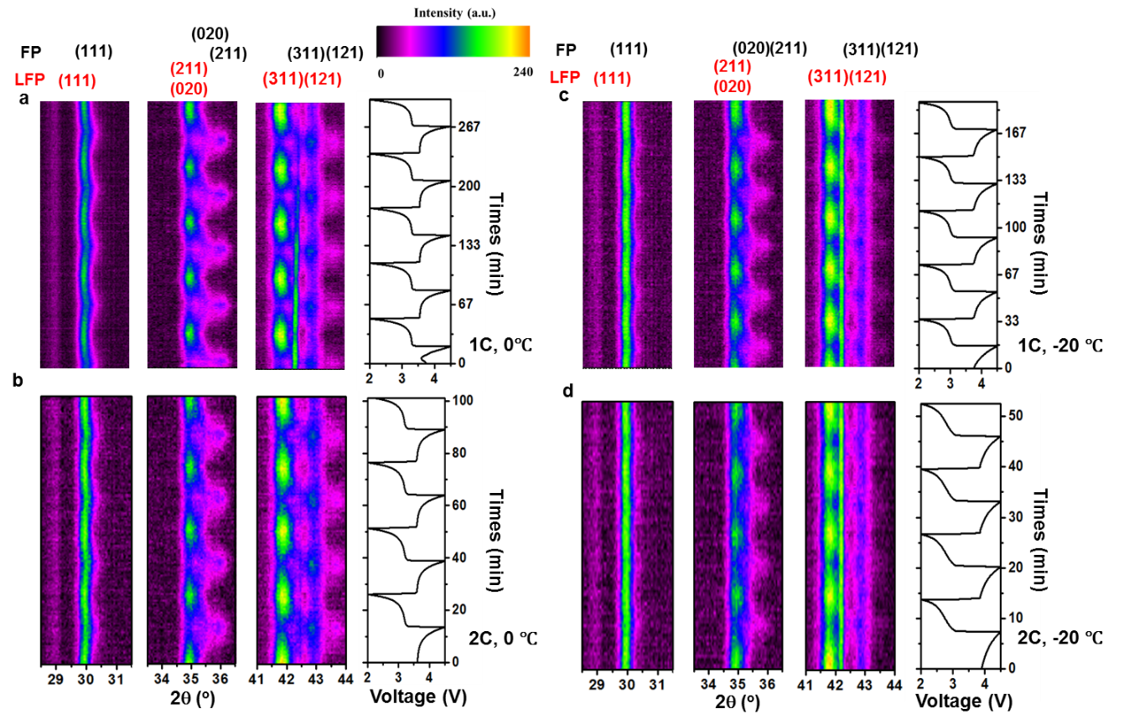
Figure S6. The image plot of diffraction patterns for (111), (211), (020), (311) and (121) reflections during the four charge/discharge cycles at a temperature of 273 K and 253 K with the scan rate of 1 C (a, c) and 2 C (b, d).

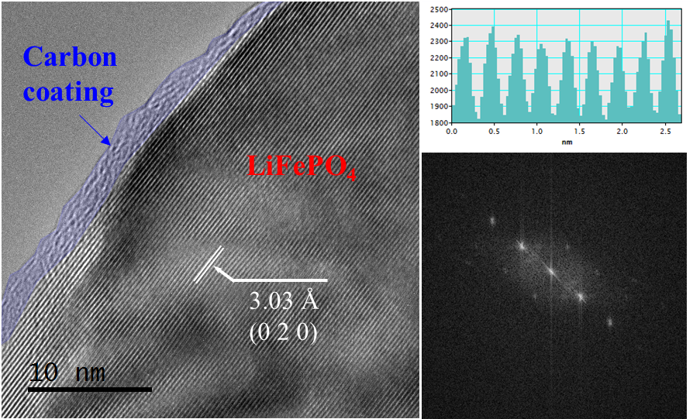
Figure S7. The TEM image and corresponding Fast Fourier Transform image of LiFePO₄.

The ex situ high resolution transmission electron microscopy (HRTEM) is applied to investigate the probable existence of intermediate phase of LiFePO₄. (The electrode materials were taken out while the formation of intermediate phase and investigated by ex situ HRTEM) As shown in Figure S7, a lattice spacing of 0.303 nm is observed which matches well with the separation between (0 2 0) planes of LiFePO₄. Although the intermediate phase is captured by high time resolution in situ XRD, there is no certain evidence which can demonstrate the existence of intermediate phase in ex situ HRTEM, which may be related to the really short life of such metastable state.

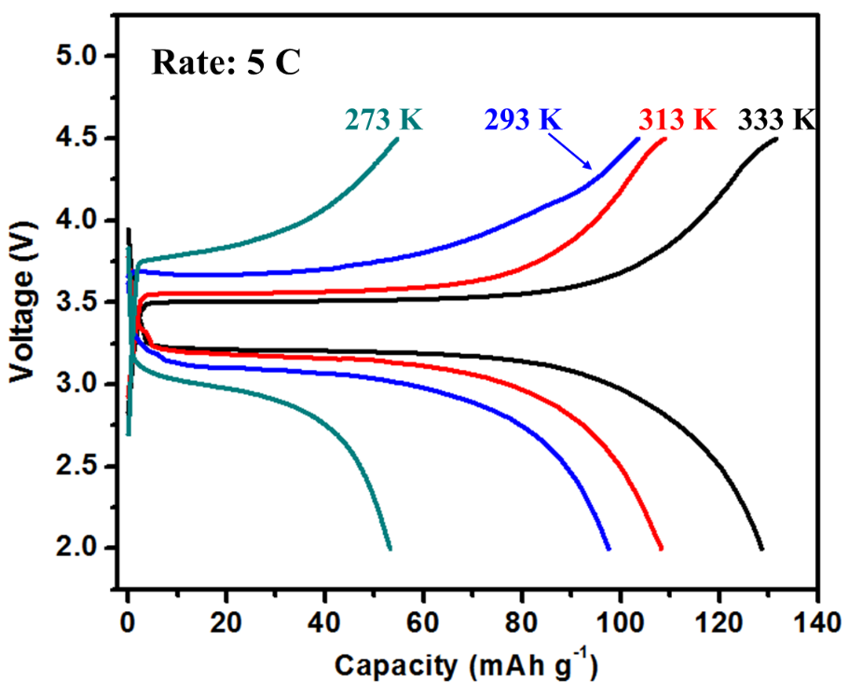
Figure S8. The charge-discharge curves of LiFePO₄ with different reaction temperature of 273, 293, 313, 333 K at 5C.

The charge/discharge curves at different reaction temperatures (273, 293, 313, and 333 K) are shown in Figure S8. It is found that, the capacity of LiFePO₄ can achieve a capacity of 131.4 mAh g⁻¹ at 333 K with a rate of 5C. With the decrease of temperature to 313, 293 and 273 K, the capacity of LiFePO₄ decrease to 108.8, 103.4, and 54.6 mAh g⁻¹, respectively.

Table S2. Comparison of time resolution, testing temperature range, rate capability and cost with different X-ray sources and detectors.

X-ray source | Time resolution | Testing temperature range | Rate capability | Cost
Ordinary in-situ equipment (lab source) ^{S1,S2} | 300 s | Room temperature | ~0.1 C | ~$ 200,000
Our in-situ equipment (lab source, 2D detector) | 10 s | -20 - 60 ºC | 5 C | ~$ 300,000
Synchrotron X-ray source ^{27, S3} | 2.5 - 4 s | Room temperature | 20 C | Expensive

There are two main advantages in this work. First of all, the lab X-ray source can achieve a high time resolution of 10 s, which is comparable to that of synchrotron X-ray source (3 – 4 s) and much higher than that of traditional in-situ equipment with lab source. This is benefitted from the application of two dimensional detector. Although the X-ray source intensity of lab technique is much lower than that of synchrotron technique, the signals of LiFePO₄, FePO₄ and corresponding intermediate phase is still obvious to the signals of noises. Secondly, the electrochemical reaction temperature is controllable (-20 – 60 ºC). Thus, we are able to capture the metastable phase of LiFePO₄ at different temperatures. Our discovery gives a deep understanding of the reaction dynamics of LiFePO₄ at low temperature.

References：
[S1] X.-Q. Yang, J. McBreen, W.-S. Yoon, C. P. Grey, Electrochem. Commun. 4.8 (2002): 649-654.
[S2] Z. Lu, J. R. Dahn, J. Electrochem. Soc. 149.7 (2002): A815-A822.
[S3] H. Komatsu, H. Arai, Y. Koyama, K. Sato, T. Kato, R. Yoshida, H. Murayama, I. Takahashi, Y. Orikasa, K. Fukuda, Adv. Energy Mater. 5.17 (2015).

