Supporting Information
Antimony Nanoparticles Anchored in Three-Dimensional Carbon Network as Promising Sodium-Ion Battery Anode
Wen Luoª†, Pengfei Zhangª†, Xuanpeng Wangª, Qidong Liª, Yifan Dongª, Jingchen Huaª, Liang Zhouª and Liqiang Maiª*

ª State Key Laboratory of Advanced Technology for Materials Synthesis and Processing, Wuhan University of Technology, Wuhan 430070, P. R. China

*Corresponding author:
E-mail addresses: mlq518@whut.edu.cn

†These authors contributed equally to this work.

- Material and methods
1.1 Synthesis of SbNPs@3D-C
All the chemical reagents were analytical pure and purchased from Sinopharm Chemical Reagent Co., Ltd. In a typical synthesis of SbNPs@3D-C, 0.5 g polyvinyl pyrrolidone (PVP) (K30) was firstly dissolved in 50 mL deionized water. Then, 2.5 g citric acid, 0.456 g SbCl₃, and 14.7 g NaCl were added into the above solution. After stirring for 10 min, the as-obtained transparent solution was rapidly frozen by pouring into liquid nitrogen at a constant speed. Subsequently, the water in the mixture was removed by freeze-drying process and the obtained sponge-like sample was ground into fine powder, which was then subjected to heat treatment. Specifically, the composite powder was placed in a quartz boat located in a tube furnace and heated at 700 ºC for 6 h with a heating rate of 2 ºC min⁻¹ under H₂/Ar (volume ratio: 5%:95%). At last, the as-synthesized products were washed by deionized water for several times to remove the NaCl template, and SbNPs@3D-C was obtained. In controlling experiments, 0.5 g cetyltrimethyl ammonium bromide (CTAB), sodium dodecyl sulfonate (SDS) and polyethylene glycol (PEG) were respectively used to replace the PVP during the synthesis. For the synthesis of 3D-C, the preparation process is the same with SbNPs@3D-C just without adding SbCl₃.
1.2 Material characterization
Field emission scanning electron microscopy (FESEM) images were collected with a JEOL-7100F microscope. Transmission electron microscopy (TEM) and high-resolution TEM (HRTEM) images were recorded by using a JEM-2100F STEM/EDS microscope. X-ray diffraction (XRD) patterns of sample were obtained with a D8 Advance X-ray diffractometer, using Cu Kα radiation (λ=1.5418 Å). Thermogravimetric analysis (TGA) was performed using a Netzsch STA 449C simultaneous analyzer and the sample was heated from room temperature to 630 ºC in air with a heating rate of 10 ºC min⁻¹.
1.3 Electrochemical performance measurements
The electrochemical measurements were carried out by assembly of 2016 coin cells in a glove box filled with pure argon gas, using Na foil as both the counter electrode and reference electrode, 1M NaClO₄ dissolved in ethylene carbonate (EC)/dimethyl carbonate (DMC) (1:1 by volume) with 5 % fluoroethylene carbonate (FEC) additive as the electrolyte, and a Celgard 2400 microporous membrane as the separator. The working electrodes were prepared by mixing the as-synthesized materials, acetylene black, and carboxyl methyl cellulose (CMC) at the weight ratio of 70:20:10. The slurry was casted onto Cu foil and dried under a vacuum oven at 70 ºC overnight. The average electrodes mass loading obtained was about 1.3 mg cm⁻². For the controlling experiments, the electrodes were prepared by mixing acetylene black with CMC at the weight ratio of 90:10, or three-dimensional carbon with CMC at the weight ratio of 90:10. Galvanostatic charge-discharge tests were performed at a potential range of 0.01-3 V vs. Na/Na⁺ using a multichannel battery testing system (LAND CT2001A). Herein, we define 1 C = 660 mA g⁻¹. Cyclic voltammetry (CV) and electrochemical impedance spectra (EIS) were tested with an electrochemical workstation (Autolab PGSTAT 302N and CHI600E).

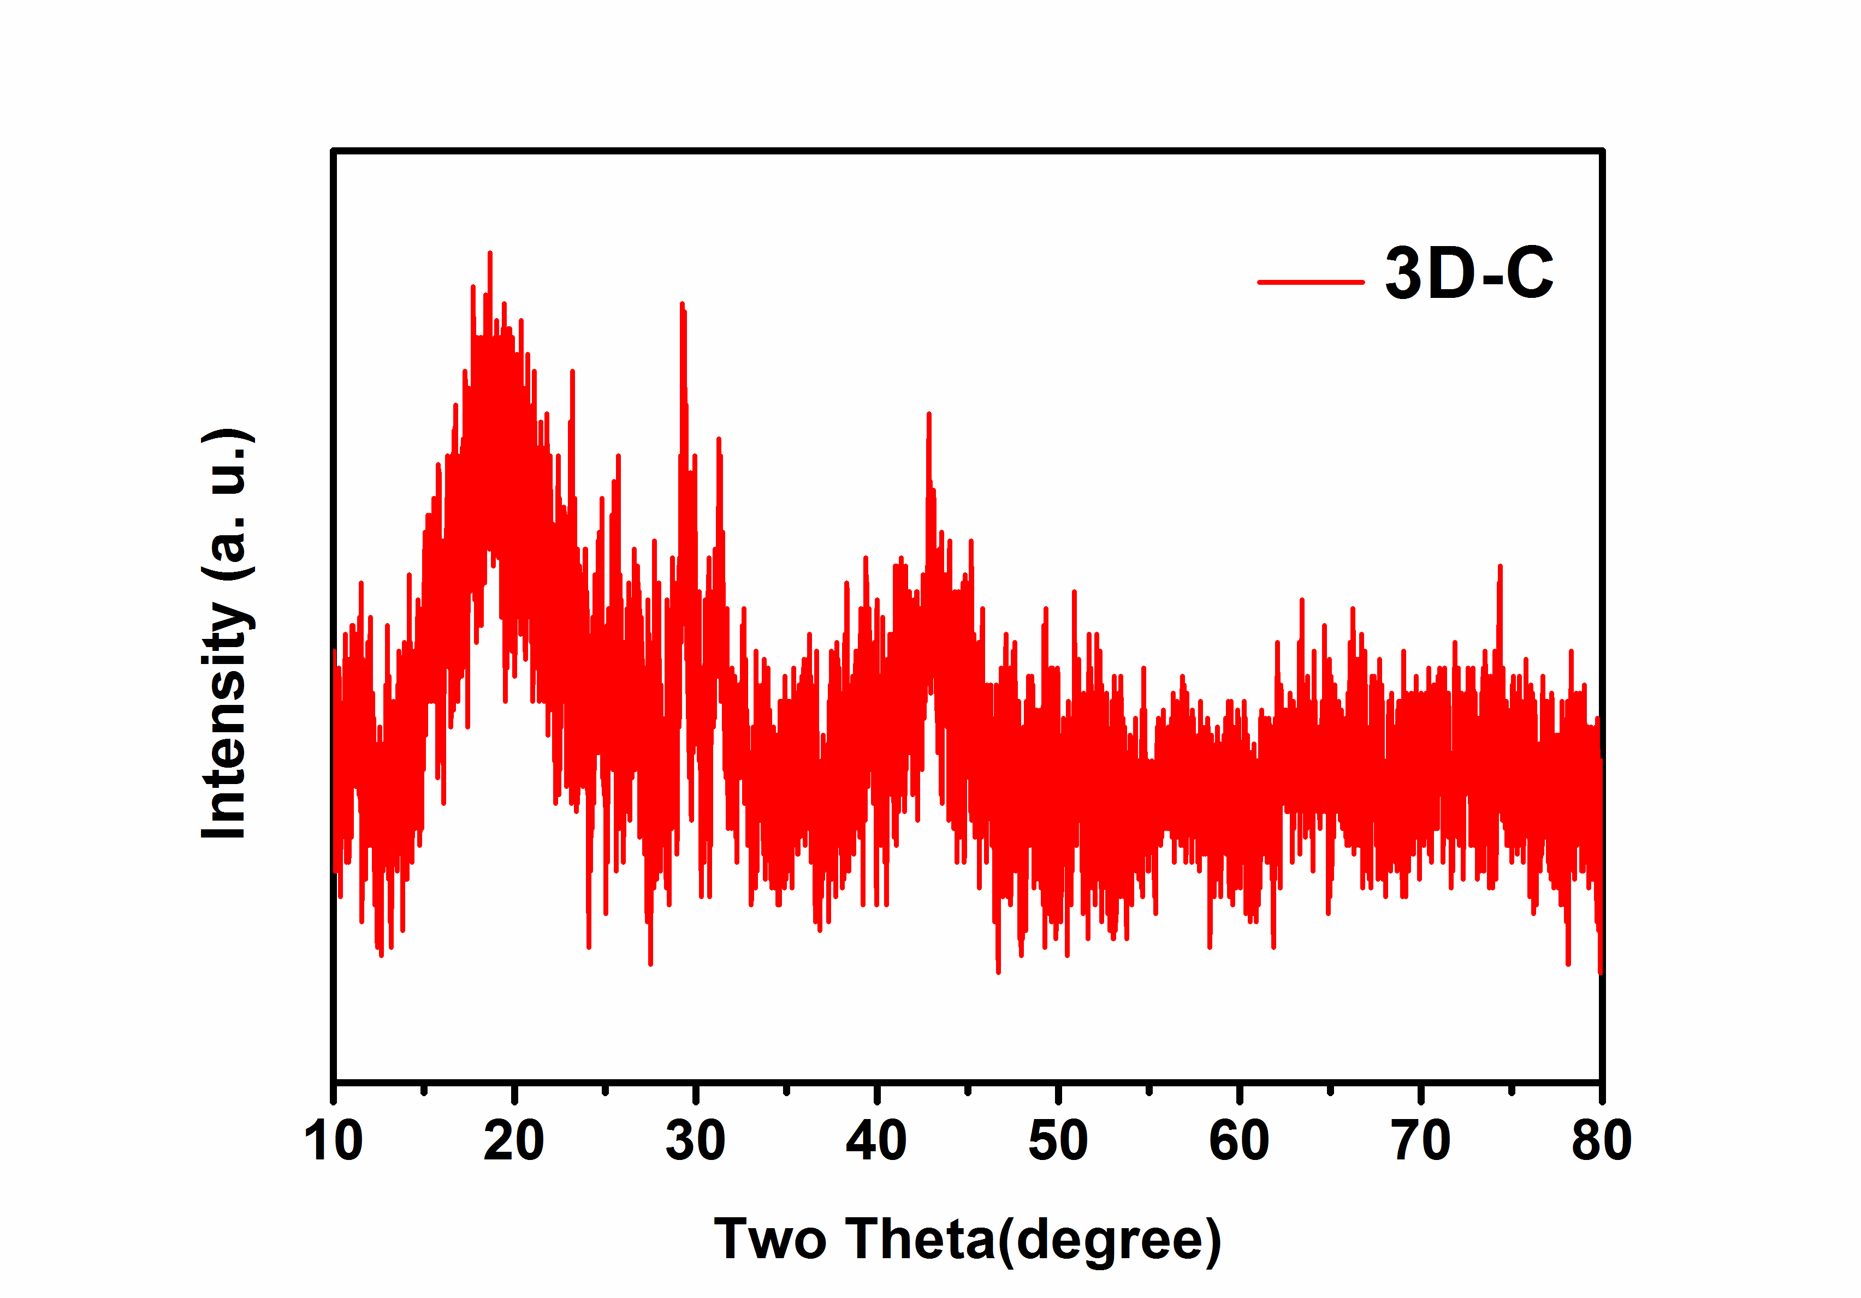
Figure S1. XRD pattern of 3D-C.
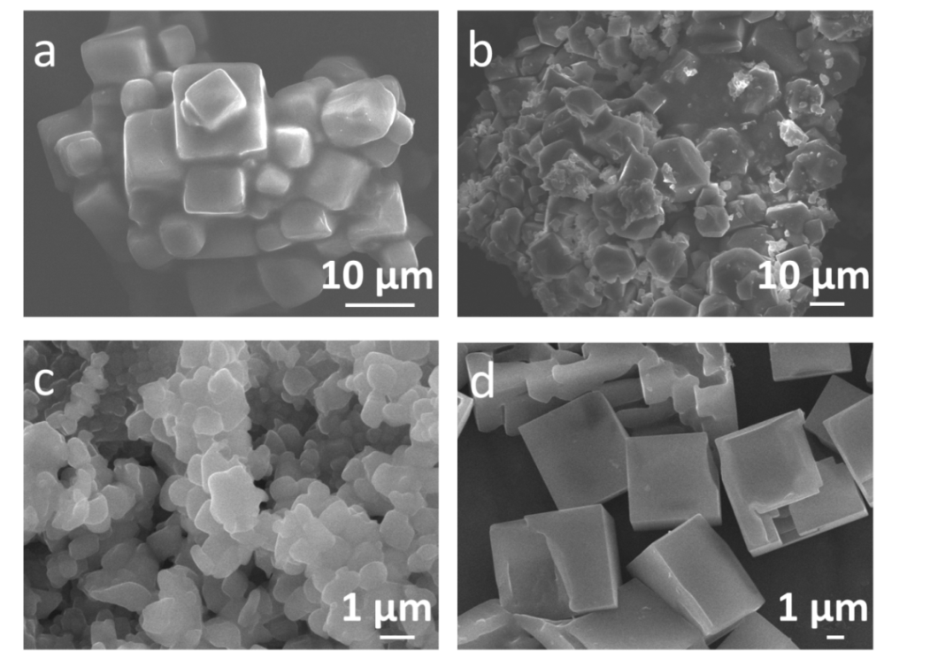

Figure S2. SEM images of the freeze-drying sample with CTAB (Figure S2a), SDS (Figure S2b), PEG (Figure S2c) and without any surfactant (Figure S2d).

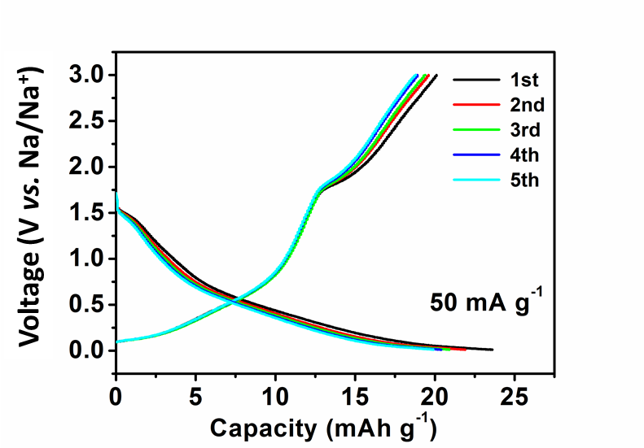
Figure S3. Charge/discharge voltage profiles of the acetylene black electrode at the current density of 50 mA g⁻¹.
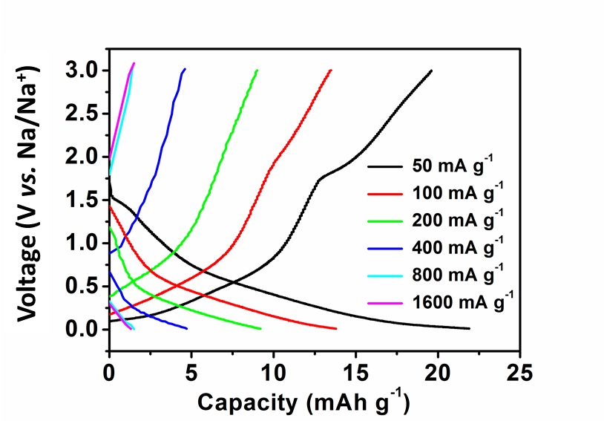
Figure S4. Charge/discharge voltage profiles of the acetylene black electrode at different current densities.

Figure S5. Coulombic efficiency of SbNPs@3D-C electrode at a specific density of 100 mA g⁻¹ with and without 5% FEC additive.
Figure S6. Coulombic efficiency of SbNPs@3D-C electrode at a specific density of 2000 mA g⁻¹ with and without 5% FEC additive.

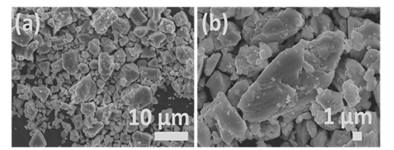

Figure S7. SEM images of the commercial antimony powder.

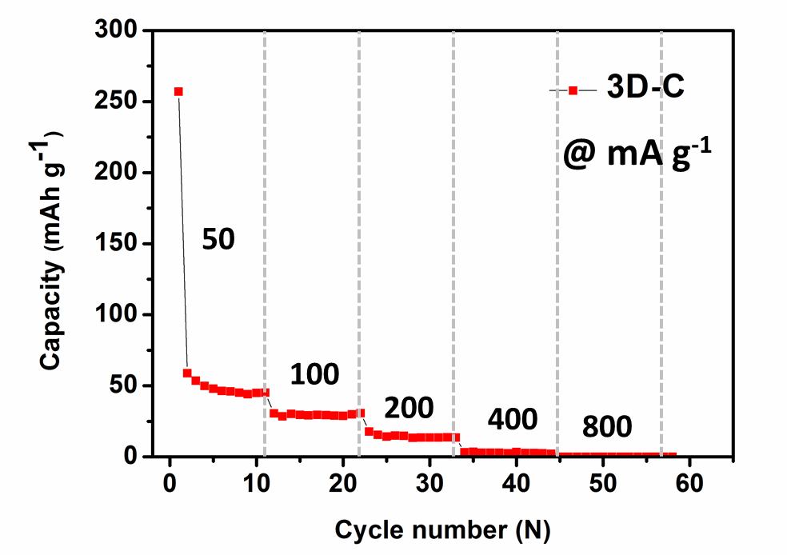
Figure S8. Rate performance of the 3D-C electrode.

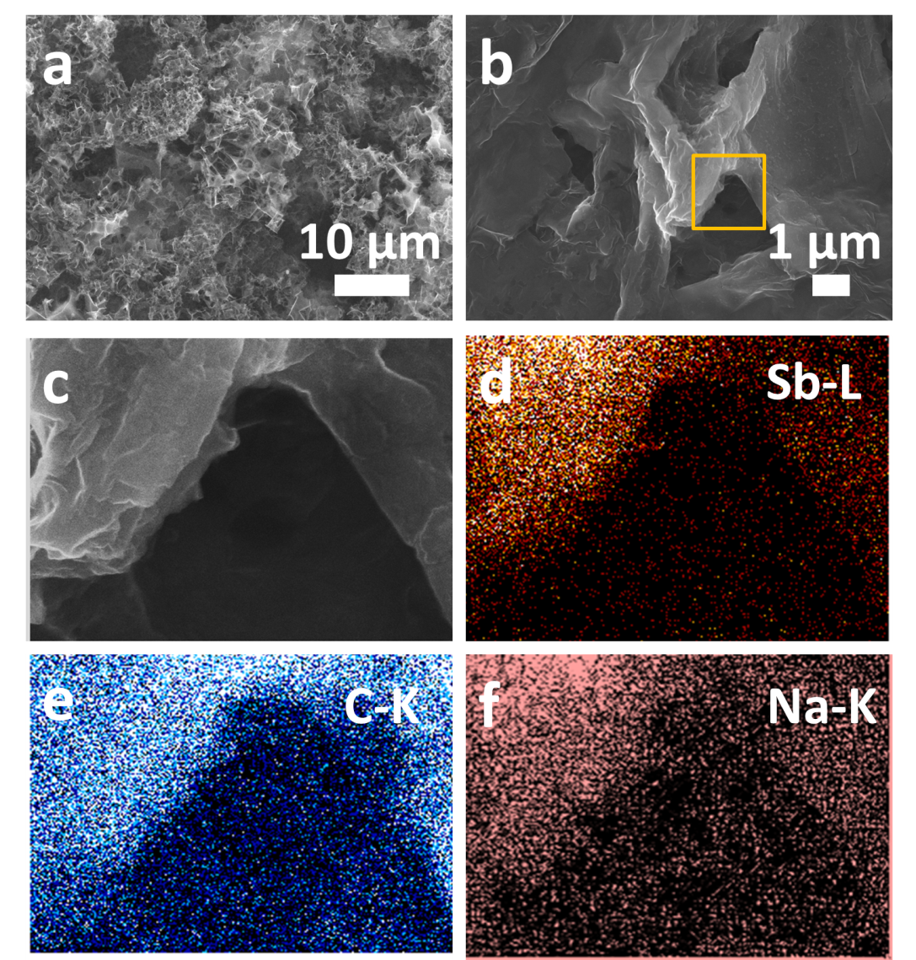

Figure S9. SEM images of the SbNPs@3D-C electrode after 100 cycles, at the specific density of 500 mA g⁻¹. (Figure S9a, b and c) The cell was disassembled at the fully desodiated state. (d-f) Antimony, carbon and sodium elemental mapping images of the SbNPs@3D-C electrode after 100 cycles, respectively.

