Supporting Information
Smart construction of three-dimensional hierarchical tubular transition metal oxide core/shell heterostructures with high-capacity and long-life-cycle lithium storage
Jiexi Wang,^{a,1} Qiaobao Zhang,^{b,1} Xinhai Li,ª Bao Zhang, ^{a,*} Liqiang Mai,^{c,*} Kaili Zhang^{b,*}
ª School of Metallurgy and Environment, Central South University, 932, South Lushan Road, Changsha, P.R. China, 410083
^{b} Department of Mechanical and Biomedical Engineering, City University of Hong Kong, 83 Tat Chee Avenue, Hong Kong
^{c} State Key Laboratory of Advanced Technology for Materials Synthesis and Processing, WUT-Harvard Joint Nano Key Laboratory, Wuhan University of Technology, Wuhan, 430070, P.R. China.
¹ These authors contributed equally.
* Corresponding authors: xinhaili_csu@126.com; csuzb@vip.163.com; (Bao Zhang);
kaizhang@cityu.edu.hk (Kaili Zhang);
mlq518@whut.edu.cn (Liqiang Mai)

ESI-1. Synthesis of 3D hierarchical solid CuO/CoO core/shell heterostructure arrays
First, the as-prepared Cu(OH)₂ nanorod arrays as introduced in Section 2.1 in main text were annealed at 120 °C for 2 h and then maintained at 180 °C for 2 h in argon gas. After that, the as-fabricated CuO nanorods on Cu foam were used as substrate rather than the direct use of Cu(OH)₂ nanorods as substrate. The same CBD process followed by a calcination process as shown in Section 2.2 in maintext was applied to integrate CoO on the surface of CuO nanorods to form solid CoO/CuO core/shell heterostructure arrays on Cu foam.

ESI-2. The method for determining the mass loading on the electrode
The mass loading on the electrode were determined by 1 M HCl washing and the weight of the active material were calculated as following equation:
m = m₁ - m₂
whereas m is the weight of the active mass, m₁ is the weight of the fresh electrode before HCl washing, and m₂ is the weight of the corresponding cycled electrode after HCl washing. The active mass on the electrodes of CuO nanowires, CuO-CoO nanowire and CoO nanowires are 5.13, 2.95, and 1.74 mg, respectively.

Figure S1 Schematic illustration of the fabrication process of 3D hierarchical solid CuO/CoO core/shell heterostructure arrays on copper foam.
To achieve the solid CuO/CoO core/shell heterostructure arrays on Cu foam, the as-obtained Cu(OH)₂ nanorods on Cu foam were first thermally converted to CuO nanorods in argon gas as shown in Figure S1(b-c) and then the same CBD process followed a calcination process was used to integrate CoO shells on the surface of solid CuO nanorods cores, forming the novel 3D hierarchical solid CuO/CoO core/shell heterostructure arrays.

Figure S2 (a-b) SEM images of Cu(OH)₂ nanorods on Cu foam, (c) TEM image of single Cu(OH)₂ nanorod, (d) SAED pattern of Cu(OH)₂ nanorod, and (e) XRD pattern of Cu(OH)₂ nanorods on Cu foam.
The representative SEM images, TEM image, the selected area electron diffraction (SAED) pattern and XRD pattern of Cu(OH)₂ nanorods are shown in Figure S2. High density of Cu(OH)₂ nanorods with lengths up to 10 µm are vertically grown on the surface of copper foam with good uniformity in large scale. TEM image of single Cu(OH)₂ nanorod shown in Figure S2(c) demonstrates that it has a very smooth surface with a diameter of 670 nm. The SAED pattern indicates that the nanorod is single crystalline. The XRD pattern shown in Figure S2(e) demonstrates that all the reflection peaks could be readily indexed to orthorhombic Cu(OH)₂ (JCPDS 13-0420) except for two strong peaks coming from the Cu foam substrate, indicating the formation of pure Cu(OH)₂ on Cu foam.
Figure S3 (a) TEM and (b) HRTEM images of CuO nanorods.
As shown in Figure S3, the CuO nanorod has a diameter of 250 nm and its corresponding HRTEM in the inset shows a distinct set of visible lattice fringes with an inter-planar spacing of 0.276 nm, in agree with the (111) plane of monoclinic structure of CuO.

Figure S4 (a) XRD patterns of bare Cu foam (black line), CuO nanorods/Cu foam (red line) and hierarchical tubular CuO/CoO core/shell heterostructure arrays/Cu foam (blue line), high-resolution XPS spectra of (b) Co 2p, (c) Cu 2p and (d) O 1s.
The crystal structures of the bare Cu foam, the CuO nanorods/Cu foam and the hierarchical tubular CuO/CoO core/shell heterostructure arrays/Cu foam are analyzed by XRD and the results are shown in Figure S4a. The bare Cu foam shows two strong peaks, centered at 43.4º and 50.5º, which correspond to the Cu diffraction planes (111) and (200), respectively.¹ Aside from the two strong peaks coming from the bare Cu foam, the CuO nanorods/Cu foam demonstrates four other well-defined diffraction peaks, at 32.4º, 35.5º, 38.7º and 48.8º, which can be indexed to the diffraction planes (110), (002), (111) and (-202) of monoclinic CuO (PDF#80-1917), respectively.² No additional diffraction peaks can be detected, suggesting the complete thermal conversion of Cu(OH)₂ nanorods into high-purity monoclinic CuO nanorods. After the integration with CoO nanosheets via CBD and the following heat treatment, two new diffraction peaks located at 36.5º and 42.4º are observed and can be assigned to cubic CoO (PDF#43-1004) (111) and (200) planes respectively,^{3,4} in addition to the diffraction peaks originating from bare Cu foam and CuO nanorods, evidencing the successful formation of CuO/CoO heterostructures. The chemical composition of the tubular CuO/CoO core/shell heterostructure arrays on Cu foam is further examined by XPS. The high-resolution Co 2p spectrum is shown in Figure S4b and demonstrates four peaks, Co 2p_{2/3}, Co 2p_{1/2}, and their corresponding satellites, centering at 779.2, 795.2, 784.8, and 801.1 eV respectively, which confirmes the Co(II) oxidation state in the CuO/CoO heterostructures.⁴ The high-resolution Cu 2p spectrum shown in Figure S4c contains four peaks, centered at 934.6, 943.4, 954.0 and 962.2 eV, and can be assigned to Cu 2p_{3/2} and Cu 2p_{1/2} of Cu(II) plus their satellites, respectively.^{5,6} The O 1s peak in Figure S4d at 531.2 eV corresponds to the oxygen species in CuO/CoO heterostructures.
Reference
1 X. Wu, H. Bai, J. Zhang, F. Chen, and G. Shi, J. Phys. Chem. B, 2005, 109, 22836.
2 S. Gao, S. Yang, J. Shu, and S. Zhang, J. Phys. Chem. C, 2008, 112, 19324.
3 L. Zhu, Z. Wen, W. Mei, Y. Li, and Z. Ye, J. Phys. Chem. C, 2013, 117, 20465.
4 S. Xiong, J. S. Chen, X. W. Lou, and H. C. Zeng, Adv. Funct. Mater., 2012, 22, 861.
5 Q. Zhang, K. Zhang, D. Xu, G. Yang, H. Huang, F. Nie, C. Liu, and S. Yang, Prog. Mater. Sci., 2014, 60, 208.
6 X. Zhang, Y.-G. Guo, W.-M. Liu, and J.-C. Hao, J. Appl. Phys., 2008, 103, 114304.

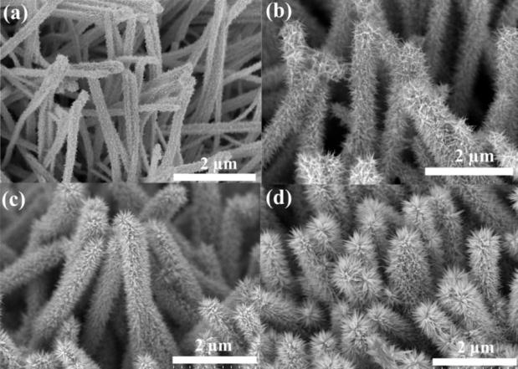
Figure S5 SEM images of hierarchical tubular CuO/CoO core/shell heterostructure arrays on copper foam prepared at different reaction time of CBD: (a) 0.5 h, (b) 1 h, (c) 2h, and (d) 4h.
In order to better understand the formation process of branched CoO nanosheets on the surface of CuO, a time series analysis is performed by inspecting the morphologies at different growth stages. Figure S5(a-d) shows the SEM images of the hierarchical tubular CuO/CoO core/shell heterostructure that are recorded at reaction times of 0.5, 1, 2, 4 h, respectively. It can be clearly seen that the diameter, length, and density of the secondary CoO branches can be tailored by changing reaction time. When the reaction time is as short as 0.5 h, a thin layer of CoO seed nanoparticles is found to be attached on the surface of the CuO nanoarrays. When the reaction time is increased to 1h, short CoO nanosheets begin to emerge on the surface of the CuO nanoarrays. Upon further increasing the reaction time to 2h, highly dense and long branched CoO nanosheets are observed to be appeared from the surface of the CuO nanoarrays, forming the interesting 3D core/shell heterostructured arrays configuration. When increase the time from 2h to 4h, the diameter, length and density of the CoO nanosheet branches increase accordingly, forming densely complex hierarchical architecture.
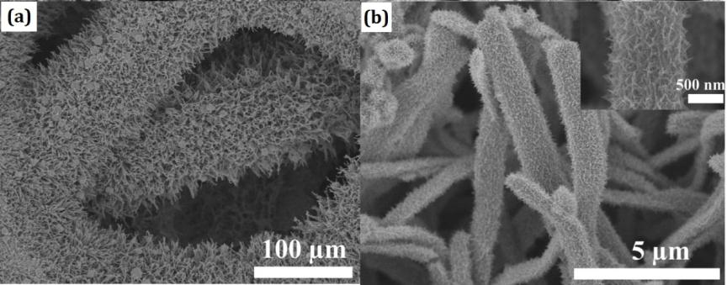
Figure S6 (a) low-magnification and (b) high-magnification SEM image of hierarchical solid CuO/CoO core/shell heterostructure arrays on Cu foam. Inset (b) is the enlarged image of a single solid CuO/CoO core/shell heterostructure.
As shown in Figure S6, though the CoO nanosheets are grown on CuO nanorods, they are not very homogeneous and do not vertically grow on CuO nanorods. Moreover, many bulked particles can be seen on the surface, without strong adhesion with CuO nanorods or Cu foam, which is not in favor of electrochemical performance production as anode for LIBs.
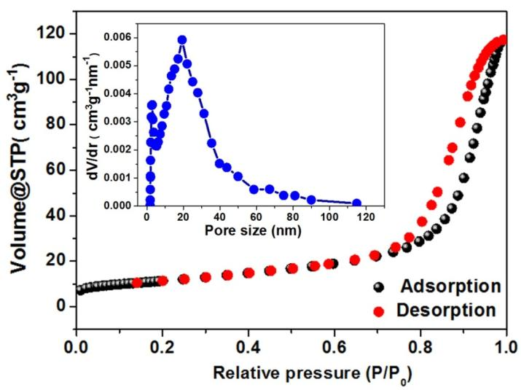
Figure S7 The N₂ absorption-desorption isotherm of CoO nanosheet shells.
From Figure S7, a typical IV isotherm with a distinct hysteresis loop in the range of 0.7−1.0 P/P_{o} can be clearly seen, indicating their mesoporous structures. It exhibit narrow pore size distribution, centered at around 19.2 nm, which confirm the mesoporous feature of CoO nanosheets. The BET surface area of CoO nanosheet shells is 40.2 m²g⁻¹.

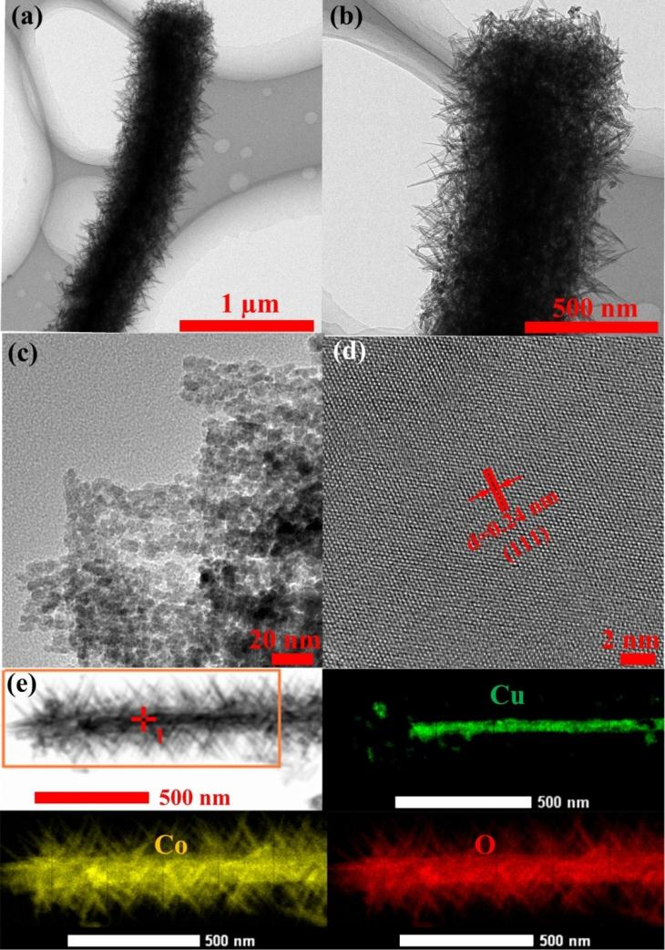
Figure S8 (a-b) Low-magnification TEM images of hierarchical solid CuO/CoO core/shell heterostructure, (c) enlarged TEM image of branched CoO nanosheets, (d) high-magnification TEM image of branched CoO nanosheets and (e) EDS mapping results of single hierarchical solid CuO/CoO core/shell heterostructure.

The detailed microstructure of hierarchical solid CuO/CoO core/shell heterostructure is also verified by TEM and HRTEM. The solid CuO/CoO core/shell heterostructure can be revealed very clearly as shown in Figure S11(a-b) and branched CoO nanosheets are uniformly and closely covered on the surface of solid CuO nanorod core. These branched CoO nanosheet shells with porous structure are assembled by numerous interconnected nanoparticles (Figure S11(c)). The HRTEM image (Figure S11(d)) of outer shell of CoO shows very clear lattice fringes with a distance of 0.24 nm, which matches well with the (111) planes of cubic CoO. TEM elemental mapping results shown in Figure S11(e) unambiguously confirm the hierarchical solid CuO/CoO core/shell heterostructure.

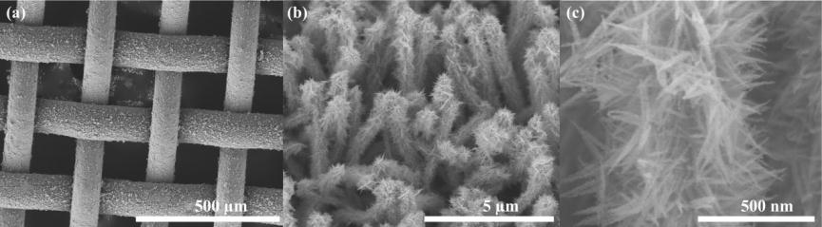
Figure S9 (a-c) SEM images of CuO/CoO on Cu mesh at different magnifications.

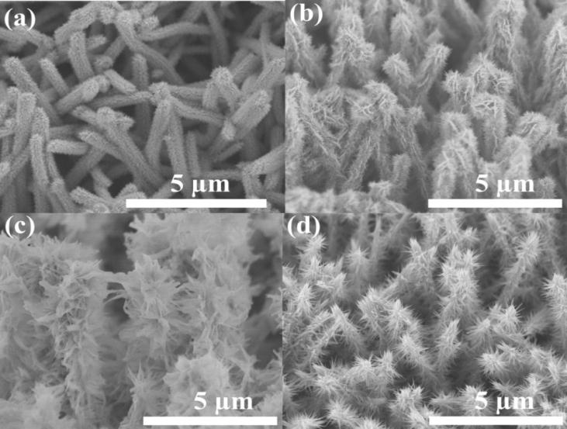
Figure S10 SEM images of (a) CuO-Co₃O₄, (b) CuO-NiCo₂O₄, (c) CuO-ZnCo₂O₄ and (d) CuO-Cu_{x}Co_{3-x}O₄ on Cu foam.

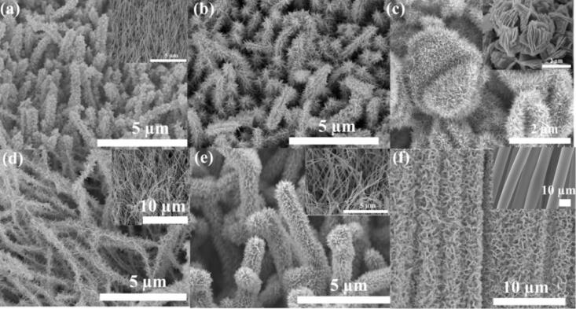
Figure S11 SEM images of (a) CuO/Co₃O₄ on Ni foam, inset is the CuO nanowires, (b) CuO/Co₃O₄ on Cu foil, (c) CuO microflowers/Co₃O₄ on Cu foam, inset is the bare CuO microflowers on Cu foam, (d) NiSi_{x} nanowires/Co₃O₄ on Ni foam, inset is the bare NiSi_{x} nanowires on Ni foam, (e) NiSi_{x} nanowires/NiCo₂O₄ on Ni foam, inset is the bare NiSi_{x} nanowires on Ni foam, (f) CoO on carbon fibers, inset is the bare carbon fibers.
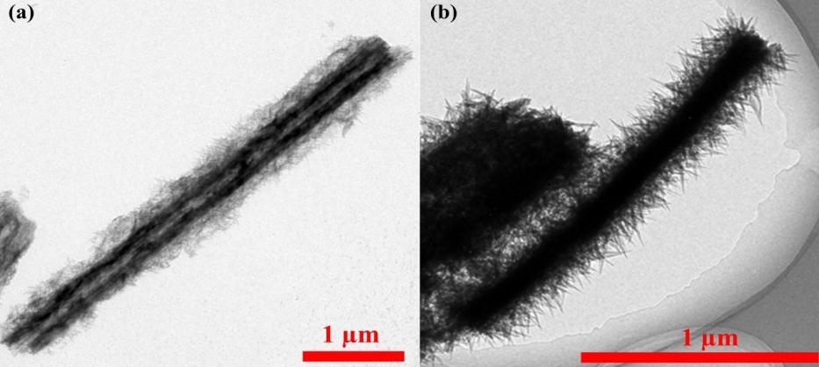
Figure S12 Low-magnification TEM images of (a) tubular structure of Cu(OH)₂ nanorod/Co precursor heterostructure and (b) CuO nanorod/Co precursor heterostructure.

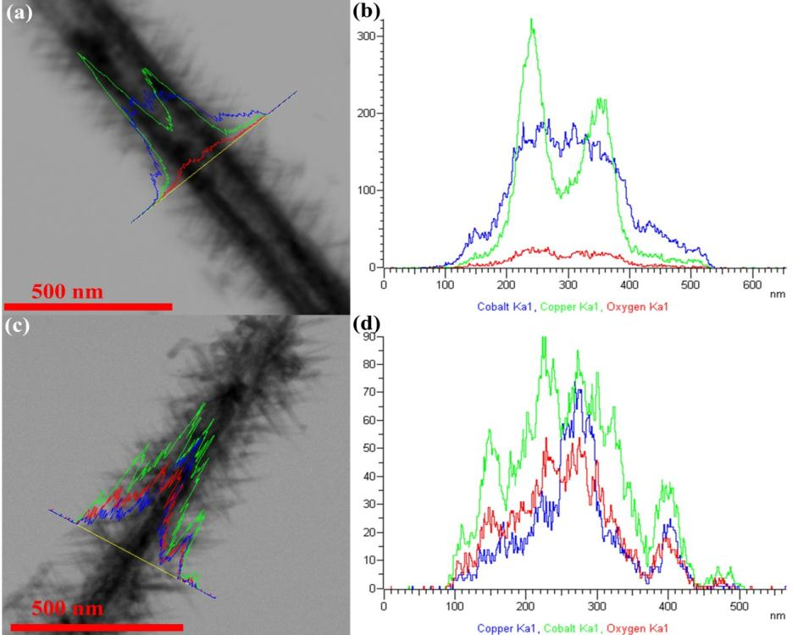
Figure S13 (a) STEM image of single CuO/CoO tubular structure, (b) element distribution spectra of single CuO/CoO tubular structure, (c) STEM image of single CuO/CoO solid structure and (d) element distribution spectra of single CuO/CoO solid structure.

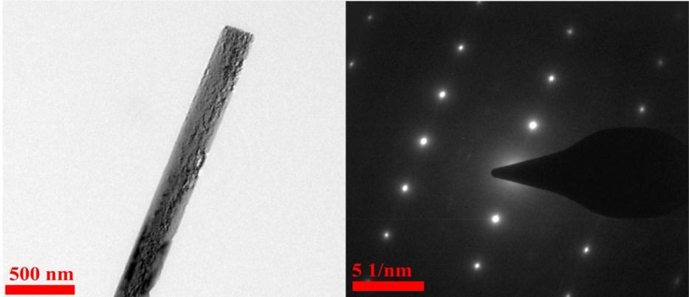
Figure S14 (a) TEM image of single Cu(OH)₂ nanonrod after reacting in urea solution at 85 ºC for 2h and (b) its corresponding SAED pattern.

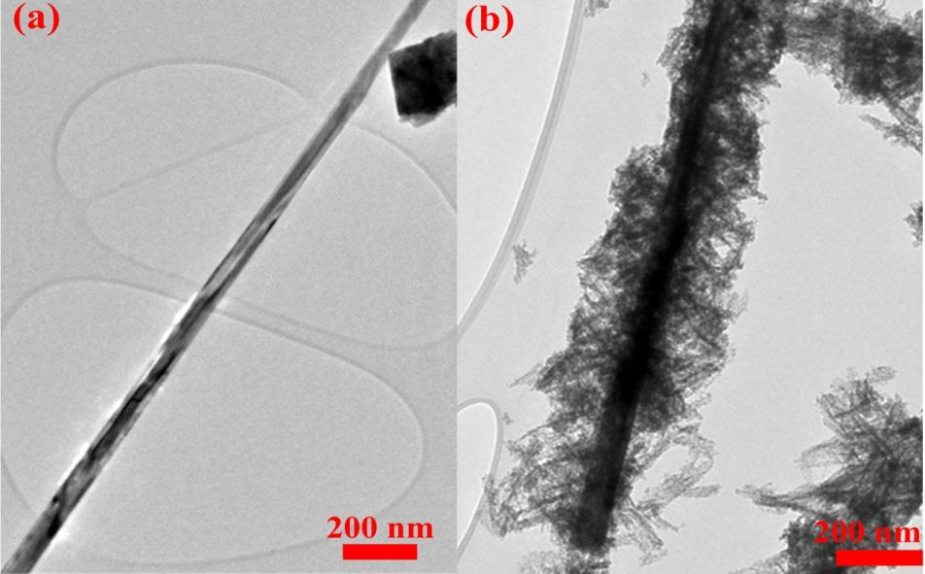
Figure S15 TEM images of (a) single CuO nanowire and (b) CuO/Co₃O₄ core/shell nanowire.
Figure S16 Electrochemical performance of CuO nanorods and CoO nanosheets on Cu foam. CV curves of (a) CuO nanorods and (b) CoO nanosheets at the scanning rate of 0.1 mV s⁻¹; Discharge-charge curves of (c) CuO nanorods and (c) CoO nanosheets at 100 mA g⁻¹; Cycle performance (e) CuO nanorods and (f) CoO nanosheets at 100 mA g⁻¹.

Figure S17 Cycle performance of cell composed of as-fabricated tubular CuO/CoO core/shell array anode on copper foam. The cell is first cycled at 100 mA g⁻¹ for 10 cycles and then cycled at 1000 mA g⁻¹ for 500 cycles.

Figure S18 The galvanostatic discharge/charge voltage profiles for the 50th, 100th, 150th, 200th, 250th, 300th, 350th, 400th, 450th, 500th, 550th cycles at current density of 1.0 A g⁻¹.
Figure S19 TEM, HRTEM and STEM images of as-fabricated tubular CuO/CoO core/shell array anode after cycles.

Table S1 Comparison of electrochemical properties as the anode materials for LIBs between various other metal oxides nanocomposites reported in the literature and tubular CuO/CoO core/shell array on copper foam in this work
Other metal oxide nanocomposite anodes | Reversible capacity (mAh g⁻¹) after n cycles | Voltage range(V) | Current density  (mAg⁻¹) | References
Fe₂O₃@Co₃O₄ nanowire array | 1005 (after 50 cycles) | 0.00–3.0 | 200 | ¹
Fe₂O₃@NiO core/shell nanorods | 1047 (after 50 cycles) | 0.00−3.0 | 200 | ²
Co₃O₄/TiO₂ hierarchical heterostructures | 603 (after 480 cycles) | 0.01–3.0 | 200 | ³
ZnO/ZnCo₂ O₄ submicron rod  arrays | 900 (after 30 cycles) | 0.01-3.0 | 45 | ⁴
Coaxial Fe₃O₄/CuO hybrid nanowires as | 953 (after 100 cycles) | 0.005–3.0 | 820 | ⁵
Co₃O₄/NiO/C nanowire arrays | 1053 (after 50 cycles) | 0.00-3.0 | 500 | ⁶
NiO/ZnO hybrid nanofiber | 949 (after 120 cycles) | 0.02-3.0 | 200 | ⁷
TiO₂–MnO₂/MnO₂ heterostructure | 888(after 50 cycles) | 0.00−3.0 | 100 | ⁸
SnO₂/MoO₃/C nanocomposites | 560 (after 120 cycles) | 0.01-3.0 | 200 | ⁹
TiO₂/Fe₂O₃ nanostructure | 530 (after 200 cycles) | 0.01-3.0 | 200 | ¹⁰
Carbon coated SnO nanoplates constructed Tubular Structures | 700 (after 50 cycles) | 0.05-1.5 | 200 | ¹¹
Tubular CuO/CoO core/shell arrays | 1140 (after 1000 cycles) | 0.01-3.0 | 1000 | This work

References
(1) Xiong, Q. Q.; Xia, X. H.; Tu, J. P.; Chen, J.; Zhang, Y. Q.; Zhou, D.; Gu, C. D.; Wang, X. L. J. Power Sources 2013, 240, 344.
(2) Xiong, Q.; Tu, J.; Xia, X.; Zhao, X.; Gu, C.; Wang, X. Nanoscale 2013, 5, 7906.
(3) Wang, H.; Ma, D.; Huang, X.; Huang, Y.; Zhang, X. Sci. Rep. 2012, 2, 701.
(4) Lee, C.; Seo, S.; Kim, D.; Park, S.; Jin, K. Nano Res. 2013, 6, 348.
(5) Saadat, S.; Zhu, J.; Sim, D. H.; Hng, H. H.; Yazami, R.; Yan, Q. J. Mater. Chem. A 2013, 1, 8672.
(6) Wu, J. B.; Guo, R. Q.; Huang, X. H.; Lin, Y. J. Power Sources 2014, 248, 115.
(7) Qiao, L.; Wang, X.; Qiao, L.; Sun, X.; Li, X.; Zheng, Y.; He, D. Nanoscale 2013, 5, 3037.
(8) Li, X.; Chen, Y.; Yao, H.; Zhou, X.; Yang, J.; Huang, H.; Mai, Y.-W.; Zhou, L. RSC Adv. 2014, 4, 39906.
(9) Si, L.; Yuan, Z.; Liang, J.; Hu, L.; Zhu, Y.; Qian, Y. J. Mater. Chem. A 2014, 2, 9784.
(10) Luo, J. ; Xia, X.;Luo, Y; Guan, C.; Liu, J.; Qi, X.; Ng., C. F.; Yu, T.; Zhang, H.; Fan, H. J. Adv. Energy Mater. 2013, 3, 737.
(11) Zhang, L.; Zhang, G.; Wu, H. B.; Yu, L.; Lou, X. W. D. Adv. Mater. 2013, 25, 2589.

Table S2 Fitted circuit component values of the cell composed of as-prepared CuO/CoO nanowire electrodes at various states
State | 1st, 0 V | 1st, 3 V | 5th, 3 V | 50th, 3 V | 1000th, 3 V
R_{e} (±3 Ω) | 8 | 7 | 10 | 7 | 7
R_{sf} (±3 Ω) | 72 | 6 | 5 | 4 | 13
R_{ct} (±3 Ω) | 81 | 35 | 18 | 19 | 29

To study the reaction kinetics of tubular CuO/CoO core/shell array anodes, EIS tests of the cells at various states are carried out, with cell states achieved by applying currents of 100 mA g⁻¹ for the first 50 cycles and 1.0 A g⁻¹ for the following cycles. Each Nyquist plot is composed of an intercept at a very high frequency that is related to the ohmic resistance (R_{e}) of the cell, two semicircles separately corresponding to the surface-film impedance at high frequencies (R_{sf}//CPE_{sf}) and the charge-transfer impedance at medium frequencies (R_{ct}//CPE_{dl}), and a sloped line at low frequency indexed to the Warburg impedance region (W_{o}). These plots are fit with an equivalent circuit, and the fitting results listed in Table S2. When discharged to 0 V, the cell shows relatively large R_{sf} and R_{ct} values, which are separately attributed to the formation of SEI film with poor conductivity at the electrode/electrolyte interface and increased resistance against further insertion of lithium ion into the host materials because of the Li⁺ concentration, respectively. When the cell is recharged to 3.0 V, R_{sf} and R_{ct} values decrease from 72 to 6 Ω and from 81 to 35 Ω, respectively. The rapid decrease of the R_{sf} value may have been due to the decomposition of SEI film during the charge process. It is also likely that the electrode/electrolyte interface would be activated by the initial discharge-charge process. Comparing the EIS results of the cell after 1 cycle with that after 5 cycles, it can be seen that the R_{sf} value shows no significant changes, indicating a stable, quality electrical contact between the electrode and electrolyte after the first cycle. However, the R_{ct} value shows a continuously decreasing trend, which can be ascribed to structural changes, leading to an increased amount of active sites for electrochemical reactions. After 5 cycles, both R_{sf} and R_{ct} values remain unchanged up to the end of the first 50 cycles, indicating the formation of a stabilized electrode/electrolyte interface for Li⁺ diffusion and electrochemical reactions. Even after 1000 cycles, the cell exhibits an only slightly enlarged value for R_{sf} and R_{ct}, demonstating that the tubular CuO/CoO core/shell heterostructure array anodes produced are able to maintain a stable structure without significant degradation even into long-term cycling. Additionally, the stable and highly conductive gel-like polymer layer formed at the interface leads to a greatly improved electron/Li⁺ conductivity and a large increase in the number of sites available for electrochemical reactions.⁴⁴ Such phenomena could contribute to restraining any increase of R_{sf} and R_{ct}. Moreover, the formation of the flexible gel-like polymer layer is also good for supressing structural degradation, which is typically caused by the strain of volume expansion and contraction during the cycling process. Throughout cycling, the cell shows only small surface-film and charge-transfer impedances, again reflecting the superior electrochemical cycling performance of this material.

