**Porous Carbonized graphene-embedded fungus film as an interlayer for superior Li-S batteries**

Liyuan Chai, a, b, 1 Jiexi Wang,a, c, 1 Haiying Wang,a, b, 1 Liyuan Zhang,a, e * Wanting Yu,d Liqiang Maic, *

a School of Metallurgy and Environment, Central South University, Changsha, 410083, P. R. China

b Chinese National Engineering Research Center for Control & Treatment of Heavy Metal Pollution, Central South University, Changsha, 410083, P. R. China  
c State Key Laboratory of Advanced Technology for Materials Synthesis and Processing, Wuhan University of Technology, Wuhan, 430070, P. R. China

d Department of Environmental Monitoring, Changsha Environmental Protection College, Changsha 410004, China

e Environmental Engineering Research Centre, Department of Civil Engineering, the University of Hong Kong, Hong Kong, P. R. China

1 Liyuan Chai, Jiexi Wang and Haiying Wang contributed equally to this work.

* Corresponding Author, [zhang_livyl@csu.edu.cn](mailto:zhang_livyl@csu.edu.cn), [lyzhk@hku.hk](mailto:lyzhk@hku.hk) (L. Zhang)

[mlq518@whut.edu.cn](mailto:mlq518@whut.edu.cn) (L. Mai)

**Figure S1. Optical microscope image of fungus.** This image was acquired by optical microscope. The sample was stained by lactophenol blue solution.

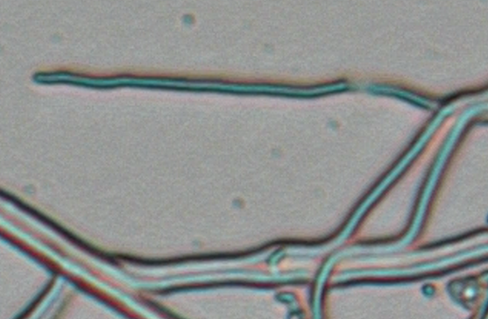

**Figure S2. SEM image of the fungus film.**

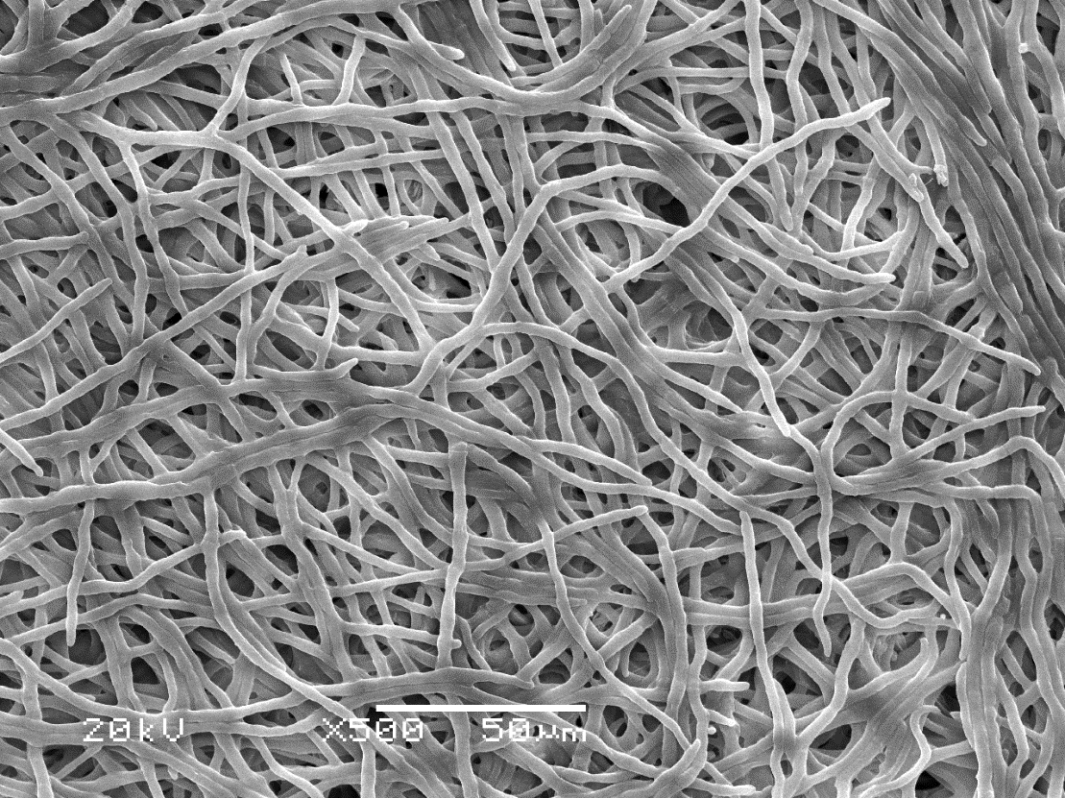

**Figure S3. Free standing film from the vacuum filtration of the fungus hyphae.**

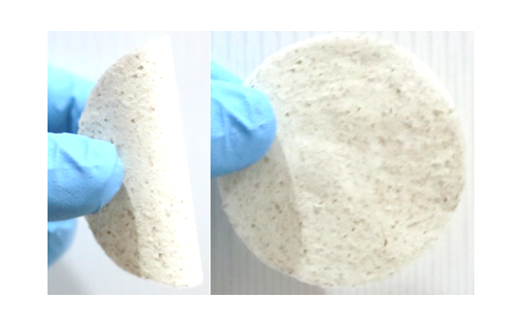

**Figure S4. Raman spectra of graphene nanosheets and fungus hyphae.**

E:\张理源\百度云同步盘\文章 需经常更新\投稿文件\M\Fungi-石墨烯\表征\Raman\Graphene-changzhou-LIBs-2.wmf

Graphene nanosheets

E:\张理源\百度云同步盘\文章 需经常更新\投稿文件\M\Fungi-石墨烯\表征\Raman\Aspergillus Niger-1.wmf

Fungus hyphae

**Figure S5. Raman spectrum of the fungus-derived carbon.**

This sample was prepared by otherwise the same carbonization condition only without using graphene nanosheets. The peak at ~1340 cm-1 is much broader than that of GFC film mentioned in the main text.

C:\Users\理源\Desktop\20141231\400 carbon1.wmf

**Figure S6. FTIR spectrum of the GFC film.**



**Figure S7. Comparison of the conductivity of the biomass-derived carbon.**

|  |  |  |  |
| --- | --- | --- | --- |
| **Materials** | **Conductivity (S cm-1)** | **Carbonization temperature (oC)** | **References** |
| Carbon aerogel | 0.1 | 950 | RSI-7-1 |
| Bacterial cellulose-derived carbon | 0.41 | 1450 | RSI-7-2 |
| Carbon fiber aerogel | 1.23 | 800 | RSI-7-3 |
| Porous Carbonized graphene-embedded fungus film | 0.71 | 800 | This work |

References

[RSI-7-1] Nicolas Brun, et al. Green Chem., 2013, 15, 2514.

[RSI-7-2] Hai-Wei Liang, et al. NPG Asia Mater., 2012, 4, e19.

[RSI-7-3] Liyuan Zhang, et al. Green Chem., 2014, 16, 3926.

**Figure S8. The pore distribution of the GFC film.**

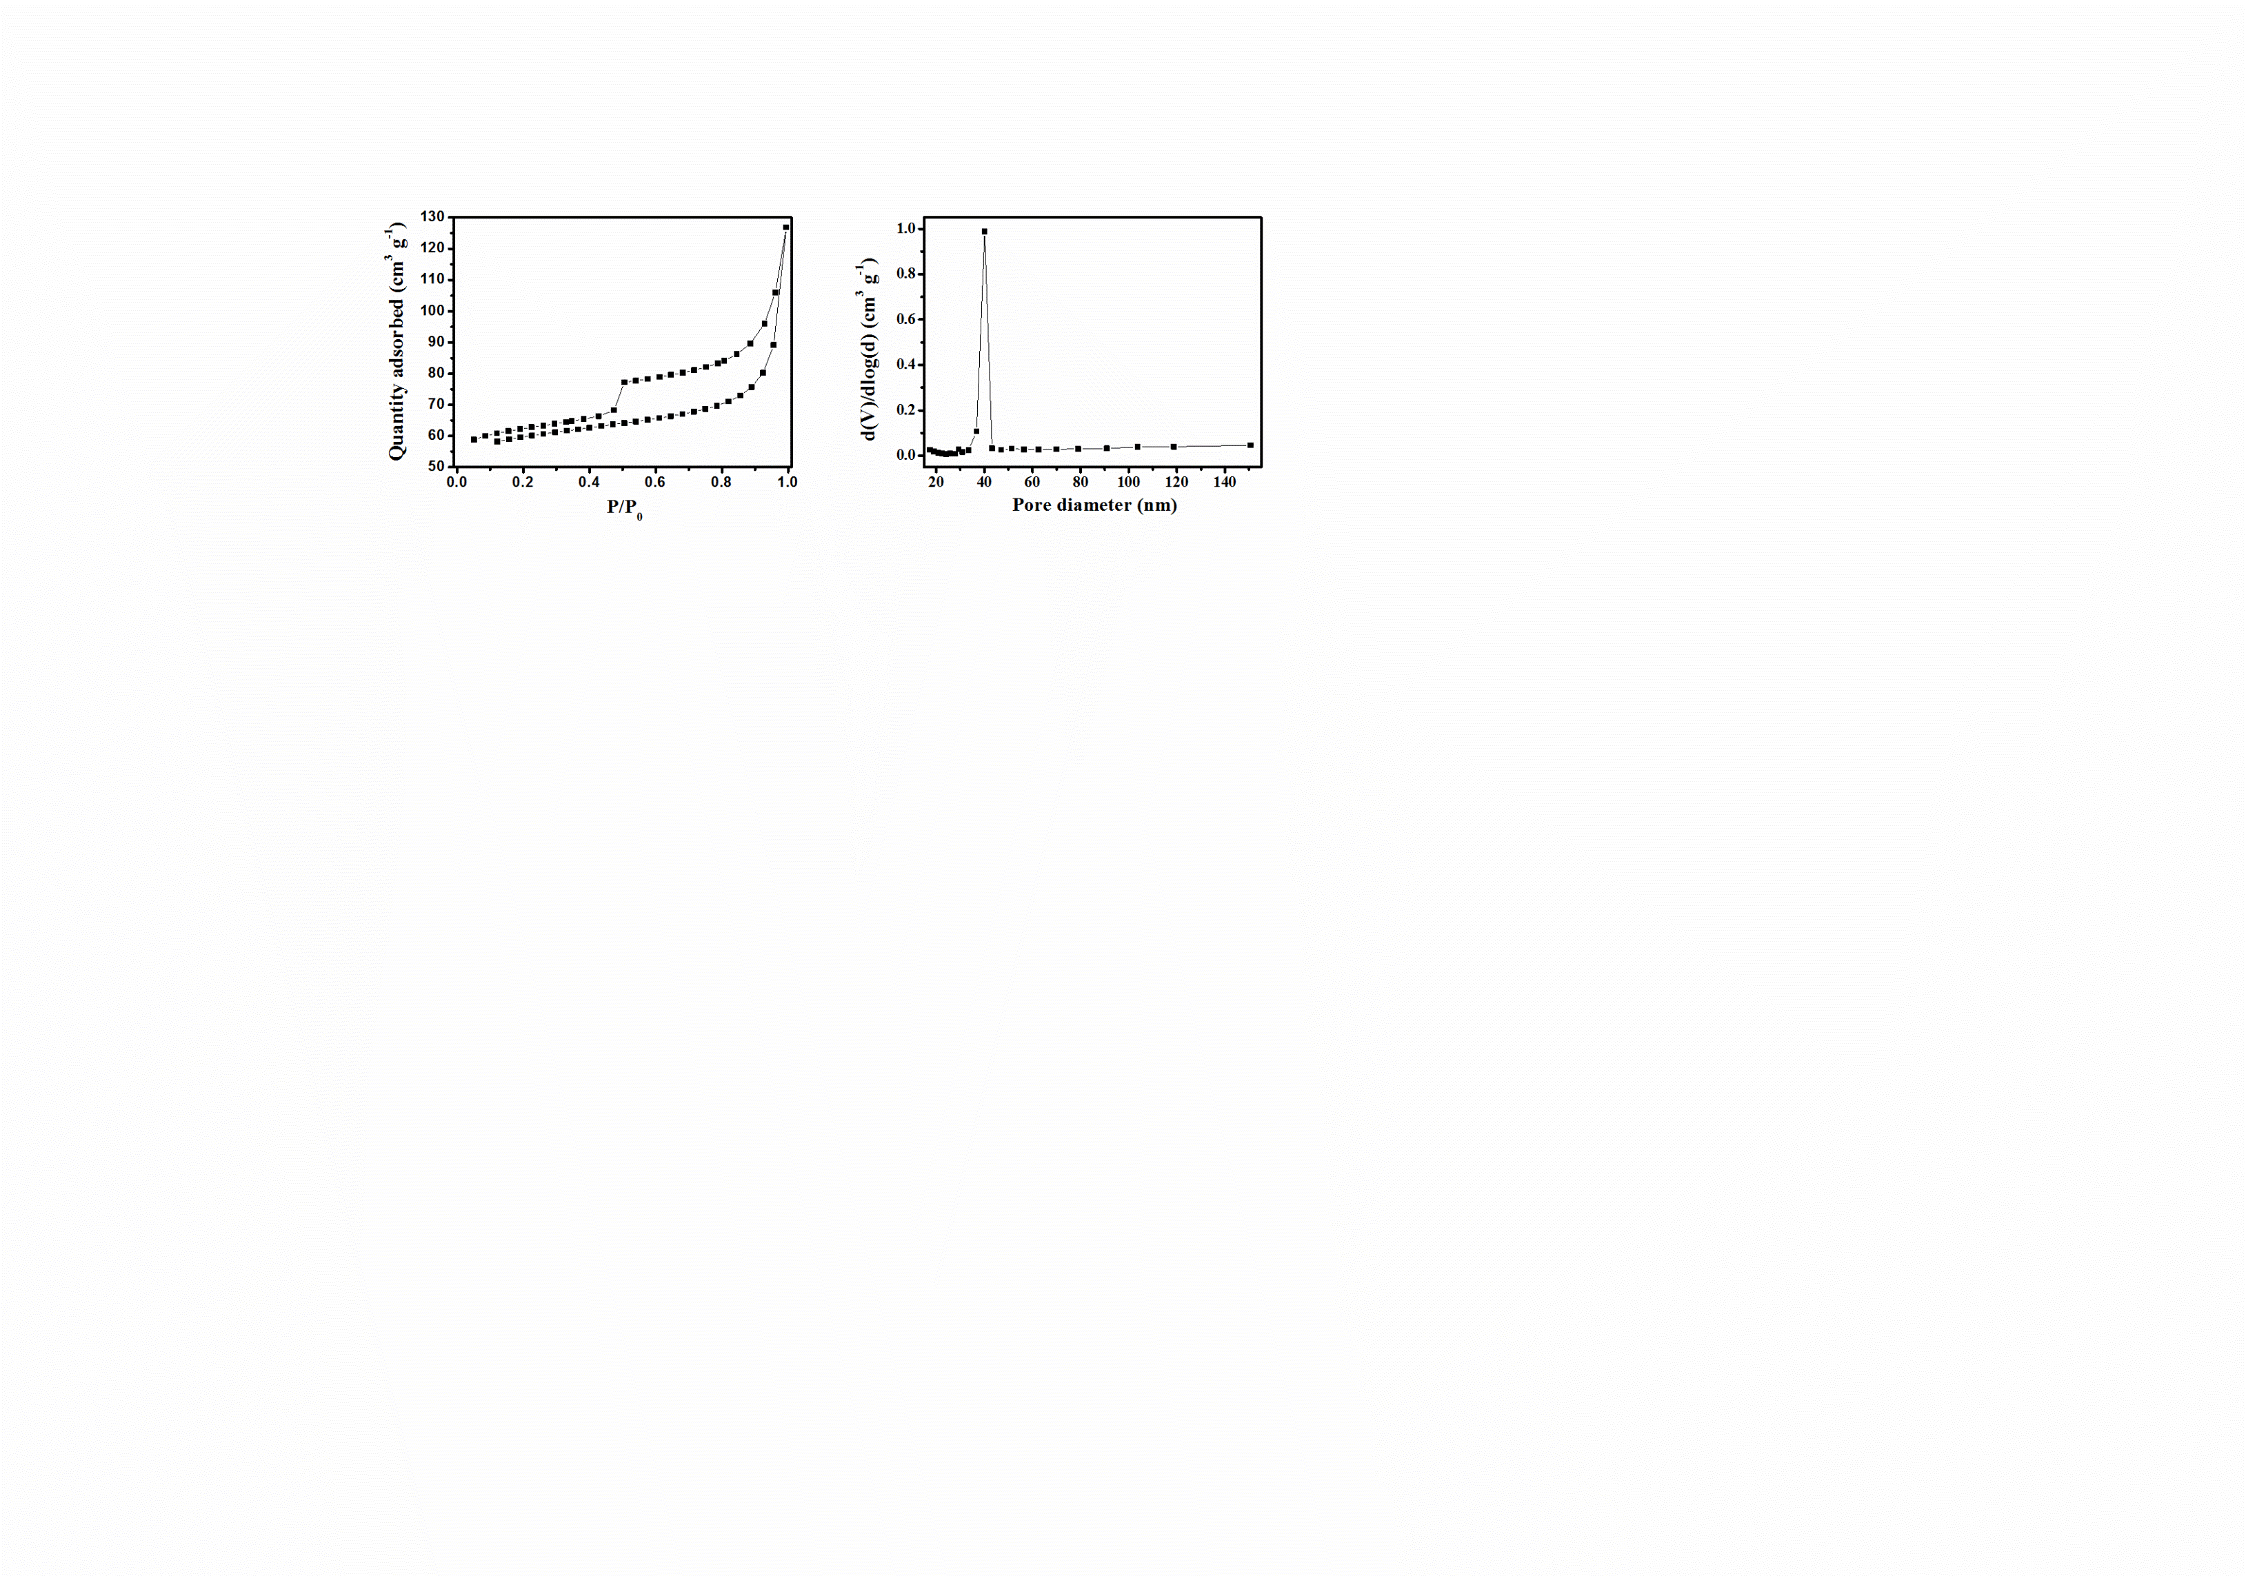

**Figure S9. Comparison of the performance of Li-S batteries with inserting biomass-derived carbon membrane.**

|  |  |  |  |  |
| --- | --- | --- | --- | --- |
| **Materials** | **Capacity (mAh g-1)** | **Cycles** | **Rate (C)** | **References** |
| Carbon fiber membrane | 630 | 100 | 0.5 | RSI-8-1 |
| Carbonized paper | 890 | 100 | 1.0 | RSI-8-2 |
| Leaf-derived carbon | 829 | 100 | 0.5 | RSI-8-3 |
| Cassava-derived carbon | 811 | 100 | 0.5 | RSI-8-4 |
| Carbonized filter paper | 560 | 50 | 1.0 | RSI-8-5 |
| Carbonized eggshell | 1000 | 100 | 0.2 | RSI-8-6 |
| Porous Carbonized graphene-embedded fungus film | 887 | 100 | 1.0 | This work |

**References**

[RSI-8-1] Liyuan Zhang, et al. Green Chem., 2014, 16, 3926.

[RSI-8-2] Sheng-Heng Chung, et al. Chem. Commun., 2014, 50, 4184.

[RSI-8-3] Sheng-Heng Chung, et al. ChemsusChem, 2014, 7, 1655.

[RSI-8-4] Furong Qin, et al. New J. Chem., 2014, 38, 4549.

[RSI-8-5] Kai Zhang, et al. Mater. Lett., 2014, 121, 198.

[RSI-8-6] Sheng-Heng Chung, et al. Adv. Mater., 2013, 26, 1360.

**Figure S10. Homogeneous sulfur distribution in the interlayer**

