*Supporting information for*

**Porous Ni0.14Mn0.86O1.43 Hollow Microspheres as High-Performing Anodes for Lithium Ion Batteries**

Zhong Maa, Xianxia Yuan*,a, Lin Lia, Zi-Feng Maa, Lei Zhangb, Liqiang Maic, and Jiujun Zhang*,b

a Shanghai Electrochemical Energy Devices Research Center, Department of Chemical Engineering, Shanghai Jiao Tong University, Shanghai, 200240, China

b Department of Chemical and Biochemical Engineering, University of British Columbia, Vancouver, BC V6T 1W5, Canada

c State Key Laboratory of Advanced Technology for Materials Synthesis and Processing, WUT-Harvard Joint Nano Key Laboratory, Wuhan University of Technology, Wuhan 430070, China

* Corresponding authors. Tel: 86-21-54742827; Fax: 86-21-54741297;

E-mail: [yuanxx@sjtu.edu.cn](mailto:yuanxx@sjtu.edu.cn) (X. Yuan), [jiujun@shaw.ca](mailto:jiujun@shaw.ca) (J.J. Zhang)

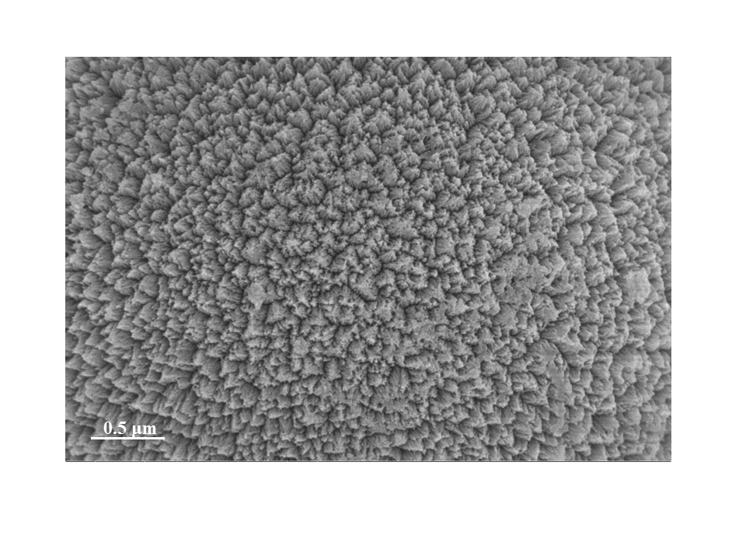

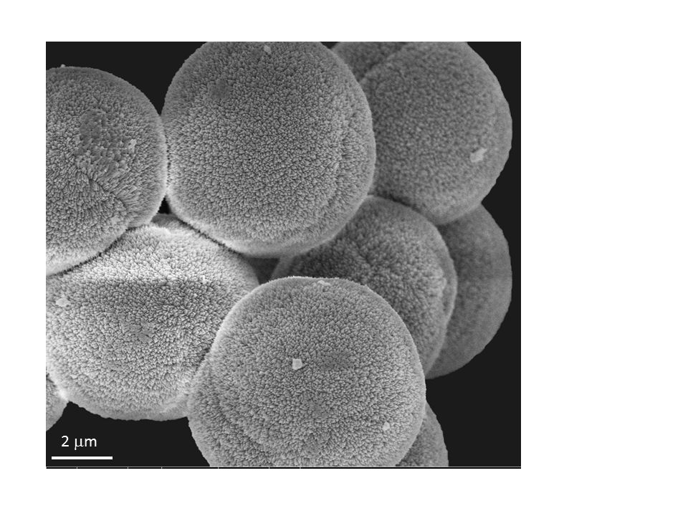

**Fig. S1** SEM images of the Ni0.14Mn0.86CO3 microspheres



**Fig. S2** XRD pattern of the Ni0.14Mn0.86CO3 microspheres

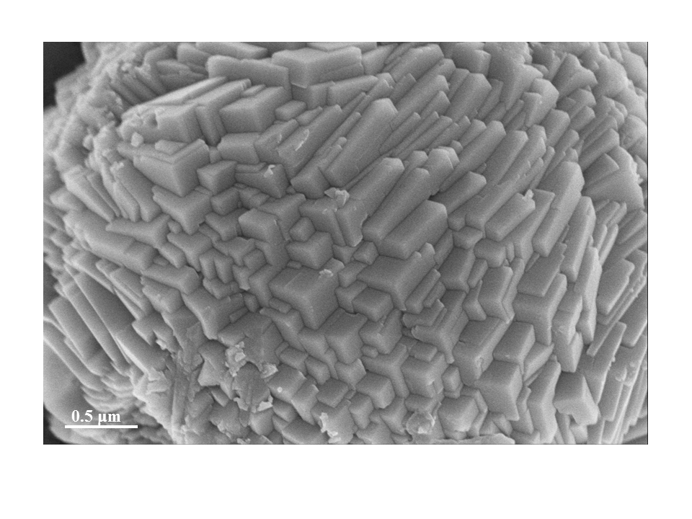

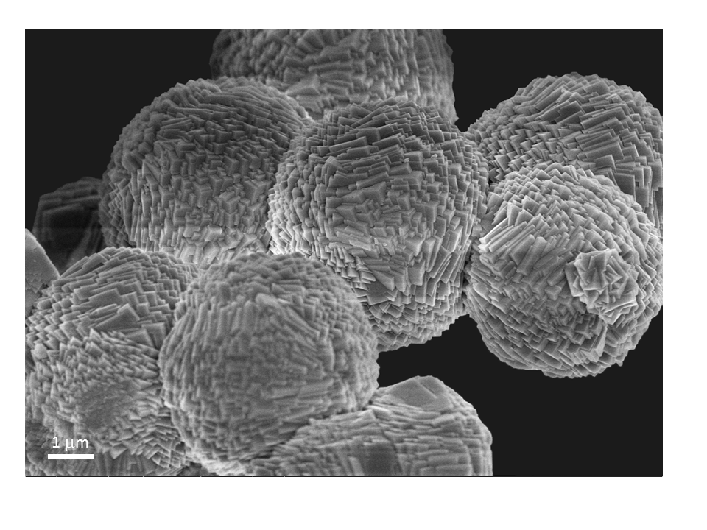

**Fig. S3** SEM images of the MnCO3 microspheres



**Fig. S4** XRD pattern of the MnCO3 microspheres



**Fig. S5** XRD pattern of the the NiCO3



**Fig. S6** XRD pattern of the Ni0.33Mn0.67CO3



**Fig. S7** TGA curve of the Ni0.14Mn0.86CO3 microspheres in air atmosphere

There are three obvious weight loss steps in the TGA curve of Ni014Mn0.86CO3. The first step below 200 ºC may be attributed to the loss of adsorbed water, the second one to the thermal decomposition of Ni0.14Mn0.86CO3 into Ni0.14Mn0.86O1.5 (0.36 Mn2O3/0.14 NiMnO3), and the third one is assigned to the conversion of Ni0.14Mn0.86O1.5 into Ni0.14Mn0.86O1.43 (0.29 Mn2O3/0.14 NiMn2O4)[1]. The particular conversion reactions are as follows:

The second step: $Ni_{0.14}Mn_{0.86}CO_{3}+ {0.25O}_{2} → 0.14NiMnO_{3}+0.36Mn_{2}O_{3}+CO_{2}↑$

The third step: $NiMnO_{3}+0.5Mn_{2}O_{3} →{NiMn}_{2}O_{4}+ {0.25O}_{2}↑$



**Fig. S8** EDX of the Ni0.14Mn0.86O1.43 microsphere in Figure 4c

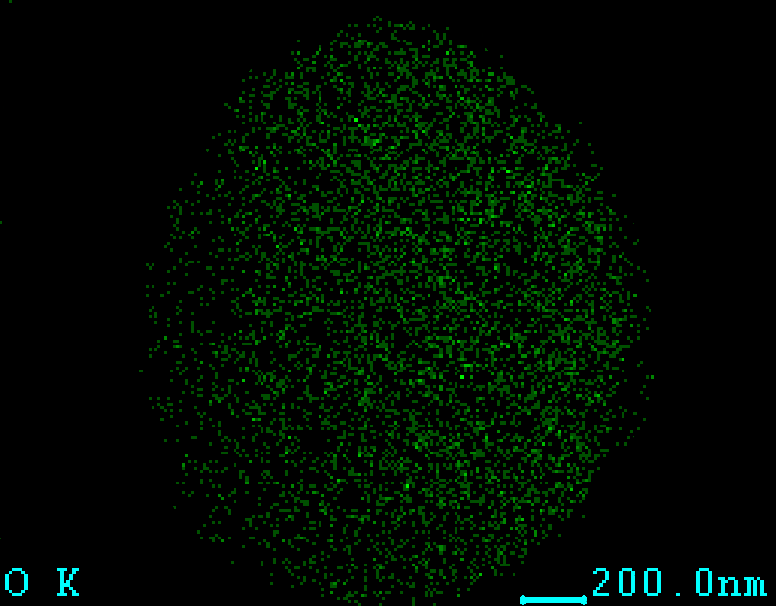

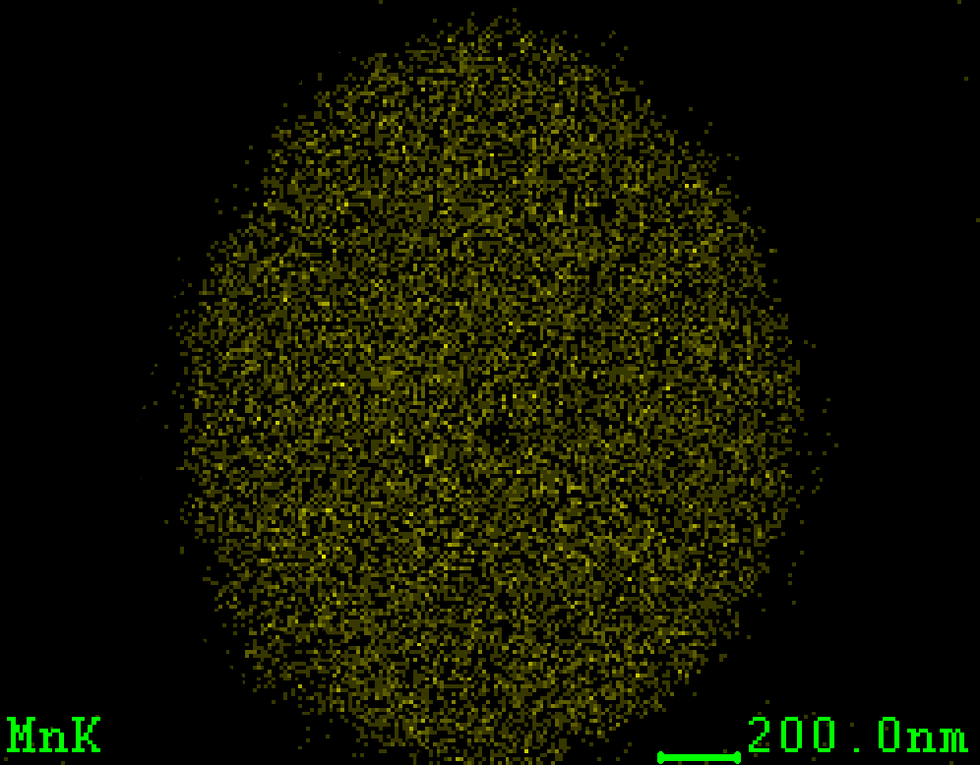

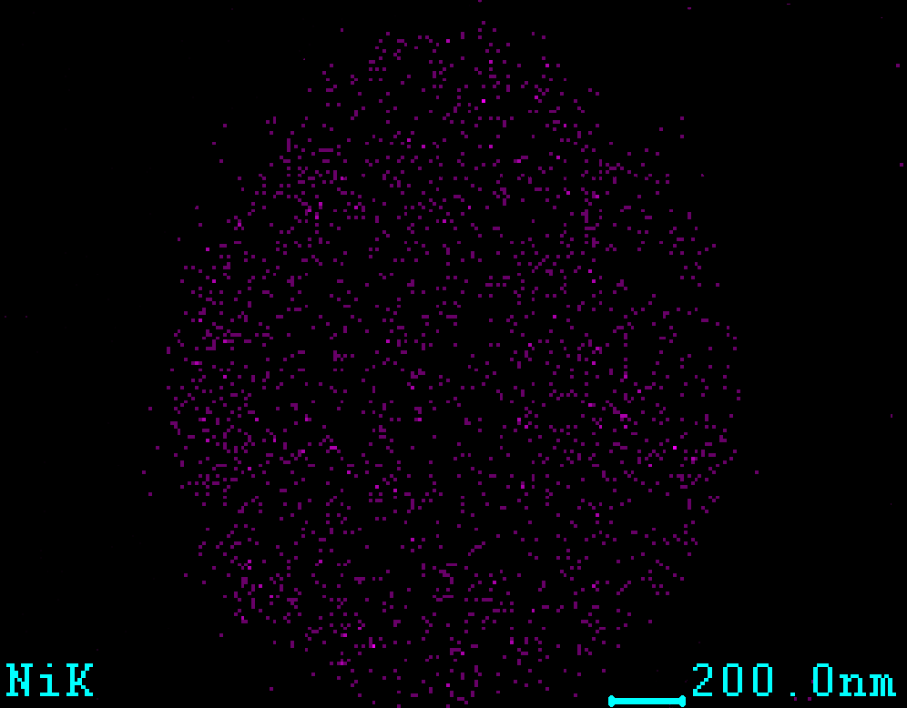

**Fig. S9** SEM-Mapping images of various elements in the Ni0.14Mn0.86O1.43 microsphere in Figure 4c

**(b)**

**(c)**

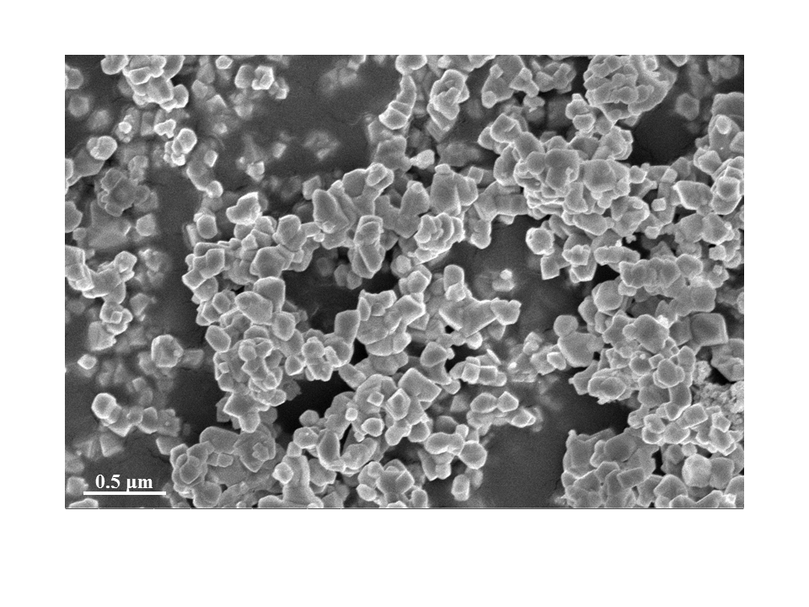

**(a)**



**(b)**

**Fig. S10** SEM image (a) and XRD pattern (b) of the NiO



**(a)**



**(b)**



**(c)**

**Fig. S11** SEM images (a,b) and XRD pattern (c) of the Mn2O3 microspheres.

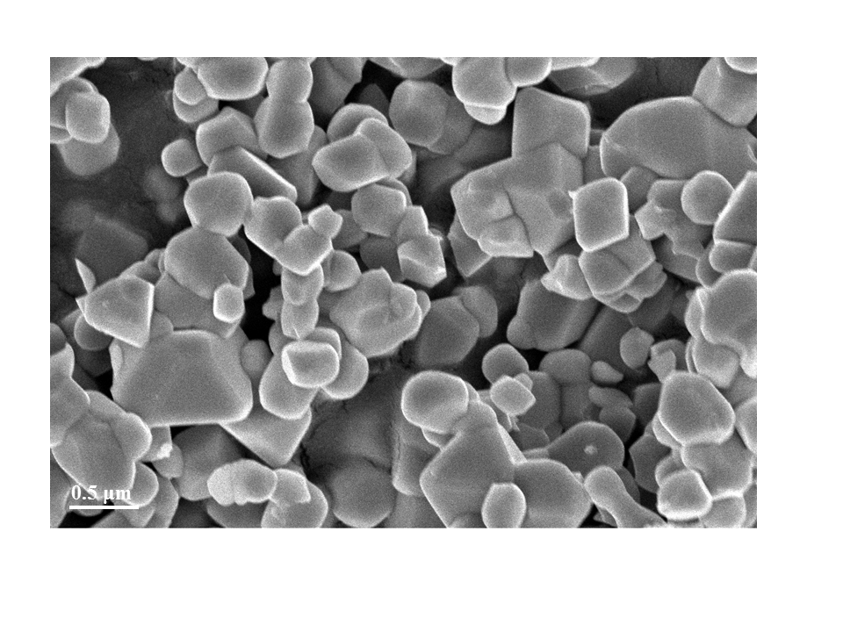

**(a)**



**(b)**

**Fig. S12** SEM image (a) and XRD pattern (b) of the NiMn2O4.



**Fig. S13**  Ratecapability of the porous Ni0.14Mn0.86O1.43 hollow microspheres at the 1st, 50th and 100th cycle.



**Fig. S14** Cycling performance of the anode with porous Ni0.14Mn0.86O1.43 hollow microspheres in the voltage range of 0.01-3.0 V *vs*. Li/Li+ at a current density of 50 mA g-1



**Fig. S15**  Cycling performance of the anode with porous Ni0.14Mn0.86O1.43 hollow microspheres in the voltage range of 0.01-3.0 V *vs*. Li/Li+ at a current density of 200 mA g-1



**Fig. S16**  Cycling performance of the anode with porous Ni0.14Mn0.86O1.43 hollow microspheres in the voltage range of 0.01-3.0 V *vs*. Li/Li+ at a current density of 800 mA g-1



**Fig. S17**  Cycling performance of the anode with porous Ni0.14Mn0.86O1.43 hollow microspheres in the voltage range of 0.01-3.0 V *vs*. Li/Li+ at a current density of 1000 mA g-1



**Fig. S18**  Cycling performance of the anode with porous Ni0.14Mn0.86O1.43 hollow microspheres in the voltage range of 0.01-3.0 V *vs*. Li/Li+ at a current density of 1200 mA g-1



**Fig. S19** Cycling performance of the anode with porous Ni0.14Mn0.86O1.43 hollow microspheres in the voltage range of 0.01-3.0 V *vs*. Li/Li+ at a current density of 1600 mA g-1



**Fig. S20** Cycling performance of the anode with Ni0.14Mn0.86O1.5 solid microspheres in the voltage range of 0.01-3.0 V *vs*. Li/Li+ at a current density of 800 mA g-1



**Fig. S21** Cycling performance of the anode with NiMn2O4 powders in the voltage range of 0.01-3.0 V *vs*. Li/Li+ at a current density of 800 mA g-1

**Lithium storage mechanism:**

The conversion reactions and the specific capacities of NiO, Mn2O3 and NiMn2O4 as well as the Ni0.14Mn0.86O1.43 (0.29 Mn2O3/0.14 NiMn2O4) as starting anode material of LIBs are as following:

**NiO:**

Reversible reaction: $NiO+2{Li}^{+}+2e^{-} ↔Ni+ {Li}_{2}O$

Specific capacity=715 mA h g-1

**Mn2O3:**

First discharge reaction: ${Mn}_{2}O_{3} + 6{Li}^{+}+6e^{-} →2Mn+3{Li}_{2}O$

Specific capacity=1019 mA h g-1

Reversible reaction:

Specific capacity=679 mA h g-1

**NiMn2O4:**

First discharge reaction:

Specific capacity=922 mA h g-1

Reversible reaction:

Specific capacity=692 mA h g-1

**Ni0.14Mn0.86O1.43 (0.29 Mn2O3/0.14 NiMn2O4)：**

First discharge capacity:

$\frac{1019 mA h g^{-1}×0.29 mol×157.9g {mol}^{-1}+922 mA h g^{-1}×0.14 mol×232.6 g {mol}^{-1}}{0.29 mol×157.9g {mol}^{-1}+0.14 mol×232.6 g {mol}^{-1}}=979 mA h g^{-1}$

Reversible capacity:

$\frac{679 mA h g^{-1}×0.29 mol×157.9g {mol}^{-1}+692 mA h g^{-1}×0.14 mol×232.6 g {mol}^{-1}}{0.29 mol×157.9g {mol}^{-1}+0.14 mol×232.6 g {mol}^{-1}}=684 mA h g^{-1}$

**References:**

[1] H. Deng, I. Belharouak, Y.-K. Sun, K. Amine, J. Mater. Chem., 19 (2009) 4510-4516.